[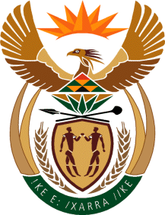](http://www.gov.za/_vti_bin/shtml.dll/symbols/coatofarms.htm/map)

**EMBASSY OF SOUTH AFRICA  
RUSKA 65, 100 00 PRAGUE 10**

**NEWSLETTER - AUGUST 2015 (No. 8)**

[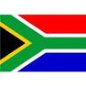](http://www.google.co.za/imgres?imgurl=http://sasportswear.co.za/images/sportswear/south_african_storm_flag.jpg&imgrefurl=http://sasportswear.co.za/sa-memorabilia-7/sports-flags-21/south-african-flag-storm-72.html&h=591&w=591&sz=35&tbnid=Uv7cCdEcYE0-pM:&tbnh=135&tbnw=135&prev=/images?q=South+African+flag&hl=en&usg=__g8gihHXhaZlPhuEToAfXga4s4Hw=&sa=X&ei=IslOTK-nNo-R4Qay7dWoCA&ved=0CAgQ9QEwAQ)



**WORD BY THE AMBASSADOR**

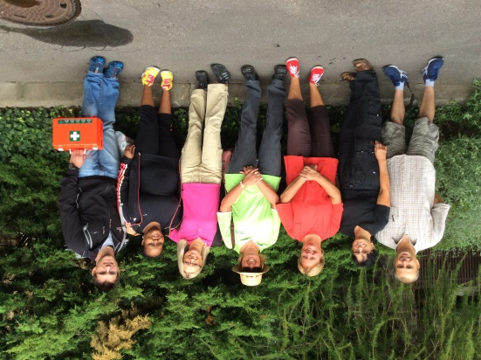

Throughout the long, hot, dry summer of 2015 we kept hearing interesting statistics about the extreme heat and drought which broke all previous records in the Czech Republic. Indeed, the heatwave persisted to the last day of August, leaving everyone limp and looking forward to autumn. But, weather apart, the Embassy had a good August and particularly enjoyed two memorable events.

Firstly, we as Embassy team spent a wonderful day working in the garden of the Home for the Elderly at Mukařov in honour of Mandela Day. It gave us as Embassy team a sense of shared purpose and a feeling of connection to the community.

We also again participated in the annual cultural festival Vibrant 9 in the municipality of Prague 9 where the South African stand attracted a lot of attention with its colourful displays and the enticing smell of homemade boerewors grilling on the coals and fresh coffee. Our day culminated in the performance of the South African jazz singer/composer Melanie Scholtz who got the crowd singing along. She really did South Africa proud.

**EMBASSY NEWS**

***Mandela Day in Mukařov***

On 20 August 2015, Embassy staff members went to Cardinal Beran Senior Home in Mukařov to do a day’s gardening to commemorate Nelson Mandela International Day through community service. It was fortunate that on the agreed date, there was break in the prolonged tropical weather, and conditions were perfect for gardening. Everyone participated with enthusiasm, cutting down dead shrubs; trimming hedges; sweeping up leaves; cleaning weeds to create a new flower bed; painting a room.

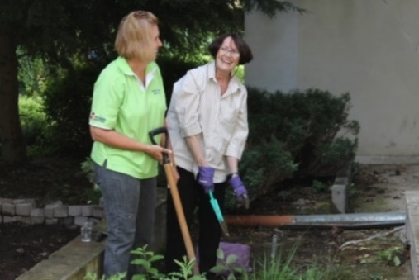

*Ms Schoeman and Ambassador Verwey*

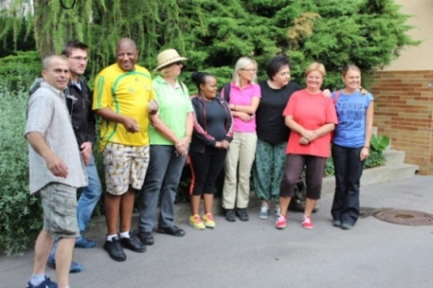

*Max Stifter, Nicholas Wood, ZM Dasa, Mariaan Schoeman, Puleng Radebe-Mothibe, Zuzana Nalevajková, Zuzana Andrstová, Mirka Rubešová before leaving to Mukařov*

***Breakfast without Prejudice***

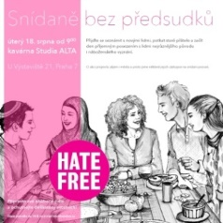Dozens of people of different faiths and various minorities met on 25 August 2015 for a *Breakfast without Prejudice* to show that people can understand each other regardless of different religions and cultures. The event was organized by the Czech Agency for Social Immigration. Participants demonstrated their will for cross-culture and interfaith dialogue and also brought traditional delicacies to share with others.

[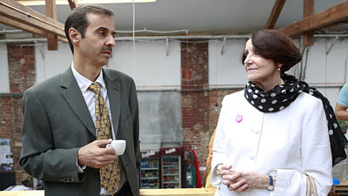](http://media.novinky.cz/454/504545-original1-xg605.jpg)

*Kuwaiti Ambassador**Mr**Ayman Mohammad Aladsani and Ambassador Verwey at the Breakfast without Prejudice, Picture: Hate Free Culture*

***Vibrant Nine***

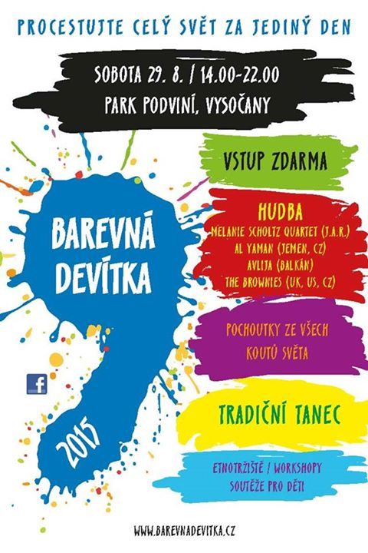The 11th annual multicultural festival *The Vibrant Nine* took place on Saturday 29 August 2015 in Podviní Park in Prague 9. The event was a kaleidoscope of foreign cultures, exotic cuisines and typical crafts from across the world. Children had the opportunity to take part in various workshops and competitions including a whole-day competition *Around the world in one hour.*

[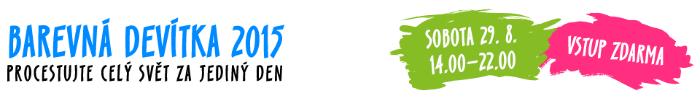](http://barevnadevitka.cz/)

The South African Embassy logo was prominently displayed on the music stage and the South African stand attracted a lot of attention.

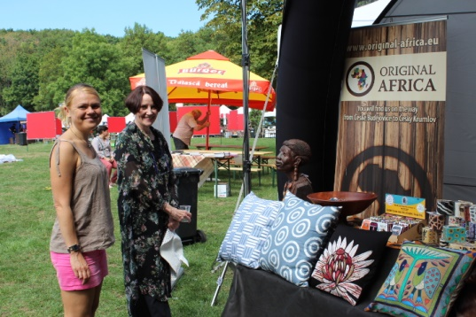

*Ms Hlávková and Ambassador Verwey*

*in front of South African stand*

Jan Brett (Original Afrika), Heather Crowther (Tombalina Wines), Petr Gol (South African Airways) and Diana Růžičková (Kafíčko 33) participated with the Embassy and contributed to the success of the event.

Visitors to the stand collected promotional materials and DVDs about South Africa; bought home-made South African boerewors; and took photos with vuvuzelas which all contributed to the fun.

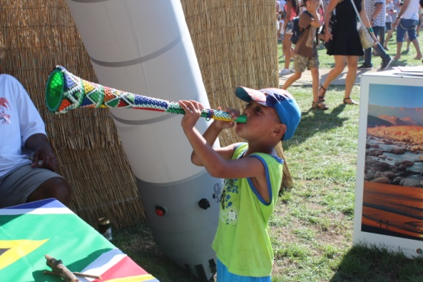

The festival programme took place both in the park area and on stage. Melanie Scholtz, the excellent South African jazz singer/composer returned to the Vibrant Nine’s main stage, this time with her band. Her performance was much applauded.

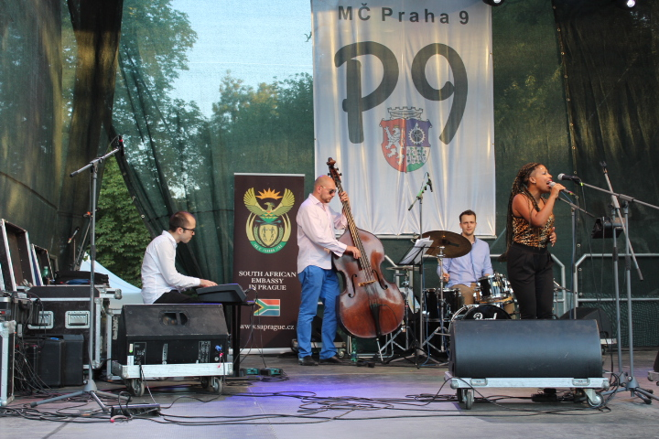 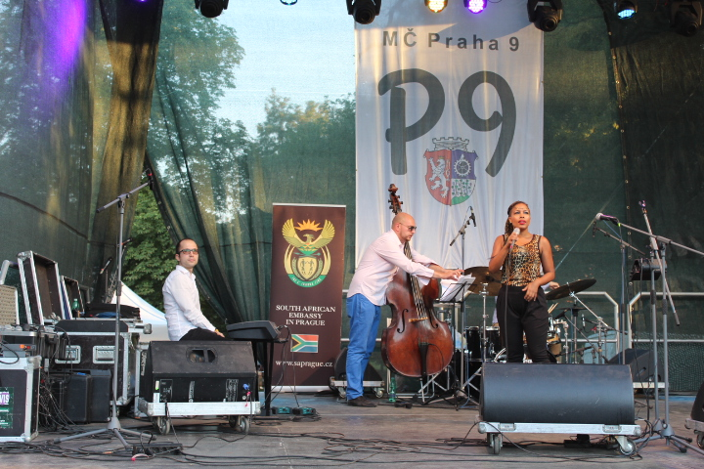 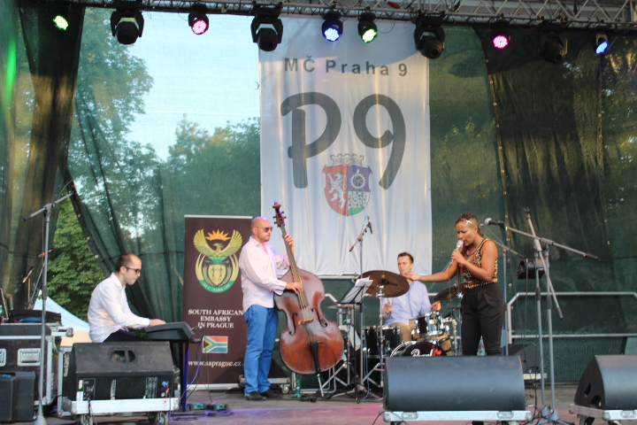

*Melanie Scholtz*

***Meeting with representatives of the Czech-African Business Council***



The Chairperson of the Czech-African Business Council, Ms Ivana Bednářová-Častvajová and her colleague Ms Jitka Palatová visited the Embassy on 18 August 2015 to introduce the new Council focusing on doing business with African countries.

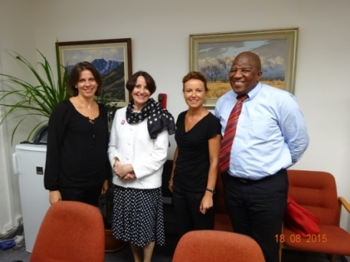

*Jitka Palatová, Ambassador Verwey, Ivana Bednářová-Častvajová and Mr ZM Dasa*

***Exhibition of South African art in Bruntál***

An exhibition of the paintings of Zdenka Miovská, a Czech living in South Africa themed *Touches of Wilderness* opened in the Bruntál Gallery on 27 August and will run until 28 November 2015.

A delegation from Bruntál visited the Embassy on 7 August 2015 to inform the Ambassador of the exhibition.

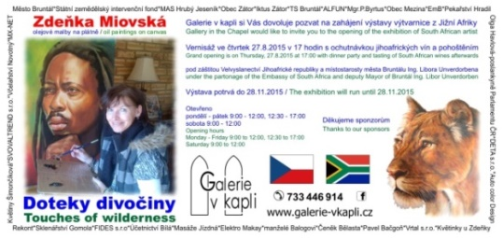

***Diplomatic functions***

In August the Ambassador attended a working lunch hosted by Ambassador of Mexico and an event hosted by the Ambassador of Thailand which included a cooking demonstration.

She received a courtesy call by the departing Ambassador of Nigeria.

**STAFF NEWS/SA CITIZENS**

***Send-off for Ms Mahmoud***

A send-off party for Social Secretary, Ms Hana Mahmoud was held on 19 August 2015 to wish her well as she goes on maternity leave from September.

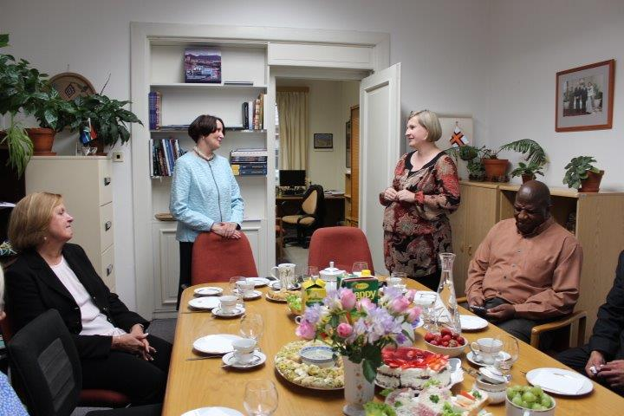

*Ambassador Verwey and Ms Mahmoud*

***Resignation of Ms Nalevajková***

The Embassy accountant, Ms Zuzana Nalevajková resigned from her post as of September 2015.

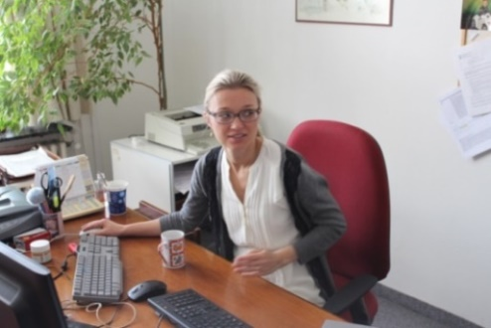

We wish much health and happiness to Hana and her baby and much success for Zuzana in her further career!

***Ms Hlávková received Janský’s plaque***

Our colleague Michaela Hlávková received a bronze Janský’s plaque for ten donations of blood from the Czech National Transfusion Service.

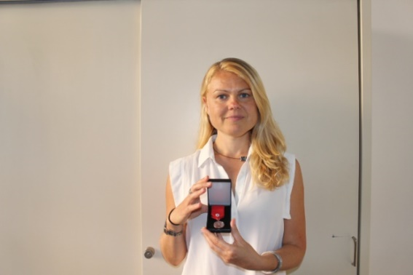 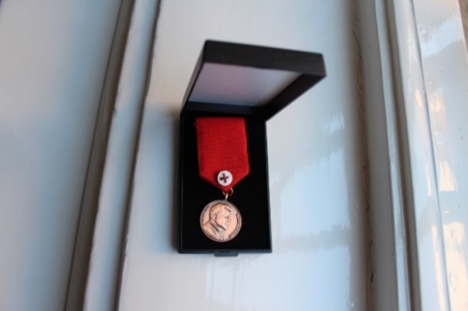

Congratulations!

**SOUTH AFRICAN NEWS**

***Visit by Deputy PM of Vietnam***

Mr Hoang Trung Hai, Deputy Prime Minister of the Socialist Republic of Vietnam, paid an official visit to South Africa on 4 August 2015.

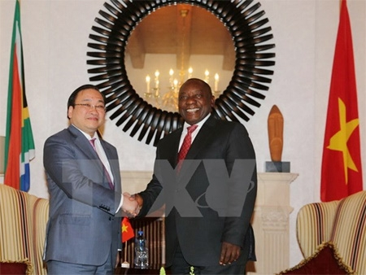

*Vietnamese Deputy Prime Minister Hoang Trung Hai after the talks with South African Vice President Cyril Ramaphosa. Picture: The Presidency*

***Deputy President visited Japan***

A high level South African government and business delegation to Japan led by Deputy President Cyril Ramaphosa took place from 22-25 August 2015.

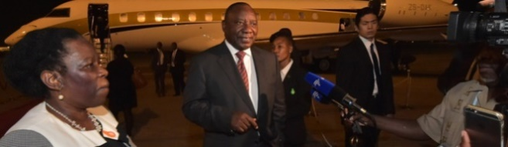

*Deputy President Cyril Ramaphosa arrives in Japan to promote South Africa as a destination for trade and investment. Picture: The Presidency*

***SADC Summit in Botswana***

President Jacob Zuma led the South African delegation to the 35th Ordinary Southern African Development Community (SADC) Summit of Heads of State and Government which was held in Botswana from 17-18 August 2015 under the theme *Accelerating Industrialisation of SADC Economies Through Transformation of Natural Endowment and Improved Human Capital.*

***Visit to Mauritania and Niger***

International Relations and Cooperation Minister Ms Maite Nkoana-Mashabane undertook a working visit to the Islamic Republic of Mauritania and the Republic of Niger, respectively, from 24-25 August 2015. An *Agreement on the Establishment of* *a Joint Commission of Cooperation* and a *Memorandum of Understanding on Regular Bilateral Consultation* between South Africa and Mauritania were signed on 24 August 2015.

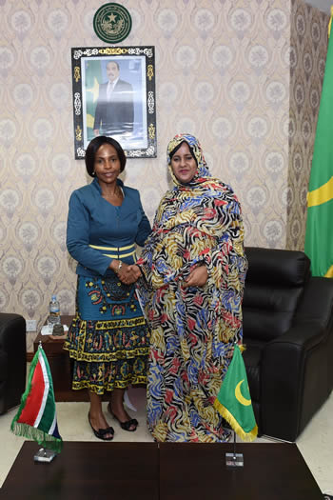 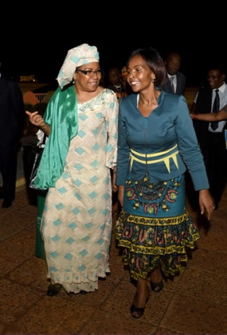

*Left: Minister Ms Maite Nkoana-Mashabane and the Minister of Foreign Affairs and Cooperation, Ms Vatma Vall Mint Soueinae, Nouakchott, Mauritania, 24 August 2015. Picture: Yolande Snyman*

*Right: Minister Ms Nkoana-Mashabane welcomed by the Minister of Foreign Affairs, Cooperation, African Integration and Nigeriens Living Abroad, Ms Kane Aichatou Boulama, Niamey, Niger, 25 August 2015.*

*Picture: Unati Ngamtwini*

***Meeting of Executive and Judiciary***

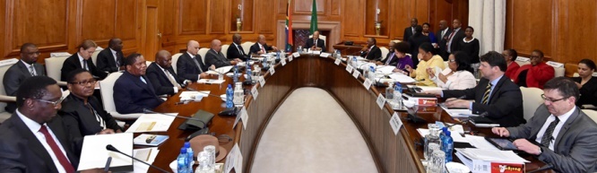

President Jacob Zuma and members of his cabinet met with Chief Justice Mogoeng Mogoeng and senior members of the judiciary on 27 August 2015 to discuss working relations between the two arms of the state at the Union Buildings in Pretoria

***RSA won three medals at 2015 IAAF World Championship***

[](https://en.wikipedia.org/wiki/File:2015_World_Championships_in_Athletics_logo.png)South Africa gained three medals at the 2015 IAAF World Championship held in Beijing from 22-30 August 2015. Wayde van Niekerk won his first world championship title in the 400m in 43.48s; Anaso Jobodwana won bronze in the 200m final, with a national record time of 19.87s and javelin thrower Sunette Viljoen claimed the bronze medal with 65.79m.

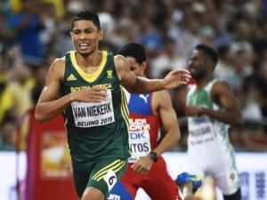 [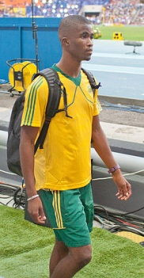](https://en.wikipedia.org/wiki/File:Anaso_Jobodwana_(Moscow_2013)_by_Dmitry_Rozhkov_75.jpg) 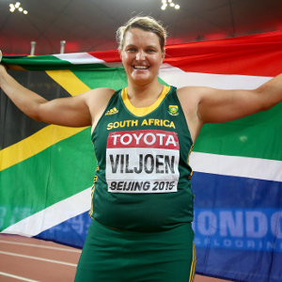

*W.van Niekerk A. Jobodwana S. Viljoen*

***Women’s Month 2015***

South Africa celebrated Women’s Month in August. On 21 August 2015, Minister Nkoana-Mashabane received a National Women’s Award from the Nelson Mandela Library in recognition of her dedication to the promotion of human rights, women’s empowerment and gender equality.

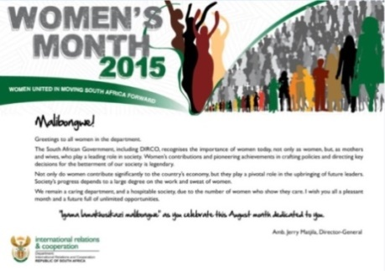

Women’s Day on 9 August 2015 marked the anniversary of the great women’s march of 1956

**CZECH NEWS**

***French Foreign Minister in Prague***

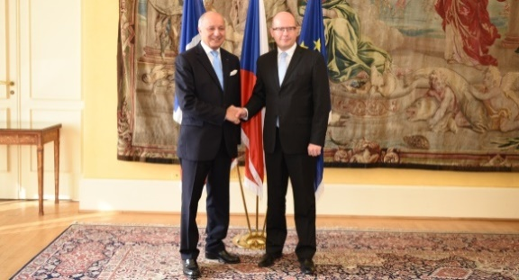

*Minister Laurent Fabius and Prime Minister Bohuslav Sobotka; Picture: M.Trnková*

French Foreign Minister Laurent Fabius visited the Czech Republic from 23-24 August 2015 to discuss strategic partnership, trade cooperation especially in the areas of transport and defence, as well as the migration crisis. He also addressed the Czech Ambassadors’ Conference.

***First Lady visited Afghanistan***

Czech President Miloš Zeman´s wife Ivana accompanied by Rostislav Pilc, head of the Presidential Office´s military department, visited Afghanistan on 11 August 2015. She met Czech female soldiers and discussed their everyday life in conditions of stress, separated from their families.

[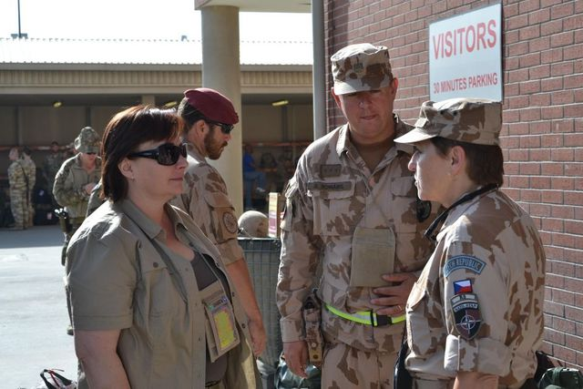](http://www.ceskenoviny.cz/news/index_img.php?id=347415)

*First lady Ivana Zemanová in Afghanistan,*

*11 August 2015. Picture: Prague Castle*

***Zuzana Hejnová retained 400m hurdle title***

Czech athlete Zuzana Hejnová won the women’s 400 m hurdles title at the World Championship in Beijing on 26 August 2015. She is the first woman to retain the title.

[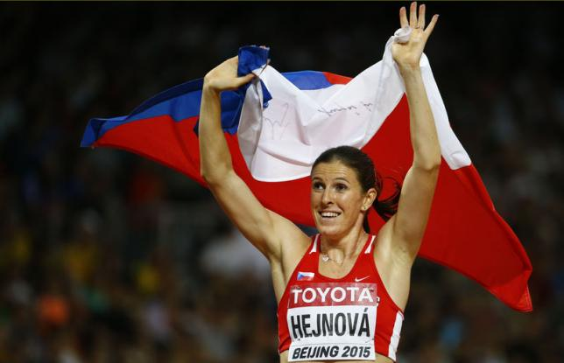](http://www.reuters.com/news/picture/czech-hejnova-first-woman-to-retain-400m?articleId=USKCN0QV1GQ20150826&slideId=1074679538)

***Extreme summer weather***

Currents of hot air moving from Africa hit the Czech Republic this summer ; dozens of temperature records were broken. The highest ever temperature of 40.4 degrees Celsius was registered in Dobřichovice near Prague on 24 August 2015. The historic drought caused many fires. The country also saw an increase in aggressive wasp behaviour.

|  |
| --- |
| For more information about the activities of the South African Embassy in Prague please visit our website: http://[www.saprague.cz](http://www.saprague.cz) |