|  |
| --- |
| [Click on the specific symbol to view its symbolism  [coatofarms.gif 22315 bytes)](http://www.gov.za/_vti_bin/shtml.dll/symbols/coatofarms.htm/map) |
|  |

**EMBASSY OF SOUTH AFRICA  
RUSKA 65, 100 00 PRAGUE 10**

**NEWSLETTER - DECEMBER 2015 (No. 12)**

[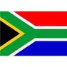](http://www.google.co.za/imgres?imgurl=http://sasportswear.co.za/images/sportswear/south_african_storm_flag.jpg&imgrefurl=http://sasportswear.co.za/sa-memorabilia-7/sports-flags-21/south-african-flag-storm-72.html&h=591&w=591&sz=35&tbnid=Uv7cCdEcYE0-pM:&tbnh=135&tbnw=135&prev=/images?q=South+African+flag&hl=en&usg=__g8gihHXhaZlPhuEToAfXga4s4Hw=&sa=X&ei=IslOTK-nNo-R4Qay7dWoCA&ved=0CAgQ9QEwAQ)



**WORD BY THE AMBASSADOR**

December is always a busy month. At offices and other work places, people need to end off the calendar year and close the books. There is excitement in the air as everyone prepares for the festive season. The city of Prague glitters with Christmas lights in the December darkness and fish tanks with live carp appear in the streets to tempt those who make the traditional Czech carp dish for the Christmas meal. There is also a feeling of nostalgia for another year gone by.

At the Embassy, we were no less busy with year-end work and events. We were sad to say goodbye to our colleague Mariaan Schoeman and her husband Andre who returned to South Africa after four years in Prague and thank them for their valuable contribution. Vivian Ncongwane arrived with his wife Nonvula and young son Sia as replacement. We warmly welcome them and wish them a happy stay in the Czech Republic. We also took leave of Hana Dastychová who has been an Embassy stalwart for twenty years and wish her all the very best for the future.

I would like to take this opportunity of thanking the Embassy staff for all their hard work during the year and to wish them and to all the Embassy friends and South African compatriots in the Czech Republic a very happy festive period and a peaceful and prosperous New Year.

**EMBASSY NEWS**

***Czech Foreign Ministry presents the Diplomatic Protocol Handbook***

[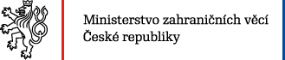](http://www.mzv.cz/jnp/cz/index.html)

On 17 December 2015 Ms Ivana Červenková, Deputy Minister of Chancery of the Czech Ministry of Foreign Affairs presented the new Diplomatic Protocol Handbook to provide diplomatic missions, consular posts and international organizations with guidance on diplomatic immunities and privileges. The Ambassador and Mr Ncogwane, new Corporate Services Manager of the Embassy attended the presentation.

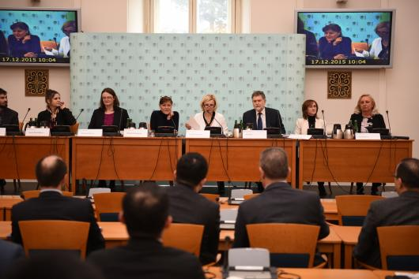

*Presentation of the new Diplomatic Protocol handbook, Prague, 17 December 2015. Picture: MFA*

***Meeting with Minister of Agriculture***

The Ambassador met the Minister of Agriculture Ing Marian Jurečka at the Ministry of Agriculture of the Czech Republic on 18 December 2015 to discuss possible cooperation.

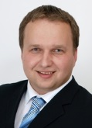 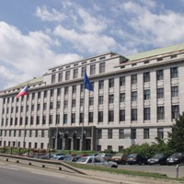*Minister Marian Jurečka Ministry of Agriculture*

***Visit to South Bohemia***

On 4 December 2015 the Ambassador attended a working brunch organized by the GEOMED institution at the České Budějovice airport where she met regional and local politicians, academics and business people, including the representatives of the Chinese Entrepreneurs Gild. The Mission has close links with South Bohemia.

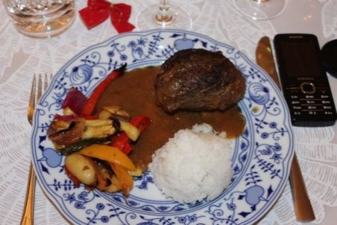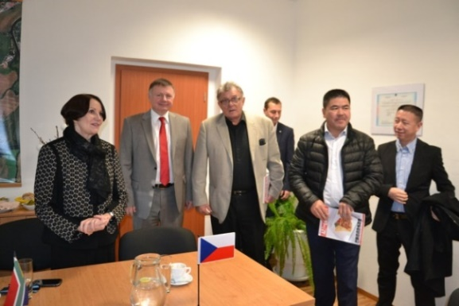

*Ambassador Verwey, Mr Ladislav Ondřich, Director of České Budějovice Airport and MUDr Petr Petr, coordinator of the GEOMED event*

***Visit to Liběchov***

On 16 December 2015 the Ambassador paid a visit to the hydro power plant in Liběchov, Central Bohemia, hosted by Mr Jan Šíp, Director of Business Development of Mavel a.s. company.

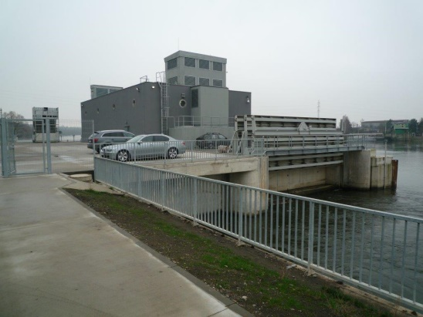

*Liběchov hydro power plant*

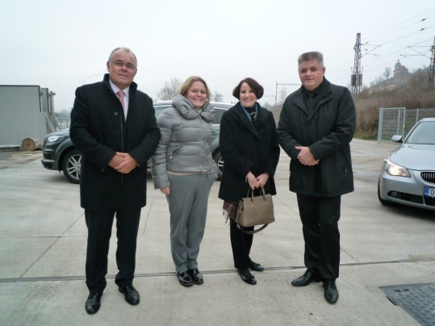

*Jan Šíp and Alžběta Šípová from Mavel a.s. company, Ambassador Verwey and Mr Vilém Růžička, Chairman of the Czech-South African Chamber of Commerce at the hydro power plant*

***Christmas lunch–Farewell to Ms Schoeman***

Ambassador hosted the traditional Christmas lunch for the Embassy staff at the Official Residence on 9 December 2015. Everybody contributed by preparing or buying typical Christmas dishes and other delicacies.

*Delicious španělský ptáček (Spanish bird) was cooked by Ms Dáša Procházková*

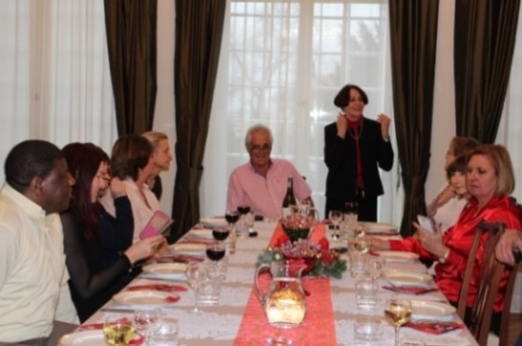

*The Ambassador welcomes the staff at the residence*

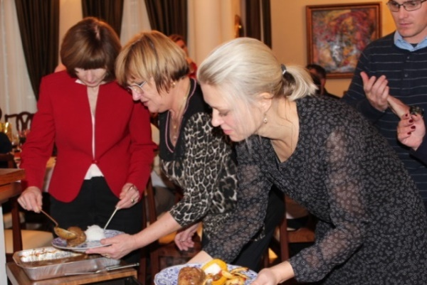

*Ms Růžičková, Ms Procházková and Ms Nalevajková*

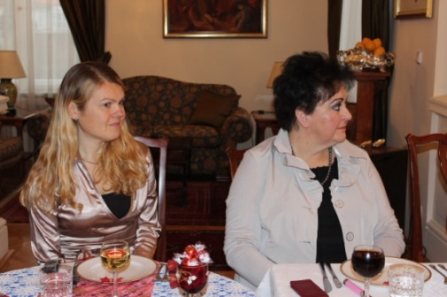 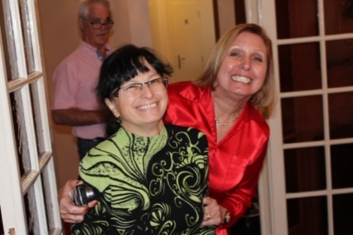

*Ms Hlávková&Ms Andrštová; Ms Herclová &Ms Schoeman*

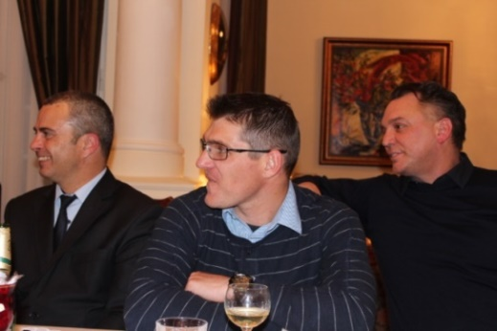

*Mr Stifter, Mr Wood and Mr Walters*

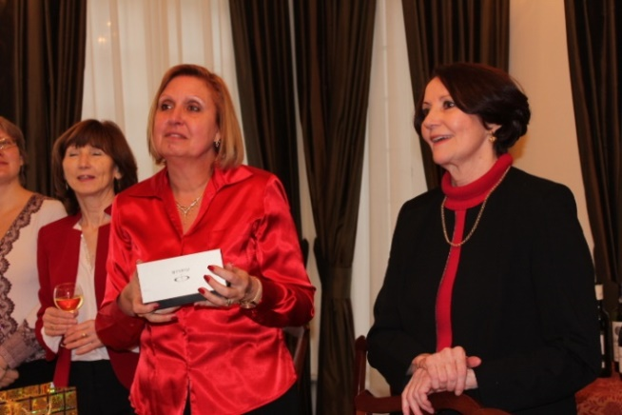

*Ms Schoeman and Ambassador Verwey*

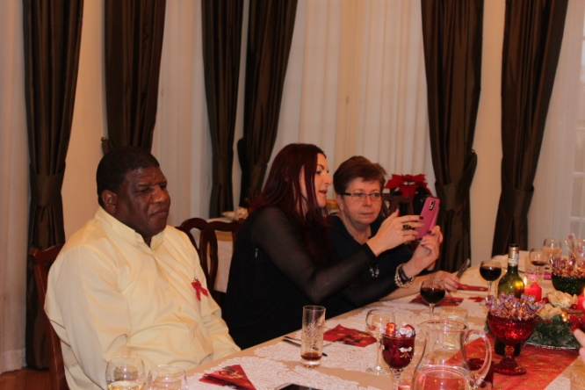 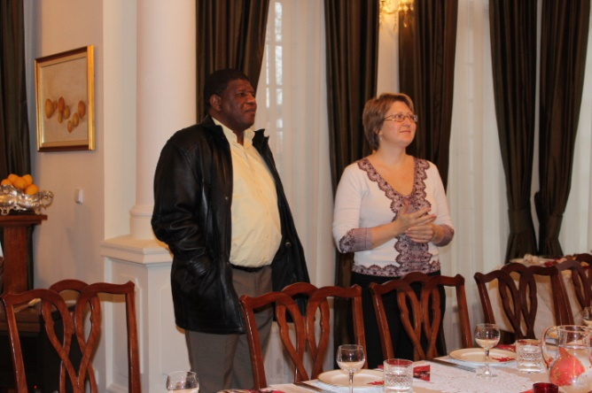

*Ms Jelinek&Ms Dastychová; Mr Dasa&Ms Haklová*

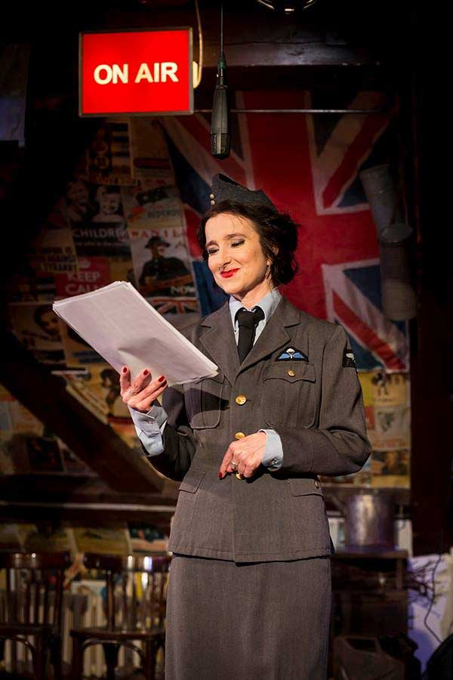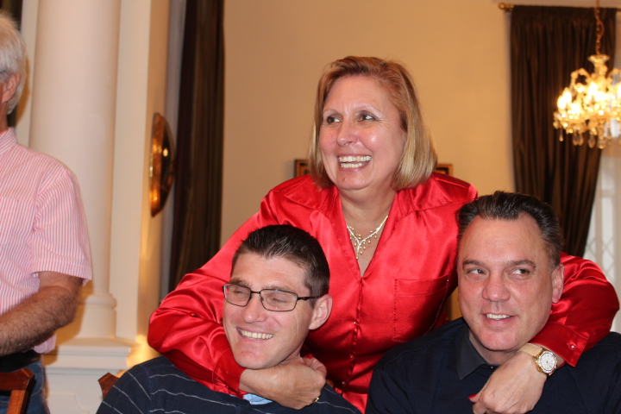The Christmas lunch also served as a farewell to Ms Mariaan Schoeman, who terminated her term of duty in Prague. We wish her much success in her further career.

***Farewell to Hana Dastychová***

On 16 December 2015, the Embassy said farewell to Ms Hana Dastychová who served as Consular Clerk at the Embassy for more than twenty years.

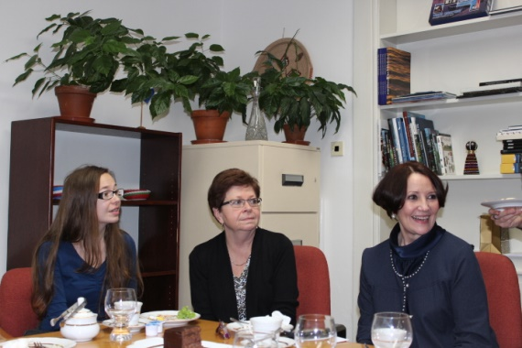

*Hana’s daughter Štěpánka, Hana Dastychová*

*and Ambassador Verwey*

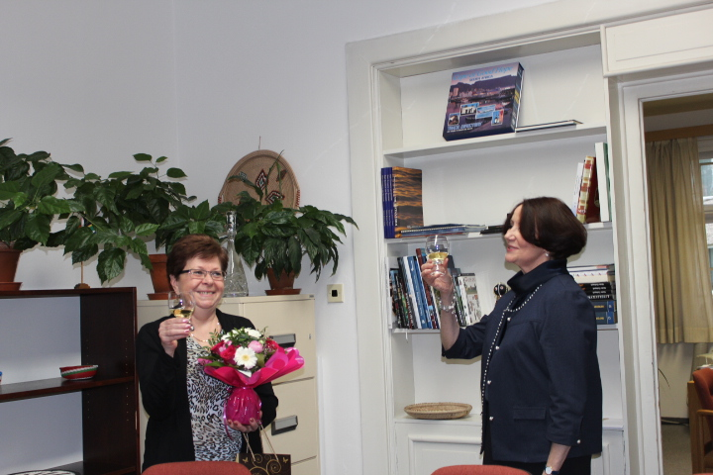

We wish Hana much health and happiness in the new phase of her life.

***Diplomatic functions***

In the month of December the Ambassador attended receptions hosted by Ambassadors of Romania, UAE, Thailand, Kazakhstan and Bosnia & Herzegovina; Sankta Lucia celebration hosted by Ambassador of Sweden; a working lunch hosted by Ambassador of Brazil; a dinner hosted by Ambassador of Denmark and the traditional end-of-year reception hosted by President of the Chamber of Deputies Mr Hamáček.

The Ambassador attended the theatre performance *Much Ado about Nothing* in Kolowrat theatre, where current British Ambassador to the Czech Republic, Jan Thompson played one of the lead roles.

*Ambassador Jan Thompson as Beatrice;*

*Kolowrat Theatre,*

*Prague, December 2015*

**STAFF NEWS/SA CITIZENS**

***Arrival of Mr Ncongwane***

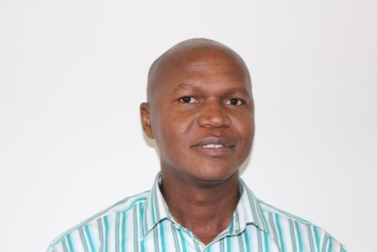

Mr Vivian Ncongwane and his family arrived in Prague on 10 December 2015.

He replaced Ms Schoeman in the post of Corporate Services Manager.

***Appointment of new Consular Clerk***

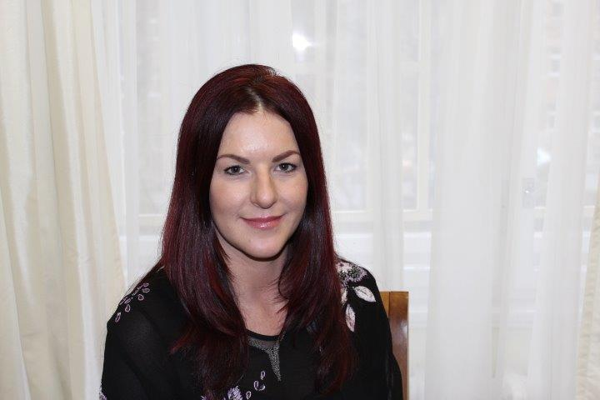

Ms Zdenka Jelínek, a Czech-South African citizen was appointed as Consular Clerk from 1 December 2015.

***We wish our new colleagues much success and happiness at their new job.***

**SOUTH AFRICAN NEWS**

Minister Ms Maite Nkoana-Mashabane hosted the President of the BRICS Development Bank, Mr KV Kamath in Pretoria on 1 December 2015. The President delivered a public lecture at DIRCO on the theme *From Concept to Reality: The BRICS New Development bank.*

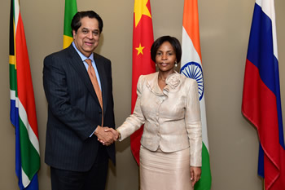

*Minister Ms Maite Nkoana-Mashabane and the President of the BRICS Development Bank, Mr KV Kamath at the O R Tambo Building, Pretoria, South Africa, 1 December 2015. Picture: Unati Ngamntwini*

***State Visit by Chinese President***

On 2 December 2015 President Zuma received the President of the People’s Republic of China, Mr Xi Jinping, on a State Visit to South Africa. The two countries have concluded *Five-to-Ten Year Strategic Programme for Cooperation.* A large number of agreements were signed during the visit.

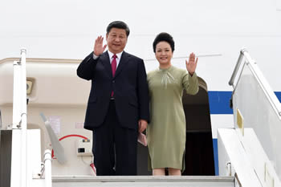

*The President of the PRC, Mr Xi Jinping, arrives in Pretoria, South Africa, 2 December 2015.*

***Agreement between RSA and Cote d’ Ivoire***

Minister Ms Maite Nkoana-Mashabane and Foreign Minister  Mr Charles Kofi Diby signed an Agreement on the establishment of a Joint Commission in the area of Cooperation between South Africa and Côte d’Ivoire in Johannesburg on 4 December 2015. Presidents Jacob Zuma and Alassane Ouattara witnessed the signing.

[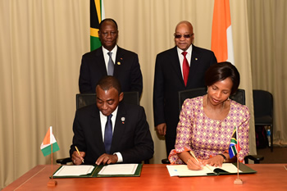](http://www.dirco.gov.za/images/gallery7/mashabane_cote-d_ivoire_diby1.jpg)

*Picture: Unati Ngamntwini*

***New Finance Minister appointed***

Mr Pravin Gordhan was re-appointed Finance Minister on 13 December 2015. Mr Gordhan was widely respected when he served as South Africa’s Finance Minister from 2009 to 2014.

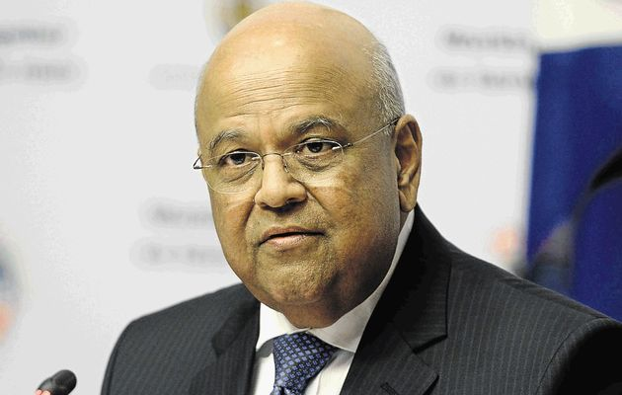

*Mr Pravin Gordhan. Picture: DIRCO*

***Day of Reconciliation***

On 16 December 2015 South Africa celebrated the Day of Reconciliation. This year’s theme was: *Bridging the divide: Building a common South African nationhood towards a national development state.*

**CZECH NEWS**

***Visit of Korean President***

South Korean President Park Geun-hye paid a visit to the Czech Republic from 1-4 December 2015. A two-year action plan on cooperation in the fields of cyber-security, defence and nuclear industries was signed during the visit, as well as several agreements and MOUs. President Park Geun-hye also attended a Prague summit of the Visegrad Four (V4) group of Central European countries.

[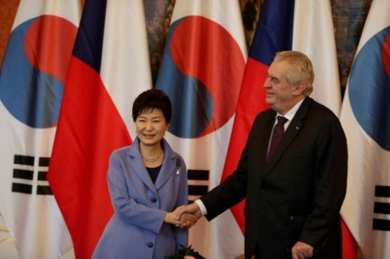](http://www.ceskenoviny.cz/news/index_img.php?id=359840)

*Picture: Prague Castle*

***New head of police inspection appointed***

[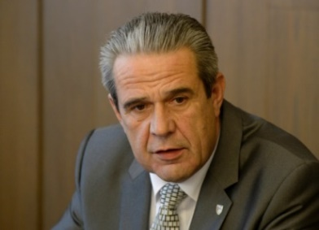](http://www.ceskenoviny.cz/news/index_img.php?id=360069)Michal Murin was appointed new head of the General Inspection of Security Corps (GIPS) on 7 December 2015. He replaced Ivan Bílek who resigned from the post at the end of November 2015.

***2016 state budget approved***

On 17 December 2015 President Zeman signed the state budget on 17 December 2015 with a 70-billion–crown deficit (1.2 percent of GDP). The budget expenditures are put at 1,251 billion crowns and revenues at 1,181 billion crowns. The government envisages an economic growth of 2.5 percent and an average growth of consumer prices of 1.5 percent.

***Karel Schwarzenberg awarded***

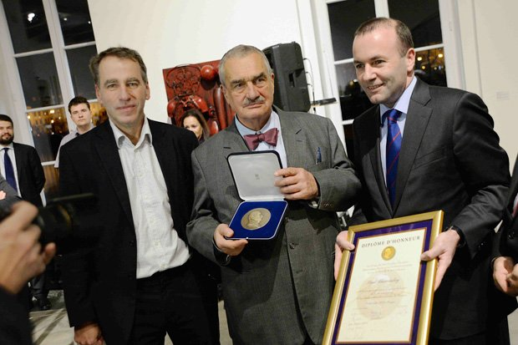Former Czech Minister of Foreign Affairs and TOP 09 honorary chairman Karel Schwarzenberg has been awarded the Robert Schuman Medal by the European People’s Party Group in the European Parliament for his contribution to peace, European development and human values on 10 December 2015. He is the first Czech to receive the Award.

***Dohnal re-instated head of Prison Service***

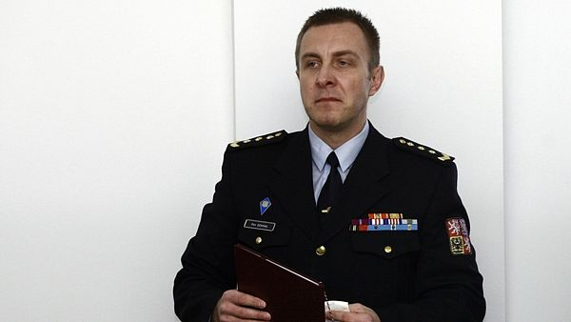Brigadier General Petr Dohnal has been re-instated head of the Prison Service on 18 December 2015 after the Prague Municipal Court ruled his dismissal by the then Justice Minister Helena Válková invalid.

***President’s Christmas message***

President Miloš Zeman praised the country’s economic growth, rise in wages and low unemployment in his Christmas message on 26 December 2015 and he warned against the migrant wave.

[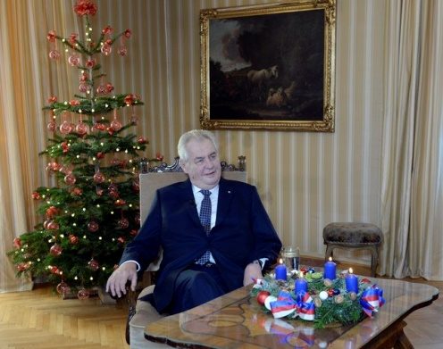](http://www.ceskenoviny.cz/news/index_img.php?id=362078)

*Picture: Prague Castle*

|  |
| --- |
| For more information about the activities of the South African Embassy in Prague please visit our website: http://[www.saprague.cz](http://www.saprague.cz) |

