|  |
| --- |
| [Click on the specific symbol to view its symbolism  [coatofarms.gif 22315 bytes)](http://www.gov.za/_vti_bin/shtml.dll/symbols/coatofarms.htm/map) |
|  |

**EMBASSY OF SOUTH AFRICA  
RUSKA 65, 100 00 PRAGUE 10**

**NEWSLETTER - FEBRUARY 2015 (No. 2)**

[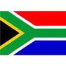](http://www.google.co.za/imgres?imgurl=http://sasportswear.co.za/images/sportswear/south_african_storm_flag.jpg&imgrefurl=http://sasportswear.co.za/sa-memorabilia-7/sports-flags-21/south-african-flag-storm-72.html&h=591&w=591&sz=35&tbnid=Uv7cCdEcYE0-pM:&tbnh=135&tbnw=135&prev=/images?q=South+African+flag&hl=en&usg=__g8gihHXhaZlPhuEToAfXga4s4Hw=&sa=X&ei=IslOTK-nNo-R4Qay7dWoCA&ved=0CAgQ9QEwAQ)



**WORD BY THE AMBASSADOR**

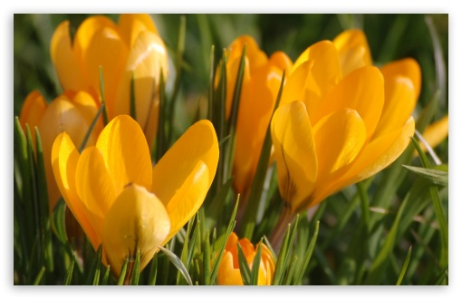

The month of February marks the last month of another mild winter and we were all very happy to see the crocuses bursting into flower, heralding the coming spring.

It was with great sadness and shock that we took note of the tragic incident in Uhersk**ý Brod, South Moravia,** where a mentally unstable man shot and killed 8 people in a restaurant before turning the gun on himself. Our deepest condolences go the families and friends of the victims.

Over the winter months, there were warnings in media reports of nasty winter respiratory and flu infections that were reaching almost epidemic proportions in the Czech Republic and affecting the work force everywhere. Initially we thought the warnings were exaggerated but, unfortunately, the Embassy did not escape and throughout February, we were limping along with considerably reduced staff as stricken Embassy members were obliged to stay home to recover. But, we are resilient and by the end of the month we were back to full strength.

**EVENTS/ EMBASSY’S PROGRAMME**

***Annual meeting with Mayor of Prague***

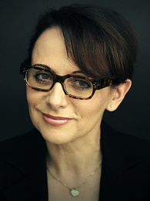The annual reception that the Mayor of Prague hosts for the Diplomatic Corps took place on 5 February 2015 at the Mayor’s Residence. The new Mayor of Prague, Ms Adriana Krnáčová, (nominated by the ANO political movement) gave a briefing on the achievements of the City of Prague and its goals for the current year.

[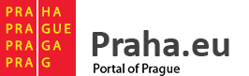](http://www.praha.eu/jnp/en/index.html)

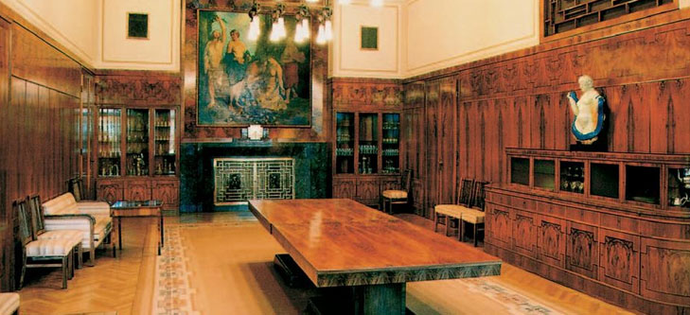

*Mayor’s Residence*

***Lunch of Africa Group***

On 24 February 2015 Ambassador attended a lunch of Africa Group hosted by the Dean of the Group, Ambassador of Morocco. African Embassies in the Czech Republic comprise Algeria [Description: Description: http://www.theodora.com/flags/ag-t.gif](http://www.theodora.com/maps/algeria_map.html), Democratic Republic of Congo Description: Description: Congo Democratic Republic flag, Egypt [Description: Description: http://www.theodora.com/wfb/egypt/eg-t.gif](http://www.theodora.com/wfb/egypt/egypt_flags.html), Ghana Description: Description: Ghana flag, Libya Description: Description: Libya Rebel flag, Morocco Description: Description: Morocco flag, Nigeria Description: Description: Nigeria flag, South Africa [Description: Description: http://www.theodora.com/wfb/south_africa/sf-t.gif](http://www.theodora.com/wfb/south_africa/south_africa_maps.html) and Tunisia Description: Description: C:\Users\herclovaz\Desktop\tunisia-t.gif.

The group discussed ways jointly to promote greater awareness of the African continent in the Czech Republic during 2015, focusing on the continent’s rich history and culture as well as opportunities for engagement at many levels.

***Visit of Ms Morake***

Ms Rachel Morake, Corporate Service Manager from the South African Embassy in Rome visited Prague from 3 - 6 February 2015 to negotiate some purchases for the Rome Embassy. Ms Hlávková accompanied Ms Morake and together they managed a successful outcome.

http://lnx.sudafrica.it/open2b/var/setting/logo.jpg

***Meeting with Mr Christian Gerber***

[](http://www.bez.sk/sk/o-nas/profil/etd-transformatory)The Ambassador and Ms Hlávková met the newly arrived CEO of the ETD Transformers Mr Christian Gerber on 19 February 2015. Mr Gerber is a South African. He came to introduce himself and discuss future cooperation.

**Diplomatic functions**

In February 2015 the Ambassador attended several receptions, including receptions hosted by the Ambassadors of Slovenia, Iran, Venezuela, Morocco and Portugal; a dinner hosted by the Ambassador of Saudi Arabia in honour of a departing Ambassador and a lunch hosted by the Ambassador of Kuwait. She also attended a farewell dinner for the Ambassador of Slovenia co-organised by all the women ambassadors in Prague.

On the fun side, Ambassador attended an ice-hockey match between the Czech Republic and Russia in the company of a colleague from the Corps at the O2 arena.

**STAFF NEWS/SA CITIZENS**

***Resignation of Mr Breytenbach***

South African national Mr Gerhard Breytenbach, who worked at the Embassy as a receptionist, resigned from his post at the end of February 2015.

***Ms Haklová gave birth to a boy***

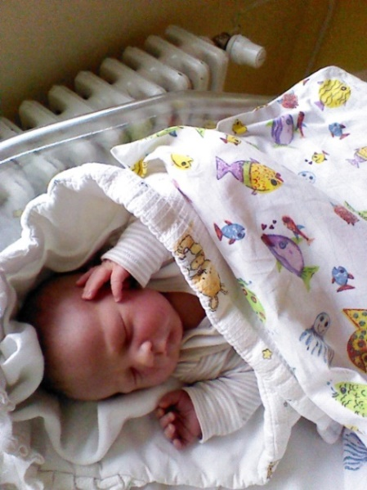

Our colleague Ms Helena Haklová gave birth to a baby boy on 10 February 2015. Dan weighed 3.84 kg and measured 51 cm.

Welcome to the world and congratulations to the parents!

**DIRCO**

***State of the Nation Address 2015***

President Jacob Zuma presented the State of the Nation Address (SONA) to a joint sitting of Parliament on 12 February 2015. The President talked about the government’s achievements of the past year and looked to the future by presenting a programme for the coming year.

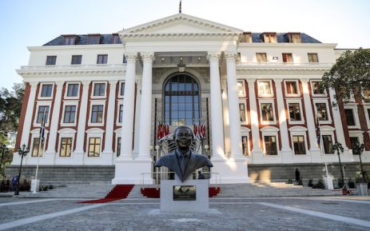

Three members of the Economic Freedom Fighters (EFF), including party leader Julius Malema had to leave the Parliament after they interrupted president Zuma during his State-of-the-Nation Address.

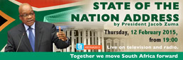

In his address, President Zuma referred to legislation that will come before Parliament this year, including legislation related to Cooperative Governance and Traditional Affairs, Labour, Rural Development and Land Reform.

President Zuma also announced the continuation of the electrification programme and the municipalities that are to benefit from the programme, but there are still many households awaiting electricity.

*(For more details please see the SONA in numbers in the enclosure)*

President Zuma invited several special guests, who were representing the RSA in various sectors on the international stage to attend SONA and the official opening of Parliament. He met them also for High Tea ahead of SONA on 11 February 2015. The special guests were: Olympic Gold medalist Mr Chad Le Clos; three girls from Moletsane High School; Banyana Banyana striker Miss Portia Modise; winner of the 2014 Agriculture Female Entrepreneur Awards Programme Ms Ivy Nokwanele Mzamo; and the winner of Water Conservation Award Ms Mapule Phokompe.

[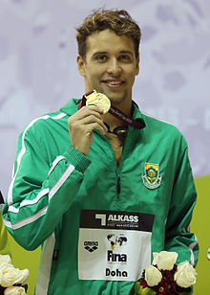](http://en.wikipedia.org/wiki/File:Chad_le_Clos_2013_3.jpg) [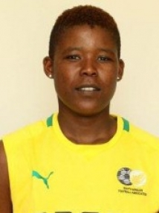](http://whoswho.co.za/portia-modise-399653)

*Chad Le Clos Portia Modise*

***Visit to Sudan***

President Jacob Zuma undertook a working visit to Khartoum, Republic in Sudan on 1 February 2015 for consultations with President Omar al-Bashir.

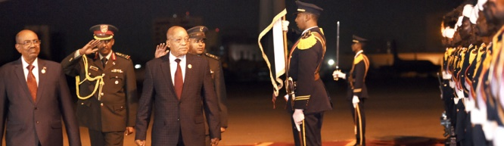

*President Zuma arriving at Khartoum International Airport in the Republic of Sudan, 1 February 2015, Picture: the Presidency*

***ERISA Public Lecture***

The South African Embassy in Eritrea hosted the 1st Public Lecture of the Eritrea-South Africa Festival (ERISA) in Asmara on 6 February 2015 with the topics *South Africa 20 Years Later (1994 – 2004): The Challenge and Progress of Nation Building.*

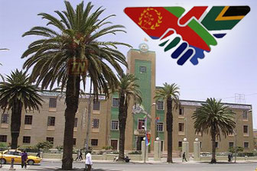*ERISA first public lecture at City Hall by South Africa’s first Ambassador to Eritrea*

The aim of the lecture and panel discussion was to seek common ground for progressive engagement on nation building between Eritrea and South Africa. The lecture was delivered by Mr Welile Nhlapo, former South African Ambassador to Eritrea.

[](http://www.google.cz/url?url=http://allafrica.com/stories/201502090152.html&rct=j&frm=1&q=&esrc=s&sa=U&ei=2_DZVIvEIIj5UJShgYAD&ved=0CBsQpwI&usg=AFQjCNGSyrgFAwmgEGzAOzM_quxo6SJnLg)

allafrica.com

***Inaugural Ubuntu Awards***

[](http://www.dirco.gov.za/ubuntu_awards/)DIRCO launched the Inaugural Ubuntu Awards at the Cape Town International Convention Centre on 14 February 2015 in order to recognize South Africa’s national interests and values across the world. The awards were presented to organisations/ individuals who have distinguished themselves as true South African ambassadors.

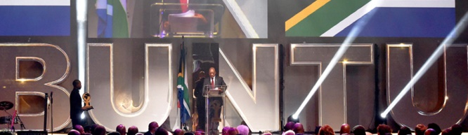

*President Zuma attends the inaugural awards held at the Cape Town International Convention Centre*

The Ubuntu Lifetime Achievement Award was presented to two recipients: Billy Modise, former High Commissioner to Canada, and Dr Ruth Mompati, one of the leaders of the historic 1956 Women’s March.

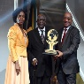*a*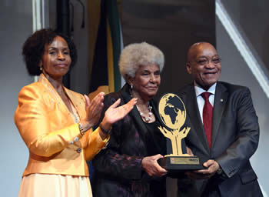

*President Jasob Zuma and Minister Maite Nkoana-Mashabane present the OR Tambo Lifetime Achievement award to Ambassador Billy Modise and Ms Ruth Mompati. Pictures: Jacoline Schoonees*

Sabmiller***,*** the second largest brewer in the worldwas chosen as an Ubuntu Awards 2015 Laureate in the Global Economic Diplomacy for its role in helping to realize the country’s socio-economic goals of, among others, creating jobs and attracting investment.

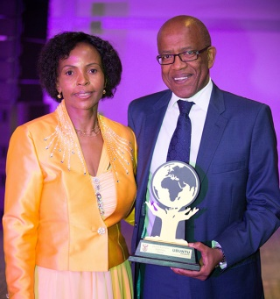

*Mr Monwabisi Fandeso, Executive Director of Corporate Affairs and Transformation at SAB, receives the award from Minister Maite Nkoana-Mashabane*

***SADC Election Observer Mission***

Minister of International Relations and Cooperation Ms Maite Nkoana-Mashabane arrived in Maseru, the Kingdom of Lesotho on 17 February 2015 ahead of the launch of SADC Observer Mission.

[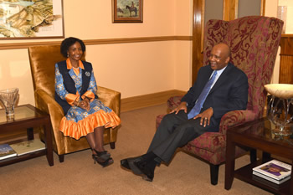](http://www.dfa.gov.za/images/gallery7/mashbane_lesotho_sadc-observe1.jpg)

*Minister Maite Nkoana-Mashabane pays a courtesy call on HE King Letsie III of Lesotho, Maseru, Lesotho, 18 February 2015. Picture: Unati Ngamntwini*

South Africa has led successful SADC Election Observer Missions to Mozambique, Botswana, Namibia, Mauritius and Zambia.

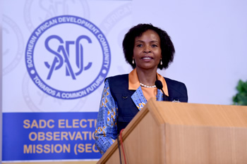

*Minister Maite Nkoana-Mashabane launches the SACD Election Observer Mission (SEOM) in Maseru, Lesotho, 18 February 2015. Picture: Unati Ngamntwini*

***Double Troika Summit in RSA***

[](http://www.sadc.int/)

South Africa hosted an Extraordinary Summit of the SADC Double Troika on 20 February in Pretoria. The summit considered the political and security situation in the Region, in particular the latest development in Lesotho ahead of the 28 February 2015 elections. The Double Troika consists of Zimbabwe, Botswana, Malawi, South Africa, Lesotho and Namibia.

**CZECH NEWS**

**Resignation of Justice Minister**

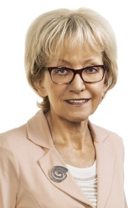Czech Minister of Justice Ms Helena Válková (for ANO) has handed in her resignation as from 1 March 2015. She will be replaced by her deputy, Robert Pelikán.

Minister Válková was criticized for her personnel decisions and her failure to submit bills she promised to prepare.

**Visit to Jordan and UAE**

President Miloš Zeman, accompanied by some 40 businesspeople, including representatives from the arms and nuclear energy industries, paid a visit to Middle East countries, Jordan and the United Arab Emirates from 9 – 13 February 2015.

Economic affairs, the need for development of tourism as well as cooperation in nuclear energy were discussed.

Jordanian King Abdullah II and Czech President Miloš Zeman exchanged their highest state awards, the Order of Hussein bin Ali and the Order of the White Lion respectively.

The new building of the Czech Diplomatic Mission in Abu Dhabi, UAE was opened during President Zeman’s visit.

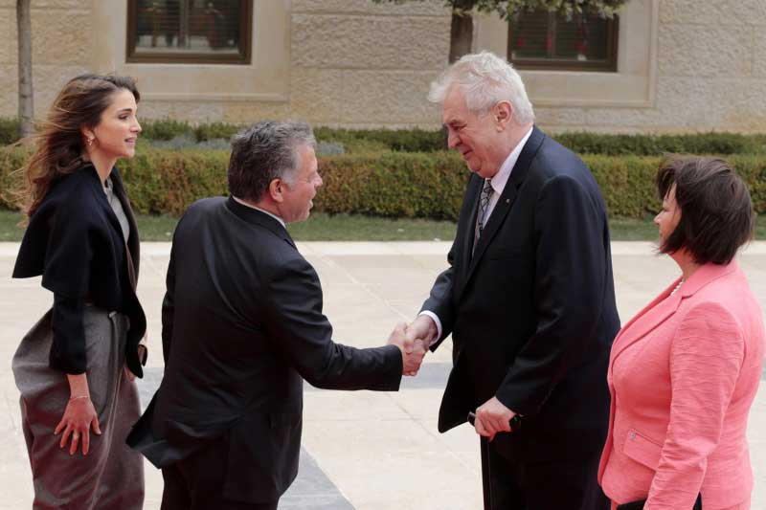

*King Abdullah II and Queen Rania welcoming President Zeman and his wife*

[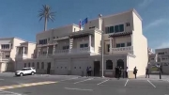](http://www.ceskenoviny.cz/video/detail.php?id=328390)

*The new building of the Czech Diplomatic*

*Mission in Abu Dhabi, United Arab Emirates*

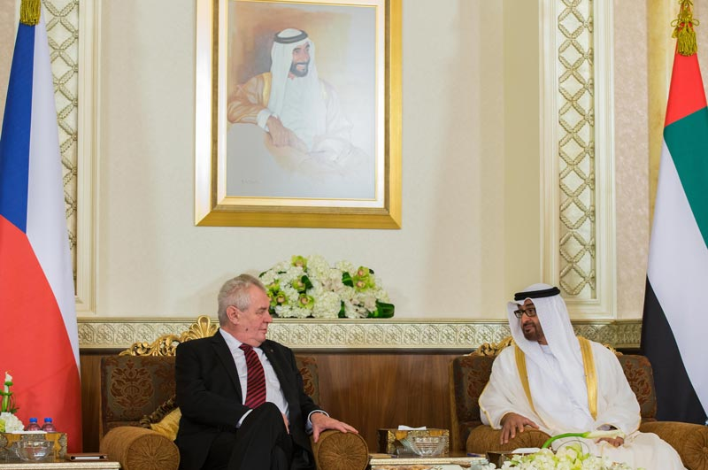

*General Sheikh Mohamed bin Zayed Al Nahyan receives Czech President Miloš Zeman, Al Mushrif Palace, Abu Dhabi, 14 February 2015*

***Babiš re-elected leader of ANO***

Finance Minister Andrej Babiš was unanimously re-elected as leader of ANO at the election conference of the ANO political movement on 27 February 2015. An amendment to party’s statutes confirming the strong position of the party leader was approved.

[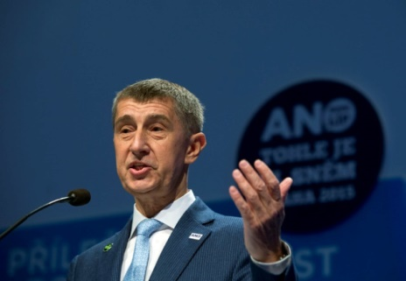](http://www.ceskenoviny.cz/news/index_img.php?id=330071)

*Andrej Babiš re-elected ANO leader*

[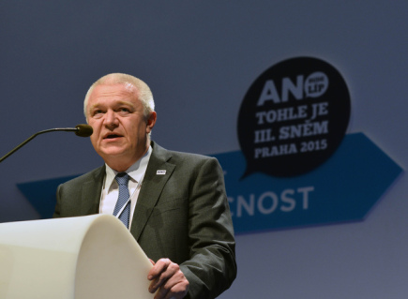](http://www.ceskenoviny.cz/domov/index_img.php?id=330114)a[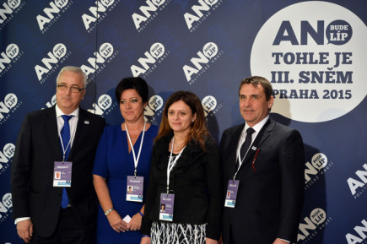](http://www.ceskenoviny.cz/domov/index_img.php?id=330140)

**Jaroslav Faltýnek was elected first deputy chairman and Jan Volný, Radmila Kleslová, Jaroslava Jermanová and Petr Vokřál were elected deputy chairpersons.**

***Tragedy in Uherský Brod***

A mentally unstable 63-year-old man shot eight people dead before killing himself in the Družba restaurant in Uhersk**ý Brod, South Moravia on 24 February 2015. Another eight people managed to escape through the back door.**

***Czech-Polish yacht reached record southern point near Antarctica***

After a month-long sailing, on 12 February 2015 the Czech-Polish yacht expedition beat a naval record by reaching the Bay of Whales near Antarctica, the southernmost place ever reached by a sports yacht.

[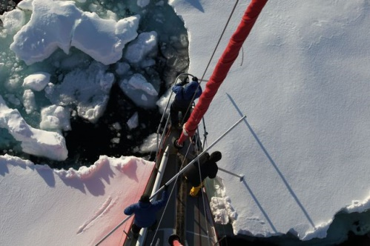](http://www.ceskenoviny.cz/zpravy/index_img.php?id=328477)

|  |
| --- |
| For more information about the activities of the South African Embassy in Prague please visit our website: http://[www.saprague.cz](http://www.saprague.cz) |

*Enclosure No.1*

**SONA-in-Numbers – February 2015**

***Historic milestones***

* **60** – years since the historic moment when South Africans from all walks of life adopted the Freedom Charter in 1955, in Kliptown, Soweto.
* **25** – the years since the release of President Nelson Mandela from prison and since the unbanning of liberation movements.

***Economy***

* **3,5%** – the gross domestic growth forecasts for global economic growth in 2015.
* **5%** – the planned growth target to be achieved by 2019.

***Employment***

* **15,3 million** – people employed in South Africa for the last quarter of 2014.
* **203 000** – the growth in the number of jobs.
* **R2 billion** – amount claimed to date by employers from the Employment Tax Incentive.
* **29 000** – employers who have claimed from the Employment Tax Incentive.
* **270 000** – number of young people that employers claimed for from the Employment Tax Incentive.
* **6 million** – target of six million work opportunities over five years.
* **850 000** – work opportunities created.
* **1 million** – annual target of job opportunities to be created over five years.
* **30 000** – work opportunities created by environmental programmes such as Working on Waste, Working for Wetlands, Working for Water and Working on Fire.
* **60 000** – work opportunities to be created by environmental programmes such as Working on Waste, Working for Wetlands, Working for Water and Working on Fire during the next financial year.

***Energy***

* **R23 billion** – to be given to Eskom by government in the next fiscal year.
* **3** – the new power stations Kusile, Medupi and Ingula.
* **10 000** – megawatts of capacity to be added to the national grid by Kusile, Medupi and Ingula power stations.
* **4 000** – megawatts procured by government from Independent Power Producers, using renewable sources.
* **R140 billion** – money from private investors following the first three bid windows of the renewable energy procurement process.
* **3 900** – megawatts of renewable energy that has been sourced.
* **32** – number of renewable energy projects completed.
* **1 500** – megawatts connected to the grid.
* **100** – megawatts being delivered to the grid by Eskom’s Sere Wind Farm.
* **2 400** – megawatts of new coal fired power generation capacity procured by government from Independent Power Producers.
* **2 400** – megawatts of new gas-fired power generation to commence in the first quarter.
* **2 600** – megawatts of hydro-electric capacity to be sourced from the Southern African Development Community region.
* **9 600** – megawatts nuclear build programme as approved in the Integrated Resource Plan 2010-2030 to be procured by government.
* **5** – the number of countries that presented the proposals on nuclear.
* **48 000** – megawatts of clean hydro-electricity to be generated from the Grand Inga Hydro-electrical Project, in partnership with the Democratic Republic of Congo.
* **15 000** – megawatts that South Africa will access from the hydro-electricity partnership with the Democratic Republic of Congo.
* **3,4 million** – households in the country without electricity.

***Land and agriculture***

* **36 000** – land claims lodged nationally to date before the cut-off date in 2019.
* **50** – farming enterprises to be identified for the 50/50 policy framework, which proposes relative rights for people who live and work on farms.
* **12 000** – maximum of hectares to be set as a ceiling of land ownership in terms of the 50/50 policy framework.
* **90 000** – hectares of land allocated to smallholder farmers, farm dwellers and labour tenants through the Land Reform Programme.
* **27** – the poorest district municipalities to receive agri-parks or cooperatives and clusters this year in order to transform rural economies.
* **R2 billion** – initial funding made available for the Agri-Park initiative.
* **R500 million** – projected to be generated in foreign exchange over three years from the export of apples alone.
* **300** – farmers in the Nwanedi Cluster in the Vhembe District Municipality in Musina, who are receiving support from the Limpopo Provincial Government to grow vegetables.
* **1 300** – hectares used for commercial purposes in the Nwanedi Cluster in the Vhembe District Municipality in Musina to grow vegetables.
* **2 500** – jobs created by vegetable farmers in the Nwanedi Cluster in the Vhembe District Municipality in Musina.

***Manufacturing***

* ***R24,5 billion –*** a private-sector investment in the Automotive Investment Scheme.
* **R103 billion** – value of exports from automotives and components in 2013.
* **152** – number of countries that South Africa’s world-class auto sector exports to.
* **60 million** – the pairs of shoes that the South African leather and footwear sector produces.
* **18%** – growth in the export of shoes.
* **R88 billion** – South Africa’s doubled Foreign Direct Investment inflows in 2013, according to the United Nations Conference on Trade and Development.
* **R2,8 billion** – committed by government to companies in the manufacturing sector, through the Manufacturing Competitiveness Enhancement Programme.
* **R12,4 billion** – committed by manufacturers in private-sector investment.

***Human settlements***

* **R2,1 billion** – ring-fenced to revitalise distressed mining towns.
* **R290 million** – approved for informal settlement upgrading in Mpumalanga, North West, Gauteng, Northern Cape, Limpopo and the Free State.
* **133** – informal settlements being assessed or prepared for upgrading through the National Upgrade Support Programme.
* **32** – settlements being upgraded through the National Upgrade Support Programme.
* **87** – housing projects being implemented across the prioritised mining towns.

***State procurement***

* **30%** – appropriate categories of State procurement for purchasing from small, medium and micro enterprises, co-operatives as well as township and rural enterprises.

***Youth issues***

* **R25 million** – amount disbursed by the National Youth Development Agency to youth-owned micro enterprises in the last financial year nationally.
* **765** – youth-owned micro enterprises that received funding from the National Youth Development Agency in the last financial year nationally.
* **2,7 billion** – value of fund for young people supported by the National Youth Development Agency in partnership with the Industrial Development Corporation and the Small Enterprise Finance Agency.

***Public entities***

* **8** – offices in district municipalities to be connected by government this year to mark the beginning of the first phase of broadband roll out.
* **90** – number of days of the turnaround strategy to stabilise the finances of South African Airways.

***Water and sanitation***

* **55** – villages in Limpopo, Eastern Cape and North West that benefited from the delivery of water in October 2014.
* **R7 billion** – money lost by South Africa a year due to water losses.
* **15 000** – artisans or plumbers to be trained through the Department of Water and Sanitation to fix leaking taps in their local communities.

***Infrastructure***

* **R9 billion** – to be spent by the Department of Transport on the Provincial Roads Maintenance Grant or the Sihamba Sonke Programme.
* **R11 billion** – for the upgrading and maintenance of roads that are not tolled.
* **R6 billion** – to be spent in 13 cities on planning, building and operating integrated public transport networks during this financial year.
* **13** – number of cities to benefit from planning, building and operating integrated public transport networks during this financial year.
* **92** – schools that have been completed through the Accelerated School Infrastructure Delivery Initiative.
* **108** – schools under construction through the Accelerated School Infrastructure Delivery Initiative.
* **342** – schools that have received water for the first time.
* **351** – schools that have received decent sanitation.
* **288** – schools that have been connected to electricity.
* **16** – sites government has identified for the construction of 12 new Technical and Vocational Education and Training College campuses and the refurbishment of two existing campuses.
* **12** – new Technical and Vocational Education and Training College campuses to be built.
* **50 000** – houses delivered in the subsidy and affordable housing segments by 30 September 2014.
* **5 000** – houses for military veterans to be provided by government.
* **R9,2 billion** – investment committed in gas and oil exploration in the port of Saldanha as part of the Operation Phakisa initiative.
* **R1,5 billion**  – value of the Infrastructure Investment Programme for
* South Africa, in partnership with the European Union.

***Fighting crime and corruption***

* **659** – life sentences secured by the South African Police Service’s Family Violence, Child Protection and Sexual Offences Investigation Unit against perpetrators of crimes against women and children.
* **13 575** – public order incidents successfully brought under control by the police.
* **1 907** – unrest-related incidents successfully brought under control by the police.
* **11 668** – peaceful incidents successfully brought under control by the police.
* **7** – anticorruption institutions in place to combat corruption.
* **17** – pieces of legislation intended to combat corruption.
* **52** – persons convicted in corruption cases involving more than R5 million in the 2013/14 financial year.
* **31** – corrupt public servants convicted in the first quarter of 2014/15.
* **R430 million** – value of freezing orders obtained.