|  |
| --- |
| [Click on the specific symbol to view its symbolism  [coatofarms.gif 22315 bytes)](http://www.gov.za/_vti_bin/shtml.dll/symbols/coatofarms.htm/map) |
|  |

**EMBASSY OF SOUTH AFRICA  
RUSKA 65, 100 00 PRAGUE 10**

**NEWSLETTER - JANUARY 2015 (No. 1)**

[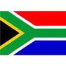](http://www.google.co.za/imgres?imgurl=http://sasportswear.co.za/images/sportswear/south_african_storm_flag.jpg&imgrefurl=http://sasportswear.co.za/sa-memorabilia-7/sports-flags-21/south-african-flag-storm-72.html&h=591&w=591&sz=35&tbnid=Uv7cCdEcYE0-pM:&tbnh=135&tbnw=135&prev=/images?q=South+African+flag&hl=en&usg=__g8gihHXhaZlPhuEToAfXga4s4Hw=&sa=X&ei=IslOTK-nNo-R4Qay7dWoCA&ved=0CAgQ9QEwAQ)



**WORD BY THE AMBASSADOR**

[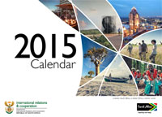](http://www.dfa.gov.za/department/desk_calendar.html)

We all came back to the office at the beginning of January full of enthusiasm for the year ahead after the Christmas and New Year’s festivities. It was a quiet month, focused on planning for the rest of the year.

We hope for a year full of interesting projects and exciting opportunities to interact with people and institutions across the Czech Republic.

This year it will be 600 years ago that the Czech Jan Hus was burnt at the stake for heresy against the doctrines of the Catholic Church. He was a priest, philosopher, early Christian reformer and Master of Charles University. He is generally considered to be the forerunner of the later Reformation movement across Europe. It is expected that there will be various events across the Czech Republic to commemorate his death.

On a happier note, Embassy members will follow with great attention how the South African teams fare at the Cricket World Cup and the Rugby World Cup which both take place this year.

**EVENTS/ EMBASSY’S PROGRAMME**

**Foreign Minister’s Reception**

[](http://www.mzv.cz/jnp/en/index.html)

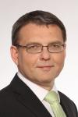Foreign Minister Mr Lubomír Zaorálek invited the Prague Diplomatic Corps on 15 January 2015 for the traditional New Year’s reception at the Foreign Ministry. In his address to the Corps, he summed up the achievements of the Czech Republic’s foreign policy and outlined its goals for 2015.

***Visit to kindergarten***

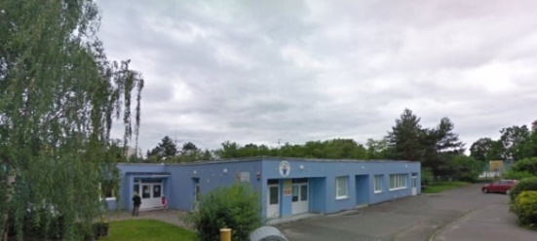

*Kindergarten Angelka*

At the invitation of Mr Vilém Růžička, President of the Czech-South African Chamber of Commerce, the Ambassador and Mr Dasa visited the kindergarten Angelka in Prague 4 – Modřany on 27 January 2015 to attend a presentation of a new interactive product, called the Magic Box. The Magic Box teaches pre-school children in a captivating way through modern technologies.

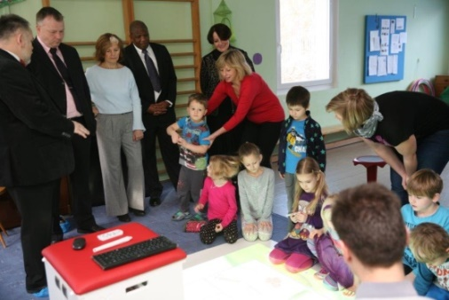

*Presentation of MagicBox, Angelka Kindergarten, Picture:Mgr Jaroslav Kñap,Mayor’s Office,Prague 12*

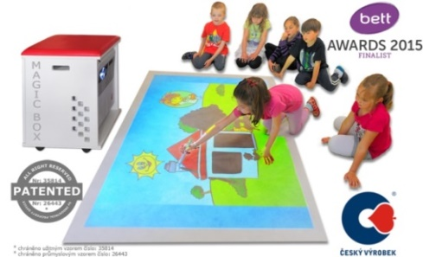

This product won an award last year for most innovative Cz.product. For more details please see [www.magbox.net](http://www.magbox.net).

The presenters mentioned that, at a recent education exhibiton, they had met some South African companies interested in acquiring this new teaching tool.

***Co-operation with South African Airways***

Description: http://www.ambafrance-rsa.org/IMG/gif/g77_logo.gif?3753/4ac780ad605690fcc222f4daf560c614208f8c06The Ambassador, Mr Dasa and Ms Schoeman met Mr Jan Kalaš, Sales Manager of the South African Airways on 28 January 2015 to discuss further cooperation with the Embassy in the course of the year.

[](http://en.wikipedia.org/wiki/File:South_African_Logo.svg)

***IYLC Conference in Prague***

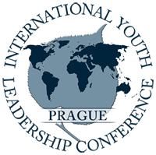On 6 January 2015 Mr Dasa attended a reception hosted by the International Youth Leadership Conference (IYLC). The annual students’ conference on world politics, international relations and justice was held in Prague from 4 to 9 January 2015. There was one South African student among the participants.

[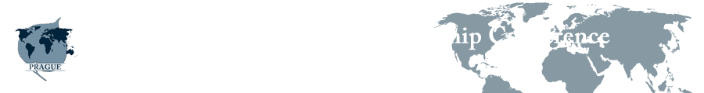](http://www.iylcprague.org/)

***Diplomatic functions***

A new Ambassador of Norway paid a courtesy call on Ambassador Verwey in January 2015.

The Ambassador attended the farewell reception hosted by the Algerian Ambassador and lunches hosted by the Ambassadors of Japan, Slovenia and South Arabia. The Ambassador hosted two lunches.

At the invitation of the Czech Academy of Sciences, the Ambassador attended a performance of the famous opera *Two Widows* by Bedřich Smetana at the National Theatre and the subsequent reception.

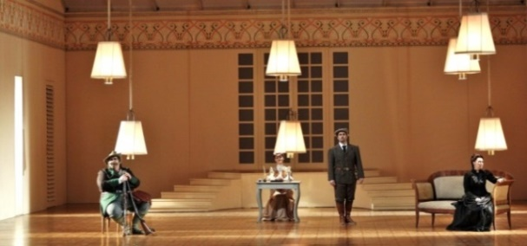

*Two Widows, National Theatre, Prague*

*15 January 2015*

**DIRCO**

***RSA assumes Chair of the Group of 77 and China***

On 8 January 2015, South Africa assumed the Chair of the *Group of 77 (G77) and China*, the largest negotiating block in the UN system at the United Nations Headquarters in New York. The South African delegation was led by International Relations and Cooperation Deputy Minister Luwellyn Landers.

Description: South Africa assumes chair of G77 south africa, sa, official site, sainfo, g77, un, chair, group of 
77, department of international relations and co-operation, dirco

*UN Secretary General Ban Ki Moon watches as Luwellyn Landers accepts the chairmanship of the G77 plus China from Bolivian President Evo Morales Ayma. Picture: Jacoline Schoones*

***Visit to Guinea, Angola and Mozambique***

President Jacob Zuma undertook a working visit to Conakry on 13 January 2015 to explore the new areas of cooperation, particularly in the field of infrastructure development.

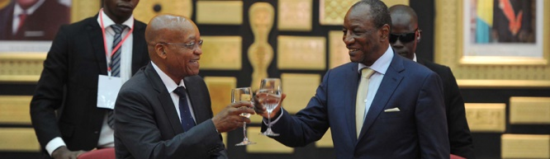

*President Zuma and Guinea’s President Alpha Condé*

*Picture: The Presidency*

On 14 January 2015 President Zuma held consultations with his counterpart, Jose Eduardo Dos Santos in Angola.

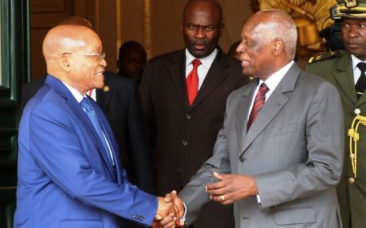

*President Jacob Zuma at the Presidential Palace with President Jose Eduardo dos Santos, 14 January 2015. Picture: GCIS*

On 15 January 2015 President Jacob Zuma arrived in Mozambique to attend the inauguration of President-elect Mr Nyusi, candidate of the Frelimo party, who won the October presidential elections.

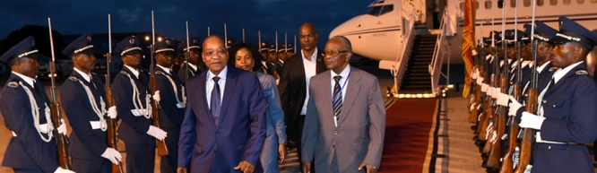

*President Zuma arrives at the Maputo Military Air force Base in the Republic of Mozambique ahead of the Inauguration Ceremony. Picture: The Presidency*

***South Africa helping Lesotho***

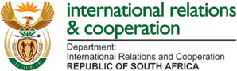aaa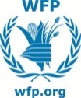

The South African government and the United Nations World Food Programme (WFP) assisted hungry people in Lesotho. Trucks carrying more than 700 metric tonnes of maize meal from the mill in Nigel were sent to Maseru, the capital of Lesotho on 14 January 2015.

***World Economic Forum***

President Jacob Zuma attended the World Economic Forum which was held in Davos-Klosters, Switzerland from 21-24 January 2015. The Forum was attended by more than 40 heads of state and government and about 2,500 other leaders from business and society.

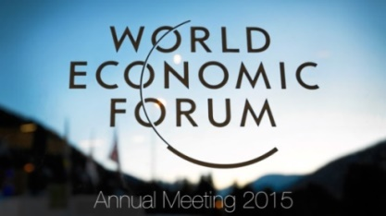

In Davos South Africa promoted the National Development Plan designed to enhance growth and development and marketed a new flagship project, Operation Phakisa, focused particularly on promoting the ocean economy.

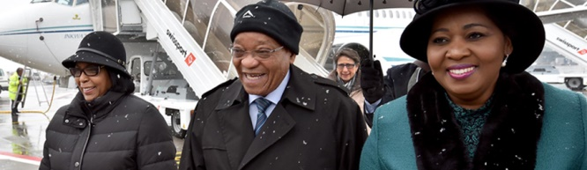

*President Zuma on a working visit to Davos, Switzerland to attend the World Economic Forum*

*Picture: The Presidency*

***African Union Summit in Ethiopia***

President Jacob Zuma led the South African delegation to the 24th Ordinary Session of the African Union Assembly held in Addis Ababa, Ethiopia from 30-31 January 2015 under the theme *Year of Women’s Empowerment and Development towards Africa’s Agenda 2063*.

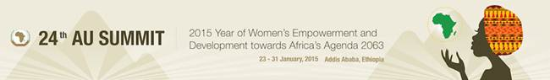

**SA NEWS**

***Table Bay Boulevard renamed***

Table Bay Boulevard in Cape Town was renamed FW de Klerk Boulevard by the City Council on 28 January 2015. Nobel peace laureate Archbishop Desmond Tutu and DA leader Helen Zille were among 27 signatories of the proposal for the renaming. The ANC, the South African Communist Party (SACP) and the trade-union umbrella body Cosatu opposed the move.

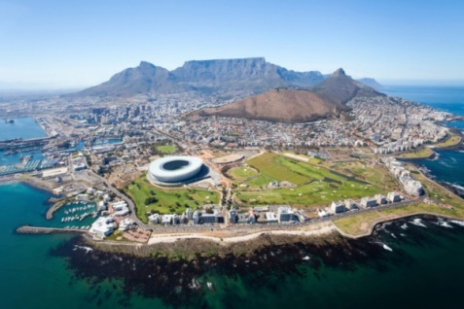

*Cape Town*

***SA scientists made gamma-ray discovery***

Wits University astronomers have discovered three extremely luminous gamma-ray sources in the Large Magellanic Cloud (LMC), the satellite galaxy of the Milky Way, using the High Energy Stereoscopic System (H.E.S.S.) telescopes. For more details please see:

<http://www.sabc.co.za/news/a/e2bb540047164a9082a0a6686e648436/SA-scientists-make-ground-breaking-gamma-ray-discovery-20152701>

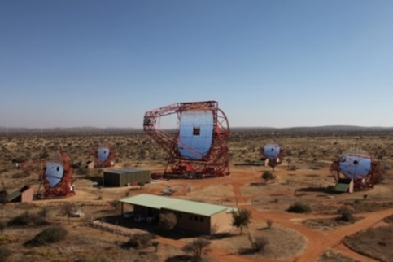

*The H.E.S.S. for the investigation of cosmic gamma rays in the energy range of 30 GeV to 100 TeV. (Clementina Medina/Irfu-CEA.)*

**CZECH NEWS**

***Traditional New Year’s Lunch***

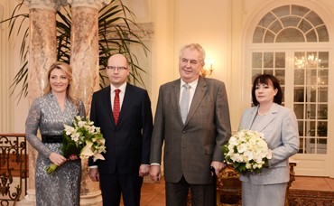

*Ms Sobotková, PM Sobotka***,** *President Zeman and Ms Zemanová, Picture: Prague Castle*

President Miloš Zeman and his wife Ivana met Prime Minister Bohuslav Sobotka and his wife Olga at a traditional New Year’s lunch at Lány Castle on 2 January 2015.

***Visit of Mongolian President***

President of Mongolia Tsakhia Elbegdorj accompanied by a large delegation paid a three-day official visit to the Czech Republic from 18-20 January 2015. He met President Miloš Zeman, Prime Minister Bohuslav Sobotka and the heads of the lower and upper houses of parliament to discuss economic affairs including water resources. President Elbegdorj also met students of Mongolian studies at Charles University.

[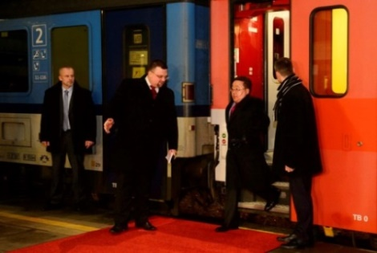](http://www.ceskenoviny.cz/news/index_img.php?id=325715)

*Mongolian President arriving by EuroCity train from Berlin; Prague Main Train Station, 18 January 2015*

[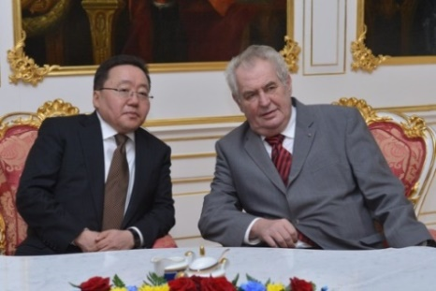](http://www.ceskenoviny.cz/zpravy/index_img.php?id=325780)

*President Elbergdorj and President Zeman at Prague Castle, 19 January 2015, Pictures: Prague Castle*

***Holocaust forum in the Czech Republic***

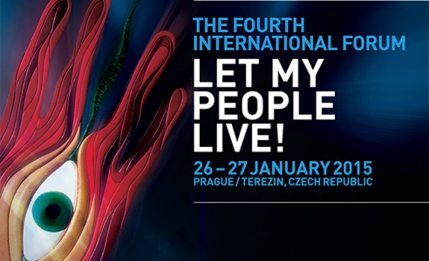

Holocaust survivors, around 500 foreign guests including two presidents and about thirty heads of Parliament and cultural figures attended the two-day Holocaust remembrance events in the Czech Republic. The international forum on the Holocaust was held under the title *Let my People Live!* at Prague Castle on 26 January 2015 and at a ceremony honouring victims of the Holocaust at the former Terezín ghetto on 27 January 2015. The forum, organized by the European Jewish Congress, expressed concern about the danger of growing anti-Semitism.

The event coincided with a ceremony at Oswiecim/Auschwitz concentration camp marking the 70th anniversary of its liberation from the Nazis.

[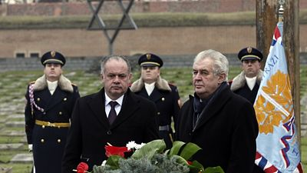](http://media.novinky.cz/226/472265-original1-n41lp.jpg)

*Slovak President Andrej Kiska and President Miloš Zeman in Terezín, 27 January 2015, Picture: ČTK*

***Resignation of Supreme Court head***

Dr Iva Brožová resigned from the post of Supreme Court chairwoman on 21 January 2015 and was replaced by criminal law expert Pavel Šámal on 22 January 2015. Brožová has headed the Supreme Court since 2002.

[](http://prague.tv/phpads/www/delivery/ck.php?oaparams=2__bannerid=3169__zoneid=381__cb=c16c956747__maxdest=http://www.plzen2015.cz/en/)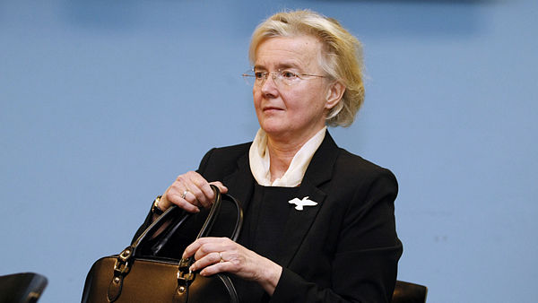 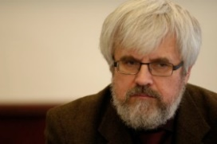

***Inauguration of President Nyusi***

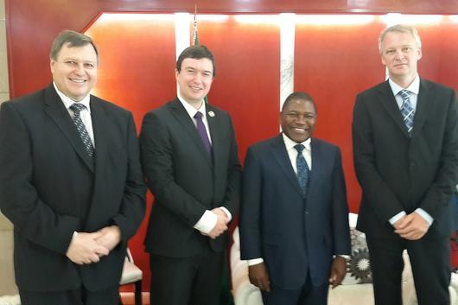

*Picture: MFA*

Deputy Minister of Foreign Affairs Lukáš Kaucký (second from the left) represented the Czech Republic at the inauguration of the new Mozambican President Filipe Nyusi on 15 January 2015 in Maputo.

President Felipe Nyusi graduated in 1990 in mechanical engineering at the University of Defence in Brno, the Czech Republic.

***Josef Postránecký becomes Deputy Minister for Civil Service***

[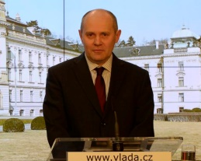](http://www.ceskenoviny.cz/news/index_img.php?id=326811)Josef Postránecký (53) will become Interior Minister in Charge of Civil Service, the government decided on 28 January 2015. The post was created to meet the demands from the European Commission with the aim of creating a professional and non-politicized administration.

***Prosecutor Brožová-Polednová died***

[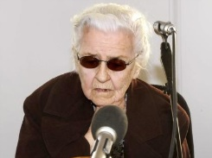](http://www.ceskenoviny.cz/news/index_img.php?id=92361)Ludmila Brožová-Polednová who acted as a prosecutor in show trial of democratic politician Milada Horáková died on 15 January 2015 aged 93 years. Milada Horáková was sentenced to death and executed in summer 1950 on charges of alleged conspiracy and treason.

***Pilsen – Town of Culture***

On 17 January 2015 Pilsen officially launched its cultural programme as the European Capital of Culture.

Under the motto *Open Up,* Pilsen will stage over 600 events – plays, concerts, exhibitions, public space happenings and artistic interventions. Detailed information about the European Capital of Culture in the year 2015 can be found at [www.plzen2015.cz](http://www.plzen2015.cz)

***President Zeman received new ambassadors***

On 29 January 2015 President Miloš Zeman received the credentials of five new ambassadors, namely North Korean Ambassador Kim Pyong-il, son of the late North Korean leader Kim Il-sung and the Ambassadors of Spain, Indonesia, Bangladesh and Bahrain.

|  |
| --- |
| For more information about the activities of the South African Embassy in Prague please visit our website:  http://[www.saprague.cz](http://www.saprague.cz) |