|  |
| --- |
| [Click on the specific symbol to view its symbolism  [coatofarms.gif 22315 bytes)](http://www.gov.za/_vti_bin/shtml.dll/symbols/coatofarms.htm/map) |
|  |

**EMBASSY OF SOUTH AFRICA  
RUSKA 65, 100 00 PRAGUE 10**

**NEWSLETTER - JANUARY 2016 (No.1 )**

[](http://www.google.co.za/imgres?imgurl=http://sasportswear.co.za/images/sportswear/south_african_storm_flag.jpg&imgrefurl=http://sasportswear.co.za/sa-memorabilia-7/sports-flags-21/south-african-flag-storm-72.html&h=591&w=591&sz=35&tbnid=Uv7cCdEcYE0-pM:&tbnh=135&tbnw=135&prev=/images?q=South+African+flag&hl=en&usg=__g8gihHXhaZlPhuEToAfXga4s4Hw=&sa=X&ei=IslOTK-nNo-R4Qay7dWoCA&ved=0CAgQ9QEwAQ)



**WORD BY THE AMBASSADOR**

The Embassy staff returned to the office in January refreshed after the Christmas break, ready for 2016. The year started off at a brisk pace with a number of traditional New Year’s receptions for the Diplomatic Corps hosted by Government leaders who used the occasion to set out their agenda for the year.

It was a great privilege to part of the group of Ambassadors visiting Charles University at the invitation of the Rector and to be taken on a guided tour of the exhibition at the university commemorating its founding in this special year of the celebration of the 700th anniversary of the birth of its founder, Charles IV. It was an extraordinary experience to walk around in the oldest part of the building where the university has been housed continuously since the 1380s. There is even a copy of its founding charter of 1348. It brought home the quest for knowledge and understanding within those walls over the centuries.

Another outstanding event was the concert with two performers from South Africa, Robert Brooks and Gisela de Villiers at the Austrian Residence. The audience was enchanted by their performance, and spellbound by Gisela astounding talent to set music to poetry that she read for the first time that evening. Robert also used the occasion to introduce the NGO *Music is a Great Investment* (MIAGI) which was established under his initiative in 2001. Its vision is to invest in human capacity through music. It aims, among others, to contribute to social upliftment through music education and music activities. MIAGI unites the power of classical, indigenous and jazz music, thereby creating a platform for intercultural creative dialogue. Long may MIAGI prosper through the universal language of music.

**EMBASSY NEWS**

***Traditional New Year’s meetings***

January is always the month of New Year’s gatherings of the Diplomatic Corps and top office bearers of Czech Government, including the Prime Minister, President of the Senate and Minister of Foreign Affairs.

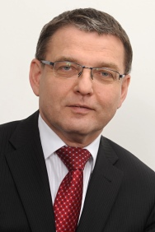

The meeting with Minister of Foreign Affairs Lubomír Zaorálek was held on 12 January 2016.

President of Senate Mr Milan Štěch met the Diplomatic Corps on 18 January 2016.

 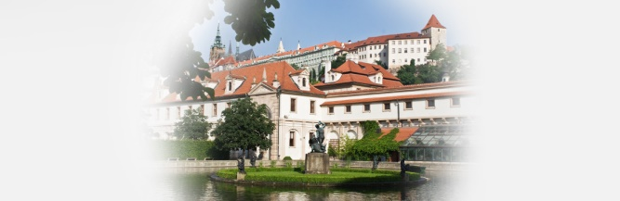

*Senate President Milan Štěch Senate*

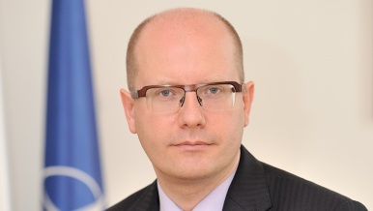

Prime Minister Bohuslav Sobotka received the Corps on 21 January 2016.

The Rector of Charles University in Prague Prof MUDr Tomáš Zima, DrSc, MBA invited the Corps to a meeting with the university management on 15 January 2016. His aim was to establish closer relations between representatives of the international community in Prague and educational and scientific institutions. The meeting took place at the historic premises of the university.

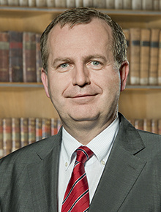 [](https://www.google.cz/url?url=https://en.wikipedia.org/wiki/Charles_University_in_Prague&rct=j&frm=1&q=&esrc=s&sa=U&ved=0ahUKEwjfxLP02KbKAhUB0xQKHer3CuQQ_B0IaTAK&usg=AFQjCNG-S2hX-nDWxERanjs9ULhNf6aNQQ)

*Prof. Tomáš Zima Logo of Charles University*

***Visit to Botanical Garden***

On 5 January 2016 the Ambassador and Ms Hlávková visited the Botanical Garden in Prague to discuss a tourism promotional event to be organized there in co-operation with South African Airways.

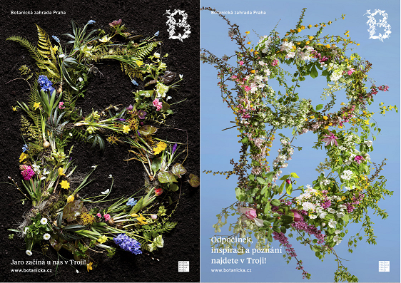

***Meeting with Director of the Cultural House in Holice***

The Ambassador met Mr Petr Kačer, Director of the Cultural House in Holice to discuss the planned journey of Czech adventurer Vojtěch Hlásnýto South Africa. He would travel to South Africa and other countries in the region later in the year in the footsteps of the famous native of Holice, Czech physician, explorer, cartographer and ethnographer of 19th century, Dr Emil Holub.

[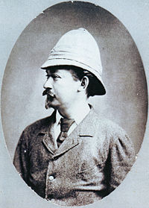](https://en.wikipedia.org/wiki/File:Emil_Holub.jpg) 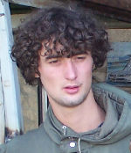

*Dr Emil Holub Vojtěch Hlásn*ý

***Diplomatic functions***

The Ambassador attended the farewell reception hosted by Ambassador of Russia, a reception on the occasion of National Day of India, a diplomatic lunch hosted the Ambassador of Korea; farewell dinners for the Russian Ambassador hosted by Ambassadors of Brazil, Armenia; and Israel respectively; and a performance of La Boheme at the State Opera at the invitation of the President of the Czech Academy of Sciences and the Director of the National Theatre.

On 12 January 2016 the Ambassador attended a concert hosted by the Chargé d’Affaires of Austria of South African- Austrian tenor Robert Brooks and a singer and pianist Gisela de Villiers followed by a buffet dinner.

[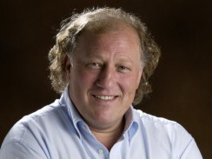](http://showme.co.za/pretoria/files/2015/11/robert-1.jpg) 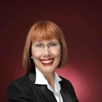

*Robert Brooks Gisela de Villiers*

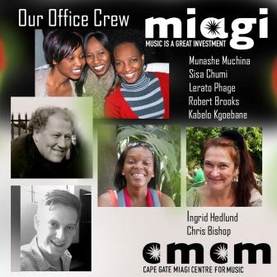

After the concert, Robert Brooks presented his organization *Music is A Great Investment* (MIAGI). For more details about the organization, please see [www.miagi.co.za](http://www.miagi.co.za).

**SOUTH AFRICAN NEWS**

***Deputy President Ramaphosa visited South Sudan***

Deputy President Cyril Ramaphosa attended the Conference of the South Sudanese Liberation Movement from 07-08 January 2016. He also paid a courtesy call on South Sudanese President Salva Kiir.

[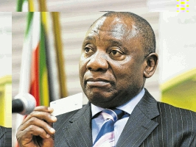](http://www.dispatchlive.co.za/wp-content/uploads/2014/10/747380_507300.jpg)

*Deputy President Cyril Ramaphosa in Juba, South Sudan*

***Meeting of the Group of 77 and China***

Description: http://www.g77.org/global/welcome.gif

[Description: http://www.g77.org/global/gheader1.gif](http://www.g77.org/)Deputy Minister of International Relations and Cooperation Mr Luwellyn Landers gave an address at the handover ceremony of the Chair of the Group of 77 in New York on 12 January 2016.

South Africa chaired the Group from 8 January 2015. The new Chair is Thailand.

***Double Troika Summit in Botswana***

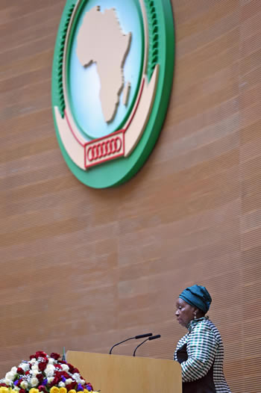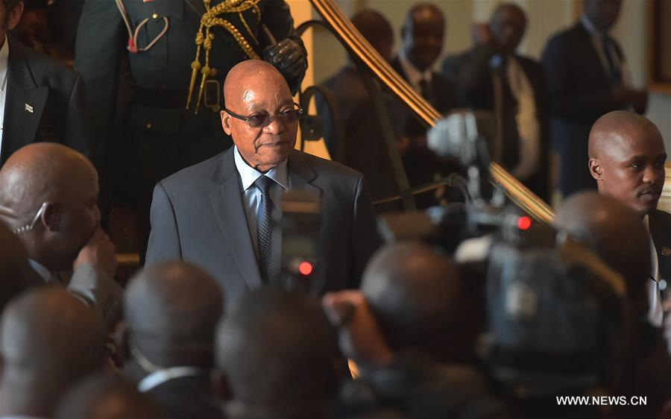

*President Jacob Zuma attends the SADC meeting in Gaborone, 18 January 2016. Picture: Xinhua/GCIS*

President Jacob Zuma led the South African delegation to the Extra-ordinary Summit of the SADC Double Troika which was held in Gaborone, Botswana on 18 January 2016. The Summit, comprising Botswana, Zimbabwe, Swaziland, Mozambique, South Africa and Tanzania considered the political and security situation in the SADC region, paying particular attention to the situation in the Kingdom of Lesotho.

***WEF in Davos***

The World Economic Forum was held in Davos, Switzerland from 20-23 January 2016. In his address, President Jacob Zuma informed the gathering of the *Invest South Africa* initiative which will be introduced in the course of the year.

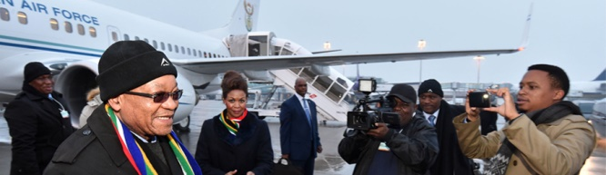

*President Zuma arrives at Zurich Int. Airport for 2016 WEF Meeting. Picture: The Presidency*

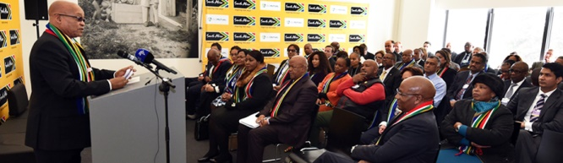

*President Zuma briefs Team South Africa at WEF in Davos. Picture: The Presidency*

***AU Summit in Addis Ababa***

The 26th Summit of the African Union was held in Addis Ababa, Ethiopia from 21-31 January 2016 under the theme *2016: African Year of Human Rights (with particular focus on the Rights of Women).*

[](http://au.int/en/summit/26)

*Chairperson*

*Dr Nkosazana Dlamini Zuma addresses the African Union Executive Council Opening Session, Addis Ababa, Ethiopia, 27 January 2016*

*Picture:*

*Jacoline Schoones*

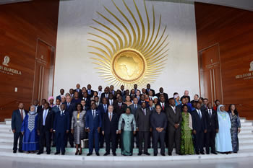

*Group photograph of the African Union Executive Council, Addis Ababa, Ethiopia, 27 January 2016. Picture: Jacoline Schoonees*

***ANC birthday celebration***



About 120 000 people attended the 104th birthday celebration of the African National Congress which was held at Royal Bafokeng Stadium in Rustenburg, North West from 9-10 January 2016.

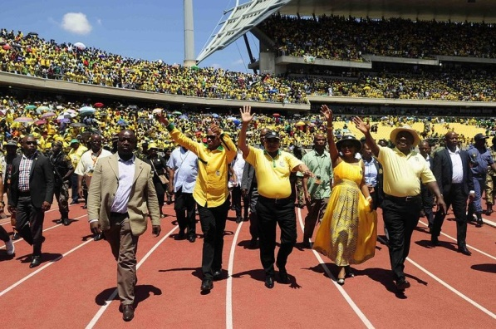

[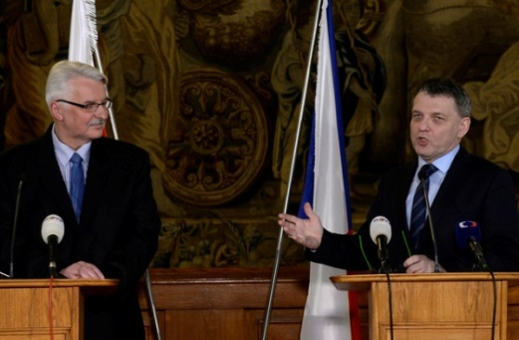](http://www.ceskenoviny.cz/news/index_img.php?id=363408)*Premier of**North West Supra Mahumapelo, President Jacob Zuma, Baleka Mbete and Cyril Ramaphosa greeting ANC's supporters at the Royal Bafokeng Stadium during the organization's 104th birthday celebrations. Photo: Thulani Mbele*

***Extreme drought persists across SA***

South Africa has been experiencing its hottest weather and worst drought in many decades. According the South African Weather Service, 2015 was the driest year on record with no sign of abating. The records date back to 1904.

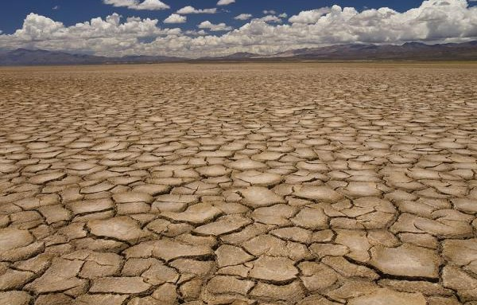

*Picture: SABC*

**CZECH NEWS**

***EU Chief Federica Mogherini in Prague***

EU Foreign Affairs chief Ms Federica Mogherini met Czech Foreign Minister Lubomír Zaorálek on 11 January 2016 to discuss current security challenges facing the world including migration, the fight against terrorism and the Islamic State. A joint public debate entitled  *The future of Europe in an Interconnected World* was held during her visit.

*[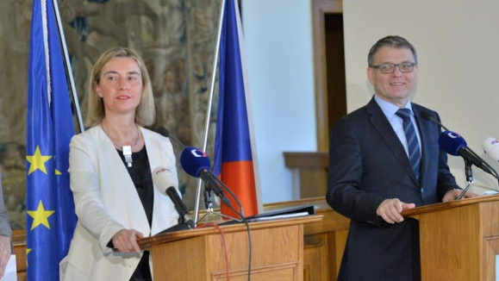](http://www.ceskenoviny.cz/news/index_img.php?id=363356)High Representative Federica Mogherini and Minister Zaorálek, Prague, 11 January 2016. Picture: MFA*

***Polish Foreign Minister in Prague***

*Minister Lubomír Zaorálek and his counterpart Witold Waszczykowski at press conference in Prague on 11 January 2016. Picture: MFA*

Polish Minister of Foreign Affairs Witold Waszczykowski met his Czech counterpart Lubomír Zaorálek on 11 January 2016 to discuss the state of bilateral relations, the development of regional cooperation and the current security situation in Europe.

***David Cameron in Prague***

British Prime Minister David Cameron arrived in Prague on 22 January 2016 to meet his counterpart Bohuslav Sobotka, President Miloš Zeman and other top representatives of the Czech Republic. The talks were dominated by Britain’s proposals for EU reform, its future in the EU, the migration crisis and business and security cooperation.

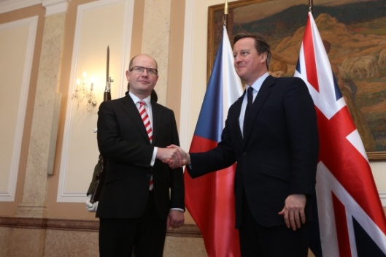

*Prime Ministers Bohuslav Sobotka and David Cameron at Straka Academy, Prague, 22 January 2016. Picture: The Government*

***General Mičánek elected Dean of NATO Defence Colledge***

[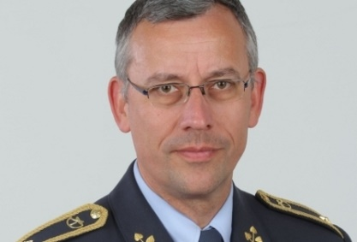](http://www.radio.cz/en/section/curraffrs/czech-defense-and-security-specialist-elected-dean-of-nato-defense-college)Brigadier General František Mičánek, head of the Centre for Security and Military Strategic Studies at the University of Defence in Brno, has been elected Dean of NATO Defense College in Rome on 25 January 2016. He is the second Czech to secure a high post in NATO structures, following General Petr Pavel’s appointment as chairman of NATO’s Military Committee.

***Czech Communist MEP Ransdorf died***

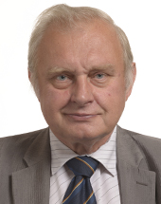Czech Communist Miloslav Ransdorf, member of Czech Parliament in 1996 -2004 and member of the European Parliament from 2004, died of a stroke on 23 January 2016 aged 62 years.

***Hutní montáže starts construction of third boiler in RSA***

Hutní montáže company started assembly of the third boiler at the Kusile coal power plant in South Africa; its completion is scheduled for September 2016. Hutní montáže company, part of the Vítkovice Machinery engineering group has been involved in the construction of the plant since 2013.

[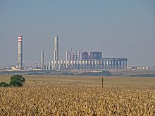](https://en.wikipedia.org/wiki/File:Kusile_Power_Station_-_002.jpg)

*Kusile power plant*

[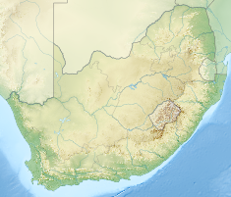](https://en.wikipedia.org/wiki/File:South_Africa_relief_location_map.svg)

|  |
| --- |
| For more information about the activities of the South African Embassy in Prague please visit our website:  http://[www.saprague.cz](http://www.saprague.cz) |