|  |
| --- |
| [Click on the specific symbol to view its symbolism  [coatofarms.gif 22315 bytes)](http://www.gov.za/_vti_bin/shtml.dll/symbols/coatofarms.htm/map) |
|  |

**EMBASSY OF SOUTH AFRICA  
RUSKA 65, 100 00 PRAGUE 10**

**NEWSLETTER - JULY 2015 (No.7)**

[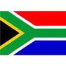](http://www.google.co.za/imgres?imgurl=http://sasportswear.co.za/images/sportswear/south_african_storm_flag.jpg&imgrefurl=http://sasportswear.co.za/sa-memorabilia-7/sports-flags-21/south-african-flag-storm-72.html&h=591&w=591&sz=35&tbnid=Uv7cCdEcYE0-pM:&tbnh=135&tbnw=135&prev=/images?q=South+African+flag&hl=en&usg=__g8gihHXhaZlPhuEToAfXga4s4Hw=&sa=X&ei=IslOTK-nNo-R4Qay7dWoCA&ved=0CAgQ9QEwAQ)



**WORD BY THE AMBASSADOR**

July and August are traditionally the European holiday months and the official events calendar slowed down accordingly. For the Embassy, July signifies the time of the year that we organise an event at the Residence to reconnect with the South African community in the Czech Republic. We make it as traditional as possible with a Braai and food that is familiar from home. The Embassy is very grateful to Andre Schoeman who made the boerewors and also to those guests who kindly brought some delicacies to share.

Other summer news is that Prague continues to swelter in heatwave after heatwave combined with the worst drought in the country since 2002. Lawns all over the city have turned brown, reminding me of winter in South Africa instead of lush green European summers.

One of the highlights of the month was the visit to House Beran in picturesque surroundings in the small town of Mukařov where we met with a representative of charity Caritas and the director of the House to discuss the possibility of an Embassy project in their garden in honour of Mandela Day. We were warmly welcomed and it was a particular pleasure to meet with some of the inhabitants of the House on this occasion.

**EVENTS/ EMBASSY’S PROGRAMME**

***Event with South African community***

The annual gathering of the South African community in the Czech Republic took place at the Official Residence on 10 July 2015. Homemade boerewors and milktart as well as South African wines reminded the guests of home. Many guests also brought delicacies like “paptert”, “Koeksisters” and “biltong”. The weather was perfect and the atmosphere very convivial.

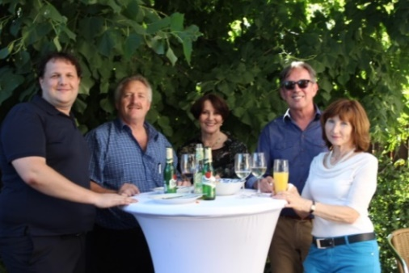

*Ambassador Verwey with guests*

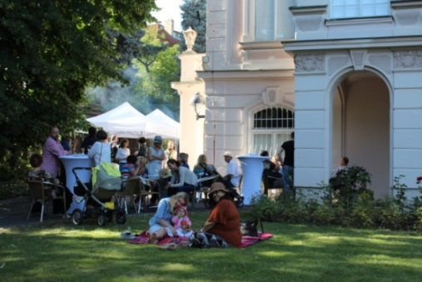

*Guests relaxing on the lawn of the Residence*

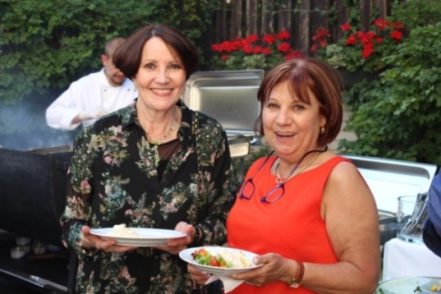

*Ambassador Verwey and Ms Sharon Hindle*

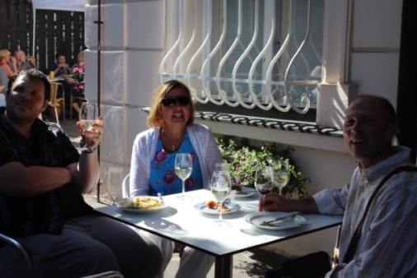 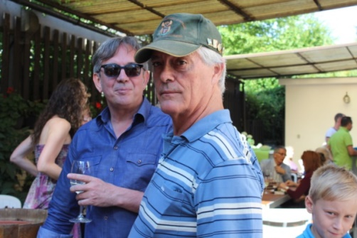

*Ms Schoeman & Mr Schoeman with guests*

***Social meeting***

An informal gathering was held on 18 July 2015 on the occasion of Ambassador’s birthday. We wish our Ambassador many happy returns of the day.

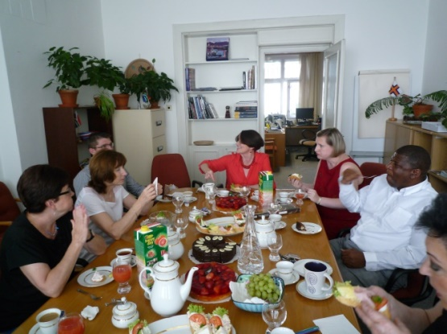

*Ambassador Verwey among Embassy Staff*

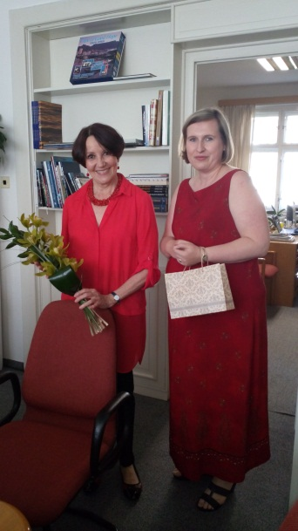

*Ambassador Verwey*

*& Social Secretary,*

*Ms Hana Mahmoud*

***Visit to Mukařov Senior Home***

Ambassador, Mr Dasa and Ms Herclová visited Cardinal Beran Senior Home in Mukařov on 27 July 2015. The purpose of the visit was to discuss the Embassy project within the scope of Mandela Day 2015. The intention is that Embassy staff would do some gardening at the House. Ms Lucie Cemperová, Director and other representatives of the Senior Home gave a presentation of the work of the charitable institution Caritas which falls under the Archdiocese of Prague. Ambassador had an opportunity to meet some of the inhabitants and Embassy staff was shown around the premises of the Senior Home.

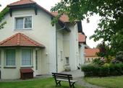

***Meeting with Ardmore Ceramic representative***

On 13 July 2015 the Ambassador met Mr Richard Summerfield of Richard Collection to discuss the launch in Prague in 2016 South Africa’s unique hand-painted and hand-sculpted ceramic artwork - Ardmore Ceramics.

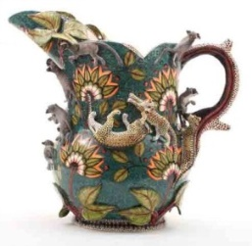 [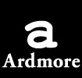](http://www.ardmoreceramics.co.za/) [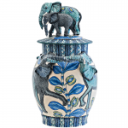](http://www.pascoeandcompany.com/ardmore-ceramic-art/blue-elephant-vase-aaa.html)

***Diplomatic functions***

In the month of July the Ambassador attended receptions hosted by Ambassadors of Canada, France and Peru, as well as farewell reception hosted by the Ambassador of Romania; a working lunch hosted by Ambassador of Brazil and a diplomatic dinner hosted by the Ambassador of Malaysia.

**DIRCO**

***Deputy Minister Landers visited five Caribbean states***

The Deputy Minister of International Relations and Cooperation, Mr Luwellyn Landers, visited five Caribbean states –Guyana, Jamaica, Suriname, Trinidad and Tobago, and Haiti from 29 June-10 July 2015. During the visit, high level meetings took place with senior members of Government, business, academia and the youth; Memoranda of Understanding on Political Consultations were signed in Guyana and Suriname.

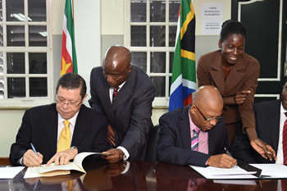

*Deputy Minister Luwellyn Landers with Minister of Foreign Affairs, Mr Winston Lackin sign the MoU, Paramaribo, Suriname, 2 July 2015*

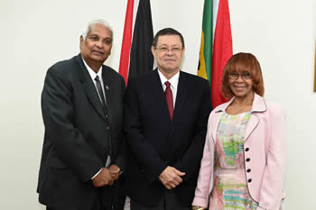

*Minister of Foreign Affairs of Trinidad and Tobago, Mr Winston Dookeran, Deputy Minister Luwellyn Landers and High Commissioner M Modiselle, Port of Spain, Trinidad and Tobago, 1 July 2015.*

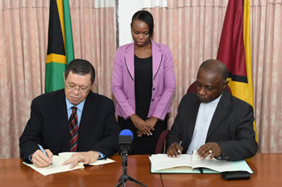

*Deputy Minister Luwellyn Landers and the Minister of Foreign Affairs, Mr Carl B Greenidge, Georgetown, Guyana, 30 June 2015. Pictures: Yolande Snyman*

***BRICS Summit in Russia***

The Heads of State of BRICS members (Brazil, Russia, India, China and South Africa) met in Ufa, Russia for the 7th BRICS Summit held from 8-9 July 2015 under the theme: *BRICS Partnership - a Powerful Factor of Global Development*.

Two Memoranda of Understanding on nuclear power cooperation were signed at BRICS meeting between Russia’s state-run company Rosatom and South Africa’s Department of Energy.

[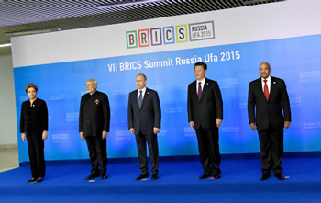](http://www.dfa.gov.za/images/gallery7/brics_summit_russia-ufa_2015_2.jpg)

*BRICS Russia UFA 2015 family photograph,*

*July 2015. Picture: Unati Ngamtwini*

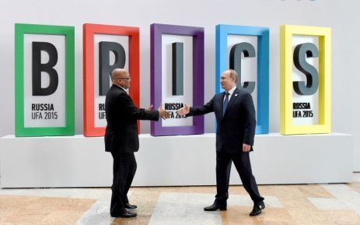

*South African President Jacob Zuma is greeted by Russian President Vladimir Putin as he arrives at the venue for the BRICS VII Summit. Picture: DIRCO*

The BRICS countries launched a New Development Bank in Shanghai on 21 July 2015. The bank with initial capital of USD 50 billion will focus mainly on funding infrastructure and sustainable development projects in BRICS countries.

***Extra-ordinary SADC Double Troika Summit***

President Jacob Zuma hosted the Heads of State of the SADC Organ on Politics, Defence and Security Cooperation for an Extra-ordinary Summit of the Double Troika on 3 July 2015. The Summit was preceded by a Double Troika Ministerial and Senior Officials Meeting.

[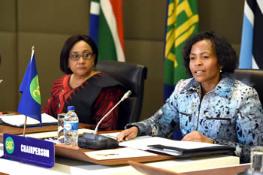](http://www.dfa.gov.za/images/gallery7/mashabane_sadc_ministerial_double_troika_1.jpg)

*Minister Maite Nkoana-Mashabane with the SADC Executive Secretary, Dr Stergomena Lawrence Tax, Ministerial Double Troika Meeting, Pretoria, South Africa, 3 July 2015. Picture: Jacoline Schoonees*

**SA NEWS**

***Mandela Day***

South Africans honoured the 67 years of former President Nelson Mandela’s service to the country with 67 minutes of charity and community action around the country on 18 July 2015. Nelson Mandela’s widow Graça Machel, the chief patron of the *Stop Hunger Now* campaign, distributed food parcels and blankets knitted for the occasion.

Minister of International Relations and Cooperation Ms Maite Nkoana-Mashabane and members of the Diplomatic Community undertook a number of activities at the Good Hope Community Organisation and the Ya Bana Orphanage in Winterveldt. The Minister also handed over a cheque to the Nelson Mandela Trust for the Nelson Mandela Children’s Hospital

[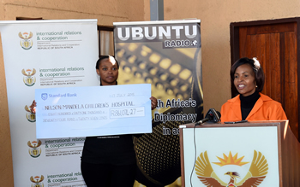](http://www.dfa.gov.za/images/gallery7/mashabane_n-mandela_day0717_9.jpg)

*Minister Maite Nkoana-Mashabane handing over a cheque to a representative of the Nelson Mandela Trust, Pretoria, South Africa, 17 July 2015.*

*Picture: Unati Ngamtwini*

**CZECH NEWS**

***Morroccan Minister in Prague***

Minister of Foreign Affairs Lubomír Zaorálek met with his Moroccan counterpart Salaheddine Mezouar in the Czernin Palace on July 23, 2015 to discuss cooperation in the economic area, as well as current topics affecting the EU and the region of the Southern and Eastern Mediterranean, e.g. situation in Libya, the so called Islamic State and issues relating to terrorism.

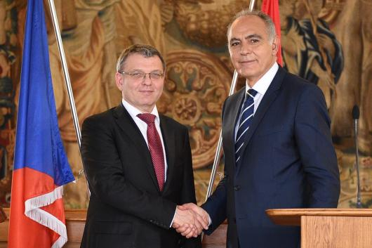

*Ministers Lubomír Zaorálek and Salaheddine Mezouar, Prague, 23 July 2015. Picture: MFA*

***Sir Nicholas Winton died***

[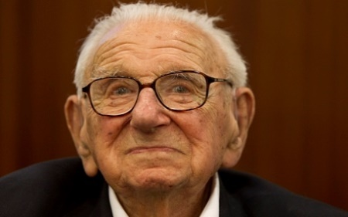](http://www.telegraph.co.uk/news/general-election-2015/politics-blog/11716093/How-my-friend-Nicholas-Winton-saved-me-from-the-Nazis.html)Sir Nicholas Winton, who organized the rescue of 669 Jewish children from occupied Prague during the World War Two, has died aged 106 on 1 July 2015.

On 28 October 2014, he was awarded the highest honour of the Czech Republic, the Order of the White Lion.

***Jan Hus celebrations***

The Czech Republic marked the 600th anniversary of the burning at the stake of reformer priest Jan Hus with numerous events highlighting his legacy. People attended theatre performances, debates, concerts and film screenings dedicated to Jan Hus. Masses were celebrated around the country, among others in Jan Hus’ birthplace Husinec and at Bethlehem Chapel in Prague, where the reformer priest preached. On 6 July 2015 a candlelit procession from Old Town Square to the Vltava River paid tribute to his memory.

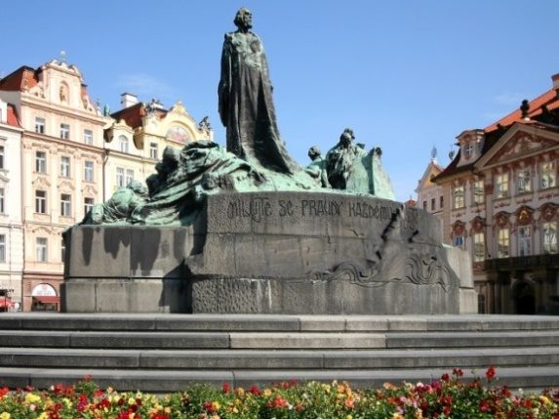

*Jan Hus statue*

*at the Old Town Square, Prague*

The Moravian Church and the Embassy of the Czech Republic in South Africa organized several events commemorating the Jan Hus anniversary at various places in the RSA. A commemorative worship service was conducted by Bishop Ngqakayi in Johannesburg on 5 July 2015.

# *Karlovy Vary festival celebrated jubilee*

[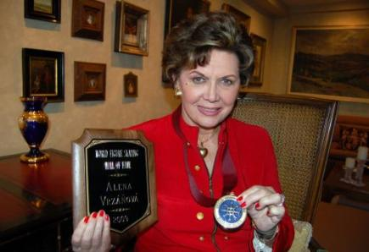](http://www.ceskenoviny.cz/news/index_img.php?id=107859)The 50th Karlovy Vary International Film Festival was held in the west Bohemian spa town from 3-11 July 2015. Over 220 films were screened and the festival opened with the 2014 American drama *Time out of Mind* which was personally presented by the film’s lead actor Richard Gere who received the festival’s highest award, the Crystal Globe for outstanding contribution to world cinema.

[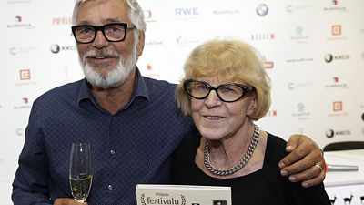](http://media.novinky.cz/798/497987-original1-p1a0q.jpg)

*Festival director Jiří Bartoška and former programme director Ms Eva Zaoralová*

***Renowned Czech violinist Václav Snítil died***

[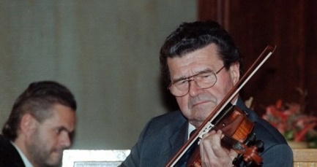](http://img.blesk.cz/img/1/full/2383598-img-snitil-housle-v2.jpg?v=2)One of the most outstanding Czech violinists of the 20th century, Václav Snítil, died in Prague on 19 July 2015 aged 87. Václav Snítil was an acclaimed interpreter of baroque music by Bach, Hӓndel, Telemann and Vivaldi as well as violin concerts by contemporary composers.

***Pianist Ivan Moravec died***

# Ivan Moravec had been treated for pneumonia for several weeks. One frequent stop on his American calendar was Philadelphia, where he was heard both as a recitalist with the Philadelphia Chamber Music Society and in concertos with the Philadelphia Orchestra. (Credit: Anost Nosek)Internationally renowned pianist Ivan Moravec died on 27 July 2015 aged 84.

He was presented with the Cannes Classical Award for lifetime achievement in 2002.

***Five Czechs kidnapped in Leban***

Five Czechs and their Lebanese driver disappeared in Bekaa Valley on 18 July 2015. One of the men is the attorney of a Lebanese citizen Ali Fayed, who is in Czech custody awaiting the decision on an extradition request from the USA.

***Legendary figure skater Vrzáňová died***

Legendary Czech figure skater Aja Vrzáňová, who lived in the United States from the 1950s, has died at the age of 84 on 30 July 2015. Vrzáňová won several European championships, as well as the world championship in Paris in 1949 and in London in 1950.

***Pendolino crash in Moravia***

A Pendolino high-speed passenger train collided with a truck transporting plates at a railway crossing in the town of Studénka, North Moravia on 22 July 2015. Three people died and 17 were injured

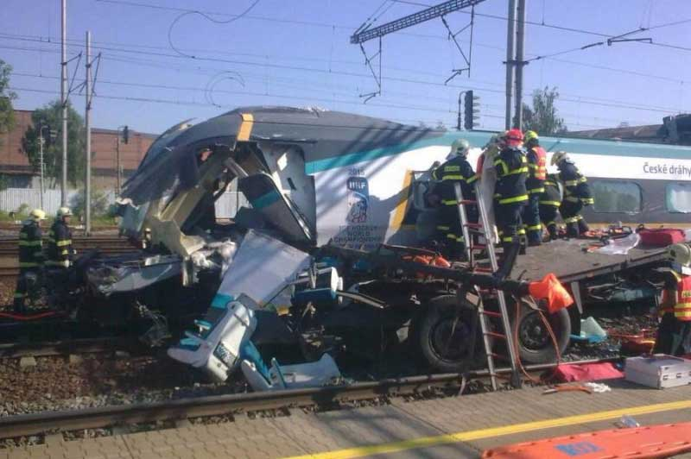

|  |
| --- |
| For more information about the activities of the South African Embassy in Prague please visit our website: http://[www.saprague.cz](http://www.saprague.cz) |

***Bring & Braai***

*Official Residence*

*10 July 2015*

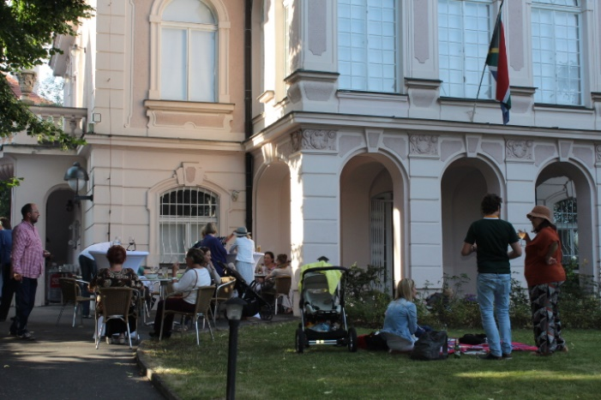

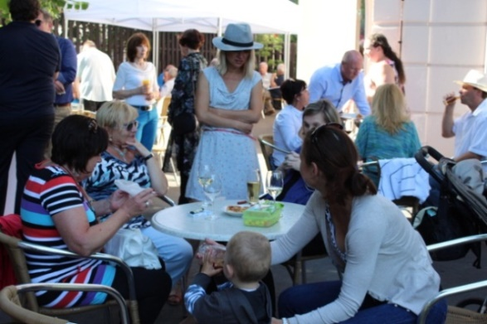 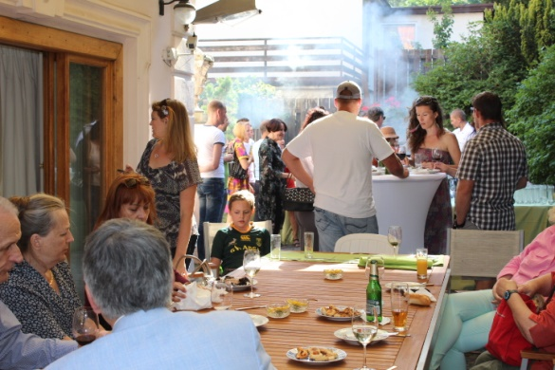

[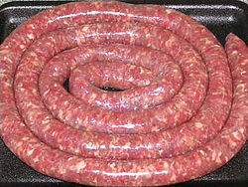](https://en.wikipedia.org/wiki/File:Boerewors_raw.jpg)  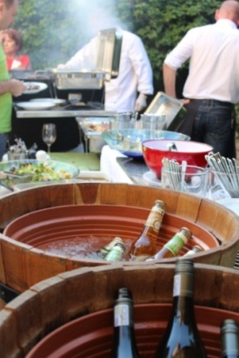 [](https://blondevoyager.wordpress.com/2015/02/13/south-africas-delicious-food/?sa=X&ved=0CCIQ9QEwAmoVChMIuKju8Z2AxwIVAbcUCh1FqgUv)

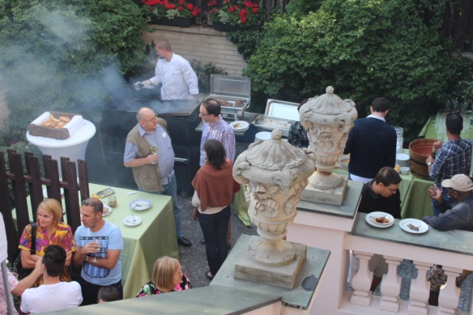 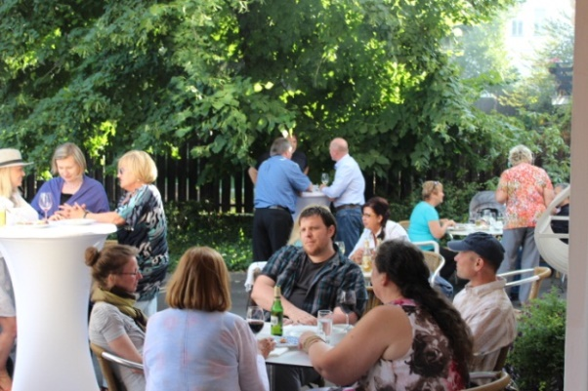

**Addendum**

**EBOLA VACCINE SHOWS PROMISE**

The last two years have been a very difficult period for the peoples and governments of the West African Region because of the disease called Ebola that killed thousands of people. The countries that were the worst affected were Guinea, Sierra Leone and Liberia but at one stage, there were fears that the disease threatened to engulf the whole African continent and even the whole world.

The international community rallied to assist the affected countries and concerted efforts were launched in conjunction with the governments of those countries to stem the disease; care for those infected; and assist communities. These joint efforts finally showed results in the first half of 2015 with containment of the disease and only a few isolated cases of reported new infections.

The fight against the disease continues unabated. In July 2015, a British Medical Journal reported that results of a trial Ebola vaccine that was administered to 3, 500 people were positive with indications that it was safe and efficacious in preventing the Ebola virus. If these medical trials succeed, it would be a major break-through holding promise not only for the African Continent but for the whole world. At this stage, it is still work in progress. As Dr. Margaret Chan, Director General of the World Health Organisation (WHO) said in an interview, the vaccine is not “a silver bullet” to head off future outbreaks and that there was no replacement for strong, resilient health systems with the capability of detecting any outbreak of disease as early as possible.

Clearly, there is still a long way in terms of eradicating Ebola and it is vital that the focus on finding a vaccine be sustained. Those scientists who are involved in this important research work are carrying the hopes of millions of inhabitants in Africa as well as the global citizens.

The most recent and virulent outbreak of Ebola instilled a lot of fear in people, not in only those in affected communities but across the world. It also had a crippling effect on the economies of the countries most affected and threatened the sustainable livelihood of communities.

Hopefully, the confirmation from WHO that the spread of the disease has been halted and also the reports on progress in developing a vaccine will encourage individual travellers and potential investors to revisit and review their decisions about which countries in the region to visit and projects to follow on.

July 2015