|  |
| --- |
| [Click on the specific symbol to view its symbolism  [coatofarms.gif 22315 bytes)](http://www.gov.za/_vti_bin/shtml.dll/symbols/coatofarms.htm/map) |
|  |

**EMBASSY OF SOUTH AFRICA  
RUSKA 65, 100 00 PRAGUE 10**

**NEWSLETTER - JUNE 2015 (No. 6)**

[](http://www.google.co.za/imgres?imgurl=http://sasportswear.co.za/images/sportswear/south_african_storm_flag.jpg&imgrefurl=http://sasportswear.co.za/sa-memorabilia-7/sports-flags-21/south-african-flag-storm-72.html&h=591&w=591&sz=35&tbnid=Uv7cCdEcYE0-pM:&tbnh=135&tbnw=135&prev=/images?q=South+African+flag&hl=en&usg=__g8gihHXhaZlPhuEToAfXga4s4Hw=&sa=X&ei=IslOTK-nNo-R4Qay7dWoCA&ved=0CAgQ9QEwAQ)



**WORD BY THE AMBASSADOR**

June is usually one of the busiest months on the Prague official calendar as everyone tries to finalise their activities before the holiday season starts. This year was no different and the month was packed with a wide range of interesting events.

One of the highlights for me was my visit to the beautiful old city of Olomouc where I had fruitful discussions at the City Hall and at Palacký University. The journey was particularly memorable (aside from being caught up in the perpetual traffic delays on the Brno highway!). All along the road the fields were covered in red poppies and there were flowering meadows with wild flowers in blue, white and yellow everywhere. Indeed a feast for the eyes.

Staying with the flower theme, I was delighted to be invited, together with my colleagues from Peru and Mexico, to the opening of a special exhibition on succulents from the three countries in the Prague Botanical Garden. In my research in preparation for the event I discovered that almost half of the world’s

10 000 known species of succulents are indigenous to South Africa. It served once again as a reminder how rich the country’s plant kingdom is.

It was also an unexpected pleasure to be invited to a rugby match here in Prague when a Czech team played a New Zealand invitation team. The Czech team was well supported by the crowd who packed the small stadium.

**EVENTS/ EMBASSY’S PROGRAMME**

***Visit to Olomouc***

Ambassador paid a visit to Olomouc, Moravia on 9 June 2015 to raise awareness of South Africa and re-establish previous links between the town and the Embassy. The Ambassador met the Deputy Mayor Aleš Jakubec and Ms Marie Jadrníčková from Foreign Relations Office. A possible cooperation project was discussed during the visit.

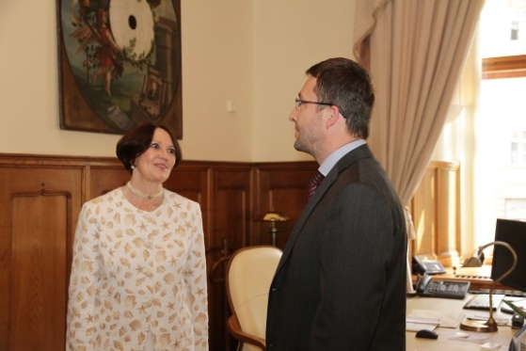

*Ambassador Verwey and the Deputy Mayor of Olomouc, Mr Aleš Jakubec*

*Picture: Blanka Martinovská, Mayor’s Office*

The Ambassador visited the Palacký University to meet the rector, Prof Jaroslav Miller. Later she met also the Vice-Rector for Study, Dr Vít Zounar, Ms Lianne Barnard, South African teacher of Afrikaans at the university and two South African students, Miss Xanani Baloyi and Mr Floyd Sekgobela.

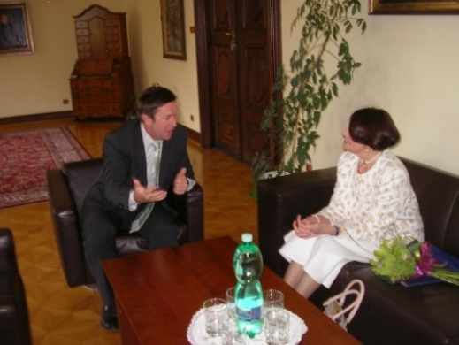

*Rector Jaroslav Miller and Ambassador Verwey*

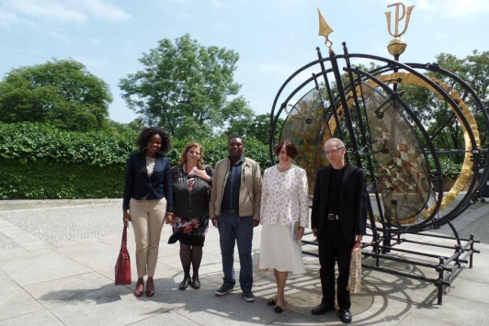

*Ms Xanani Baloyi, Ms Lianne Barnard, Mr* *Floyd Sekgobela, Ambassador Verwey and Vice-Rector Mr Vít Zounar. Picture : Pavel Konečný, Press department, Palacký University*

***Export Festival***



The Embassy participated in the third annual Export Festival CZ which was held at Prague Congress Centre from 17-18 June 2015. The festival is a platform for trade and investment promotion, especially for small medium sized companies.

There were around 800 participants, with presentations by 63 speakers from 35 countries. Minister of Industry and Trade Mr Jan Mládek and Deputy Minister Mr Martin Tlapa opened the festival, followed by remarks from the Ambassadors of participating countries.

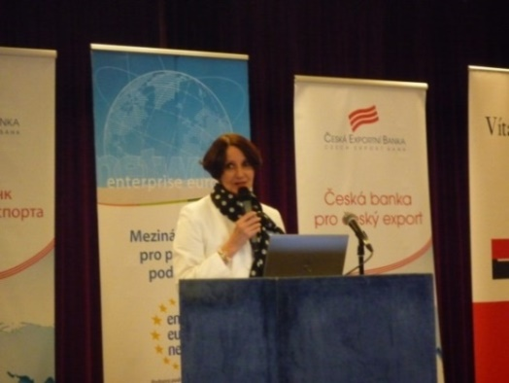

*Ambassador Verwey addressing the audience*

The Mission partnered with Tombalina wines, introducing visitors at the Embassy stand to variety of South African wines.

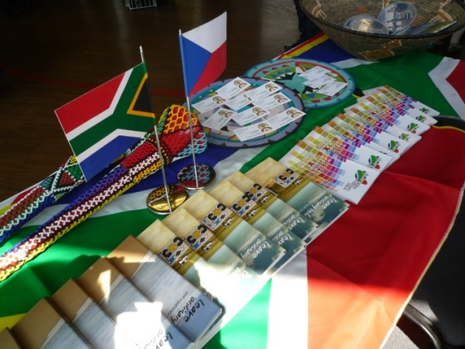

*South African stand*

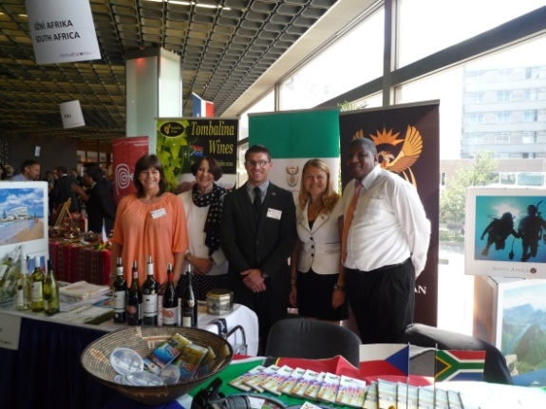

*Heather Crowther, Ambassador Verwey, Nicolas Wood, Michaela Hlávková and Mr ZM Dasa at the South African stand*

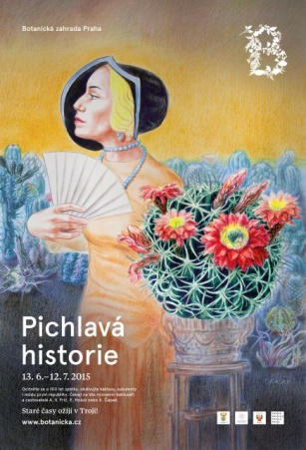***Exhibition in Botanical garden***

The Prague Botanical Garden mounted an exhibition on cacti and succulents under the theme *Spiny History*. The Embassies of South Africa, Mexico and Peru jointly acted as patrons and the three Ambassadors jointly cut the ribbon at the formal opening on 12 June 2015. The three countries are among the most biodiverse in the world. The exhibition simulates the natural habitat of the plants on display.

**[](http://www.saprague.cz/)[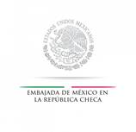](http://embamex.sre.gob.mx/republicacheca/)[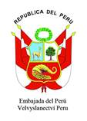](http://www.peru-embajada.cz/)**

South African wines were served, as well as typical Peruvian food; Mexican Mariachis played traditional music.

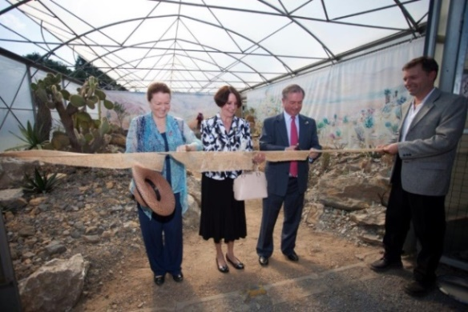

*Ambassador of Peru, Ms Maria Landaveri Porturas, Ambassador Verwey and Ambassador of Mexico, Mr Mr Pablo Macedo Riba cutting the ribbon at the opening of the exhibition*

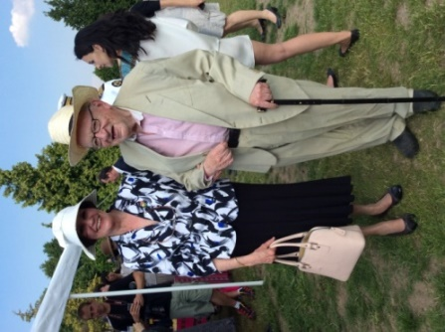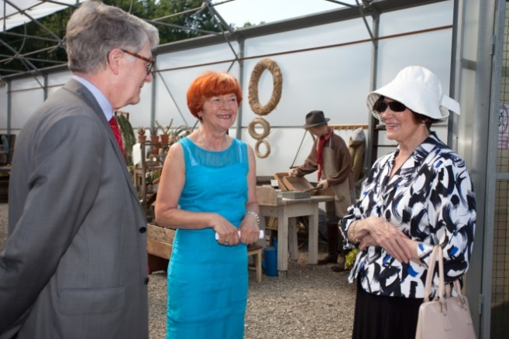

*Ambassador Verwey and Ms Eva Smrżová, Deputy*

*famous Czech traveler, Director of the Botanical*

*writer and ethnographer Garden and Ambassador*

*Mr Miroslav Stingl Verwey*

***Rugby match***

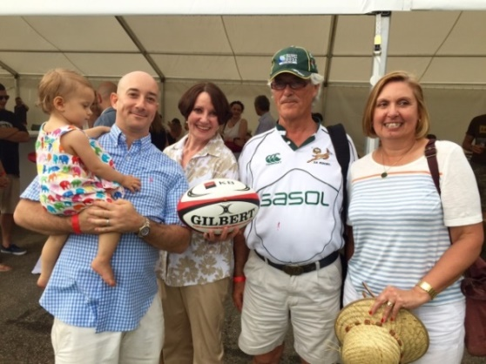

*Mr Martin Colley and his daughter Sasha, Ambassador Verwey and Mr and Mrs Schoeman*

The Ambassador and Mrs & Mr Schoeman attended the international friendly rugby match *Czech Republic vs New Zealand Ambassador’s XV* on 13 June 2015. The Kiwi team was composed of players from different European rugby competitions and won 32:36. Patron of the match was the Czech Minister of Foreign Affairs, Mr Lubomír Zaorálek.

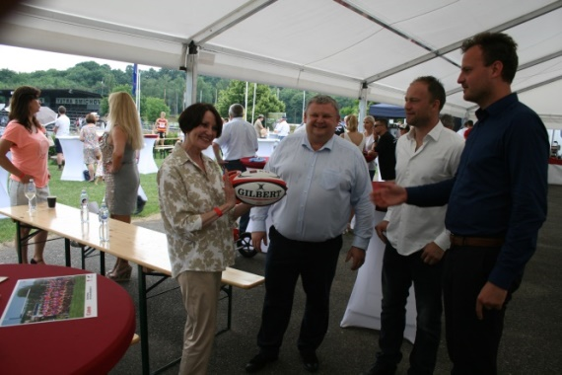

*Ambassador Verwey receives a rugby ball from*

*the Czech rugby team Tatra-Smíchov*

***Visit to Jablonec***

On 18 June 2015 the Ministry of Foreign Affairs arranged a visit to the Museum of Glass and Jewellery in Jablonec nad Nisou for the Diplomatic Corps in Prague. The visit was followed by the opening of the exhibition *Hot & Cold, Contemporaty Drinking Glass and Porcelain from Central Europe.*

[](http://www.msb-jablonec.cz/)

***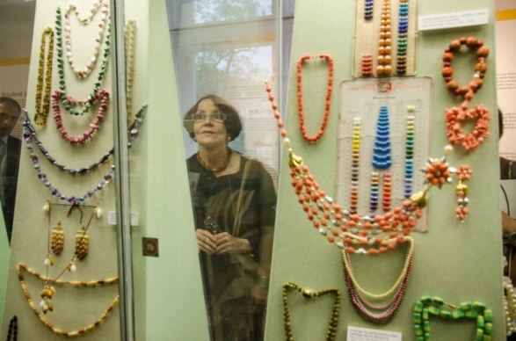****Ambassador Verwey admires the exhibits*

***Diplomatic functions***

In the month of June the Ambassador attended several receptions, including the annual reception hosted by the Czech Academy of Sciences; receptions hosted by the Embassies of Slovenia, Croatia, Venezuela, USA, Ireland, Sovereign Order of Malta and the Nordic-Baltic reception hosted jointly by the embassies of Denmark, Estonia, Finland, Latvia, Lithuania, Norway and Sweden; Swiss Summer Garden Party as well as dinners hosted by Ambassadors of Malaysia and Japan. The Ambassador also attended the screening of a rare film of a puppet version of the famous Czech story of the Good Soldier Švejk at the Czech National Film Archive.

Ambassador hosted a lunch for Czech Foreign Ministry officials.

New Ambassador of Kazakhstan paid a courtesy call to Ambassador Verwey.

**STAFF NEWS/SA CITIZENS**

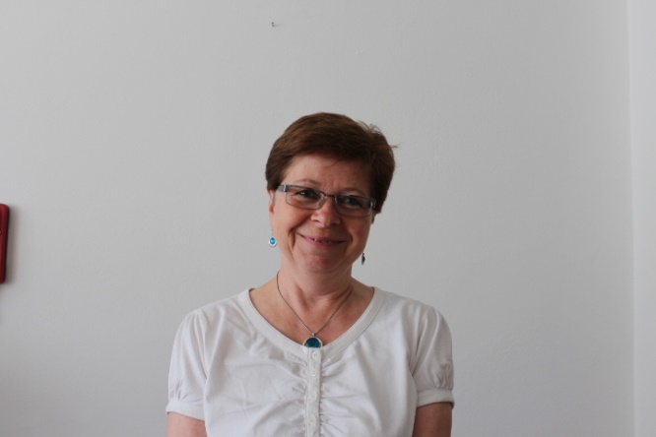Ms Hana Dastychová, Consular Clerk of the Embassy retired from her post at the end of June 2015.

We wish her much success for the future.

**DIRCO**

***WEF Africa***

[](http://www.weforum.org/)25th World Economic Forum on Africa was held in Cape Town from 3-5 June 2015. The main topics were: *growth, economy, society and employment*.

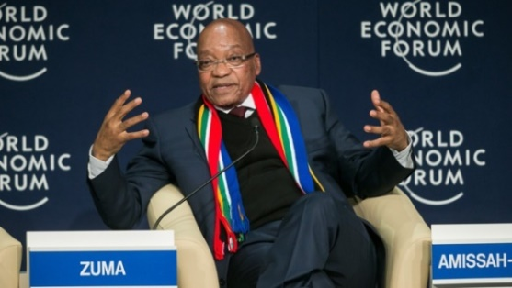

*President Jacob Zuma giving a speech at World Economic Forum on Africa, Picture: GCIS*

***African Union Summit***



Heads of State and Government of the 54 member states of the African Union met in Johannesburg for the 25th African Union Summit held from 14-15 June 2015 with discussion topics *Year of Women Empowerment and Development towards Africa’s Agenda 2063.*

[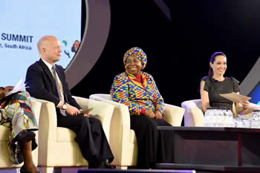](http://www.dfa.gov.za/images/gallery7/25_au_summit_june_2015_22.jpg)

*MP in the UK Parliament, William Hague, Chairperson of the African Union Dr Nkosazana Dlamini Zuma and UN Special Envoy for Refugees Issues, Actress Angelina Jolie Pitt, Johannesburg, 12 June 2015. Picture: Elmond Jiyane, (GCIS)*

***Cuban Five visited RSA***

The so-called Cuban Five arrived in South Africa on 21 June 2015 for a two-week visit to celebrate international solidarity which led to their release from US imprisonment. They were arrested in Miami in 1998 for allegedly spying against the Clinton administration and spent about 15 years in prison. South Africa continuously supported the campaign for their release.

[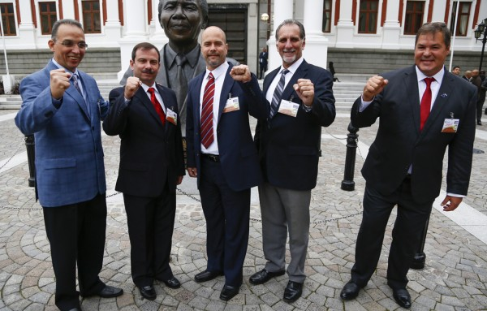](http://images.enca.com/enca/Cuban5_Parly.jpg)

Deputy Minister Luwellyn Landers hosted the Cuban Five in Cape Town from 22-23 June under the theme *Cuban Five Heroes: tribute to International Solidarity.*

**SA NEWS**

***Youth Day***

Youth Day celebrations and a month-long programme of supporting activities were held throughout South Africa to commemorate the Soweto youth uprising on 16 June 1976.

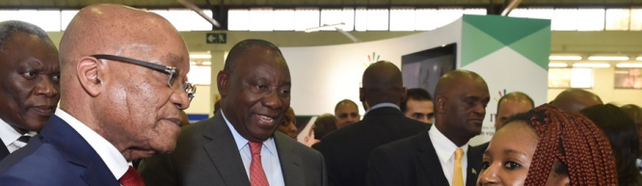

*President Zuma and Deputy President Cyril Ramaphosa lead the celebrations held at the Tshwane Events Centre in Pretoria*

***Four South African Parks in the Top 10 Best Safari Parks of Africa***

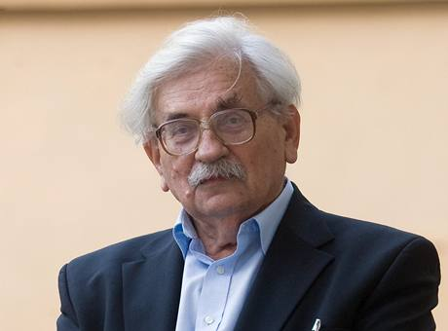**Four South African parks (MalaMala, Sabi Sands, Phinda and Kgalagadi) were awarded a top 10 position in the definitive list of** [**Africa’s best safari parks**](https://www.safaribookings.com/blog/258) **published on** SafariBookings.com. It is based on more than 3,000 reviews from both safari travelers and reputable industry experts.

**No other safari country has so many parks in the top 10.**

http://www.safaribookings.com/logo/SafariBookings_logo_long_250px.jpg

**CZECH NEWS**

***Valachová appointed Education Minister***

Ms Kateřina Valachová, Deputy Minister for Human Rights, Equal Opportunities and Legislation, was appointed as new Minister of Education on 17 June 2015. She replaced Marcel Chládek (ČSSD).

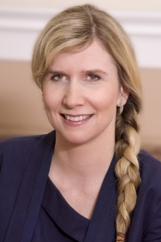 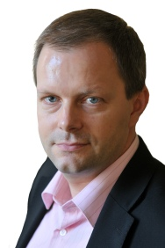

*Kateřina Valachová Marcel Chládek*

# *General Pavel taking up senior NATO post*

Former Czech Chief of Staff, General Petr Pavel took up his post as Chairman of the NATO Military Committee on 26 June 2015. He will serve as principal military adviser to the Secretary General.

*[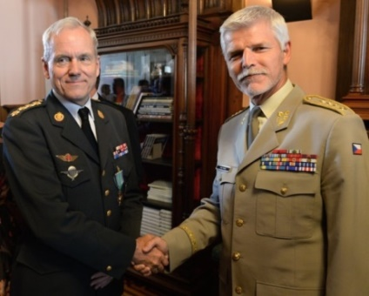](http://www.ceskenoviny.cz/news/index_img.php?id=343020)*[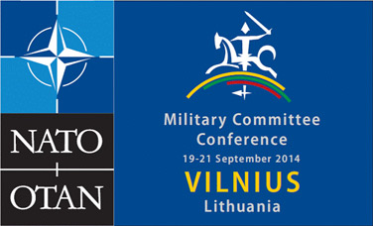](http://www.nato.int/cps/en/natohq/events_113040.htm)

*Czech General Petr Pavel(right) and his*

*Danish predecessor General Knud Bartels.*

***Writer and journalist Ludvík Vaculík died***

Czech writer and journalist Ludvík Vaculík, author of the *Two Thousand Words manifest* from 1968 and Charter 77 signatory, died at the age of 88 on 6 June 2015.

# *Czech comics illustrator Kaja Saudek died*

[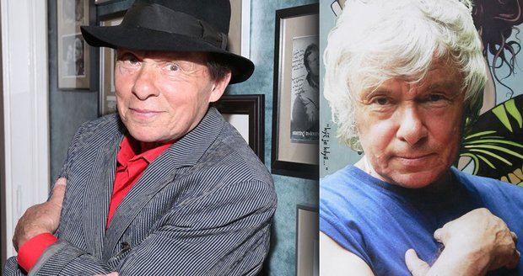](http://www.blesk.cz/galerie/413964?foto=0)Czech illustrator Kaja Saudek, known as the "King of Czech Comics", who had been in a coma in hospital from 2006, died of heart failure at the age of 80 on 25 June 2015.

***Josef Masopust died***

[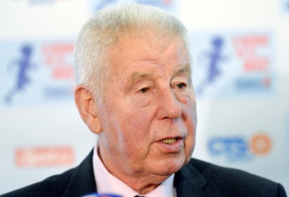](http://www.sportovninoviny.cz/zpravy/index_img.php?id=343267)Josef Masopust, European Footballer of the Year in 1962 and midfielder of the Czechoslovak team that won the silver medal at the 1962 World Cup in Chile, died on 29 June 2015 aged 84 years.

***People in Need suspends activities***

The Czech humanitarian organization *People in Need* suspended all its activities in Afghanistan after the killing of all nine of their local employees in the Zari district on 1 June 2015.

|  |
| --- |
| For more information about the South African Embassy in Prague please visit our website: http://[www.saprague.cz](http://www.saprague.cz) |

***Visit to Olomouc – 10 June 2015***

***Visit to the Town Hall***

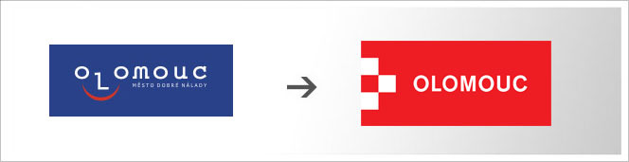  [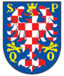](http://en.wikipedia.org/wiki/File:Olomouc_CZ_CoA.png)

*Logo of Olomouc City Coat of arms*

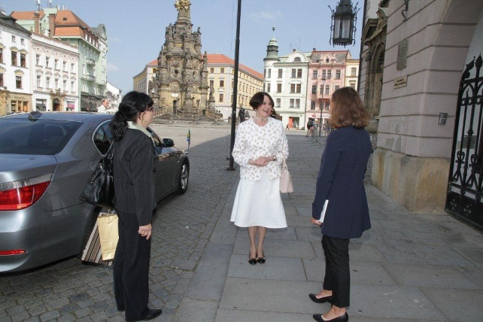 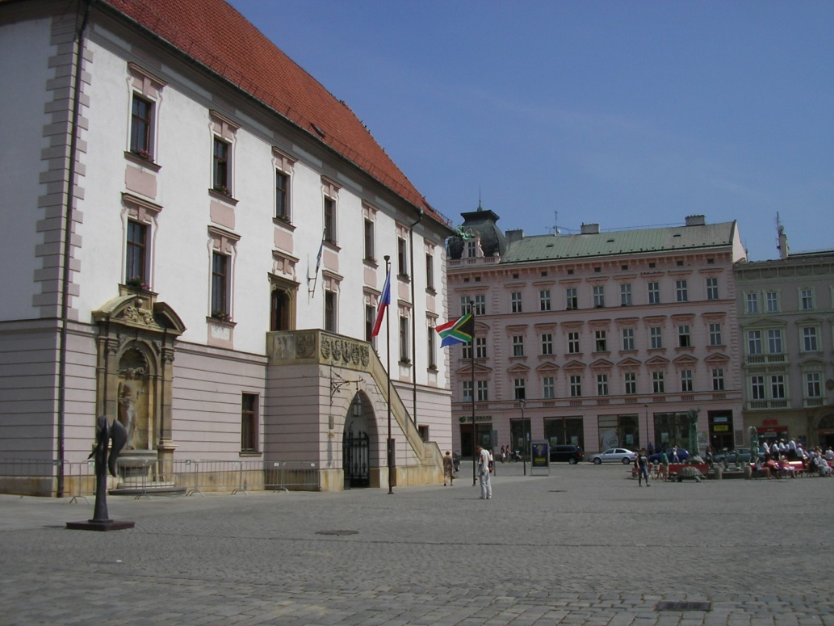

*Welcome in front of the Town Hall Czech and SA flag displayed at the Town Hall*

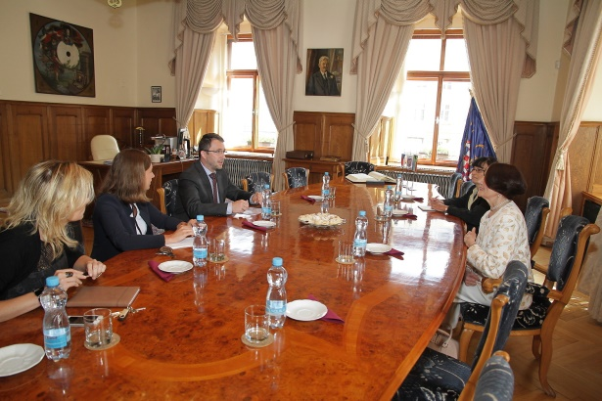

*Discussions at the Town Hall*

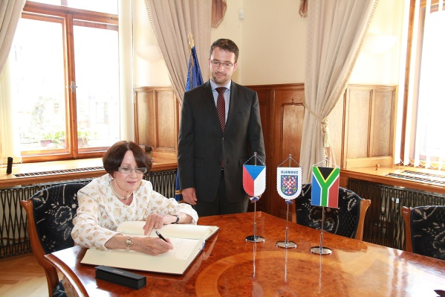 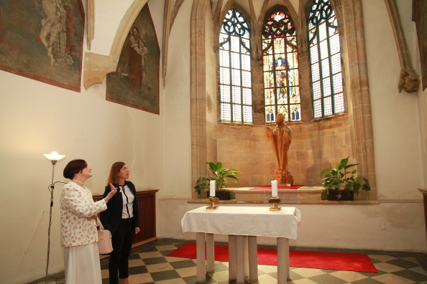

*Signing of Memory Book Ambassador Verwey and Ms Marie Jadrníčková*

*in Town Hall chapel*

*(pictures: Blanka Martinovská, Mayor’s Office)*

***Visit to Olomouc University***



[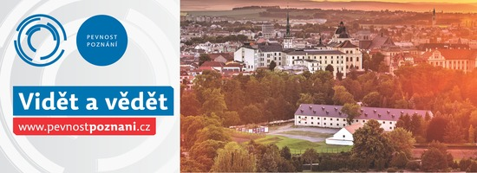](http://www.pevnostpoznani.cz/)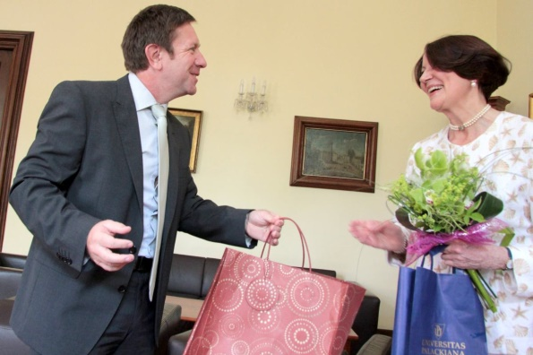

*Rector Jaroslav Miller welcomes Ambassador Verwey*

*at Palacký University 9 (Picture: Mgr. Pavel Konečný, Olomouc*

*Press Department, Palacký University)*

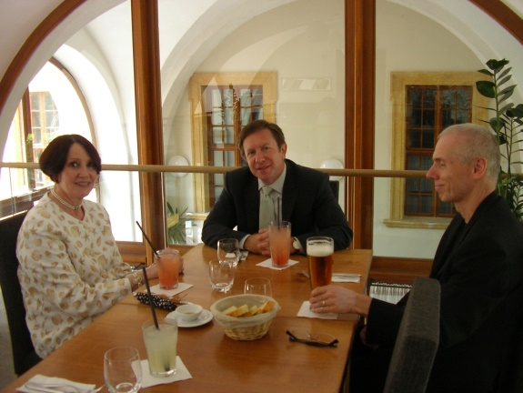 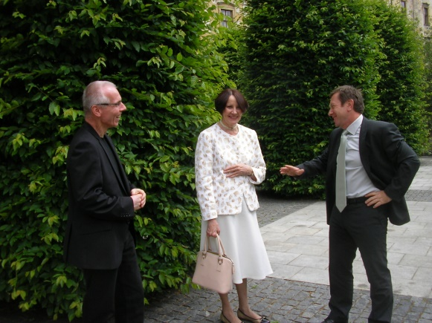

*Lunch with Rector Jaroslav Miller and Vice-Rector Vít Zouhar, Ambassador Verwey and*

*Vice-Rector Vít Zouhar Rector Jaroslav Miller in the university garden*

***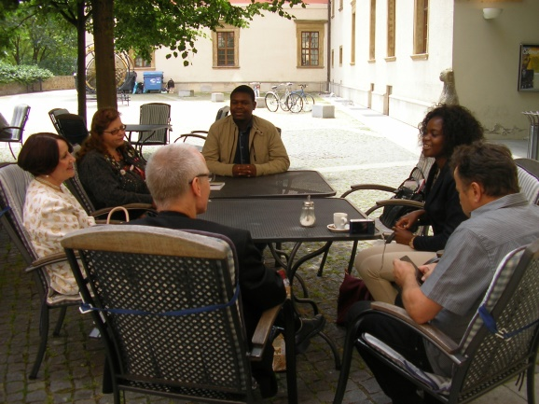 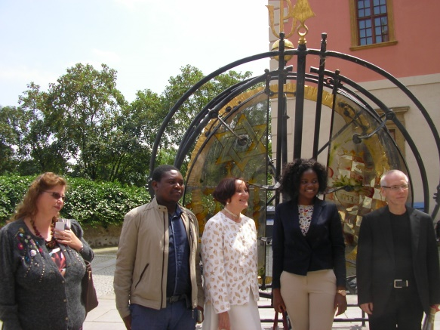****n Informal meeting with SA teacher and students SA teacher Ms Lianne Barnard, student Floyd*

*Sekgobela, Ambassador Verwey, student Xanani*

*Baloyi and Vice-Rector Vít Zouhar*

***Export Festival***

***17-18 June 2015***

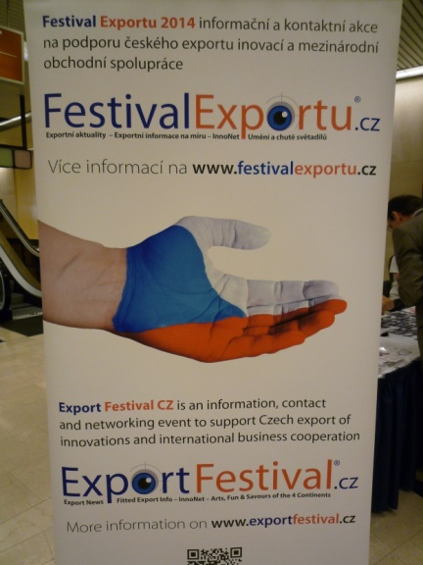

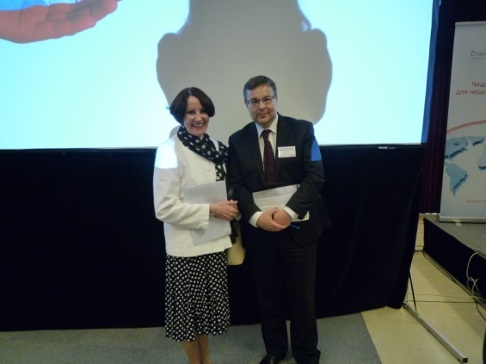 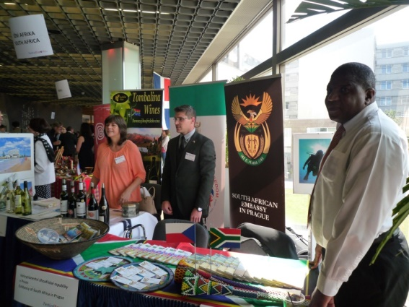

*Ambassador Verwey and Deputy Minister Ms Heather Crowther, Mr Nicolas Wood*

*of Foreign Affairs Mr Martin Tlapa and Mr ZM Dasa at South African stand*

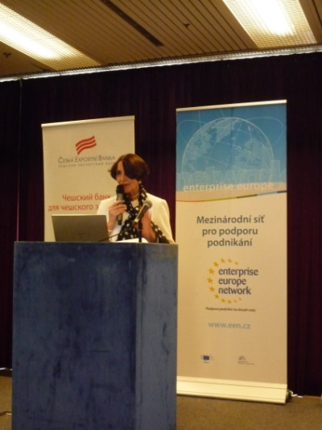 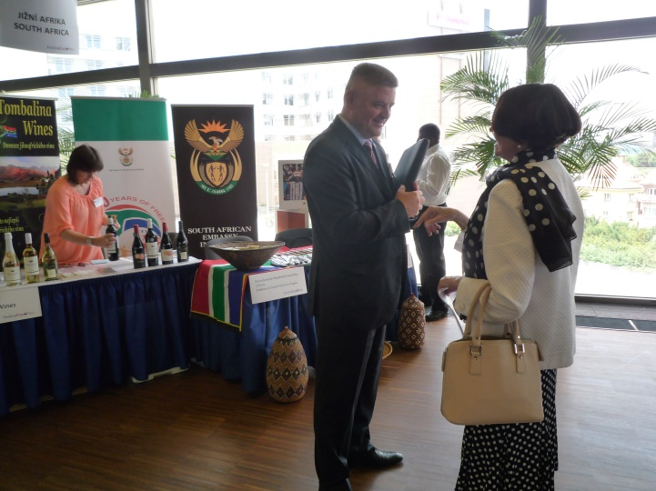 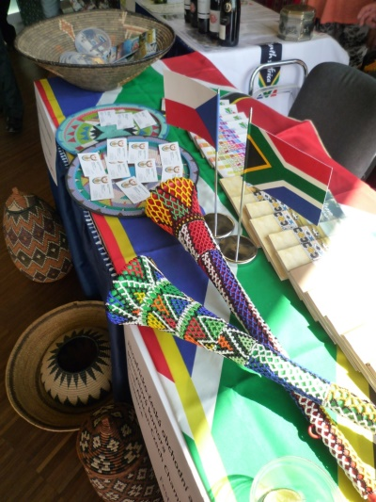

*Ambassador Verwey addresses Mr Vilém Růžička, President of Czech-SA South African stand*

*audience at festival Chamber of Commerce and* *Amb. Verwey*

***Opening of Exhibition of Cacti and Succulents at Botanical Garden***

***13 June 2015***



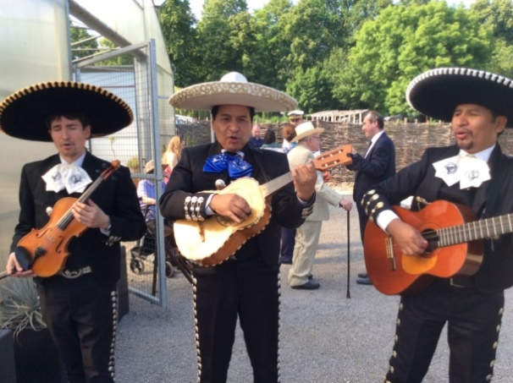

*Mariachi*

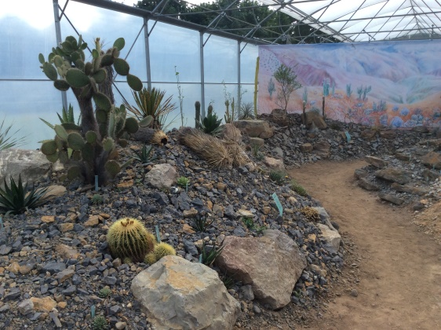 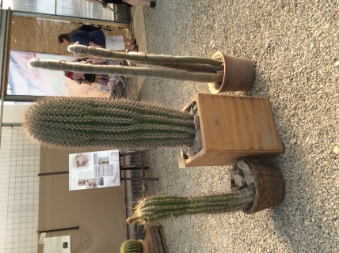 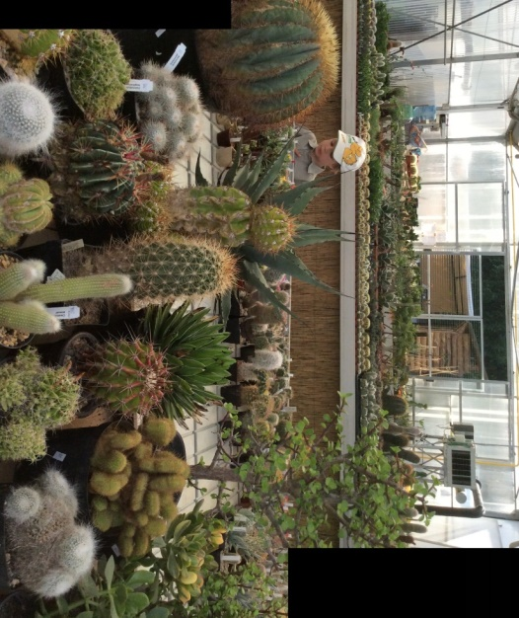

*Exhibition of cacti and succulents*

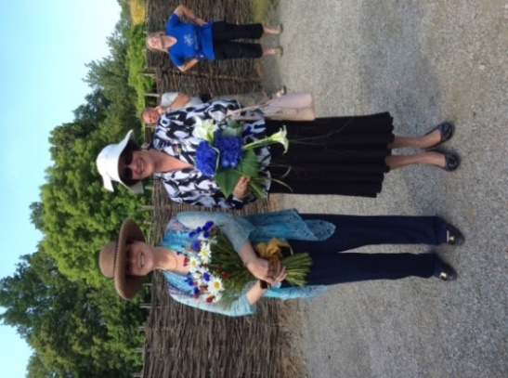 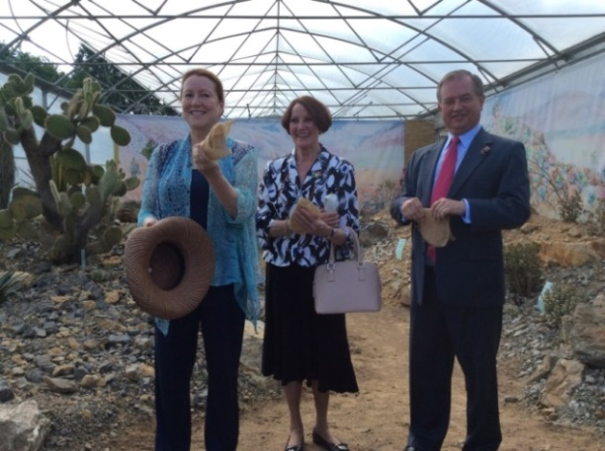 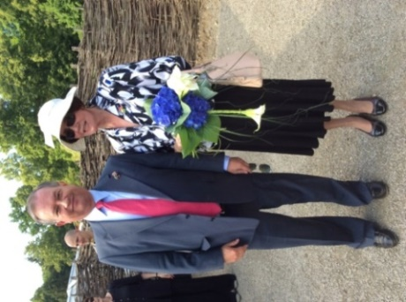

*Ambassador Verwey with colleagues from Peru and Mexico,*

*Ms Maria Landaveri Porturas and Mr Pablo Macedo Riba*