|  |
| --- |
| [Click on the specific symbol to view its symbolism  [coatofarms.gif 22315 bytes)](http://www.gov.za/_vti_bin/shtml.dll/symbols/coatofarms.htm/map) |
|  |

**EMBASSY OF SOUTH AFRICA  
RUSKA 65, 100 00 PRAGUE 10**

**NEWSLETTER - MARCH 2015 (No. 3)**

[](http://www.google.co.za/imgres?imgurl=http://sasportswear.co.za/images/sportswear/south_african_storm_flag.jpg&imgrefurl=http://sasportswear.co.za/sa-memorabilia-7/sports-flags-21/south-african-flag-storm-72.html&h=591&w=591&sz=35&tbnid=Uv7cCdEcYE0-pM:&tbnh=135&tbnw=135&prev=/images?q=South+African+flag&hl=en&usg=__g8gihHXhaZlPhuEToAfXga4s4Hw=&sa=X&ei=IslOTK-nNo-R4Qay7dWoCA&ved=0CAgQ9QEwAQ)



**WORD BY THE AMBASSADOR**

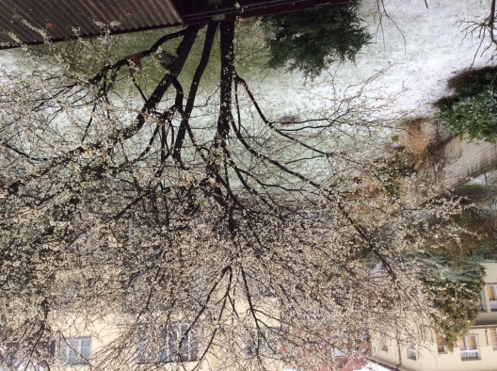

*View from the residence –tree in blossom*

*with snow on the lawn*

March was a busy month with many official engagements and Embassy events. The book closure for the end of the South African financial year also kept us fully occupied. Even the weather was unusually busy, changing by the hour from mild spring sunshine; to storm winds; to rain mixed with sleet. The inclement weather did not discourage nature, however, and the hills facing the Vltava are dotted with trees covered in white and pink blossom.

One of the highlights of the month was the feast of South African flavours that Ms Heleen Rabe from Hartenberg Estate conjured up for an official lunch at the Official Residence paired with outstanding wines from Hartenberg and Cederberg. Her culinary skills were much appreciated by the guests. She did certainly South Africa proud.

**EVENTS/ EMBASSY’S PROGRAMME**

***Joint Embassy - SAA event***

On 19 March 2015, the Embassy co-hosted an event with Ms Martina Bimanová, Commercial Director of Globair who also represents South African Airways in Prague, to promote South Africa as a tourist destination and to introduce the services that South African Airways are able to offer.  Around twenty managers of travel/ticket agents and tour operators  in Prague attended the event at the Cape Point Wine Bar in Malá Strana.  The guests also had an opportunity to taste a range of excellent South African wines.



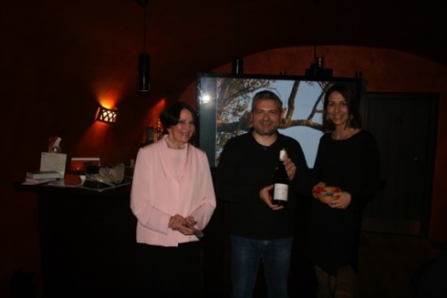

*Ambassador Verwey, Mr Zdeněk Lang and Ms Bimanová, Cape Point Wine Bar, 19 March 2014*

***Graduation ceremony in Pardubice***

On 14 March 2015 the Ambassador, Mr Dasa and Ms Herclová attended the graduation ceremony of Miss Tshimangadzo Masindo who successfully finished her Bachelor studies at the Transport Faculty at Pardubice University. Miss Masindi was the last of a group of the South African students from the Department of Transport who studied at the university.

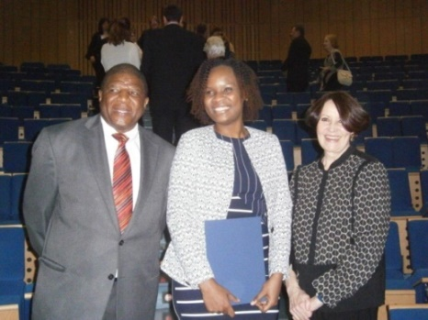

*From right: Ambassador Verwey, Miss Tshimangadzo Masindo and Mr ZM Dasa*

After the ceremony, the Ambassador hosted a dinner for the graduate, her family and friends and the representatives of the university.

We wish Miss Tshimangadzo Masindo much success in her further career.

***Diplomatic lunch***

On 12 March 2015, Ambassador hosted a working lunch at the Official Residence for a group of Ambassadors. As luck would have it,  Miss Heleen Rabe from Hartenberg Wine Estate was on a visit to Prague and agreed to prepare the food. The menu reflected South African flavours and traditional dishes including Springbok carpaccio, beef fillet in Cape Malay spice crust and milktart. The dishes were paired with excellent Cape wines.

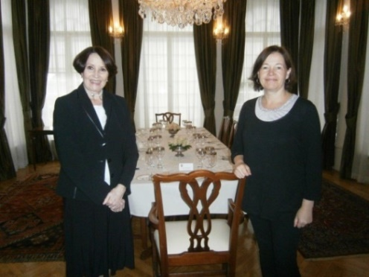

*Ambassador Verwey and Ms* *Heleen Rabe*

On 24 March 2015, the Ambassador hosted a diplomatic dinner for twelve Ambassadors and their spouses.

***Prague Students’ Summit***

Three students from Ostrava, North Moravia, 2015 visited the Embassy on 5 March 2015 to clarify some questions relating to South Africa and its foreign policy. The students represented South Africa at the annual Prague Students’ Summit. The Summit simulates three key international organizations – the United Nations, NATO, European Union and the Višegrad Group.

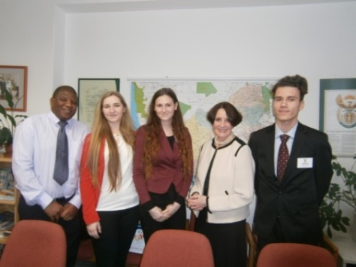

*Ambassador Verwey and Mr Dasa with the aaparticipants of the Prague Student Summit*

***Diplomatic functions***

During March 2015 the Ambassador attended a meeting of the Prague Africa Group; several events including receptions hosted by the Ambassador of Bulgaria and the Ambassador of Pakistan; receptions organized on the occasion of the International Women’s Day hosted by Ambassadors of China and France respectively; a piano recital of a renowned Mexican pianist hosted by the Ambassador of Mexico and a visit to the Czech national film archives with a group of other women ambassadors.

On 6 March 2015[](https://www.facebook.com/pragueshakespearecompany/photos/gm.1548906788723649/994979097183091/?type=1) the Ambassador attended a performance of *Twelfth Night* staged by the Prague Shakespeare Company at the Kolowrat Theatre. The British Ambassador to the Czech Republic, Ms Jan Thompson played the role of Olivia in the comedy.

**STAFF NEWS/SA CITIZENS**

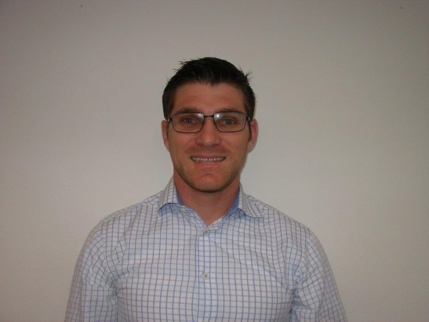

Mr Nicholas Wood, a South African citizen was appointed as new receptionist of the Embassy as of 25 March 2005.

*We wish our new colleague aaaaaaaaaaaa much success at his new post.*

**DIRCO**

***Visit to South America***

Deputy Minister Luwellyn Landers visited Uruquay, Chile and Colombia from 01-09 March 2015 to hold bilateral meetings with his counterparts, Deputy Minister Jose-Luis Cancela, Acting Deputy Minister Alfredo Labbe and Deputy Minister Patti Londono Jaramillo respectively.

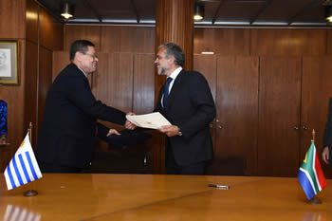

*Deputy Minister Luwellyn Landers and Deputy Minister Jose Lius Cancela, Montevideo, Uruguay 2-3 March 2015.*

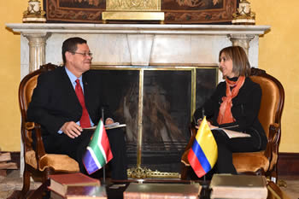

*Deputy Minister Luwellyn Landers and the Deputy Minister of Foreign Affairs of Colombia, Ms Patti Londono Jaramillo, Bogota, Colombia, 9 March 2015.Pictures: Yolande Snyman*

***UN Human Rights Council in Geneva***

Minister of International Relations and Cooperation Ms Maite Nkoana-Mashabane participated in the High-Level Segment of the 28th session of the United Nations Human Rights Council (HCR) in Geneva from 02-06 March 2015. The topics of the session were: *Human Rights Mainstreaming, the question of Death Penalty, and Human Rights and Climate Change*. South Africa has been a member of HCR since 2013.

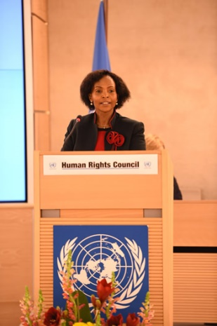

*Minister Ms Maite Nkoana -Mashabane delivers a statement at the High Level Segment of the United Nations Human Rights Council, Geneva, Switzerland, 3 March 2015. Picture: Unati Ngamntwini*

***SADC Council in Harare***

Minister of International Relations and Cooperation Ms Maite Nkoana-Mashabane and Minister of Trade and Industry Dr Rob Davies led the South African delegation to the SADC Council of Ministers held in Harare, Zimbabwe from 06-07 March 2015. The Council focused on integration and industrialization.

***International Women’s Day celebration***

On the occasion of the international Women’s Day, *Africa for Africa* Women’s Conference was held in Port Elizabeth on 8 March 2015. The theme of the conference was *Locating Women at the Centre of the Global Economy for Sustainable Development – Make it happen.* President Jacob Zuma delivered a keynote address.

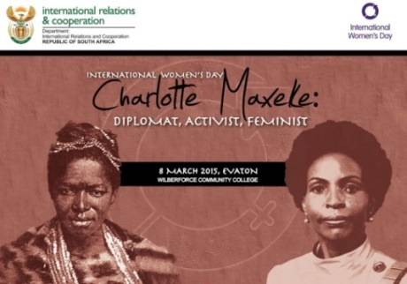

Minister of International Relations and Cooperation Ms Maite Nkoana-Mashabane honoured struggle heroine Charlotte Maxeke by handing over computers to the Charlotte Maxeke Secondary School and the Wilberforce Community FET College on 8 March 2015.

***Grand Opening of the Year of China***

The Embassy of China in collaboration with the Department of International Relations and Cooperation and the Department of Arts and Culture hosted a concert on 15 March 2015 in Pretoria to officially launch the 2015 Year of China in South Africa.



***Visit to Namibia***

Deputy President Cyril Ramaphosa, accompanied by Minister of International Relations and Cooperation Ms Maite Nkoana-Mashabane, attended the inauguration ceremony of President-elect, Dr Hage Geingob of the Republic of Namibia, on 21 March 2015 in Windhoek.

**SA NEWS**

***Minister Chabane died in a car crash***

[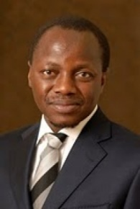](http://whoswho.co.za/collins-chabane-2259)It was with deep sadness that South Africa learnt of the death of South African Public Service and Administration Minister Collins Chabane. He and his two bodyguards died when their vehicle collided with a truck near Polokwane on 15 March 2015.

***Cape Town on fire***

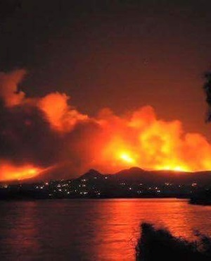The worst fires in many years hit the Cape Peninsula at the beginning of March. Thousands of hectares of vegetation as well as several houses were burnt. Hundreds of people had to be evacuated and at least one person died. It took more than one week to extinguish the fires.

**CZECH NEWS**

***Robert Pelikán appointed Justice Minister***

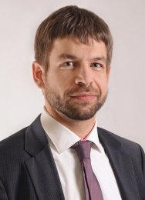

Mr Robert Pelikán was appointed Minister of Justice on 12 March 2015. He replaced Helena Válková who resigned from her post at the beginning of March.

***Congress of ANO***

Czech Finance Minister Andrej Babiš was re-elected leader of the ANO political movement at the congress held from 28 February to 1 March 2015.

[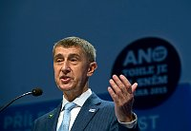](http://img.radio.cz/pictures/ctk1503/babis.jpg)

*Andrej Babiš at ANO Congress,*

*28 February 2015*

Jaroslav Faltýnek was elected the first Deputy Chairman. Deputy Chairwoman of the Chamber of Deputies Jaroslava Jermanová, head of Prague ANO branch Radmila Kleslová, Mayor of Brno Petr Vokřál and Member of Parliament Radka Maxová were elected deputy chairpersons.

***Congress of ČSSD***

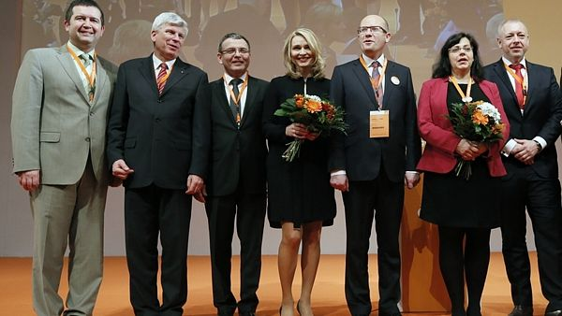

*ČSSD leadership: Jan Hamáček, Martin Starec, Lubomír Zaorálek, Lenka Teska Arnoštová, Bohuslav Sobotka, Michaela Marksová and Milan Chovanec*

***Okamura expelled from Dawn Deputies group***

[](http://en.wikipedia.org/wiki/File:Sv%C4%9Bt_knihy_2011_-_Tomio_Okamura.jpg)Dawn chairman Tomio Okamura and his ally Radim Fiala were expelled from the Dawn Deputies’ Group on 24 March 2015. In the past weeks the Dawn had been rocked by internal turbulences. Some Deputies intend to found a new political grouping.

***U.S. military convoy crossed the Czech Republic***

[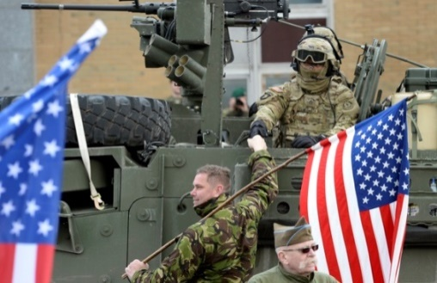](http://www.ceskenoviny.cz/news/index_img.php?id=333431)

TheU.S. military convoy of about 120 vehicles and some 500 personnel travelled through the Czech Republic on the way from the Baltic countries to the army’s home base in Germany after taking part in the operation Atlantic Resolve. The convoy demonstrated NATO unity and US commitment to stability in Europe.

***Two Czech women kidnapped in 2013 freed***

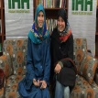

*Antonie Chrástecká and Hana Humpálová*

Two Czech tourists, Hana Humpálová and Antonie Chrástecká, who had been abducted in March 2013 in Baluchistan province in Pakistan, returned to the Czech Republic on 28 March 2015.

A Turkish humanitarian organization IHH helped negotiate their release.

***Czech citizen kidnapped in Libya***

A Czech citizen was among nine foreign oil workers kidnapped by the militants from Libya’s Islamic State from the al-Ghani oilfield in south-east of Tripoli on 6 March 2015. There is no news about his whereabouts.

[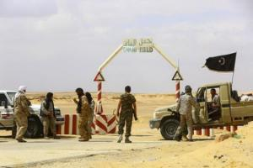](http://news.yahoo.com/czech-austrian-other-foreigners-missing-libya-oilfield-attack-074701404.html)

*Rebels guard the entrance of the al-Ghani oil field*

***Two Czech restaurants keep Michelin stars***

Two Prague restaurants, the Alcron Radisson (Chef Roman Paulus) and La Degustation Bohême Bourgeoise (Chef Oldřich Sahajdák) retained their stars in the 34th edition of the prestigious Michelin Gastronomical Guidebook.

 *Chef Oldřich Sahajdák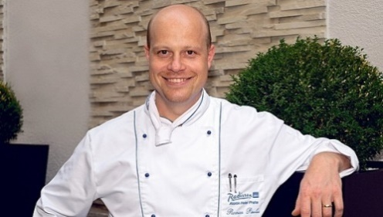 Chef Roman Paulus*

|  |
| --- |
| For more information about the South African Embassy in Prague please visit our website: http://[www.saprague.cz](http://www.saprague.cz) |