|  |
| --- |
| [Click on the specific symbol to view its symbolism  [coatofarms.gif 22315 bytes)](http://www.gov.za/_vti_bin/shtml.dll/symbols/coatofarms.htm/map) |
|  |

**EMBASSY OF SOUTH AFRICA  
RUSKA 65, 100 00 PRAGUE 10**

**NEWSLETTER - MAY 2015 (No. 5)**

[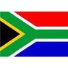](http://www.google.co.za/imgres?imgurl=http://sasportswear.co.za/images/sportswear/south_african_storm_flag.jpg&imgrefurl=http://sasportswear.co.za/sa-memorabilia-7/sports-flags-21/south-african-flag-storm-72.html&h=591&w=591&sz=35&tbnid=Uv7cCdEcYE0-pM:&tbnh=135&tbnw=135&prev=/images?q=South+African+flag&hl=en&usg=__g8gihHXhaZlPhuEToAfXga4s4Hw=&sa=X&ei=IslOTK-nNo-R4Qay7dWoCA&ved=0CAgQ9QEwAQ)



**WORD BY THE AMBASSADOR**

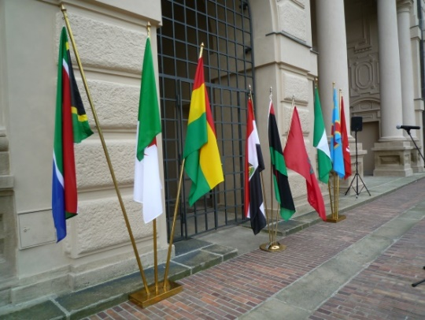

*African flags at Foreign Ministry*

The Embassy’s focus for the month of May was the celebration of Africa Day in conjunction with the other African Embassies in the Czech Republic. This year, the Africa Group decided to expand the scope of this celebration in order to create greater awareness of the African continent among the people of Prague. It was against this background that the nine Embassies participated for the first time in the open-air Farmers’ Market in Prague 6 where we created an African Village with traditional food and other produce at our stands. The result was a colourful array representing the many tastes and cultures of Africa. The event attracted thousands of visitors. This year’s Africa Day celebration concluded with a more formal reception in the beautiful gardens of the Foreign Ministry jointly hosted by the nine Embassies. There was also vibrant music and dancing from across the continent.

**EVENTS/ EMBASSY’S PROGRAMME**

***Africa Day celebrations in 2015***

The African Embassies in Prague jointly hosted a reception at the Foreign Ministry on 28 May 2015 to celebrate Africa Day.

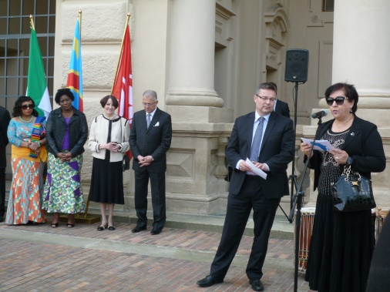

*Ambassador of Morocco, Mrs Souriya Otmani, Dean of the Prague Africa Group and Deputy Minister of Foreign Affairs, Mr Martin Tlapa opening the reception.*

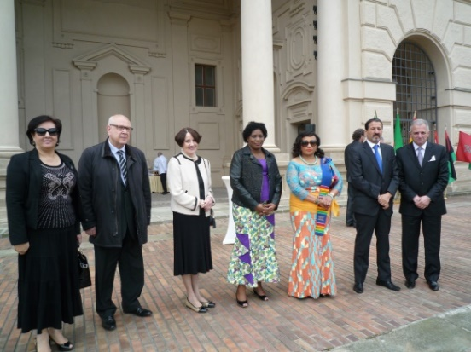

*African ambassadors welcome guests*

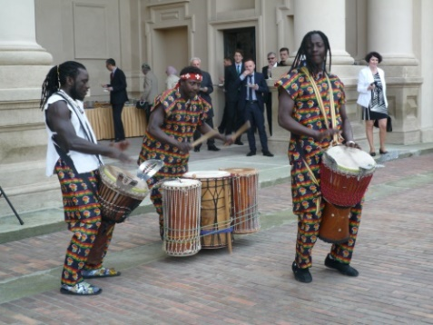

*The Papis Drums Group setting the tone*

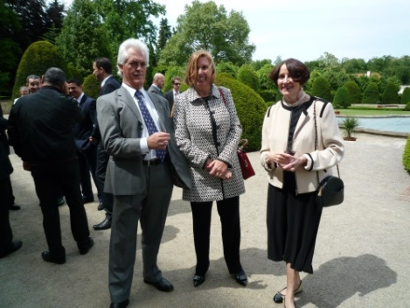

*Mr&Ms Schoaman and Ambassador Verwey at Africa Day reception, Min. of Foreign Affairs, 28 May 2015*

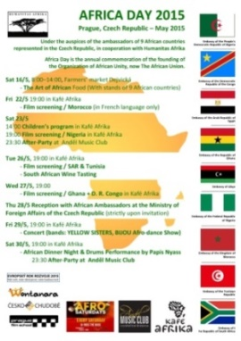Each of the African Embassies provided typical African food and wines from their countries.

***African Farmers’ Market***

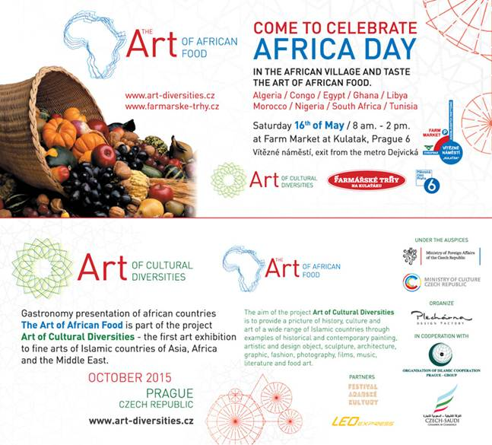The African Embassies jointly organized an African Farmers’ Market at the weekly open air market in Prague 6 on 16 May 2015.

Each country hosted a stand offering a variety of traditional food and other produce. After the official opening, there was a performance of traditional dances from the various countries. The African Village at the market proved to be very popular. All the produce was sold and people joined in the dancing.

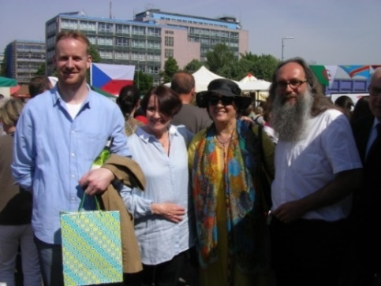

*Mr Ondřej Kolář, Mayor of Prague 6, Ambassador Verwey, Ms Souriya OTMANI, Ambassador of Morocco& Mr Pavel Šťastný, organizer of the event*

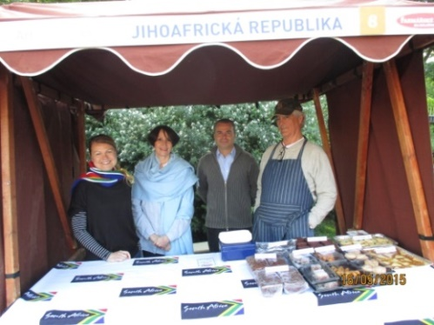

*Ms Hlávková, Ambassador Verwey, Mr Stifter and Mr Schoeman at the South African stand*

**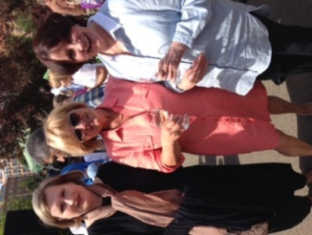 *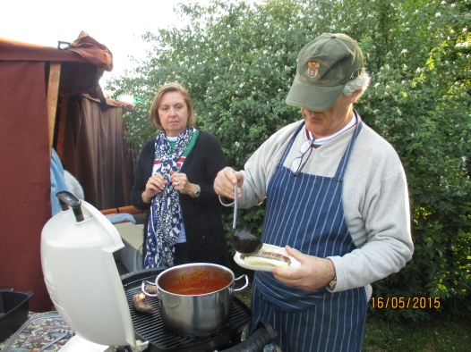***

*Ms Mahmoud, Ms Procházková Ms & Mr Schoeman*

*& Ambassador Verwey preparing a boerewors roll*

In addition to the official programme of the Embassies, the NGO Humanitas Afrika also arranged some events for the African community in Prague in celebration of Africa Day.

*Please see photographic depiction of Africa Day celebrations (Pages 6-8).*

***Victory Day celebrations***

[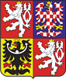](http://www.hrad.cz/cs/index.shtml)On 5 May 2015, President Miloš Zeman hosted a Ceremonial Gathering at Prague Castle on the occasion of the 70th anniversary of the end of the World War II. The gathering also honoured the memory of the fallen during the war.

On the same day, the Prime Minister Bohuslav Sobotka and Minister of Defence Martin Stropnický hosted a concert in commemoration of Victory Day in Prague Congress Centre. The Ambassador attended both events.

***Meeting with Captain Fillis***

Description: IDET logoOn 18 May 2015 the Ambassador, Mr Dasa and Ms Schoeman met Captain Nigel Fillis (SA Navy), Defence Attaché at the South African Embassy in Berlin. Captain Fillis was on a visit to the Czech Republic to accompany the South African delegation led by Major General Mbuli to the International Fair of Defence and Security Technology (IDET) in Brno from 19-21 May 2015. It is one of the biggest shows of defence technology in Central and Eastern Europe.

***Book fair***

[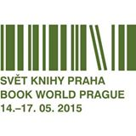](https://www.facebook.com/svetknihypraha/photos/a.166389946710662.45915.116282085054782/940367549312894/?type=1&source=11)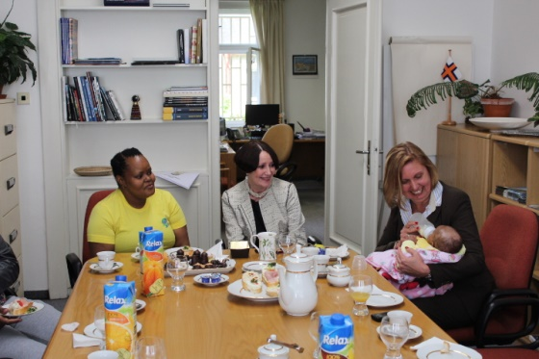The Ambassador attended the opening address of the Egyptian Ambassador at the International Book Fair & Literary Festival held at the Holešovice Exhibition Grounds on 14 May 2015. Egypt was Guest of Honour at the festival this year and hosted a big stand at the event.

***Diplomatic functions***

The Ambassador attended the annual meeting of the Minister of Industry and Trade with the Diplomatic Corps; the Spring BBQ Party hosted by the First Deputy Prime Minister and Minister of Finance Andrej Babiš; a Presentation of Activities of Public Diplomacy of the Czech Ministry of Foreign Affairs; as well as several receptions, hosted by the Embassies of Israel, Kazakhstan, Russia, Poland, Azerbaijan and Poland; a Garden Party hosted by the British Ambassador on the occasion of Queen Elizabeth’s birthday; a concert of Triinu Taul & Peeter Rebane hosted by the Ambassador of Estonia and a concert hosted by the Ambassador of Armenia. She also attended a lunch organized by the three Nordic women ambassadors (Sweden, Norway and Finland) for the women ambassadors in Prague with the Mayor or Prague, Ms Adriana Krnáčová as guest of honour. The Ambassador of Kenya, resident in The Hague, paid a courtesy call to Ambassador Verwey.

**STAFF NEWS/SA CITIZENS**

***Visit of Ms Radebe-Mothibe and family***

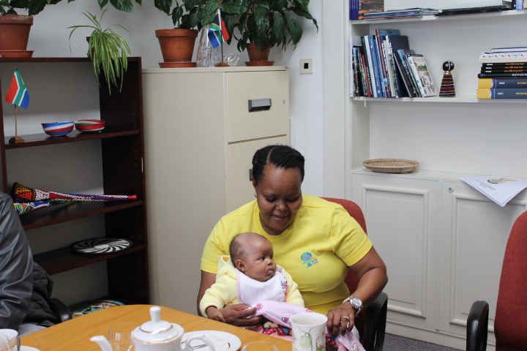aa 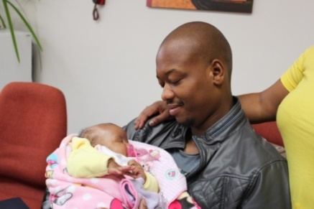

Ms Puleng Radebe-Mothibe, and her husbandvisited the Embassy on 28 May 2015 to introduce their new baby Relebogile to the Embassy staff.

*Ms Radebe-Mothibe, Ambassador Verwey*

*and Ms Schoeman with little Relebogile*

We welcome the youngest member of our community and wish the family much joy with her.

**DIRCO**

***Blue Economy Workshop***

[](http://www.iora.net/) The first IORA (Indian Ocean Rim Association) Blue Economy Core Group Workshop entitled *Promoting Fisheries & Aquaculture and Maritime Safeety & Security Cooperation in Indian Ocean Region*  was held in Durban from 04-05 May 2015. South Africa is due to chair IORA from 2017 to 2019.

***Namibian President visited RSA***

President Hage Geingob of the Republic of Namibia was on a working visit to South Africa on 6 May 2015. The two countries enjoy a close relationship and have strong trade cooperation.

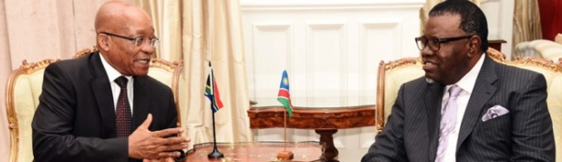

*President Zuma receives a courtesy call from the Namibian President Hage Geingob, Pretoria, 6 May 2015. Picture: The Presidency*

***Visit to Russia***

From 8-9 May 2015 President Jacob Zuma and his wife visited Russia for the commemoration of the 70th anniversary of the Victory in the Great Patriotic War.

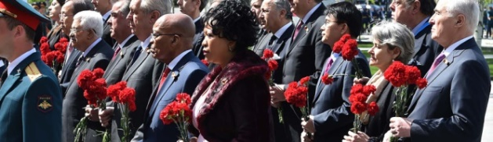

*President Zuma and his wife attending the ceremony in Moscow, May 2015. Pictures: GCIS*

***South Africa-Iran Joint Commission***

Minister of International Relations and Cooperation Ms Nkoana-Mashabaneled the South African delegation to the twelfth meeting of the South Africa-Iran Joint Commission held in Tehran from 10-11 May 2015. South Africa and Iran cooperate in various fields, including arts and culture, education and health.

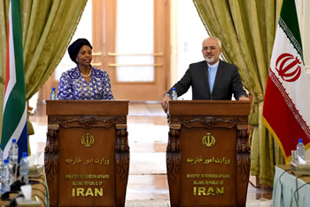

*Minister Ms Nkoana-Mashabane and her Iranian counterpart, Mr Mohammad Javad Zarif Khonsari, Tehran, 10 May 2015.Picture: Unati Ngamtwini*

***ICGLR Summit in Angola***

President Jacob Zuma attended the Extraordinary Summit of the International Conference on the Great Lakes Region (ICGLR) in Luanda, Republic of Angola from 17-18 May 2015.

The Summit considered the prevailing security situation in Region. South Africa has observer status in the ICGLR.

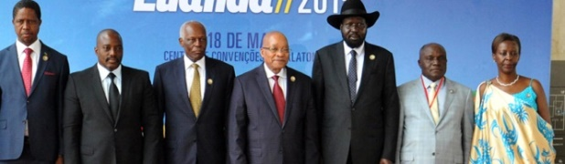

*President Zuma attends the Extraordinary Summit of the International Conference on the Great Lakes Region, Luanda, Angola. Picture: GCIS*

***State Visit to Mozambique***

President Jacob Zuma paid a State Visit to Mozambique from 20-21 May 2015, focusing on economic ties. Mozambique is South Africa’s biggest trade partner on the continent, with trade valued at over R30 billion.

[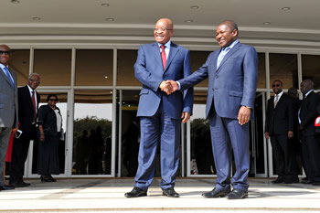](http://www.dfa.gov.za/images/gallery7/zuma_mozambique_nyosi2.jpg)

*President Zuma and his counterpart, President*

*Nyosi, Maputo, Mozambique, 20-21 May 2015.*

*Picture: Unati Ngamtwini*

***Working visit to Nigeria***

President Jacob Zuma undertook a working visit to Abuja, Federal Republic of Nigeria on 29 May 2015 to attend the inauguration of the President-Elect, General Muhammadu Buhari.

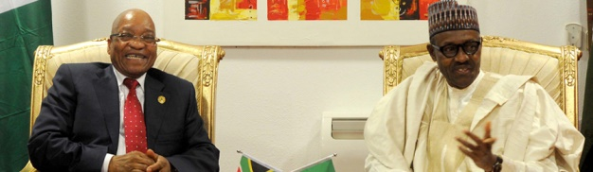

*President Zuma meeting with the new President of Nigeria. Picture: The Presidency*

**SA NEWS**

***Africa Day***

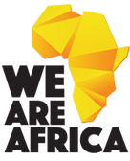President Jacob Zuma led the Africa Day celebration under the theme: *We are Africa-Opening the doors of learning and culture from Cape to Cairo* at the Mamelodi Campus of the University of Pretoria to mark the formation of the Organisation of African Unity (OAU), the precursor to the [African Union (AU)](http://www.au.int/), on 25 May 1963 .

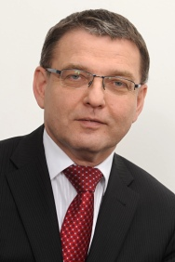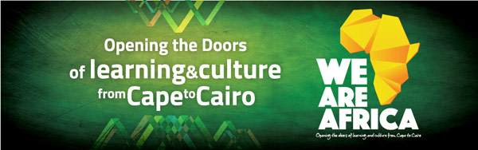

**CZECH NEWS**

***Visit to Moscow***

Czech President Miloš Zeman visited Moscow from 08-09 May 2015 to pay homage to the Soviet soldiers who died in WWII. On 9 May 2015 he met President Vladimir Putin to discuss mainly economic cooperation with the emphasis on Czech firms’ claims in Russia.

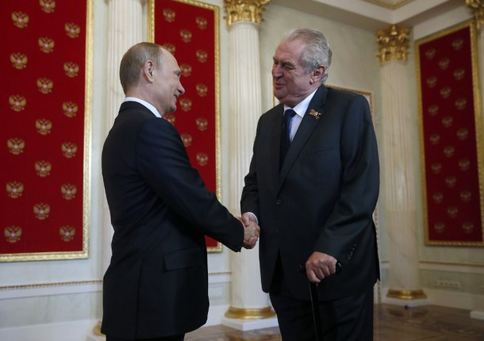

*Presidents Vladimir Putin and Miloš Zeman,*

*8 May 2015, Moscow, Picture: Prague Castle*

***Vietnamese President in Prague***

Vietnamese President Truong Tan Sang paid a State Visit to Prague from 11-13 May 2015 to meet his counterpart, President Miloš Zeman. The two Heads of State also attended a Vietnamese-Czech trade forum. Vietnamese President promised to lift the administrative barriers to facilitate Czech trade with Vietnam.

[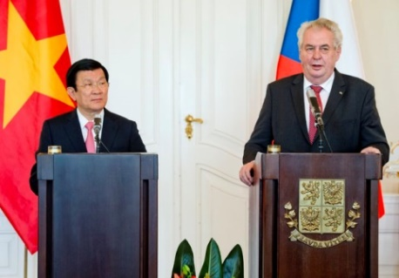](http://www.ceskenoviny.cz/news/index_img.php?id=338128)

*Presidents Truong Tan Sang and Miloš Zeman,*

*12 May 2015, Prague. Picture: Prague Castle*

***Foreign Minister’s visit to Africa***

Minister of Foreign Affairs Lubomír Zaorálek visited Kenya, Mozambique and Mauritius from 25-30 May 2015 to deepen cooperation in the field of economy and trade. Issues relating to migration, security and defence were also discussed during his visit.

***Eastern Partnership Summit in Riga***

President Miloš Zeman attended the Eastern Partnership Summit in Riga from 21-22 May 2015. The Eastern Partnership, launched in 2009, seeks to deepen relations between the European Union and six eastern countries, namely Armenia, Azerbaijan, Belarus, Georgia, Moldova and Ukraine.

***Government survived no-confidence vote***

Prime Minister Sobotka’s government survived a no-confidence vote on 26 May 2015. Out of 184 lawmakers present, only 47 supported the no-confidence motion. The opposition tabled the no-confidence motion in protest of a bill approved last week which they claim serves the business interests of Finance Minister Andrej Babiš.

***KDU-ČSL Congress***

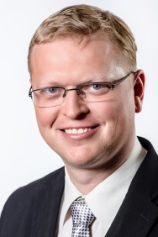Mr Pavel Bělobrádek was re-elected as the chairman of the Christian Democrats (KDU-ČSL) at the party congress on 23 May 2015.

Minister of Agriculture Marian Jurečka was re-elected as the first deputy chairman.

The KDU-ČSL is the junior partner in Mr Sobotka’s coalition government. Mr Bělobrádek serves as a Deputy Prime Minister for Science, Research and Innovation.

|  |
| --- |
| For more information about the South African Embassy in Prague please visit our website: http://[www.saprague.cz](http://www.saprague.cz) |

***Africa Day celebration at Foreign Ministry*** *28 May 2015*

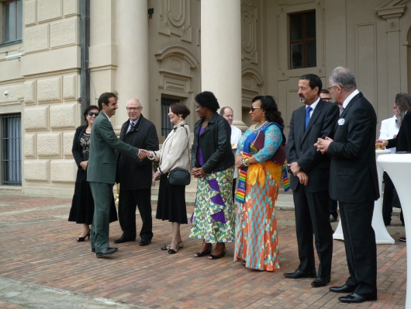

*African Ambassadors welcoming the guests*

 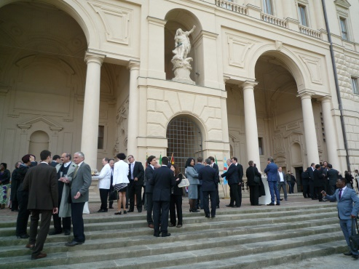 ***a***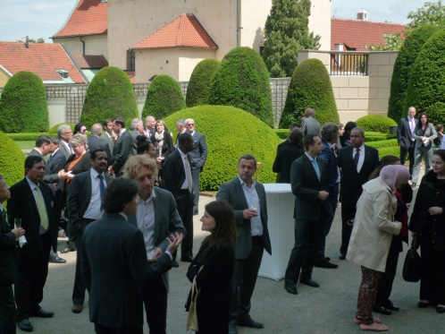

*Wonderful premises of the garden of Foreign Ministry*

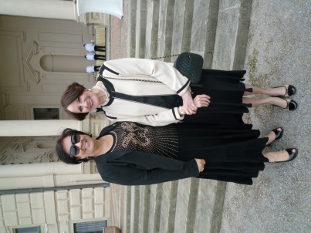 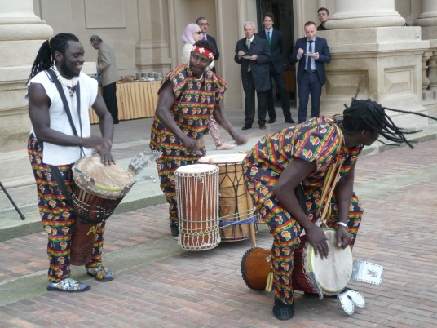  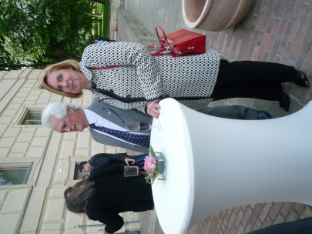

*Amb.of Morocco Ms Otmani & Amb. Verwey Papis group Mr&Ms Schoeman* ***a*** *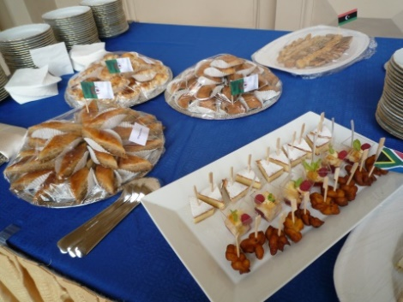****a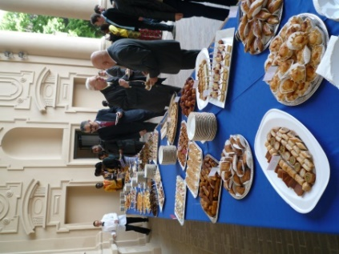a****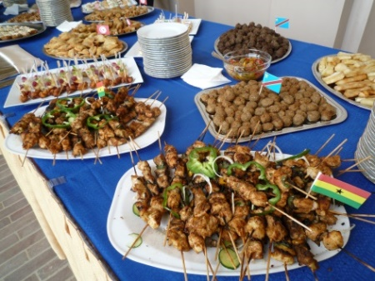* ***aaaaaaaaaaaaaaaaaaaaaaaaaaaaa****African food served at the reception*

***African Farmers’ Market*** *16 May 2015*



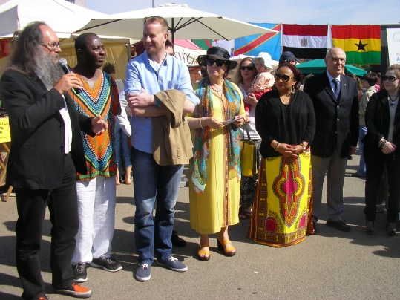 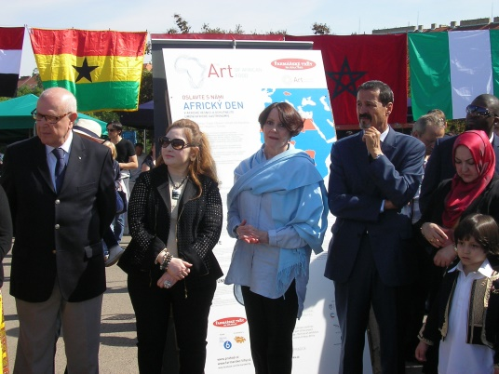

*Representatives of Prague 6 and African Ambassadors opening the African Farmers’ Market*

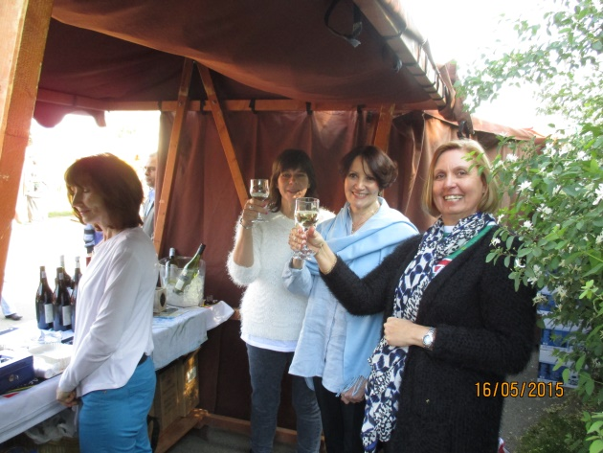

*Ms Heather Crowther (Tombalina Wines), Ambassador Verwey and Ms Schoeman*

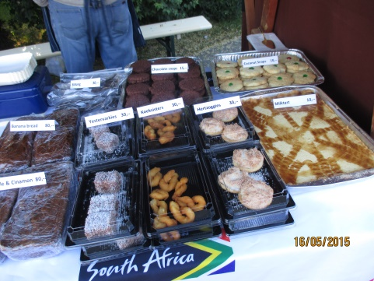 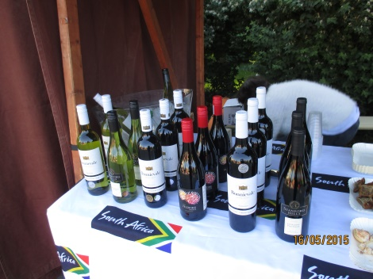

*South African wines and delicacies sold at the stand*

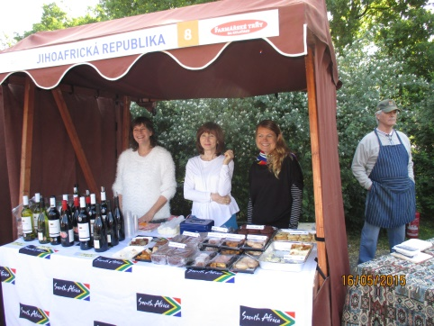 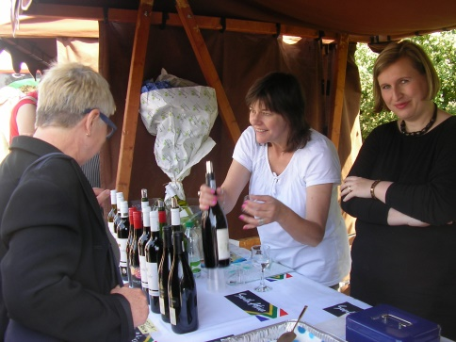 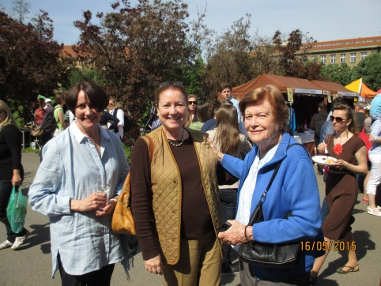

*Ms Crowther, Ms Růžičková, Ms Hlávková Ms Crowther and Ms Mahmoud Ambassador Verwey & Peruvian Ambassador*

*& Mr Schoeman at South African stand Ms Maria Landaveri Porturas and her mother*

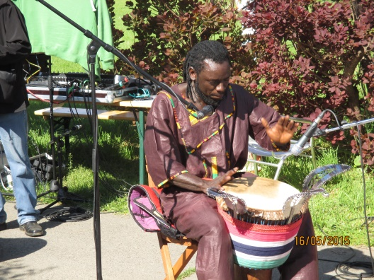 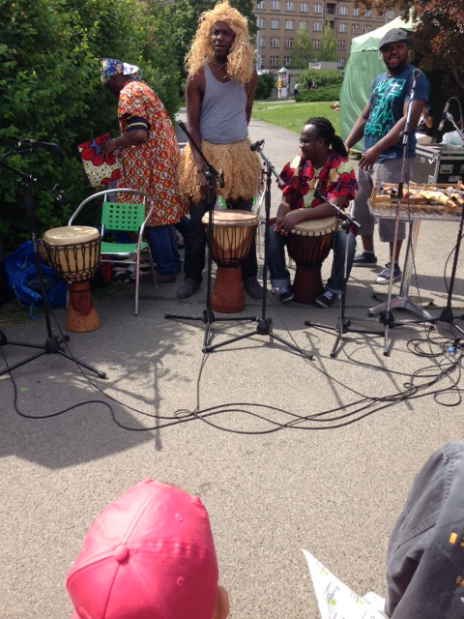

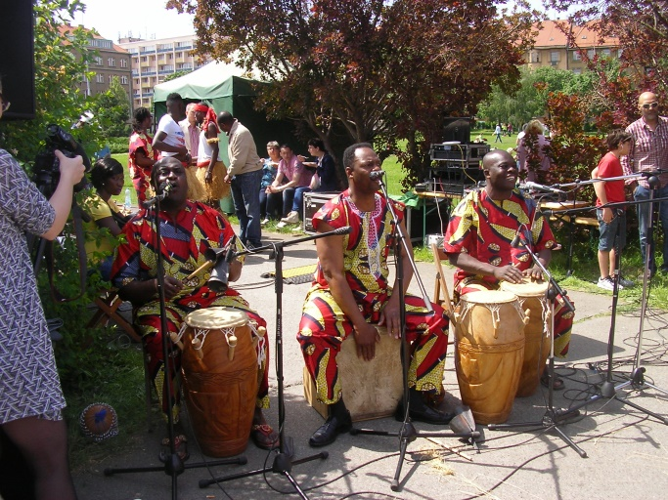

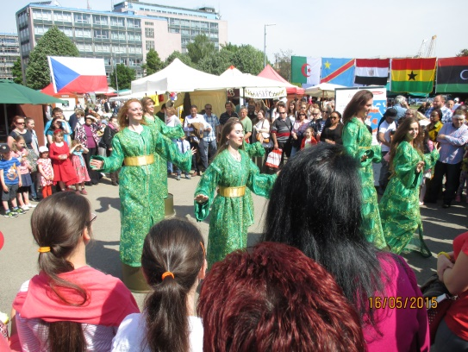 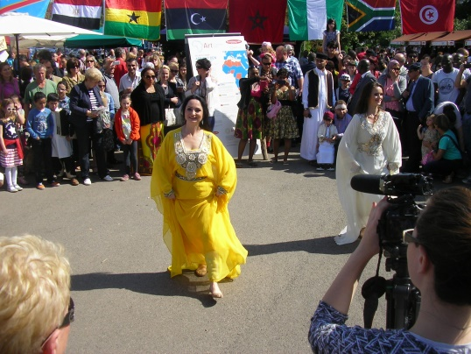

*Some musicians and dancers performing at African Farmers’ Market*