|  |
| --- |
| [Click on the specific symbol to view its symbolism  [coatofarms.gif 22315 bytes)](http://www.gov.za/_vti_bin/shtml.dll/symbols/coatofarms.htm/map) |
|  |

**EMBASSY OF SOUTH AFRICA  
RUSKA 65, 100 00 PRAGUE 10**

**NEWSLETTER - NOVEMBER 2015 (No.11 )**

[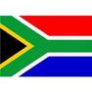](http://www.google.co.za/imgres?imgurl=http://sasportswear.co.za/images/sportswear/south_african_storm_flag.jpg&imgrefurl=http://sasportswear.co.za/sa-memorabilia-7/sports-flags-21/south-african-flag-storm-72.html&h=591&w=591&sz=35&tbnid=Uv7cCdEcYE0-pM:&tbnh=135&tbnw=135&prev=/images?q=South+African+flag&hl=en&usg=__g8gihHXhaZlPhuEToAfXga4s4Hw=&sa=X&ei=IslOTK-nNo-R4Qay7dWoCA&ved=0CAgQ9QEwAQ)



**WORD BY THE AMBASSADOR**

November is the month of Remembrance Sunday to commemorate those who had fallen in war. It was again, deeply moving to attend the ceremony at the Commonwealth War Graves Cemetery in Prague with the trumpeter sounding the Last Post and Reveille in the still autumn air. I used the opportunity to spend a moment at the graves of each of the 19 South African soldiers buried in the cemetery, so far from home; most of them very young.

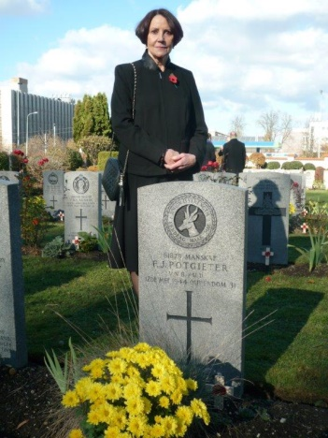Talking of young people, it was a great pleasure for me this month to have a chance to interact with the Master students of the Faculty of International Politics at the Prague University of Economics when I gave a talk on South African foreign policy. They were the kind of lively, open-minded young people who make one optimistic for the future.

The Czech word for November perfectly describes the month: *Listopad* - ‘Leaves are falling’. The Embassy gardener Mirka had no sooner swept the paths and driveways than they were covered again in a carpet of autumn leaves. She was no doubt relieved when, at the end of the month, the trees were finally bare and the pathways stayed clean.

**EMBASSY NEWS**

***Meeting with Chairman of Parliament***

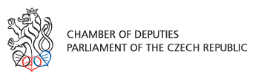 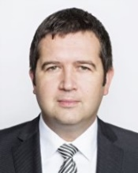

On 13 November 2015 the Ambassador paid a call on the Speaker of Parliament Mr Jan Hamáček to hand over a letter from his South African counterpart.

***Remembrance Day***

Ambassadors of Commonwealth countries, military officers and war veterans gathered at Prague’s Olšany Military Cemetery on 8th November 2015 for Remembrance Sunday in honour of soldiers who lost their lives in times of war. After laying wreath at the Central Cross, the Ambassador paid tribute to the nineteen South African soldiers who died on Czech soil during World War II.

*Ambassador Verwey at the grave of a South African soldier buried at the Olšany cemetery*

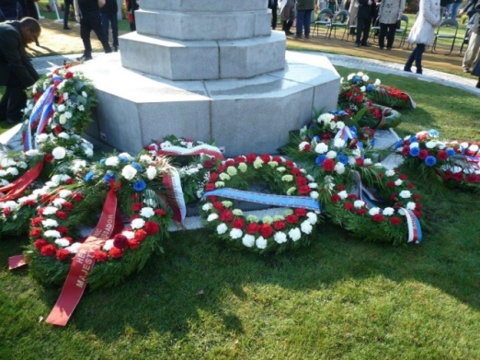

*Central Cross at Prague Military Cemetery*

***Visit of SA students to the Embassy***

Five South African students from Palacký University in Olomouc paid a visit to the Embassy on 20 November 2015. They briefed Ambassador and Mr Dasa on their studies in the Czech Republic and their plans for the future.

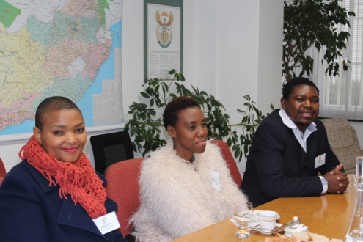

*Ms Phakisi, Ms Shange and*

*Mr Floyed Sekgobela*

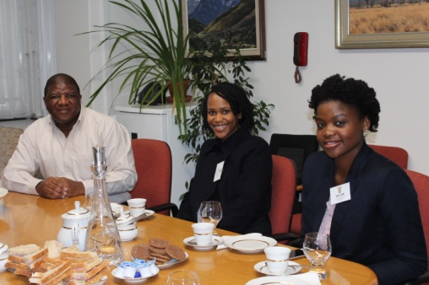

*Mr Dasa, Ms Thankholi and Ms Baloyi*

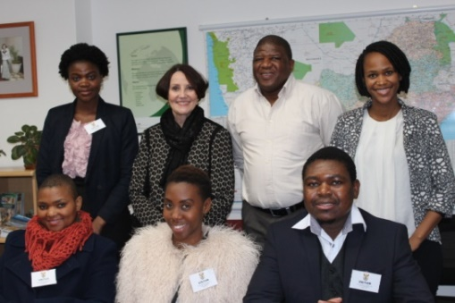

*At the back: Ms* *Baloyi, Ambassador Verwey,*

*Mr Dasa and Ms Thakani.*

*In front: Ms Phakisi, Ms Shange and Mr Sekgobela.*

[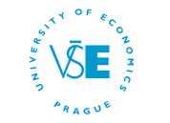](http://www.vse.cz/english/)***Lecture at Prague School of Economics*** The Ambassador gave a lecture on South African foreign policy to about 30 students of the University of Economics in Prague on 23 November 2015. The students showed lively interest; Ambassador answered more than twenty questions after the presentation.

After the lecture, the Ambassador discussed further cooperation with the Dean of the Faculty of International Relations, Doc Ing Štěpán Müller, CSc.

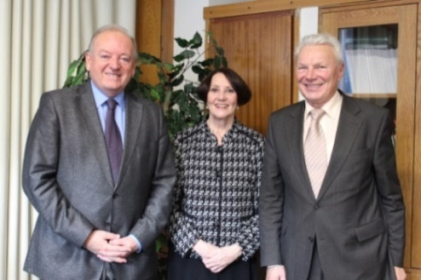

*Doc Ing Štěpán Müller, CSc, Ambassador*

*Verwey and JUDr Zdeněk Matějka*

***Around Africa in a month***

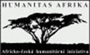The second session of the monthly discussion on current African affairs initiated by Humanitas Afrika under the title *Around Africa in a month* was held on 27 November 2015.

Ambassador Verwey and Ambassador of Brazil, George Monteiro Prata were guests of honour; Dr Papa Gaye from Senegal and Mr Tomáš Lindner, journalist from magazine Respekt were guest speakers.

***Christmas Festival***

About fifty diplomatic missions, including the South African Embassy took part in the annual international Christmas Festival which was held at the Prague Hilton Hotel on 29 November 2015, organized by the Diplomatic Spouses’ Association. The festival was opened by its patron, Mrs Ivana Zemanová. Visitors had the opportunity to buy a wide variety of products from all over the world. Proceeds from the festival will be donated to various Czech charity organizations.

The South African stand offered proteas South African arts and crafts and delicious South African wine.

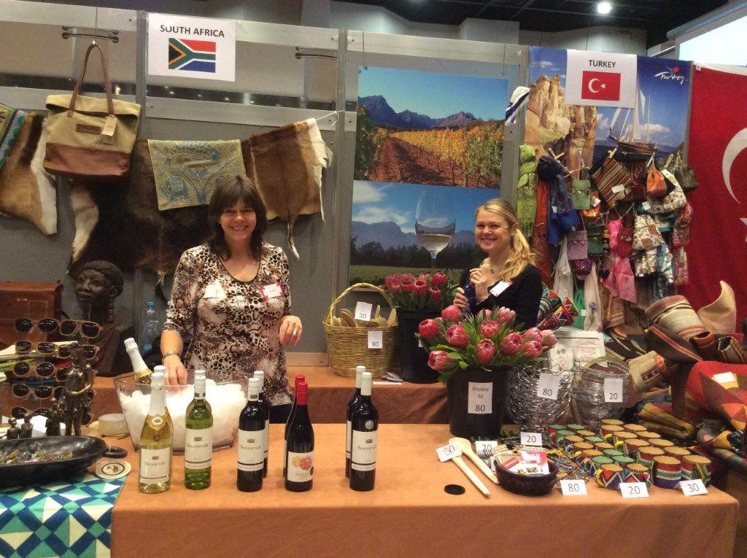 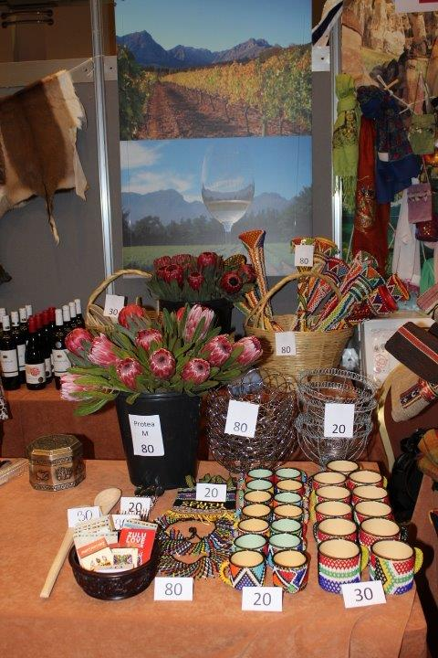

*Ms Hlávková at South African stand*

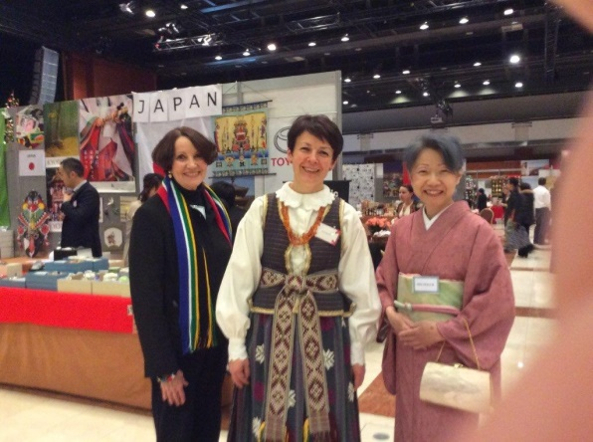

*Ambassador Verwey with the spouses of*

*Lithuania and Japan, in their national dress*

Ms Heather Crowther from Tombalina Wines and Mr Jan Brett and his wife Jana from Original Afrika partnered with the Embassy.

 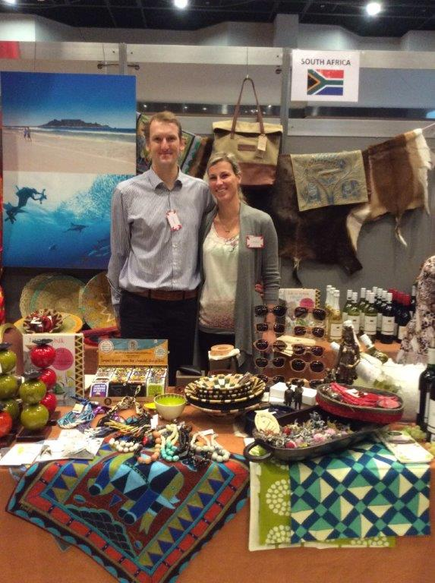

*Ms Heather Crowther Mr & Ms Brett*

***Diplomatic Functions***

The Ambassador attended receptions hosted by the Ambassadors of Albania, Algeria and Japan; a lunch hosted by Ambassador of Kuwait; the ASEAN Food Festival at a Farmers’ Market in the city; an exhibition *Architecture of Synagoges in Central-Europe* organized by the Federation of Jewish Communities and the Embassy of Hungary; an exhibition of a painter from Belgrade under the auspices of the Serbian Ambassador; a concert organised by the Association for Music & Arts Czech-Paris followed by a dinner; a performance by an acclaimed Georgian pianist hosted by Ambassador of Georgia; a Christmas concert hosted by Ambassador of Bulgaria; a music & food festival hosted by Ambassador of Palestine and a discussion over lunch hosted by the French Ambassador.

The Ambassador attended the conference *News in Czech Economic and Public Diplomacy* at the Ministry of Foreign Affairs.

**STAFF NEWS/SA CITIZENS**

**Visit of Hana Mahmoud and family**

Our colleague Ms Hana Mahmoud and her husband came to the Embassy on 4 November 2015 to introduce their son Adam. Hana is on maternity leave since September. In her absence, Ms Michaela Hlávková is helping out in the post of social secretary.

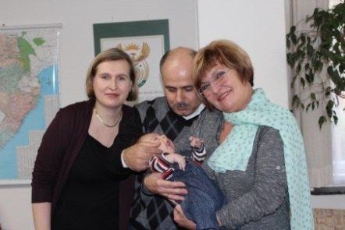

*Mrs & Mr Mahmoud and Ms Dagmar*

*Procházková with little Adam*

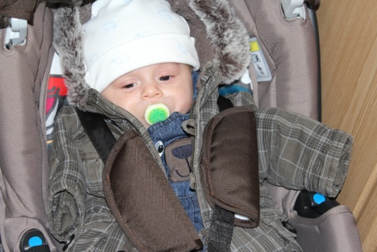

**SOUTH AFRICAN NEWS**

***Official visit to Berlin***

President Jacob Zuma undertook an official visit to Germany on 10 November 2015. South Africa and Germany have strong trade and investment relations. Over 600 German companies in South Africa provide more than 100000 employment opportunities mainly in the automotive industry, chemical industry and in the mechanical and electrical engineering sectors.

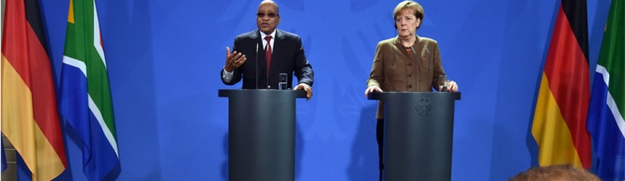*President Zuma and Chancellor Merkel address media over trade relations, Berlin. Picture: The Presidency*

***Official visit to Namibia***

President Jacob Zuma attended the official opening ceremony of the Southern African Customs Union (SACU) Headquarters on 12 November 2015 in Windhoek. President Zuma is the Chairperson of SACU for the period July 2015 to July 2016.

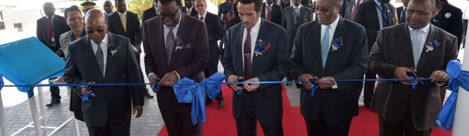

# *President Jacob Zuma officially* *opens the SACU Headquarters, Namibia. Picture: The Presidency*

***Angolan Independence Anniversary***

At the invitation of Angolan President José Eduardo dos Santos, President Jacob Zuma visited Angola on 24 November 2015 to discuss matters relating to peace and security in the Southern African Development Community (SADC) and the continent. He was accompanied by Minister of State Security, Mr David Mahlobo.

President Jacob Zuma also attended the 40th Anniversary of the Independence of Angola on 11 November 2015.

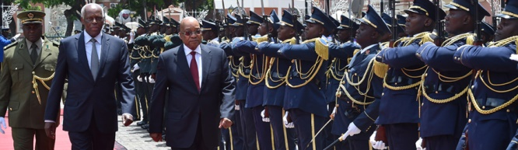

*President Jacob Zuma on a working visit to the Republic of Angola. Picture: The Presidency*

***ITEC session***

International Relations and Cooperation Minister Maite Nkoana-Mashabane and Minister of Natural Resources and Environment of the Russian Federation, Mr Sergey Donskoy co-chaired the 13th session of the annual South Africa-Russia Joint Intergovernmental Committee on Trade and Economic Cooperation (ITEC) in Moscow on 12 November 2015.

[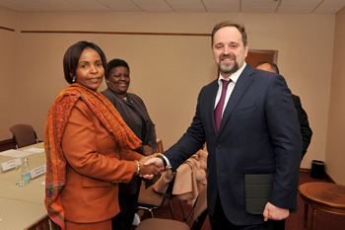](http://www.dfa.gov.za/images/gallery7/mashabane_itec-russia_donskoy1.jpg)

*Ministers Maite Nkoana-Mashabane and Sergey Donskoy, ahead of the Thirteenth Session of ITEC, Moscow, 12 November 2015. Picture: Unati Ngamntwini*

***Working Visit to Sweden***

Minister Maite Nkoana-Mashabane arrived in Stockholm, Sweden on 12 November 2015 on a working visit to reaffirm bilateral relations.

[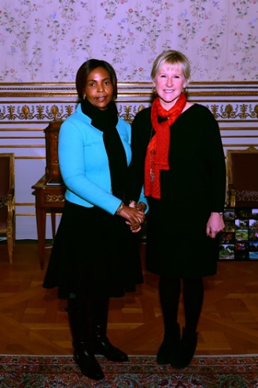](http://www.dfa.gov.za/images/gallery7/mashabane_sweden_wallstrom1.jpg)

*Minister Maite Nkoana-Mashabane meets with the Swedish Foreign Minister, Margot Wallström, for a working lunch, in Stockholm, Sweden, 13 November 2015. Picture: Unati Ngamntwini*

***ASP Session in The Haague***

International Relations and Cooperation Minister Maite Nkoana Mashabane led the South African delegation to the 14th Session of the Assembly of States Parties (ASP) of the International Criminal Court in The Hague from 18-26 November 2015.

[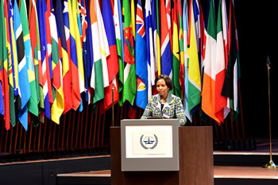](http://www.dfa.gov.za/images/gallery7/mashabane_icc_netherlands3.jpg)

*Minister Maite Nkoana-Mashabane at the Opening of the 14th Session of the ASP of the International Criminal Court, The Hague, 18 November 2015. Picture: Unati Ngamntwini*

***Working Visit to Italy***

International Relations and Cooperation Minister Maite Nkoana-Mashabane paid a working visit to Italy on 20 November 2015 to meet her counterpart,Minister of Foreign Affairs and International Cooperation, Paolo Gentiloni to renew political and economic relations between the two countries.

[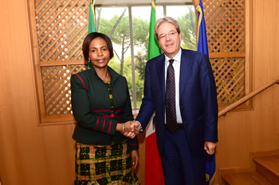](http://www.dfa.gov.za/images/gallery7/mashabane_italy_gentiloni1.jpg)

*Ministers Maite Nkoana-Mashabane and Paolo Gentiloni, ahead of the Bilateral Meeting, Rome, Italy, 20 November 2015. Picture: Unati Ngamntwini*

***CHOGM in Malta***

International Relations and Cooperation Minister Maite Nkoana-Mashabane led the South African delegation at the Commonwealth Heads of Government Meeting (CHOGM 2015) in Malta from 25 to 29 November 2015 under the theme *The Commonwealth – Adding Global Value.*

[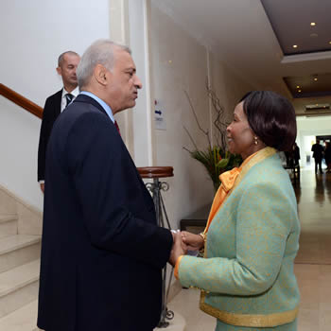](http://www.dfa.gov.za/images/gallery7/mashabane_chogm-malta_sharma2.jpg)*Minister Maite Nkoana-Mashabane and the Commonwealth Secretary-General, Kamalesh Sharma, Valetta, Malta, 26 October 2015.*

*Picture: Jacoline Schoonees*

***End of AMANI AFRICA II exercise***

AMANI AFRICA II, the largest military field exercise in South Africa since 1994, was held at Lohathla in the Northern Cape from 19 October 2015 to 8 November 2015. (AMANI is the Kiswahili word for peace).

[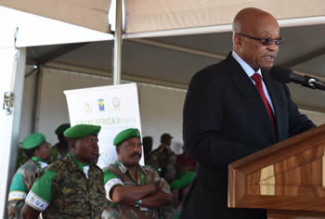](http://www.dfa.gov.za/images/gallery7/zuma_au_amani2.jpg)

*President Jacob Zuma at the African Union Closing Ceremony of the AMANI AFRICA II Field Training Exercise, SA Army Combat Training Centre, Lohatla, Northern Cape Province, South Africa, 8 November 2015. Picture: Jacoline Schoonees*

***16 Days of Activism for No Violence Against Women and Children 2015***

As every year, South Africa joined the international awareness-raising campaign for *No Violence Against Women and Children*whichtakes place from 25 November to 10 December 2015.

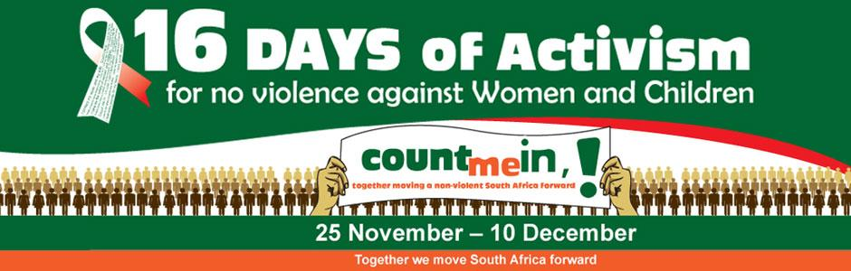

***Drought in the RSA***

South Africa has been hit by the worst drought in more than 20 years. Five provinces have been declared disaster areas. Taps ran dry even in some parts of Johannesburg; water tankers were dispatched.

**CZECH NEWS**

***Prime Minister Sobotka visited China***

Prime Minister Bohuslav Sobotka paid a week-long working visit to China from 21- 27 November 2015. He met top Chinese politicians, businessmen and bankers, opened the Czech-Chinese Business Forum, gave lecture at the university and also attended a meeting of 16 Prime Ministers from Central, Eastern and Southeastern Europe and China in Suzhou.

36 agreements and memoranda with the Chinese partners were signed during the visit.

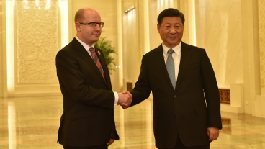

*Bohuslav Sobotka and Chinese President Si Ťin-pching, 26 November 2015. Picture: Government Office*

[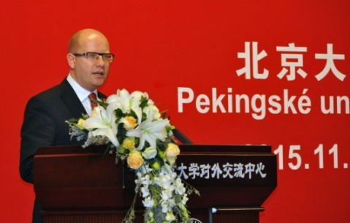](http://www.ceskenoviny.cz/zpravy/index_img.php?id=359074)

*PM Bohuslav Sobotka gives lecture at the University of Beijing, 25 November 2015. ČTK Šupová Tereza*

***V4 countries increase contribution to Africa***

Countries of the Visegrad Group agreed to increase their contribution to Africa by another EUR 100 thousand each at the Valetta Summit, Malta on 12 November 2015.

***17 November celebrations***

[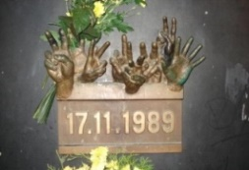](javascript:;)On 17 November 2015, the Czech Republic commemorated two anniversaries: closure of universities in 1939 and the

beginning of the Velvet Revolution in 1989.

Prime Minister Bohuslav Sobotka and other dignitaries paid tribute to Struggle for Freedom and Democracy Day in a ceremony at Hlávka Hall of residence. Then they laid flowers and candles at the monument in Národní Třída at the site where the Velvet Revolution started. A human chain was formed in the street in honour of the victims of communism.

The sympathizers of migrants assembled at Náměstí Míru; at Albertov, where the students began their march in 1989, an event was staged by the Bloc against Islam in the presence of President Miloš Zeman.

On 22 November 2015, students organized a separate commemoration of the fall of the communist government regime at Albertov.

***Bohemian King Charles IV’s anniversary on UNESCO list***

[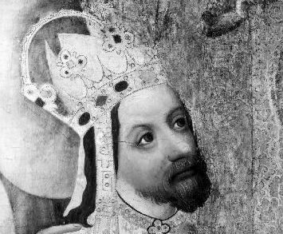](http://www.ceskenoviny.cz/news/index_img.php?id=24162)The 700th birth anniversary of King of Bohemia and Roman Emperor Charles IV (1316-1378) has been included in the UNESCO list of important world anniversaries in the years 2016-2017. The list was approved at the 38th session of the UNESCO General Conference held in Paris on November 3-18.

***Czech Republic steps up security measures***

In connection with terrorist attacks in France, Mali, Tunisia and other countries, the Czech Republic increased security measures at airports, railway stations, foreign embassies and other key institutions. Higher security measures are likely to be in place in the Czech Republic over Christmas and the New Year.

|  |
| --- |
| For more information about the activities of the South African Embassy in Prague please visit our website: http://[www.saprague.cz](http://www.saprague.cz) |