|  |
| --- |
| [Click on the specific symbol to view its symbolism  [coatofarms.gif 22315 bytes)](http://www.gov.za/_vti_bin/shtml.dll/symbols/coatofarms.htm/map) |
|  |

**EMBASSY OF SOUTH AFRICA  
RUSKA 65, 100 00 PRAGUE 10**

**NEWSLETTER - OCTOBER 2015 (No. 10)**

[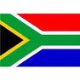](http://www.google.co.za/imgres?imgurl=http://sasportswear.co.za/images/sportswear/south_african_storm_flag.jpg&imgrefurl=http://sasportswear.co.za/sa-memorabilia-7/sports-flags-21/south-african-flag-storm-72.html&h=591&w=591&sz=35&tbnid=Uv7cCdEcYE0-pM:&tbnh=135&tbnw=135&prev=/images?q=South+African+flag&hl=en&usg=__g8gihHXhaZlPhuEToAfXga4s4Hw=&sa=X&ei=IslOTK-nNo-R4Qay7dWoCA&ved=0CAgQ9QEwAQ)



**WORD BY THE AMBASSADOR**

After meeting the Zululand Gospel Choir in September, we had an opportunity to attend their performance in Prague during October. Their vibrancy and energy on stage and their sheer musicality blew away the audience. They really did South Africa proud.

I travelled through the colourful autumn countryside to go to Holice this month, home of the famous 19th century explorer, Dr Emil Holub who was as well known in his day as explorers such as David Livingstone. His explorations in Southern Africa took him all the way from Cape Town to the Victoria Falls which he was the first person to map. I am proud to note a connection with him because he published his book on the Victoria Falls in my hometown, Grahamstown! I was warmly received by the Mayor and other town dignitaries and spent a very interesting day meeting the senior students at the High School, visiting the Africa Museum and also being honoured at the Art School by a music performance by a very gifted young trio.

I was out of the country for two weeks, but returned in time to attend the Czech National Day celebration on 28 October 2015. The solemn ceremony in the beautiful Gothic Vladislav Hall at Prague Castle was, as always, impressive and moving.

**EVENTS/ EMBASSY’S PROGRAMME**

***Heads of Mission Conference***

Ambassador attended a Regional Heads of Mission Conference in London from 20-23 October 2015.

***Visit of Parliamentary delegation***

Hon Mr R.J. Tau, Deputy Chair of the National Council of Provinces, and three members of his delegation visited the Embassy on 15 October 2015*.*

They were in Prague to participate in the A*ssembly of Parliamentarians for Nuclear Non-Proliferation and Disarmament.*

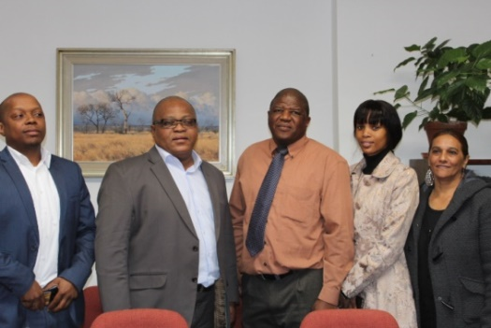

*Mr Kwazikwenkosi Mthethwa, Hon Mr R.J. Tau, aaMr ZM Dasa, Ms Sebolelo Mvulane and Ms Zurina aaJardin*

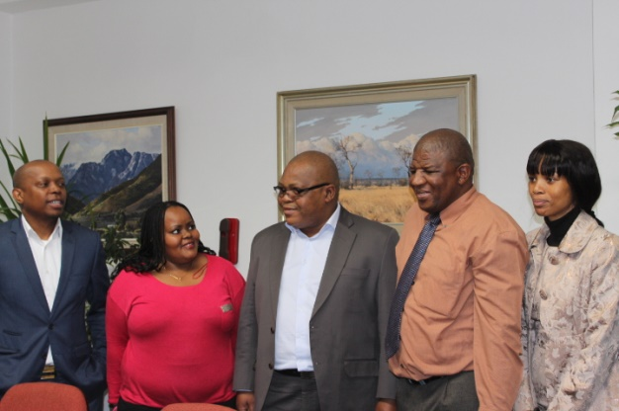

*Ms Puleng Radebe-Mothibe, Hon Mr R.J.Tau*

*and Mr ZM Dasa*

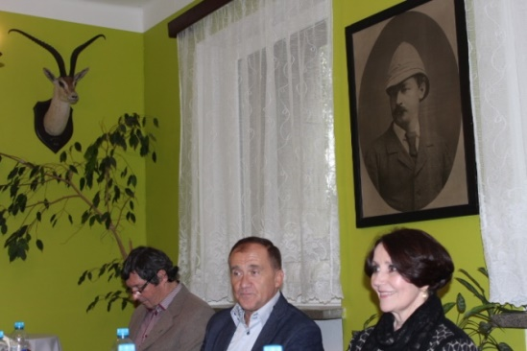***Visit to Holice***

The Ambassador visited the town of Holice on 9 October 2015, during the annual *Holub Holice Week* which commemorates the famous Czech traveller to Southern Africa, Dr Emil Holub (1847-1902).

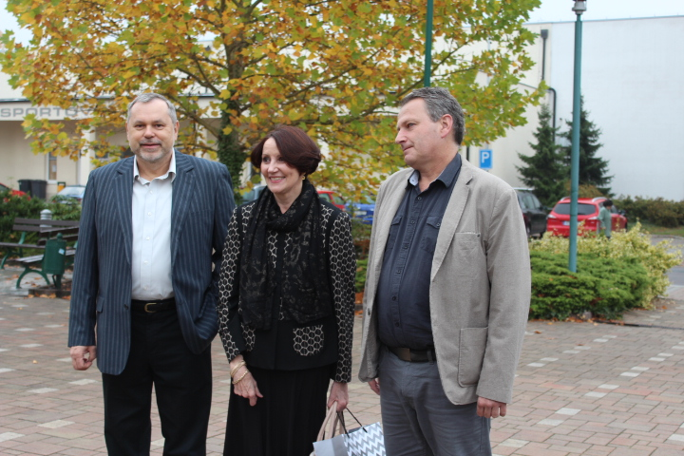

*Mr Zdeněk Kasík, intepreter, Ambassador Verwey and Mr Petr Kačer, Director of Holice Cultural House*

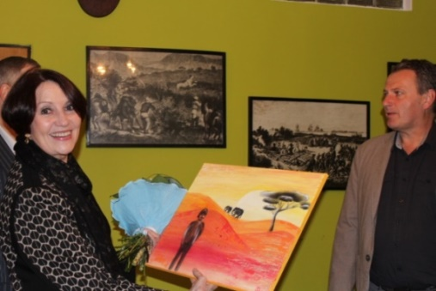

*Director of the Cultural House, Mr Petr Kačer giving the Ambassador Verwey a picture of Dr Emil Holub painted by students from Holice Art School*

The Ambassador met representatives of the town, including Mayor of Holice Mgr Ladislav Effenberk, Deputy Mayor Petr Bajer and acting Secretary Ing Vladislav Brand. She gave presentation on South Africa at the Emil Holub High School where the students welcomed her with music in African style.

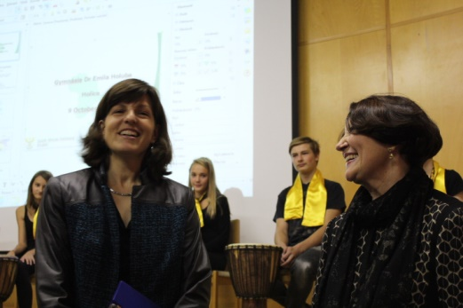

*Mgr Andrea Daňková, Director of the Emil Holub High School and Ambassador Verwey*

*Mayor of Holice*

*Mgr Ladislav Effenberk & Ambassador Verwey during the lunch in the Holub lounge of the Cultural House.*

*On the wall - picture of Dr Emil Holub.*

In the afternoon, the Ambassador visited Emil Holub Africa Museum and the Karel Malich Art School where she was enchanted by the performance of a young wind- instrument trio.

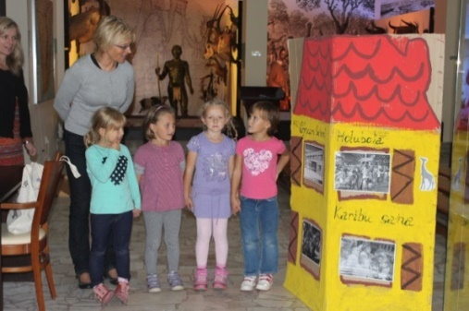

*Children from Emil Holub nursery greet the Ambassador in the Africa Museum*

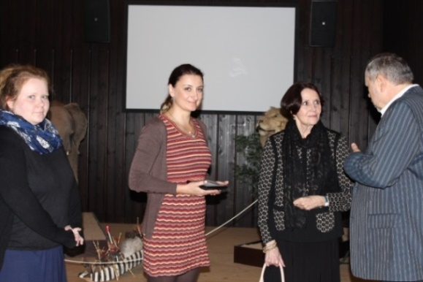

*Ms Barbora Vohralíková, Ms Marcela Jeřábková, Head of the Africa Centre in Holice and Ambassador Verwey in the Africa Museum*

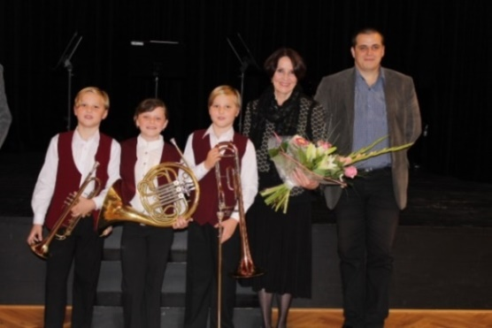

*Wind-Instrument Trio at the Karel Malich Art School after their performance, Ambassador Verwey and Director of the school, Mgr Art František Machač*

The programme in Holice was very interesting and the Ambassador particularly appreciated the warm hospitality of the town.

***Zululand Gospel Choir concert***

[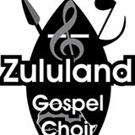](https://www.facebook.com/133752216643466/photos/a.153909701294384.32693.133752216643466/219550724730281/?type=3&source=11)The Ambassador hosted a concert of the Zululand Gospel Choir and Czech singer Lucie Kostelecká at the Royal Club in Prague on 1 October 2015. Several Ambassadors and other guests accepted the invitation and enjoyed a wonderful evening of music, dance and joy.

***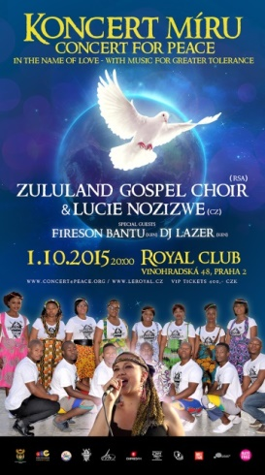* 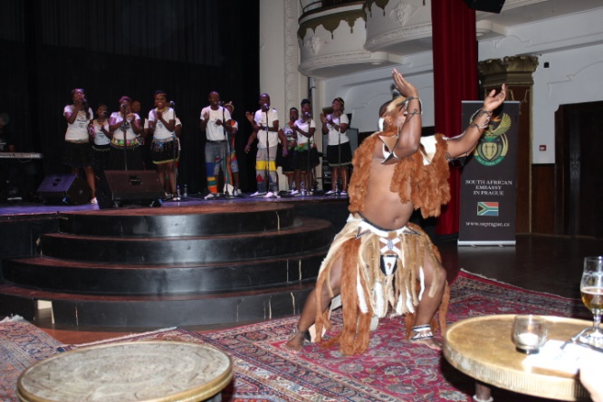**

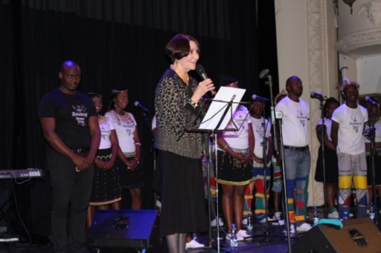

*Ambassador Verwey introducing the Zululand Gospel Choir*

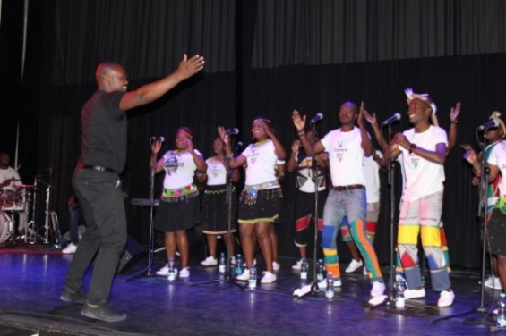

*Zululand Gospel Choir, Royal Club,*

*Prague, 1 October 2015*

***Viva Africa Conference***

On 22 October 2015, Mr Dasa attended the 9th International Conference on African Studies VIVA AFRICA 2015 organized by the Metropolitan University Prague in cooperation with the Department of Political Science, University of Hradec Králové and Cultura Africa Association.

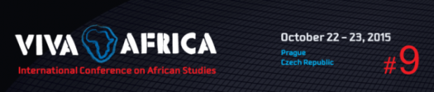

Mvuselelo Ngcoya and Narendran Kumarakulasingam from KwaZulu Natal University gave an address on *Imifino and the limits of indigenous governance in Post-Apartheid South Africa at the conference.*

***Diplomatic functions***

In the month of October, the Ambassador attended receptions hosted by the Ambassadors of South Korea; Austria; and Turkey; a dinner hosted by Ambassador of Saudi Arabia in honour of outgoing Ambassador of Peru and a concert with Pietari Inkinen and Jose Cure hosted by Ambassador of Finland.

New Ambassador of Egypt paid a courtesy call on 6 October 2015.

The Ambassador hosted a dinner in honour of the South African Military Ombud, retired Lieutenant General T. T. Matanzima.

[](http://www.milombud.org/) 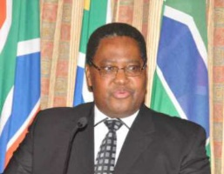

*Lt Gen (Ret) TT Matanzima*

Lt General Matanzima led the South African delegation to the 7th International Conference of Ombud Institutions for the Armed Forces (ICOAF) in Prague from October 25-27.

**SOUTH AFRICAN NEWS**

***State Councillor of China visited the RSA***

On 9 October 2015, International Relations and Cooperation Minister Ms Maite Nkoana- Mashabane hosted Mr Yang Jiechi, State Councillor of the People’s Republic of China for bilateral consultations.

[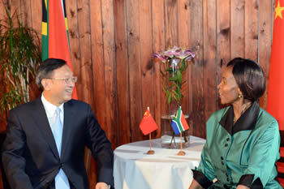](http://www.dfa.gov.za/images/gallery7/mashabane_china_yang-jiechi3.jpg)

*Minister Maite Nkoana-Mashabane and the State Councillor of the PRC, Mr Yang Jiechi, Johannesburg, South Africa, 9 October 2015. Picture: Jacoline Schoonees*

***RSA –DRC Bi-National Commission***

International Relations and Cooperation Minister Ms Maite Nkoana Mashabane and her Congolese counterpart Raymond Tshibanda N'Tungamulongo co-chaired the 9th Ministerial Session of the Bi-National Commission (BNC) on 15 October 2015.

President Jacob Zuma and Congolese President Joseph Kabila Kabange co-chaired the Bi-National Commission at Head of State level on 16 October 2015.

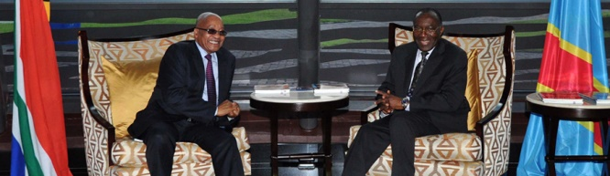

*President Jacob Zuma in DRC for the 9th Bi-National Commission between South Africa and Democratic Republic of Congo, Picture: The Presidency*

***Working Visit to Sweden, Cuba and Mexico***

Deputy President Cyril Ramaphosa paid a working visit to Sweden from 18-20 October 2015; to Cuba from 21-25 October; and to Mexico from 26-28 October 2015 to strengthen bilateral political, economic and trade relations between South Africa and the mentioned countries.

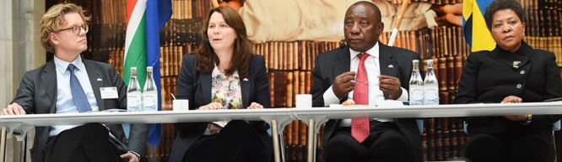

*Deputy President Cyril Ramaphosa and Swedish Deputy Prime Minister Asa Romson co-chair the official opening of the SA-Sweden Bi-National Commission*

***Africa-United Kingdom Bilateral Forum***

The Minister of International Relations and Cooperation Ms Maite Nkoana- Mashabane co-chaired the 11th session of the South Africa-United Kingdom Bilateral Forum with the British Secretary of State for Foreign and Commonwealth Affairs, the Rt Hon Phillip Hammond in London on 19 October 2015.

[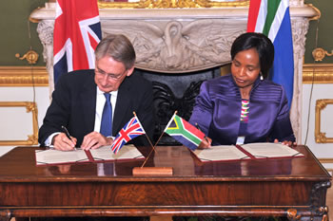](http://www.dfa.gov.za/images/gallery7/mashabane_uk_hammond2.jpg)

*Minister Maite Nkoana-Mashabane and the UK Secretary of State, Rt Hon Phillip Hammond, sign the Joint Communiqué of the 11th South Africa – United Kingdom Bilateral Forum, London, 19 October 2015. Picture: Unati Ngamntwini*

***Visit of Mozambique President***

President Filipe Nyusi of Mozambique paid his first State Visit to South Africa from 21-22 October 2015. The South Africa-Mozambique Bi-National Commission was launched during the visit.

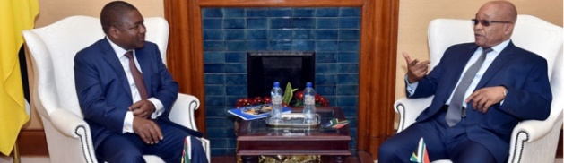

*President Zuma hosts Mozambique President Filipe Nyusi, Union Buildings. Picture: The Presidency*

***India-Africa Forum***

The 3rd India-Africa Forum Summit (IAFS-III) took place in New Delhi on 27

October 2015 under the theme *Partners in Progress: Towards a dynamic and transformative development agenda.*

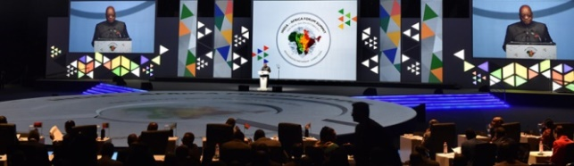

*President Jacob Zuma addressing the India-Africa Forum Summit. Picture: The Presidency*

***Media Freedom Day***

On 19 October 2015, President Jacob Zuma gave an address on the occasion of Media Freedom Day to commemorate *Black Wednesday*, 19 October 1977, when the apartheid regime clamped down on the media, banning newspapers and jailing journalists.

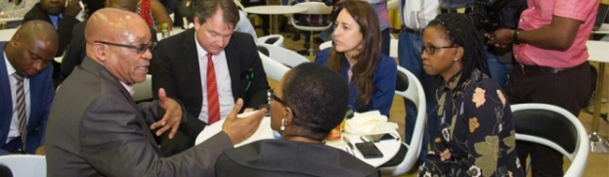

*President Zuma hosts editors and journalists to commemorate Media Freedom Day. Picture: The Presidency*

***Diplomatic Fun Fair***

[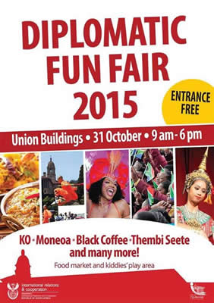](http://www.dfa.gov.za/docs/2015/poster-dipfair_2015.pdf)[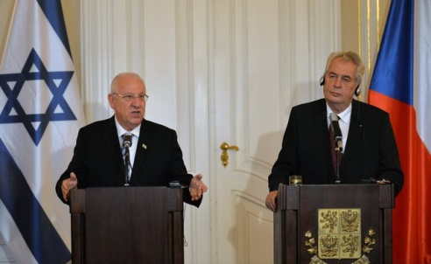](http://www.ceskenoviny.cz/news/index_img.php?id=354887)DIRCO in partnership with the City of Tshwane hosted the Annual Diplomatic Fair on 31 October 2015 at the Union Buildings in Pretoria. Foreign diplomatic missions accredited to South Africa showcased and promoted cultural diplomacy through arts, music, cuisine etc.

***Students protested against higher fees***

Nation-wide student protests against the plan to increase tuition fees took place in South Africa in the second half of October 2015, leading to the closure of most universities for several days. After the announcement of 0% fee increase at all South African universities in 2016, calm gradually returned to the campuses.

***Rugby World Cup***

20 teams competed in the 2015 Rugby World Cup which was held in the United Kingdom from 18 September to 31 October 2015. New Zealand beat Australia 34-17 in the final and became the first team to retain the World Cup. The South African Springboks finished third after winning the play-off against Argentina 24-13 on 30 October 2015.

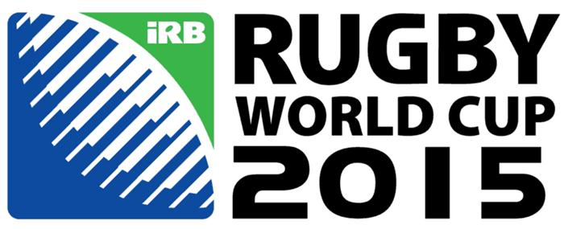 [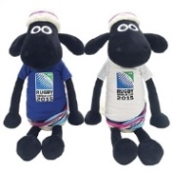](http://johnlewis.scene7.com/is/image/JohnLewis/234452529alt1?$prod_exlrg$)

*2015 Rugby World Cup logo and Shaun the Sheep -* *Mascot of 2015 Rugby World Cup*

**CZECH NEWS**

***Visit of Israeli* *President***

Israeli President Reuven Rivlin visited the Czech Republic from 20-21 October 2015 to meet President Miloš Zeman and discuss cooperation in the fields of the economy, culture and tourism. He also paid homage to WWII victims at Terezin.

*President Miloš Zeman and Israeli President Reuven Rivlin during a press conference,* *Prague Castle, 21 October 2015 ČTK Doležal Michal*

**Visit to Jordan**

Prime Minister Bohuslav Sobotka paid a two-day visit to Jordan from 24-25 October 2015. He visited the Zaatari refugee camp in Jordan and offered 100 million crowns to Jordanian King Abdullah II to assist the country with the ongoing migrant crisis. It was his first visit to the Arab world.

[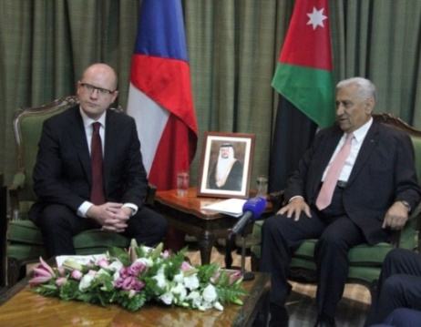](http://www.ceskenoviny.cz/zpravy/index_img.php?id=355360)

*Czech Prime Minister Bohuslav Sobotka and Jordan Prime Minister Abdallah Ansur, CTK Weiser Martin*

***National Day celebrations***

The Czech Republic marked the 97th anniversary of the foundation of Czechoslovakia with several events across the country on 28 October 2015.

In Prague, President Miloš Zeman and other top politicians laid wreaths at the National Monument at Prague Vítkov Hill.

In the evening, the President bestowed state decorations on 35 personalities, some of them in memoriam.

[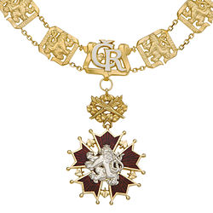](https://commons.wikimedia.org/wiki/File:%C5%98%C3%A1d_B%C3%ADl%C3%A9ho_lva_%C5%99et%C4%9Bz.jpg) [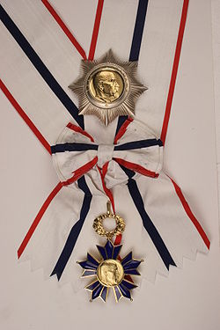](https://commons.wikimedia.org/wiki/File:%C5%98%C3%A1d_masaryka.jpg) [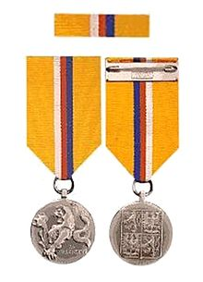](https://commons.wikimedia.org/wiki/File:Tapferkeitsmedaille_der_Tschechischen_Republik.jpg) [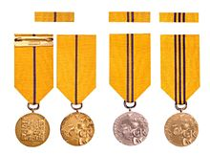](https://commons.wikimedia.org/wiki/File:Verdienstmedaille_der_Tschechischen_Republik.jpg)

*Order of White Lion, Order of Tomáš Garrique Masaryk, Medal of Heroism and Medal of Merit*

The highest state decoration, the Order of White Lion, was given to the late wartime fighter pilot Josef František, who served in the British Royal Air Force during WWII. The Order of Tomáš Garrique Masaryk was given to František Kriegl, the only Prague Spring leader who refused to sign the Moscow Protocol in 1968 and Medal of Heroism to Petr Vejvoda, a 16-year-old student who died when defending his classmate from an aggressive deranged woman last year. Thirty-two people received Medals of Merit.

***Czech Press Photo***

Jan Zátorský won both the main prize, the Crystal Eye award for Photograph of the Year and best picture in the Sporst News category in this year’s Czech Press Photo competition for his picture featuring migrants at the Hungarian-Serbian border.

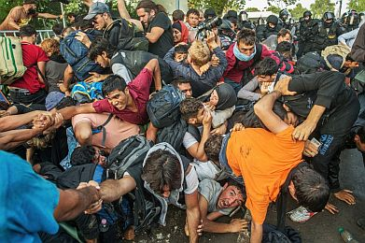

***Prague Light Festival***

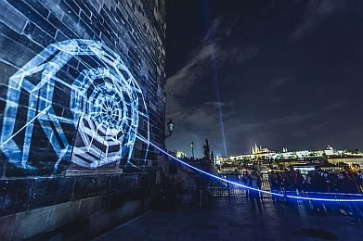The third Light Festival, which was held in Prague from 15-18 October 2015, offered more than 20 installations including video-mappings, light projections, interactive installations and workshops.

[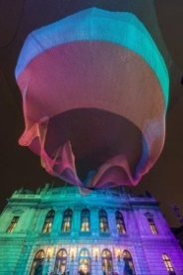](https://www.facebook.com/SignalFestival/photos/a.852077338203629.1073741847.348266351918066/852491508162212/?type=3)

**Czech Romany policeman receives order**

Czech Romany policeman Petr Torák who has lived in the United Kingdom since 1999, was decorated with the Order of the British Empire by Queen Elizabeth II for his services to the local Romany community in Peterborough, north of London and his skills in dealing with migrants.

[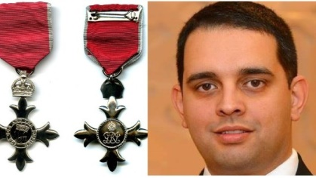](http://img.cz.prg.cmestatic.com/media/images/600x338/Oct2015/1801517.jpg?d41d)

*Order of the British Empire & Petr Torák*

|  |
| --- |
| For more information about the activities of the South African Embassy in Prague please visit our website: http://[www.saprague.cz](http://www.saprague.cz) |