|  |
| --- |
| [Click on the specific symbol to view its symbolism  [coatofarms.gif 22315 bytes)](http://www.gov.za/_vti_bin/shtml.dll/symbols/coatofarms.htm/map) |
|  |

**EMBASSY OF SOUTH AFRICA  
RUSKA 65, 100 00 PRAGUE 10**

**NEWSLETTER - SEPTEMBER 2015 (No. 9)**

[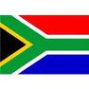](http://www.google.co.za/imgres?imgurl=http://sasportswear.co.za/images/sportswear/south_african_storm_flag.jpg&imgrefurl=http://sasportswear.co.za/sa-memorabilia-7/sports-flags-21/south-african-flag-storm-72.html&h=591&w=591&sz=35&tbnid=Uv7cCdEcYE0-pM:&tbnh=135&tbnw=135&prev=/images?q=South+African+flag&hl=en&usg=__g8gihHXhaZlPhuEToAfXga4s4Hw=&sa=X&ei=IslOTK-nNo-R4Qay7dWoCA&ved=0CAgQ9QEwAQ)



**WORD BY THE AMBASSADOR**

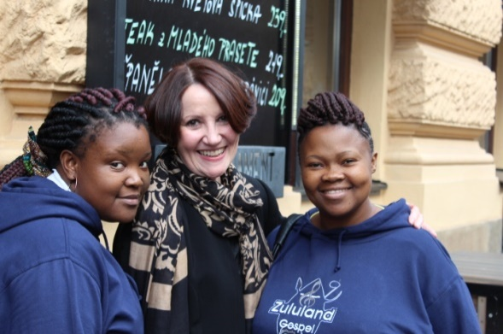

With the start of September, Prague shifted gear. Gone were the hot, relaxed days of summer. At the Embassy, we worked with singer and concert promoter Lucia Kostelecká on arrangements for a concert at the beginning of October with the Zululand Gospel Choir. We had an opportunity to have lunch with them after their arrival in Prague and were all quite enchanted by their youthful enthusiasm and radiant smiles.

During September, former President de Klerk was in Prague to participate as a speaker at the annual Forum 2000 conference. Much to my disappointed, I was unable to hear him speak as I had to be in Brno on that date, but I was honoured to meet him briefly.

There was a degree of excitement in Prague when the Blanka Tunnel finally opened after many years of construction and much delay. Everyone is waiting to see if it will ease the perennial traffic congestion in the city.

**EMBASSY NEWS**

***Forum 2000***

[](https://www.forum2000.cz/)The annual conference of Forum 2000 was held in Prague and other Central European cities from 13-16 September 2015 under the topics *Democracy & Education.*



Nobel Peace Prize Laureate and former South African President Frederik Willem de Klerk was among the most important speakers at the conference.

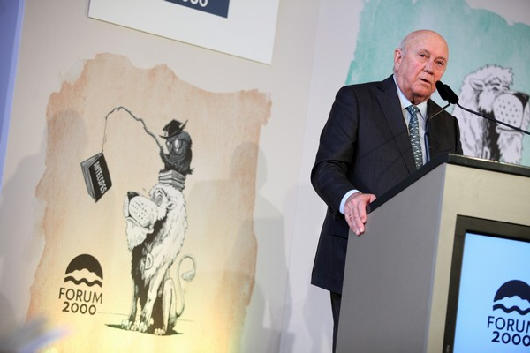

*Frederik de Klerk delivering an address at Forum 2000 Conference, Prague, September 2015.*

*Picture: Forum 2000*

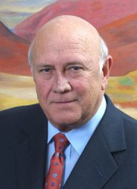

*Forum 2000 has become a very good place for meeting where it is possible to reach consensus.*

*Frederik Willem de Klerk*

***Brno Trade Fair***

[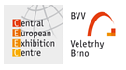](http://www.bvv.cz/)The Ambassador, Mr Dasa and Ms Hlávková visited the annual Brno Trade Fair on 15 September 2015 to participate in a conference which was organized during the Fair with the topic *Africa – new Markets and Opportunities for Czech Exporters* and to meet Embassy business contacts.

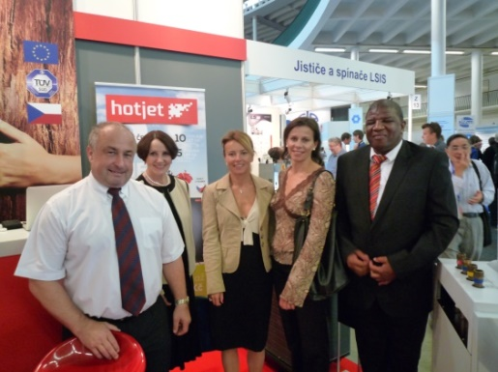

*Mr Milan Hintz, Ambassador Verwey, Ms Ivana Častvajová-Bednářová and Jitka Palátová from the Czech – African Business Council and Mr Dasa in front of the stand of hot pumps producer Hotjet*

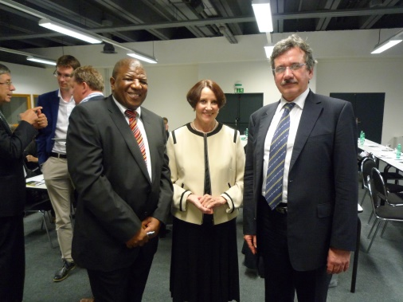

*Mr Dasa, Ambassador Verwey and Mr Vladimír Jeništa, Representative of Czech Trade in Johannesburg at the conference “Africa – New Markets and Opportunities for Czech Exporters“*

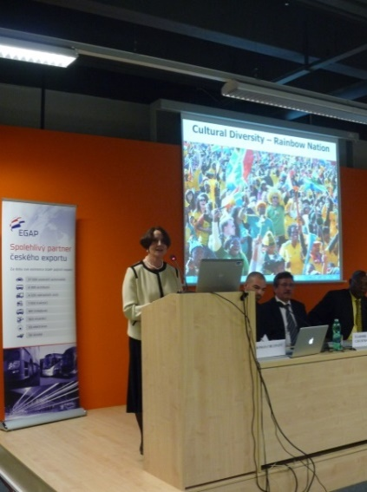

*The Ambassador addressing the conference Africa – new Markets and Opportunities for Czech Exporters*

***Lunch with Zululand Gospel Choir***

On 29 September 2015, the Ambassador hosted a lunch for the Zululand Gospel Choir. The choir came to the Czech Republic at the invitation of the Czech singer Lucie Kostelecká to perform in Prague and other Czech towns. The concerts *In the name of love – Music Against Violence* will be held in October.

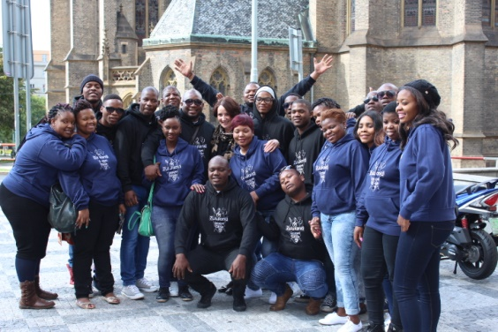

*Ambassador Verwey and Mr Dasa with the members of the Zululand Gospel Choir*

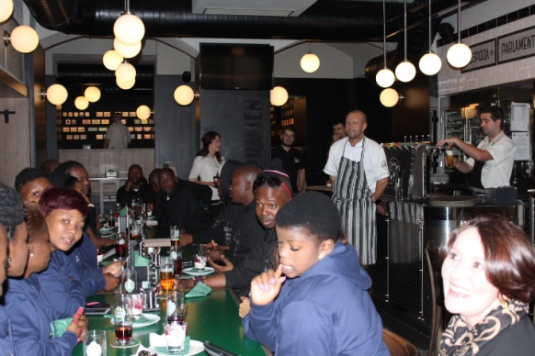

*Ambassador Verwey and Zululand Gospel Choir in Vinohradský Parlament rest., 24 September 2015*

***Diplomatic functions***

In the month of September the Ambassador attended several receptions, namely National Day of Slovakia, Mexico, Armenia, China, Saudi Arabia and Pakistan; a farewell dinner for Ambassador of Peru; a good bye meeting for outgoing Nigerian Ambassador; a lunch hosted by the Ambassador of Pakistan and a dinner hosted by the Swedish Ambassador; a concert of Armenian Folks Ballet Navasart and a concert of Lithuanian Chamber Music hosted by Ambassador of Armenia and Lithuania respectively.

The Ambassador hosted a dinner for Ambassador Designate Michal Král who will leave for the RSA at the end of the month.

**STAFF NEWS/SA CITIZENS**

***Ms Mahmoud gave birth to a boy***

Ms Hana Mahmoud, member of the Embassy staff, gave birth to a boy on 6 September 2015. Adam Mahmoud weighed 3,58 kg and measured 52 cm.

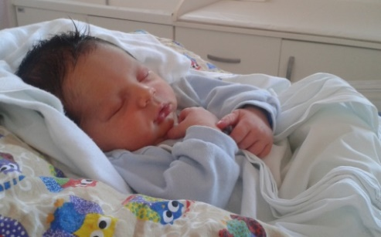

*Welcome to the world and congratulations to the parents!*

**SOUTH AFRICAN NEWS**

***IORA Conference in Beijing***

The Deputy Minister of International Relations and Cooperation, Ms Nomaindiya Mfeketo led the South African delegation at the Indian Ocean Rim Association (IORA) Blue Economy Conference in Mauritius from 2-3 September 2015. South Africa is one of IORA’s members to start the Blue Economy initiative.

[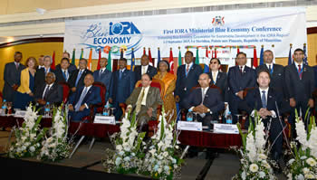](http://www.dfa.gov.za/images/gallery7/mfeketo_mauritius_iora7.jpg)

*Group photo of the IORA Ministerial Blue Economy Conference, Port Louis, Mauritius, 2-3 September 2015. Picture: Jacoline Schoonees*

***President Zuma in Beijing***

[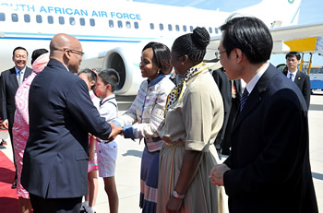](http://www.dfa.gov.za/images/gallery7/zuma_china_ww2_3.jpg)

*President Jacob Zuma greeting Minister of International Relations and Cooperation Ms Maite Nkoana-Mashabane on arrival in Beijing, PRC, 2 September 2015. Picture: Unati Ngamtwini*

President Jacob Zuma attended the 70th Anniversary of the End of the Occupation of China and the Second World War, Beijing, China from 2 - 4 September 2015.

***China-Africa Think Tanks Forum***

The Department of International Relations and Cooperation co-hosted the 4th meeting of the China-Africa Think Tanks Forum (CATTF IV) in Pretoria from 9-10 September 2015.

[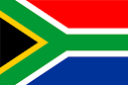](http://www.google.cz/url?url=http://www.crwflags.com/fotw/flags/za.html&rct=j&frm=1&q=&esrc=s&sa=U&ved=0CCgQwW4wBmoVChMImte8246ryAIVCOkUCh0GXgpA&usg=AFQjCNGnLZid3MGULJ3FSR-6D7ARzt6QoQ) [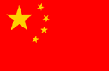](http://www.google.cz/url?url=http://www.enchantedlearning.com/asia/china/flag.shtml&rct=j&frm=1&q=&esrc=s&sa=U&ved=0CBoQwW4wAmoVChMIpLaa0I6ryAIVxFIUCh1t5Q8-&usg=AFQjCNH5-yeEwxRnwbMk48WpuJ-Qw3Oshg)

Its purpose was to create a platform for dialogue and exchanges between Chinese and African think-tanks and encourage exchanges among the academia of China and Africa. More than a hundred Chinese and African scholars and government representatives participated in the Forum which had the theme *Africa’s Agenda 2063.*

***Ministerial meeting in Pretoria***

The 3rd Session of the Ministerial Meeting of the Tripartite Mechanism on Dialogue and Cooperation between the Republic of South Africa; the Republic of Angola; and the Democratic Republic of Congo was held in Pretoria on 12 September 2015.

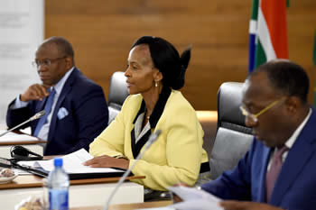

*Minister Ms Maite Nkoana-Mashabane with her counterparts Mr Raymond Tshibanda from the DRC (right) and Mr Georges Rebelo Chicoti from Angola (left), Pretoria,12 September 2015. Picture: Jacoline Schoonees*

***United Nations General Assembly***

A South African delegation attended the historic 70th session of the United Nations General Assembly held in New York under the theme *The United Nations at 70: the Road ahead for Peace, Security and Human Rights”*on 27 September 2015.

The Assembly also commemorated the 70th anniversary of the end of World War II and the establishment of the UN.

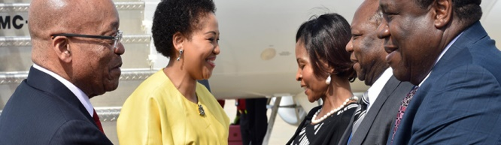

*President Zuma arrives in New York to attend the 70th Session of the United Nations General Assembly*

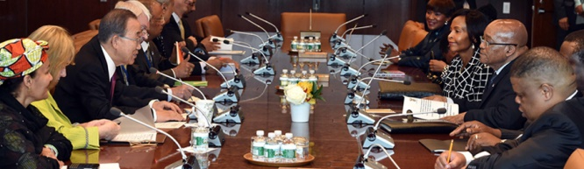

*President Jacob Zuma holds Bilateral talks with UN Secretary General Ban Ki-moon*

*Pictures: The Presidency*

***Visit to Jamaica***

Minister of International Relations and Cooperation Ms Maite Nkoana-Mashabane paid a working visit to Jamaica from 20-22 September 2015. A Memorandum of Understanding on the Establishment of Political Consultations was signed during the visit.

[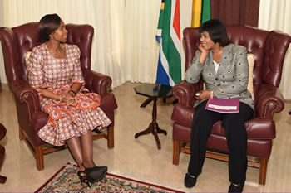](http://www.dfa.gov.za/images/gallery7/mashabane_jamaica_miller1.jpg)

*Minister of International Relations and Cooperation Ms Maite Nkoana-Mashabane pays a courtesy call on the Prime Minister of Jamaica, Ms Portia Simpson Miller, Kingston, Jamaica, 20-22 September 2015 2015. Picture: Uunati Ngamntwini*

On 20 September 2015 the Minister addressed the International Women’s Forum held under the theme *Phenomenal Women*.

***Heritage month***

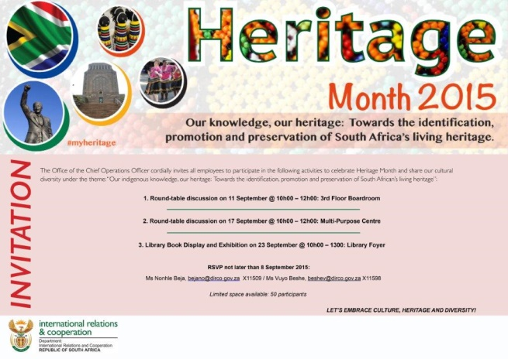

As every year, Heritage month was celebrated in South Africa from 1 to 30 September 2015. This year the theme was *Our indigenous knowledge, our heritage: Towards the identification, promotion and preservation of South Africa’s living heritage.* Key activities included the launch of the National Book week in Johannesburg and the unveiling of the sculpture of Chief Bhambatha in KwaZulu-Natal.

**CZECH NEWS**

***Visegrad Group Extraordinary Summit***

Prime Ministers of the Visegrad Group met in Prague on 4 September 2015 for an Extraordinary Visegrad Group Summit on migration. Czech PM Bohuslav Sobotka and his counterpart Robert Fico (Slovakia), Ewa Kopacz (Poland) and Viktor Orbán (Hungary) discussed a joint course of action of the V4 countries in dealing with the current migration crisis in Europe.

[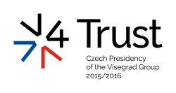](http://www.visegradgroup.eu/documents/presidency-programs/presidency-programs)

[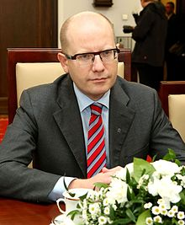](https://en.wikipedia.org/wiki/File:Bohuslav_Sobotka_Senate_of_Poland_01.JPG) [](https://en.wikipedia.org/wiki/File:Robert_Fico_official_gov_portrait.jpeg) [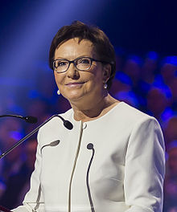](https://en.wikipedia.org/wiki/File:Ewa_Kopacz_-_Warszawa_Konwencja_PO_(cropped).jpg) [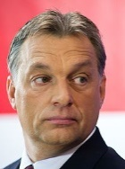](https://en.wikipedia.org/wiki/File:OrbanViktor_2011-01-07.jpg)

*V4 Prime Ministers: Bohuslav Sobotka , Robert Fico, Ewa Kopacz and Viktor Orbán*

***President Zeman visited China***

President Miloš Zeman visited China from 3-4 September 2015 to take part in events commemorating the 70th anniversary of the end of World War II in Asia, including the military parade. Important Czech-Chinese agreements were signed during the visit.

[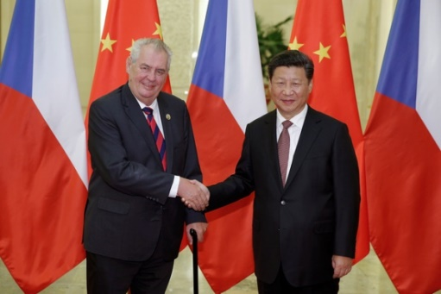](http://www.ceskenoviny.cz/zpravy/index_img.php?id=349850)

*President Zeman and Chinese president Xi Jinping*

*in Beijing, 4 Sept 2015. Picture: Xinhua/Yao Dawei*

***US convoy crossed the Czech Republic***

[](http://www.nato.int/cps/en/natohq/index.htm)The US military convoy crossed the Czech Republic on 9 September 2015 on its way from the Vilseck base, Germany, to NATO’s Brave Warrior 2015 exercise in Hungary. NATO Secretary General Jens Stoltenberg met representatives of the US military convoy. He also met top Czech representatives to discuss NATO’s adaptation to changing security conditions.

***Visit to USA***

Prime Minister Bohuslav Sobotka and Minister of Foreign Affairs Lubomír Zaorálek paid a two-day working visit to the USA from 29 - 30 September 2015 to attend the summit in New York dedicated to the fight against the Islamic State and violent extremisms.

[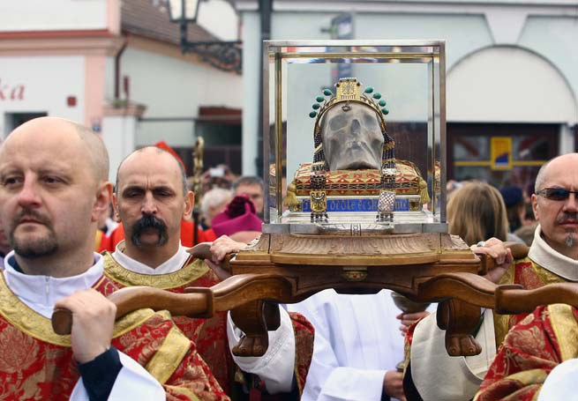](http://ivarfjeld.files.wordpress.com/2013/01/skull1.jpg)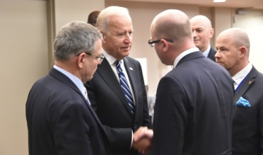

*Picture: Prime Minister Bohuslav Sobotka and Minister Lubomír Zaorálek with the US Vice President Joe Biden, New York, 29 Sept 2015. Picture: The Government*

***Government approved 2016 state budget***

The Czech government approved the 2016 state budget bill with a 70-billion-crown deficit on 23 September 2015. To take effect,

the bill has to be passed by the Chamber of Deputies and signed by the President into law.

***Sir Nicholas Winton remembered in Prague***

A special stamp was issued by Czech Post in September 2015 to commemorate Sir Nicholas Winton, who saved the lives of 669, mostly Jewish children, by arranging their evacuation from Nazi-occupied Czechoslovakia before the outbreak of World War II.

[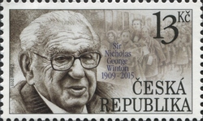](http://www.wnsstamps.post/stamps/2015/CZ/CZ030.15.jpg)

Sir Nicholas died on July 1 this year at the age of 106.

***Saint Wenceslas Pilgrimage***

About 5 500 people attended the National Saint Wenceslas Pilgrimage in Stará Boleslav, Central Bohemia to commemorate the patron saint of the Czech Lands. The traditional pilgrimage Mass was served by Prague Archbishop Cardinal Dominik Duka.

*Skull of*

*Saint Wenceslas*

Wenceslas, a prince from the ruling Premyslid dynasty was murdered by his brother Boleslav in Stará Boleslav 1080 years ago.

|  |
| --- |
| For more information about the activities of the South African Embassy in Prague please visit our website: http://[www.saprague.cz](http://www.saprague.cz) |