|  |
| --- |
| [Click on the specific symbol to view its symbolism  [coatofarms.gif 22315 bytes)](http://www.gov.za/_vti_bin/shtml.dll/symbols/coatofarms.htm/map) |
|  |

**EMBASSY OF SOUTH AFRICA  
RUSKA 65, 100 00 PRAGUE 10**

**NEWSLETTER - MARCH 2016 (No.3)**

[](http://www.google.co.za/imgres?imgurl=http://sasportswear.co.za/images/sportswear/south_african_storm_flag.jpg&imgrefurl=http://sasportswear.co.za/sa-memorabilia-7/sports-flags-21/south-african-flag-storm-72.html&h=591&w=591&sz=35&tbnid=Uv7cCdEcYE0-pM:&tbnh=135&tbnw=135&prev=/images?q=South+African+flag&hl=en&usg=__g8gihHXhaZlPhuEToAfXga4s4Hw=&sa=X&ei=IslOTK-nNo-R4Qay7dWoCA&ved=0CAgQ9QEwAQ)



**WORD BY THE AMBASSADOR**

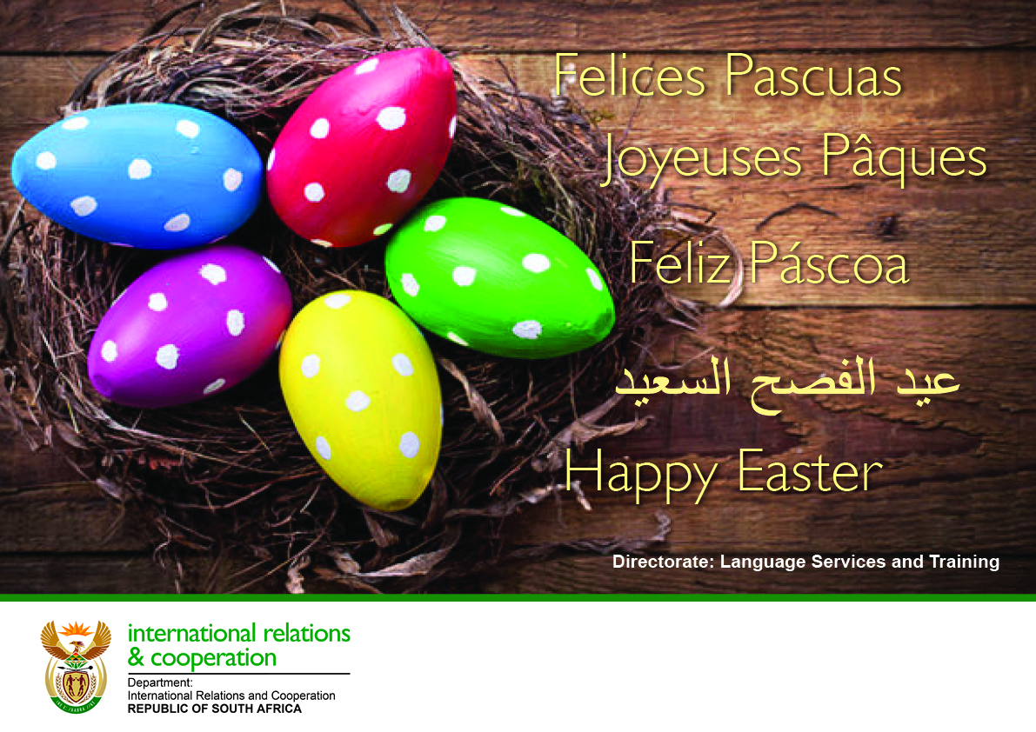

As always, March was a busy month with preparations for the financial year book closure and a number of Embassy events. It was a busy time in nature as the spring burst forth in all its glory in the mild weather, covering trees in blossom and transforming gardens and parks into carpets of daffodils, hyacinths and other spring flowers.

Sadly, in this month when we celebrate the rebirth of nature after the winter months, we were also again served a cruel reminder of the frailty of life when the latest terrorist attacks in Brussels and in Lahore destroyed so many lives in senseless violence. Our deepest sympathy goes to the families and friends of the victims.

I had the precious opportunity this month of a guided tour of the magnificent Strahov Library with its treasure of centuries’ old books. It vividly illustrates the importance not only knowledge and learning but also how vital it is to preserve such knowledge and learning for the future and all generations to come.

**EMBASSY NEWS**

***Francophone lunch***

The Ambassador attended a Francophone lunch hosted by the Ambassador of France on 29 March 2016. Czech Minister of Defence Mr Martin Stropnický was the guest of honour.

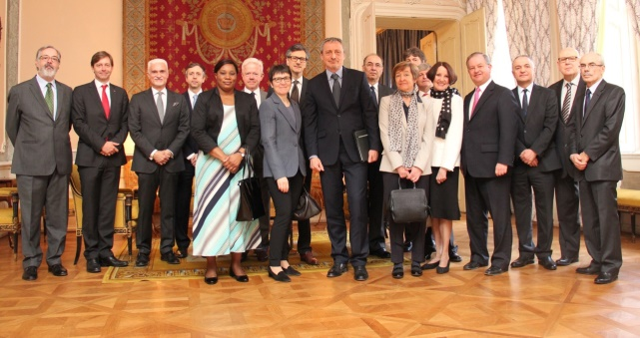

*Minister Stropnický with the participants of the Francophone lunch. Picture: French Embassy*

***Prague Student Summit***

Four students from Litvínov grammar school representing South Africa during the Prague Student Summit visited the Embassy on 31 March 2016 to discuss South African foreign policy with the Ambassador and Mr Dasa. The Summit, which will be held in Prague from 1-4 April 2016, simulates the activities of international organizations (UN, EU, NATO, Visegrad Group).

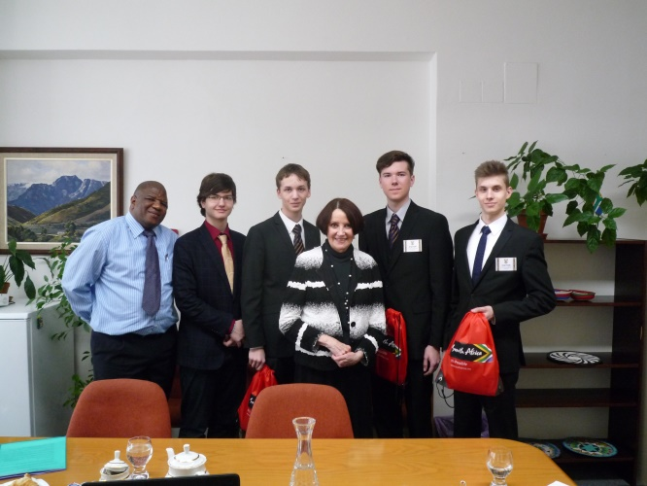

***Spotlight on Africa*** ***& Indian Ocean Islands******Travel Workshop***

Mr Dasa and Ms Hlávková attended the *Spotlight on Africa* *& Indian Ocean Islands Travel Workshop* on 15 March 2016.

The workshop was organized by Houston Travel Marketing Services in co-operation with Mr Paddington Tucker of Travel Advance to enable the African travel agencies, tour operators, airlines and safari lodges to enter into and deepen contacts with prospective Czech buyers.

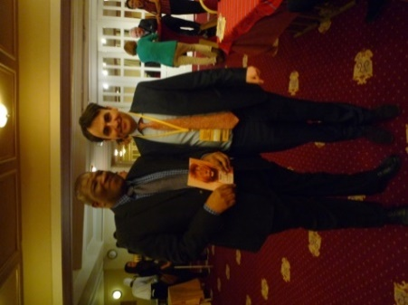***aa*** 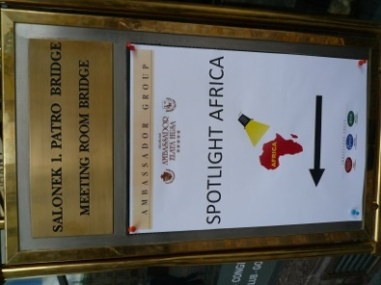

*Mr Dasa and Mr Tucker; Spotlight Africa Travel Workshop, Prague, 15 March 2016*

***Auditors***

A team from the South African Auditor-General’s Office visited the Embassy from 7-11 March 2016 to conduct a routine audit. The Ambassador hosted an informal lunch for them at the Official Residence on 9 March 2016.

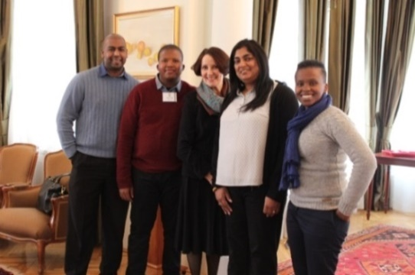

*Ambassador Verwey with the auditors*

***Diplomatic Functions***

The Ambassador attended several receptions, including the National Days of Bulgaria, Ireland and Pakistan; a celebration of the International Women’s Day hosted by the Embassy of France; a dinner hosted by the Ambassador of Bulgaria; an informal get-together of female Ambassadors; and a diplomatic lunch hosted by the Ambassador of Luxembourg.

The Ambassador hosted a wine tasting at the Cape Point Wine Bar to introduce South African wines and a diplomatic dinner at the Official Residence.

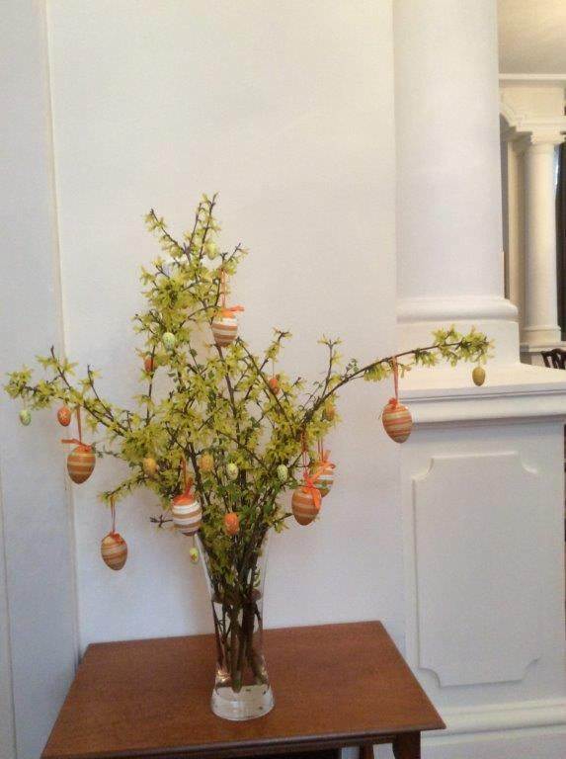

*Easter decoration for the Official Residence made by Ms Mirka Rubešová*

***Embassy’s New Car***

There was great excitement at the Embassy when the new official vehicle arrived in mid-March to replace the old vehicle which had been giving problems for years.

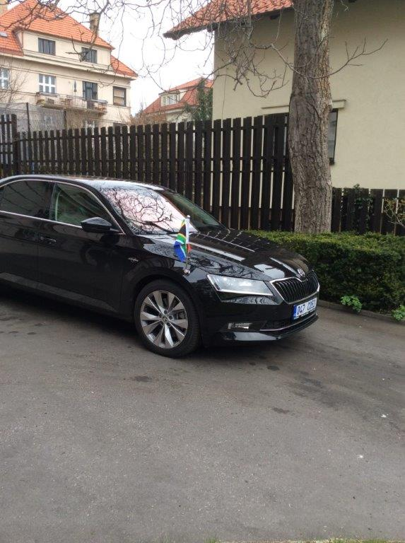

We wish theAmbassador many happy and safe journeys in the new car.

**STAFF NEWS/SA CITIZENS**

***Zuzana Andrštová retired on pension***

Another colleague left the Embassy team. On 4 March 2016, the Embassy said farewell to Ms Zuzana Andrštová who had served as a Secretary at the Embassy for about eight years.

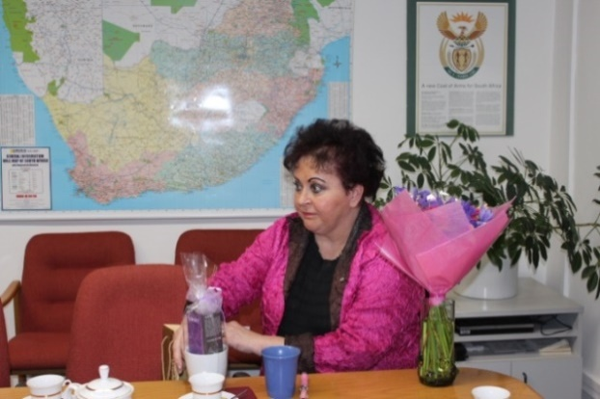

We wish Zuzana much health and happiness in the new phase of her life.

**SOUTH AFRICAN NEWS**

***RSA received Distinguished Diplomatic Service Award***

South Africa received the *Distinguished Diplomatic Service Award* from the World Affairs Council attheGlobal Education Galain Washington D.C., USA on 29 March 2016.



[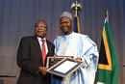](http://www.dirco.gov.za/department/gallery.htm)*The award was accepted by the South African Ambassador to the USA,*

*Mr Mninwa J Mahlangu*.

*Picture: Jolande Snyman*

Quoting Nelson Mandela, Ambassador Mahlangu said: *Education is the most powerful weapon that you can use to change the world.*

***President Zuma visited Saudi Arabia and the United Arab Emirates***

President Jacob Zuma, accompanied by several ministers and a substantial business delegation, paid a State Visit to Saudi Arabia from 26-27 March 2016, followed by a Working Visit to the United Arab Emirates on 28 March 2016.

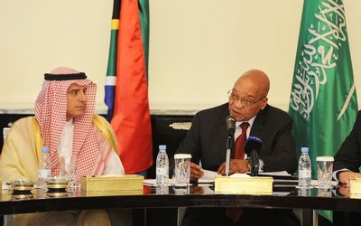

*President Jacob Zuma speaking at the South Africa-Saudi Arabian Business Seminar in Riyadh, Saudi Arabia. Picture: GCIS*

Saudi Arabia and the UAE are South Africa’s largest trading partners in the Gulf region.

***President Zuma in France***

President Jacob Zuma and French President Francois Hollande co-chaired the official launch of the United Nations High-level Commission on Health Employment and Economic Growth in Lyon on 23 March 2016.

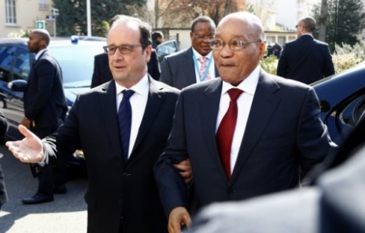

*Presidents Francois Hollande and Jacob Zuma arrive at the children’s oncology center in Lyon, 23 March 2016. Photo: EPA/Francois Mori*

***Human Rights Day***

Thousands of people gathered in Durban on 21 March 2016 to commemorate South African Human Rights Day. President Zuma delivered the country’s national message under the theme *South Africa United Against Racism*. He called on everyone to fight against racism.

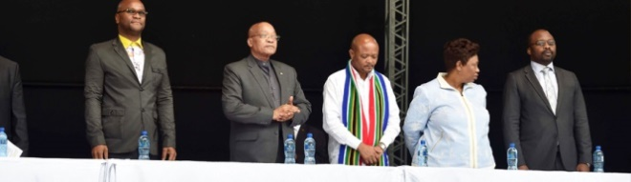

*President Zuma addresses the celebration held at Moses Mabhida Stadium, Durban. Picture: The Presidency*

***President Zuma visited Nigeria***

PresidentJacob Zuma, accompanied by members of his cabinet and a South African business delegation, paid a State Visit to Nigeria from 8-9 March 2016.

Over 120 South African companies are doing business in Nigeria in various sectors, including telecommunications, aviation, tourism, banking, property, retail, entertainment and the fast food industries.

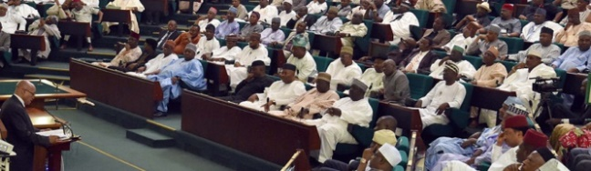

*President Zuma addressing the Joint Sitting of the National Assembly, Abuja, Nigeria. Picture: The Presidency*

***Annual Opening of National House of Traditional Leaders***

On 3 March 2016 President Jacob Zuma addressed the audience at the opening of the National House of Traditional Leaders (NTHL) at the Old Assembly in Parliament in Cape Town. He advised traditional leaders to work together in land claims.

NTHL was established in 1997 to preserve the traditional culture and values of rural communities.

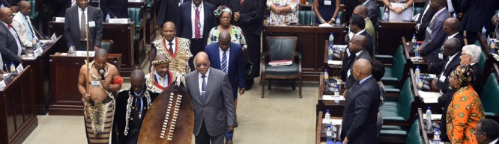

*Picture: The Presidency*

***International Women’s Day***

On 12 March 2016, the Minister of International Affairs and Cooperation Ms Maite Nkoana-Mashabane hosted an event marking International Women’s Day at the Mokomene Stadium, Ga-Ramokgopa in the Limpopo Province. The event honoured struggle stalwart, Ms Charlotte Maxeke.

[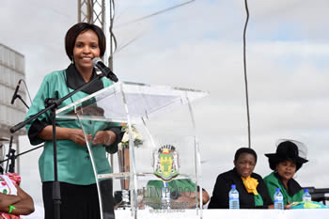](http://www.dirco.gov.za/images/gallery8/mashabane_ppp_ga-ramokgopa_limpopo8.jpg)

*Minister Maite Nkoana-Mashabane addresses the crowds during the International Women’s Day event at Mokomene Stadium, 12 March 2016. Picture: Jacoline Schoones*

***Miss South Africa***

23-year-old Ntandoyenkosi Kunene from Mpumalanga was crowned as *Miss South Africa 2016* on 19 March 2016.

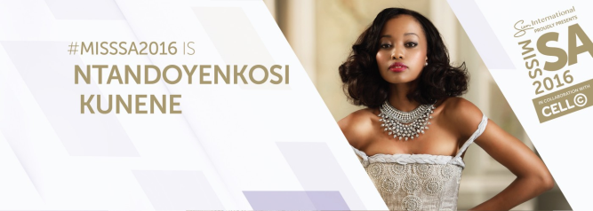

***Mrs SA crowned as Mrs World 2016***

Candice Abrahams, the reigning Schwarzkopf Professional Mrs South Africa 2016, was named *Mrs World 2016* in China on 12 March 2016. She is the first South African to be crowned as Mrs World.

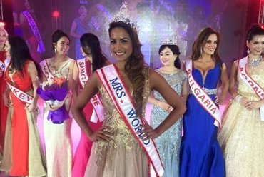[](http://mrssouthafrica.co.za/)

**CZECH NEWS**

***Visit of Chinese President***

Chinese President Xi Jinping paid a State Visit to the Czech Republic from 28-30 March 2016. It was the first visit by a Chinese President to the Czech Republic.

[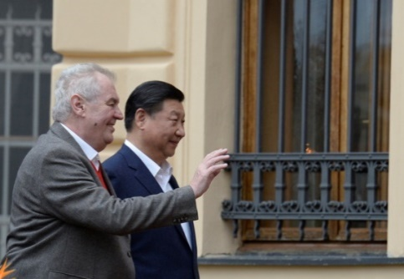](http://www.ceskenoviny.cz/news/index_img.php?id=371503)

*Presidents Xi Jinping and Miloš Zeman at*

*Lány Castle, 28 March 2016*

[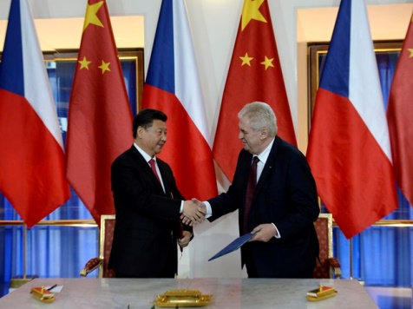](http://www.ceskenoviny.cz/news/index_img.php?id=371580)

*Presidents Xi Jinping and Miloš Zeman at Prague Castle, 29 March 2016.ČTK Krumphanzl Michal*

Czech President Milos Zeman and Chinese President Xi Jinping signed a strategic cooperation treaty between the two countries. Czech ministers and their Chinese counterparts signed memoranda of understanding in the fields of industry, transport, health care and education. Participants in the Czech-Chinese economic forum signed some 30 trade agreements in various sectors.

[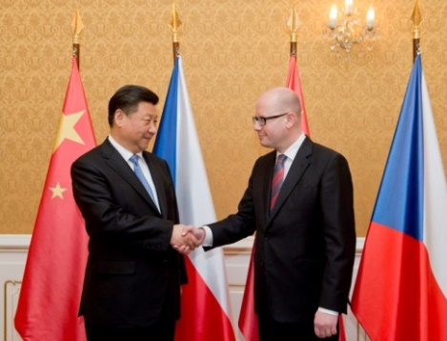](http://www.ceskenoviny.cz/news/index_img.php?id=371626)

*President Xi Jinping and Prime Minister Bohuslav Sobotka,* *Prague, 29 March 2016.ČTK Šimánek*

China will invest 95 billion crowns in the Czech Republic this year.

***Polish President visited Prague***

Polish President Andrzej Duda paid an Official Visit to the Czech Republic on 15 March 2016.

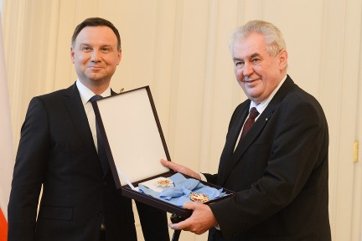

*The Presidents exchanged the highest state orders: President Duda received the Order of the White Lion and President Zeman the Order of the White Eagle. Picture: Prague Castle*

Topics discussed by the Heads of State included cooperation between the Visegrad Four, the migration crisis and the July 2016 NATO summit in Warsaw.

***Private visit of Moroccan King***

Moroccan King Mohammed VI, who was on a private visit to the Czech Republic, met President Zeman on 21 March 2016. Their discussion focused on bilateral relations as well as co-operation in the economic and cultural fields.

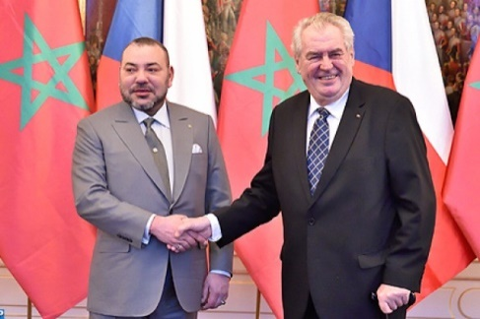

*Moroccan King Mohammed VI and President Miloš Zeman. Picture: Morocco World News*

***Minister Zaorálek met Minister******Wallström***

Minister of Foreign Affairs Lubomír Zaorálek met Minister for Foreign Affairs of the Kingdom of Sweden Margot Wallström in Prague on 15 March 2016. The discussions included migration, security issues, fight against international terrorism, regionals conflicts, Russia, Ukraine and other foreign policy issues.

[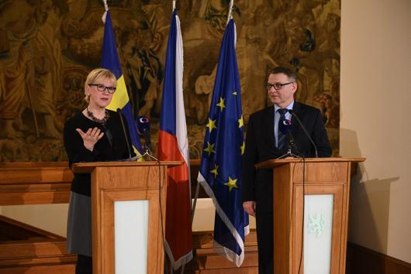](http://www.mzv.cz/jnp/cz/udalosti_a_media/tiskove_zpravy/x2016_03_15_ministr_zaoralek_prijal_ministryni.html)

*Minister Margot Wallström and Minister Lubomír Zaorálek, Prague, 15 March 2016*.*Picture: MFA*

***3rd Michelin-Starred restaurant for Prague***

The Old Town restaurant *Field*, with Chef Radek Kašpárek received a Michelin star on 9 March 2016. *Field* is the third Prague restaurant to receive the award; *Alcron* and *La Degustation Bohême* retained their stars this year.

[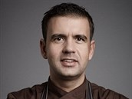](http://ekonomika.idnes.cz/michelin-kasparek-oceneni-09i-/test.aspx?c=A160310_133049_test_ozr)

*Chef*

*Radek*

*Kašpárek*

|  |
| --- |
| For more information about the activities of the South African Embassy in Prague please visit our website:  http://[www.saprague.cz](http://www.saprague.cz) |