|  |
| --- |
| [Click on the specific symbol to view its symbolism  [coatofarms.gif 22315 bytes)](http://www.gov.za/_vti_bin/shtml.dll/symbols/coatofarms.htm/map) |
|  |

**EMBASSY OF SOUTH AFRICA  
RUSKA 65, 100 00 PRAGUE 10**

**NEWSLETTER - MAY 2016 (No. 5 )**

[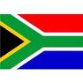](http://www.google.co.za/imgres?imgurl=http://sasportswear.co.za/images/sportswear/south_african_storm_flag.jpg&imgrefurl=http://sasportswear.co.za/sa-memorabilia-7/sports-flags-21/south-african-flag-storm-72.html&h=591&w=591&sz=35&tbnid=Uv7cCdEcYE0-pM:&tbnh=135&tbnw=135&prev=/images?q=South+African+flag&hl=en&usg=__g8gihHXhaZlPhuEToAfXga4s4Hw=&sa=X&ei=IslOTK-nNo-R4Qay7dWoCA&ved=0CAgQ9QEwAQ)



**WORD BY THE AMBASSADOR**

[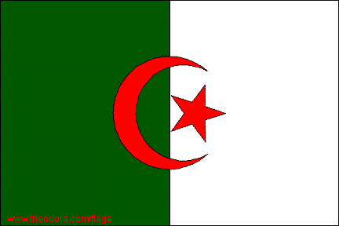](http://www.theodora.com/maps/algeria_map.html) 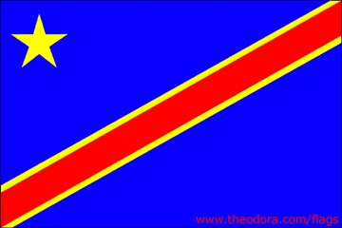 **[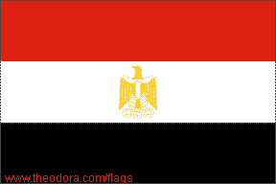](http://www.theodora.com/wfb/egypt/egypt_maps.html)** 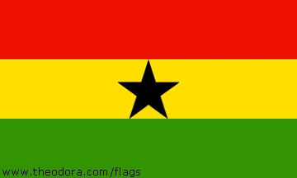 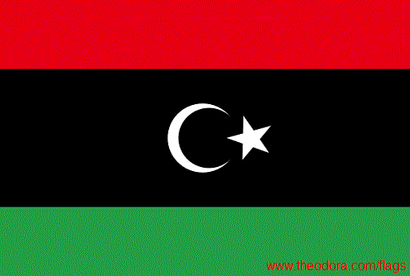

*Algeria DRCongo Egypt Ghana Libya*

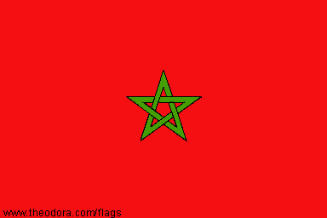 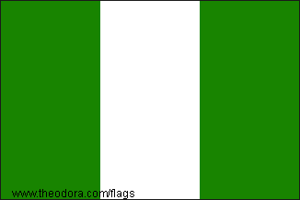 [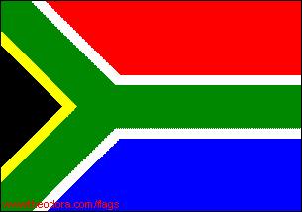](http://www.theodora.com/wfb/south_africa/south_africa_maps.html) [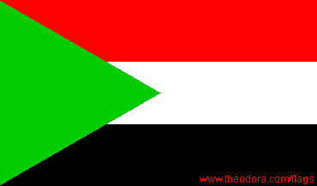](http://www.theodora.com/maps/sudan_map.html) 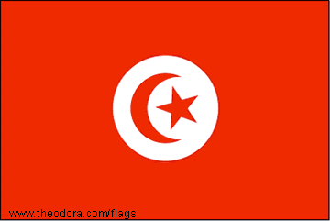

*Morocco Nigeria RSA Sudan Tunisia*

The month of May was packed with interesting events and experiences. For the Embassy, the highlight was the celebration of Africa Day with a reception in the garden of the Foreign Ministry jointly hosted by the ten resident African embassies in Prague. It was a joyful occasion with traditional food from the ten African countries adding to the colour and diversity of the occasion. I was particularly proud that a group of South African students studying in the Czech Republic were present at the event.

I was also privileged to attend some of the various events in Prague organised in celebration of the 700th anniversary of King Charles IV, the revered 14th century monarch. It was a reminder that during his long reign of almost 30 years, he presided over the Golden Age of the Czech Lands with Prague as the cultural capital of central Europe.

It was refreshing to drive through the beautiful countryside on the way to attending a symposium in Marianské Lázně at the end of May. Living in the city, one tends to miss the bounty of nature at this time of the year with the flowering meadows and fresh green forests.

**EMBASSY NEWS**

***Africa Day***

African Embassies in Prague jointly hosted a reception in the gardens of the Czech Foreign Ministry on 25 May 2016 to celebrate Africa Day. Addresses were given by Foreign Minister Mr Lubomír Zaorálek and Doyenne of the African Group, Ambassador of Morocco Ms Souriya Otmani. About 200 guests attended and had an opportunity to taste typical African food and different wines provided by the Embassies. The event with Heads of Mission representing African countries from “Cape to Cairo” reflected both the diversity and the unity of the African continent.

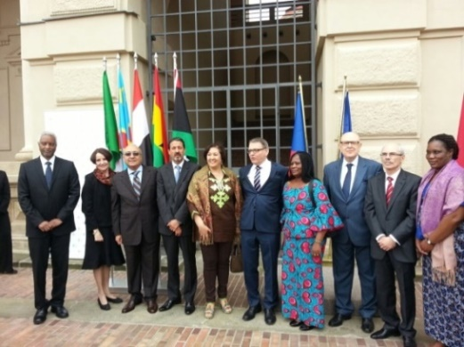

*Deputy Minister Martin Tlapa (in the middle) and African Ambassadors at Africa Day celebration, MFA, 25 May 2016*

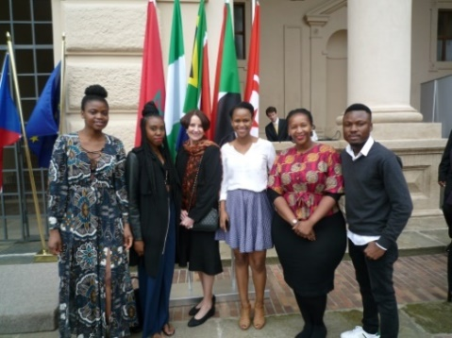

*Ambassador Verwey and South African students*

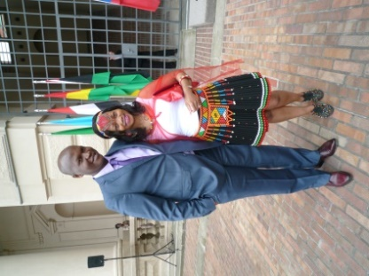 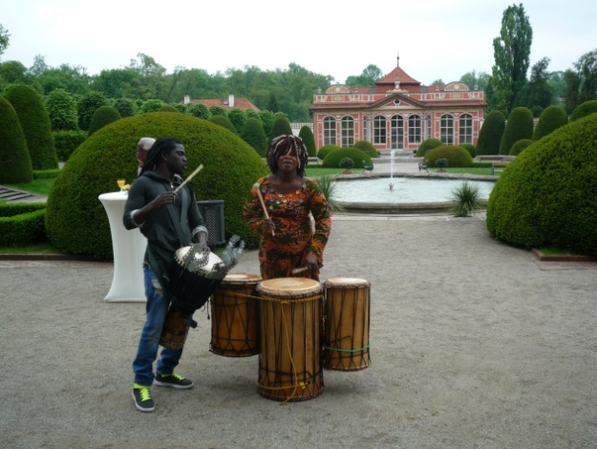

*Mr V.Ncongwane & his wife African musicians*

*Africa Day celebration, MFA, Prague, 25 May 2016*

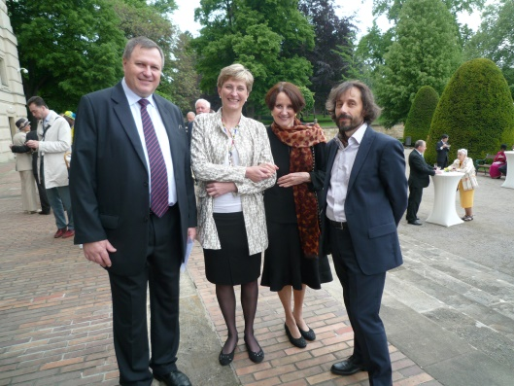

*Former Czech Ambassadors to RSA, Mr Jaroslav Siro and Ms Blanka Fajkusová, Ambassador Verwey and Mr Michal Jeřábek, MFA*

***Prospects of Africa***

The Heads of Mission of African countries accredited to the Czech Republic jointly participated in a symposium on the topic *Prospects of Africa* at the Metropolitan University Prague (MUP) on 9 May 2016. Following presentations on their respective countries, there was a lively discussion with the audience on issues such as migration, regional economic prospects, economic sanctions, south-south cooperation and the African Union.

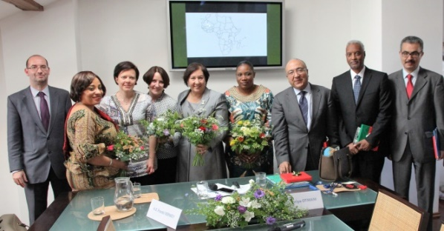

*Heads of Mission participating in the discussion at the Metropolitan University Prague. Picture: MUP*

***Events marking Charles IV anniversary***

The Ambassador attended several events marking the 700th anniversary of the birthday

of the Czech King and Roman Emperor Charles IV, including a Mass at St Vitus Cathedral; a commemorative event at St Barbara Chapel in the presence of the Grand Duke of Luxemburg and an exhibition of Czech crown jewels.

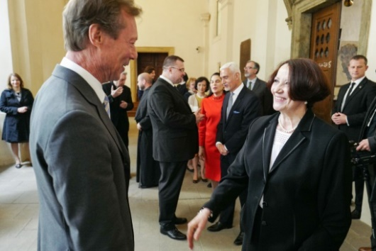

*Ambassador Verwey meeting His Royal Highness the Grand Duke of Luxemburg during the Charles IV 700th anniversary celebrations, Prague, 13 May 2016*

*Picture: Embassy of Luxemburg*

***Visit to Marienbad (Mariánské lázně)***

[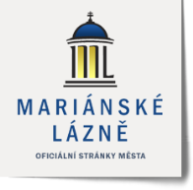](http://www.muml.cz/)Ambassador was invited to the GEOMED symposium held at Mariánské lázně on 27 May 2016. She met the Deputy Mayor and was also taken on a guided tour of the famous spa town.

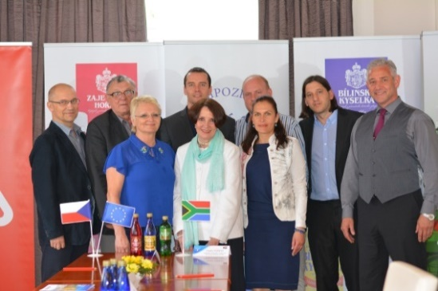

*Ambassador Verwey, symposium organizer Dr Petr Petr (second from the left) and other participants of the GEOMED symposium*

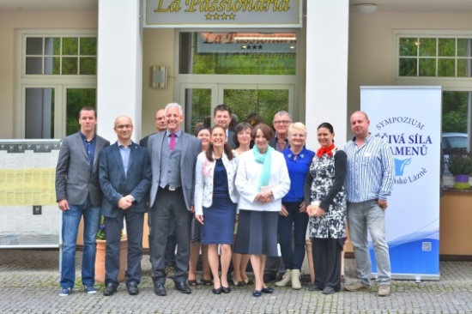

*Symposium participants in front of the La Passionaria Hotel. Pictures: Karel Bašta, Marketing Manager*

***Embassy Get-Together***

On Friday afternoon, 6 May 2016 the Ambassador hosted a spring party/team building gathering for the Embassy staff at the Official Residence. While the women prepared salads, the men grilled sausages and toasted sandwiches. Staff members tried their hand at pétanque and other games.

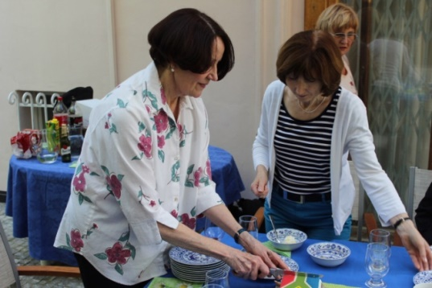 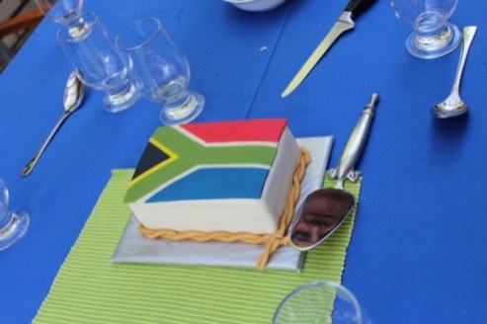

*Ambassador Verwey cutting a cake donated by a hotel*

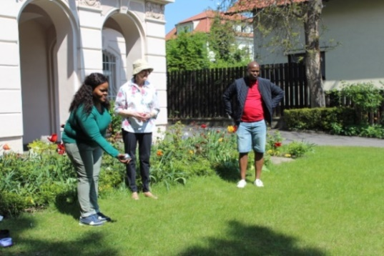

*Ms Puleng Radebe-Mothibe, Ambassador Franki Verwey and Mr Vivien Ncongwane*

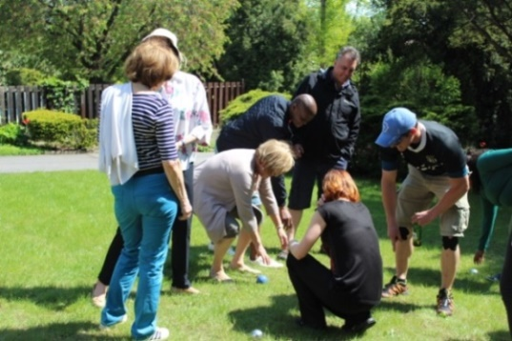

*Judging the result of the game*

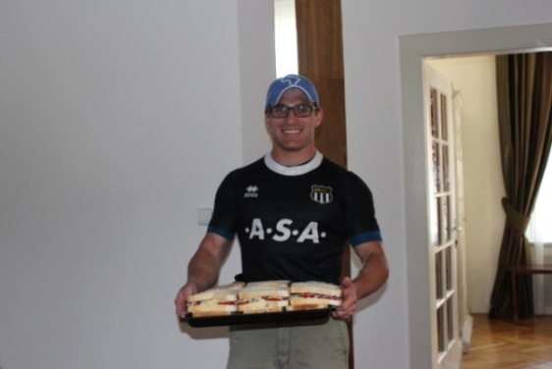 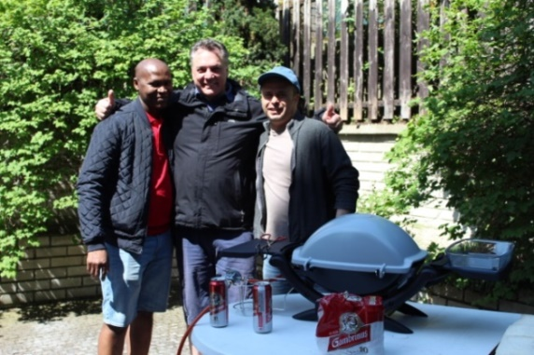

*Mr Wood Messrs Ncongwane, Walters & Stifter*

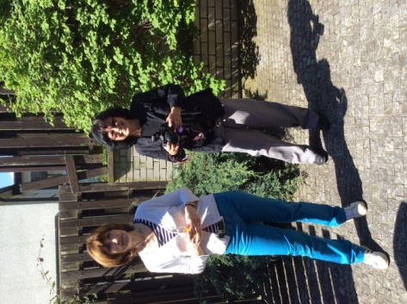 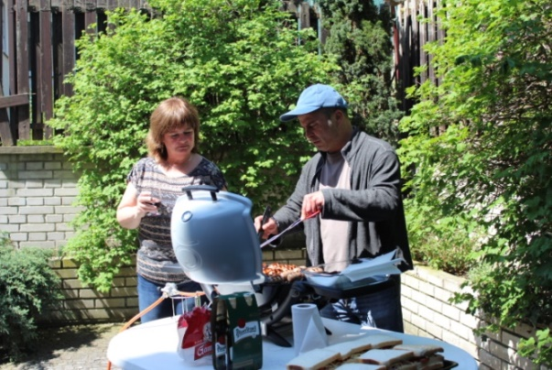*A.Růžičková & Z.Herclová M.Rubešová & M.Stifter*

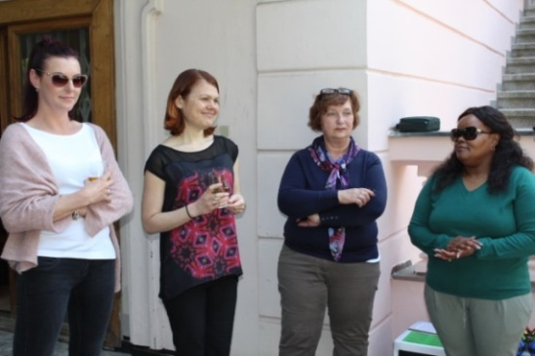

*Z.Jelínková, M.Hlávková, D.Vinická, P.Radebe-Mothibe*

***Diplomatic functions***

The Ambassador attended the annual joint Benelux reception; national days of Azerbaijan, Georgia and Poland; Victory Day hosted by the Ambassador of Russia; a working lunch hosted by the Ambassador of Kuwait; a diplomatic dinner hosted by the Ambassador of Belgium; the opening concert of the Prague Spring Festival conducted by Estonian conductor Paavo Jӓrvi and an exhibition marking 110 years of the Jerusalem Synagogue.

**STAFF NEWS/SA CITIZENS**

***Ms Růžičková’s birthday***

Embassy staff arranged a small tea party to celebrate a special birthday of our colleague Alenka Růžičková on 19 May 2016.

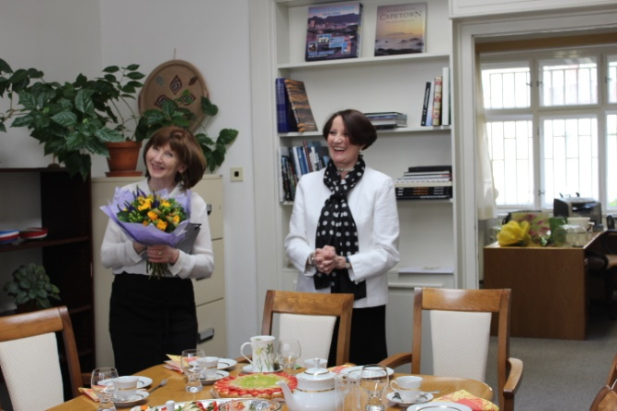

Congratulations!

**SOUTH AFRICAN NEWS**

***President Zuma paid a state visit to Qatar***

President Jacob Zuma paid a State Visit to Qatar from 18 - 19 May 2016. Bilateral political and economic relations with Qatar have grown significantly over recent years; most of South Africa’s investments in the country are in petrochemical-related sectors.

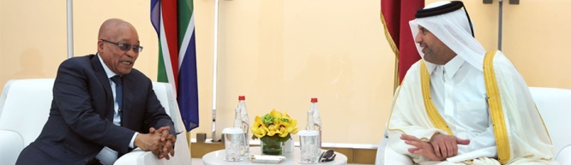

*President Zuma in Doha, Qatar for State Visit*

*Picture: The Presidency*

***Palestine President visited RSA***

President Jacob Zuma hosted President Mahmoud Abbas of Palestine on a Working Visit to South Africa on 25 May 2016. South Africa and Palestine enjoy cordial relations that date back to the days of the Anti-Apartheid struggle.

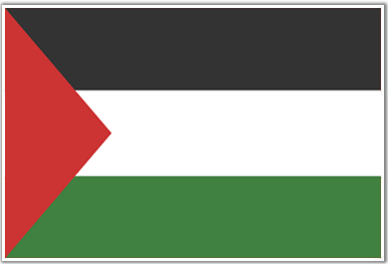 [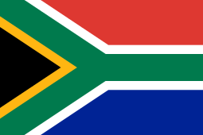](https://en.wikipedia.org/wiki/File:Flag_of_South_Africa.svg)

***Deputy President of Venezuela visited RSA***

Deputy President of the Bolivarian Republic of Venezuela, Mr Aristóbulo Istúriz paid a Working Visit to South Africa from 8 - 10 May 2016. South Africa was the first stop on his round of visits to BRICS countries.

[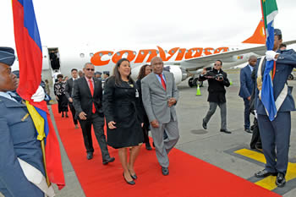](http://www.dirco.gov.za/images/gallery8/ramaphosa_venezuela_isturiz1.jpg)

*Deputy President Aristóbulo Istύriz arrives at OR Tambo Airport. Walking next to him is Venezuela's Ambassador to South Africa, Ms Mairin Moreno.*

*RSA, 8 May 2016. Picture:Jacoline Schoonees*

***Credentials presentation in RSA***

Ambassadors and High Commissioners Designate from 16 countries presented their Letters of Credence to President Jacob Zuma at a credentials ceremony at the Sefako Makgatho Presidential Guesthouse in Pretoria on 13 May 2016.

[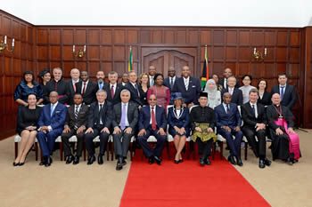](http://www.dirco.gov.za/images/gallery8/zuma_credentials-ceremony_160513_4.jpg)

*Group photograph of President Jacob Zuma and the Ambassadors and High Commissioners, Pretoria, 13 May 2016. Picture: Jacoline Schoonees*

***Budget Vote Speech***

International Relations and Cooperation Minister Ms Maite Nkoana-Mashabane presented her Budget Speech in Parliament on 3 May 2016. The Minister outlined the programme and activities of her Department in pursuit of South Africa’s foreign policy objectives.

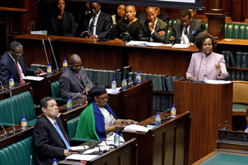

*Minister Maite Nkoana-Mashabane delivers her Budget Vote speech, Old Assembly Hall, Parliament, Cape Town, South Africa, 3 May 2016. Picture: Jacoline Schoonees*

***Visit to Ghana***

[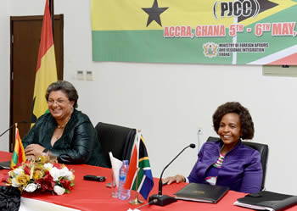](http://www.dirco.gov.za/images/gallery8/mashabane_ghana_tetteh8.jpg)

*Minister of Foreign Affairs of Ghana, Ms Hanna Tetteh and Minister Maite Nkoana-Mashabane, Accra, Ghana, 6 May 2016. Picture: Jacoline Schoonees*

Minister Maite Nkoana-Mashabane co-chaired the 4th Session of the Permanent Joint Commission for Cooperation between South Africa and Ghana held from 5-6 May 2016 in Accra. Ghana is a strategic partner for South Africa; more than sixty South African firms operate in Ghana.

***Women 20 Meeting in Xi'an, PRC***

Foreign Minister Maite Nkoana-Mashabane participated in a summit of the W20, a G20 engagement group which was held in Xi'an, the People's Republic of China from 24-26 May 2016 under the theme: *Equal participation and innovative development.* South Africa is ranked number 17 out of 142 countries on women's equality.

***Africa-Nordic Ministerial Meeting***

**Minister Ms Maite Nkoana-Mashabane participated in the 15th Africa-Nordic Meeting held in Oslo from 26-27 May 2016 under the theme *Ensuring stability and prosperity in a new security landscape.***

[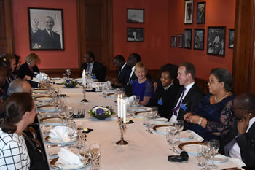](http://www.dirco.gov.za/images/gallery8/mashabane_africa-nordic_meeting2.jpg)

[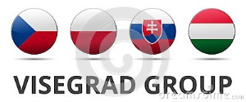](http://thumbs.dreamstime.com/z/v-visegrad-group-country-flag-summit-czech-republic-poland-slovakia-hungary-reflection-shadow-middle-european-41969167.jpg)***Minister Maite Nkoana-Mashabane at the Opening Dinner of the Ministerial Meeting, Oslo, 26-27 May 2016. Picture: Yolande Snyman***

***Africa Day celebration***

President Jacob Zuma hosted the Africa Day celebration which was held on 25 May 2016 at the Cape Town International Convention Centre under the theme *Building a better Africa and a Better World.*

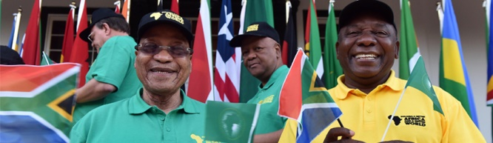

*President Jacob Zuma and Deputy President Cyril Ramaphosa celebrating Africa Day during a Cabinet Meeting in Cape Town. Picture: The Presidency*

South Africa plays a key role in the economic development of the continent and contributes to peacekeeping and post-war reconstruction and development efforts.

**CZECH NEWS**

***Czech Republic marked 71st anniversary of the end of World War II***

A number of memorial events took place on 8 May 2016 across the Czech Republic to mark the 71st anniversary of the end of World War II. The main ceremony is traditionally held at Prague's Vítkov memorial. Two Gripen fighter jets flew over the memorial to mark the national holiday.

On the occasion of Liberation Day, President Miloš Zeman appointed five new army generals and promoted other leading representatives of the military and police.

[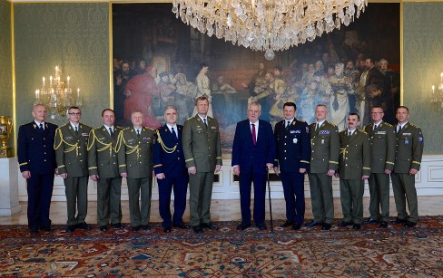](https://www.hrad.cz/cs/pro-media/tiskove-zpravy/aktualni-tiskove-zpravy/prezident-republiky-jmenoval-generaly-acr-1-12657)

*Picture: Prague Castle*

***Visegrad Four Ministers met in Prague***

The Ministers of Foreign Affairs of the Visegrad Group (V4) and the Eastern Partnership countries met from 3-4 May 2016 in Prague under the Czech Republic Presidency.

Visegrad Group Defence Ministers met in Liblice Chateau, Czech Republic on 25 May 2016. Cooperation in connection with the migrant crisis and the current security situation was discussed.

The group's ministers focused on the strengthening of the collective defence of the Alliance's eastern wing, including the V4's rotation military presence in the Baltic and Poland.

***Charles IV 700th anniversary***

[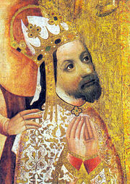](https://en.wikipedia.org/wiki/File:Charles_IV-John_Ocko_votive_picture-fragment.jpg)On the occasion of the 700th anniversary of the birthday of Charles IV, King of Bohemia and Holy Roman Emperor (1316 -1378), various commemorative events were organised at Prague Castle and other places. People queued several hours to see the crown jewels.

***Czech-Israeli bilateral consultations***

On 22 May 2016, the Governments of the Czech Republic and the State of Israel held the 4th Intergovernmental Consultations chaired by the Prime Minister of the Czech Republic, Mr Bohuslav Sobotka and the Prime Minister of the State of Israel, Mr. Benjamin Netanyahu. The Czech delegation included some 30 entrepreneurs. Both sides expressed appreciation about the rising trend of cooperation in new areas such as cyber security, science, technology and innovation.

[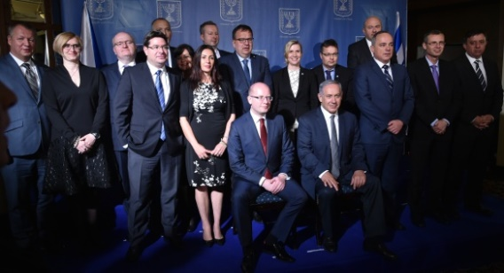](http://www.vlada.cz/en/media-centrum/aktualne/prime-minister-sobotka-attended-czech-israeli-intergovernmental-consultations-on-trade--security--and-research-and-development-144483/)

*Joint photograph of government officials following intergovernmental consultations in Jerusalem, 22 May 2016. Picture: The Government*

***President Zeman appointed a new Governor of ČNB***

[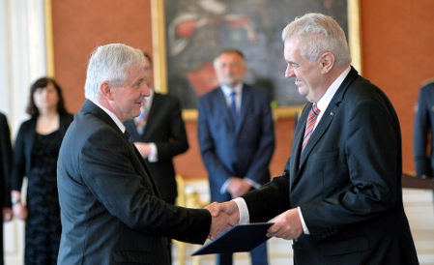](http://www.radio.cz/en/section/curraffrs/rusnok-named-new-governor-of-czech-national-bank)

*President Miloš Zeman appoints Jiří Rusnok,, Prague Castle, 25 May 2016. Photo: CTK*

**On 25 May 2016, President Miloš Zeman appointed** former caretaker Prime Minister and Minister of Finance Jiří Rusnok as the next Governor of the Czech National Bank **for a term of six years starting on 1 July 2016 at a ceremony at Prague Castle. Mr Rusnok is currently a member of the CNB Bank Board.**

***Filip re-elected KSČM chairman***

The Czech opposition Communist Party of Bohemia and Moravia (KSČM) re-elected Vojtěch Filip as the party chairman for another four years at its national congress on 14 May 2016. He received 176 out of 275 votes and defeated his only rival candidate, Josef Skála.

**[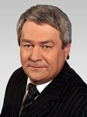](http://www.kscm.cz/data2/dep_35/filip_vojtech_307x410(3).jpg)**[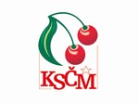](https://www.kscm.cz/ke-stazeni/data2/dep_35/Logo_KSCM_na_vysku_410x307.jpg)

***Prague Fringe Festival***

The 15th Prague Fringe Festival, a mix of theatre, comedy, music, dance and storytelling takes place in Prague from 27 May to 4 June 2016. Five South African groups are participating in the Festival this year, giving 23 performances in total.

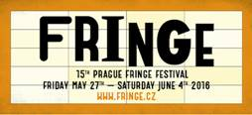

***Artist and painter Adolf Born died***

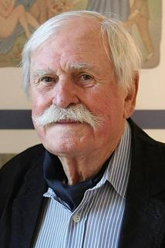Renowned Czech artist Adolf Born, creator of an animated television series and well-known graphic prints and illustrator of over 250 books died at the age of 85 on 22 May 2016.

|  |
| --- |
| For more information about the activities of the South African Embassy in Prague please visit our website:  http://[www.saprague.cz](http://www.saprague.cz) |