|  |
| --- |
| [Click on the specific symbol to view its symbolism  [coatofarms.gif 22315 bytes)](http://www.gov.za/_vti_bin/shtml.dll/symbols/coatofarms.htm/map) |
|  |

**EMBASSY OF SOUTH AFRICA  
RUSKA 65, 100 00 PRAGUE 10**

**NEWSLETTER - JUNE 2016 (No.6)**

[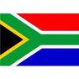](http://www.google.co.za/imgres?imgurl=http://sasportswear.co.za/images/sportswear/south_african_storm_flag.jpg&imgrefurl=http://sasportswear.co.za/sa-memorabilia-7/sports-flags-21/south-african-flag-storm-72.html&h=591&w=591&sz=35&tbnid=Uv7cCdEcYE0-pM:&tbnh=135&tbnw=135&prev=/images?q=South+African+flag&hl=en&usg=__g8gihHXhaZlPhuEToAfXga4s4Hw=&sa=X&ei=IslOTK-nNo-R4Qay7dWoCA&ved=0CAgQ9QEwAQ)



**WORD BY THE AMBASSADOR**

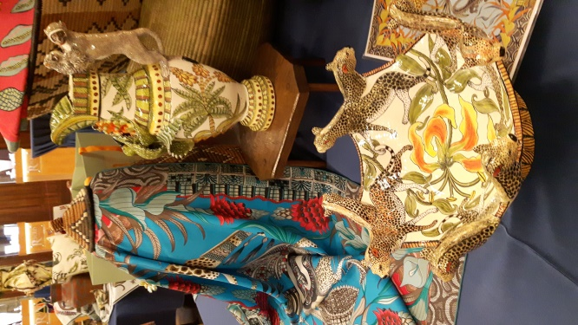

*Ardmore Ceramics*

June is always the busiest month on the official calendar in Prague as everyone tries to arrange their events before the summer holidays begin.

One of the highlights for me was the Ardmore Ceramics Exhibition at the iconic Obecní Dům/Municipal House. It was a moment of great pride for us at the Embassy to partner with *Richard Collection* for this event showcasing the creativity of South African artists.

I had a very instructive visit to the Regions of Vysočina and Zlín during the month. In particular, it was an extraordinary experience to witness the project dating back to the first decades of the 20th century of the phenomenal visionary Czech businessman Tomáš Bat’a. All around the world people had grown up with Bata shoes, never realising that it originated in Zlín.

**EMBASSY NEWS**

***Ardmore Exhibition***

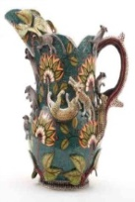An exhibition of the magical world of Ardmore Ceramics and the formal opening and private viewing of Richard Collection Fine Jewellery Boutique took place in the Municipal House in Prague on 7 June 2016 with the support and co-operation of the South African Embassy. Guests had the opportunity to admire unique ceramics and jewellery inspired by African nature.

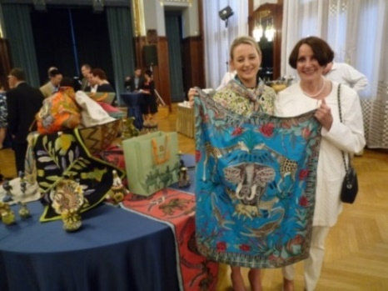

*Ms Catherine Halsted, Ardmore Ceramics and Ambassador Verwey*

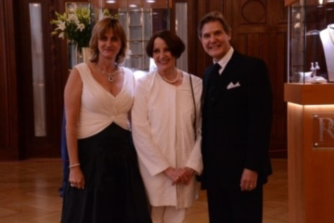

*Ambassador Verwey with Ivana*

*and Richard Summerfield*

***Visit to Jihlava and Zlín***

The Ambassador accompanied by Ms Hlávková visited Jihlava on 8 June 2016 to promote South Africa and discuss possible cooperation. First she met representatives of the town, Deputy Mayors Vratislav Výborný; Jaromír Kalina; and Milan Kolář.

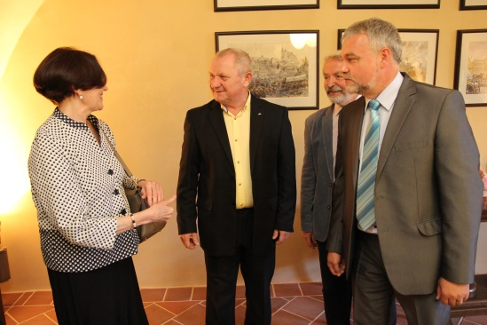

*Ambassador Verwey welcomed in Jihlava by Deputy Mayors Vratislav Výborný, Milan Kolář and Jaromír Kalina. Picture: Radek Tulis, Press spokesman, Jihlava city*

**[](http://www.zoojihlava.cz/)**

In the afternoon, the Ambassador met Ing Eliška Kubíková, Director of Jihlava Zoo to discuss continuation of the long-term contacts between the Embassy and the Zoo. It was agreed that the Zoo will display a photo exhibition on the Cape Floral Kingdom at its entrance throughout summer.

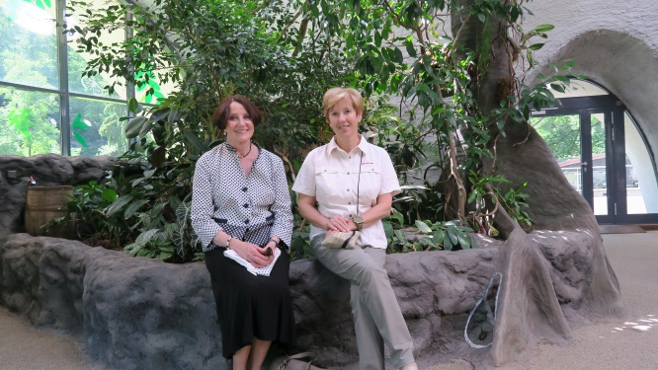

*Ambassador Verwey and Ing Eliška Kubíková, Director of Jihlava Zoo*

*Picture: Michal Ryneš, Jihlava Zoo*

On 9 June 2016, the Ambassador visited Zlín. She met the Governor of the Zlín Region, MVDr Stanislav Mišák, Mayor MUDr Miroslav Adámek, the Vice-Rector for International Affairs of Tomáš Baťa University ((TBU), Mgr Pavel Krutil and other personalities of the city.

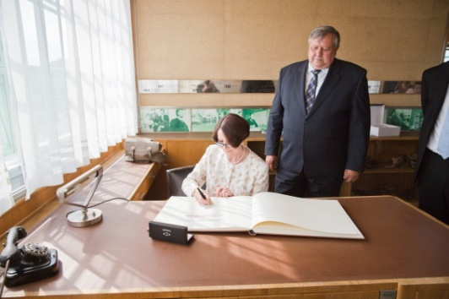

*Ambassador signs the Memory book in the presence of Governor of the Region, MVDr Stanislav Mišák. Picture: Mgr Art. Jiří Balát, Press Dept.*

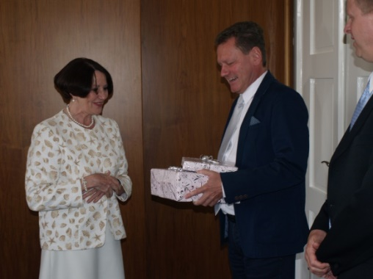

*Mayor of Zlín MUDr Miroslav Adámek presents a gift from the city to Ambassador Verwey.*

*Picture: Mgr Zdeněk Dvořák, Press Spokesman*

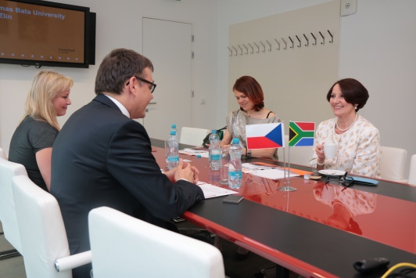

*Ing Jana Školoudíková, TBU, Mgr Pavel Krutil, Vice-Rector for International Affairs of TBU, Ms Hlávková and Ambassador Verwey ,*

*Picture: Tomáš Baťa University in Zlín*

The programme in Jihlava and Zlín was very interesting and the Ambassador appreciated the hospitality of both regions.

***Embassy Food & Culture Festival***

Under the auspices of Prague 6 Municipality, 39 Embassies and a dozen NGOs jointly participated in the first festival of food and culture from the whole world at the weekly farmers market at Vítězné Square in Prague 6 on 4 June 2016. Each country hosted a stand offering a selection of traditional and exotic food and drinks. The South African stand offered traditional fare like biltong, as well as popular koeksisters, vetkoek, ystervarkies and banana/carrot bread. Cultural performances from around the world contributed to the joyful atmosphere of the event.

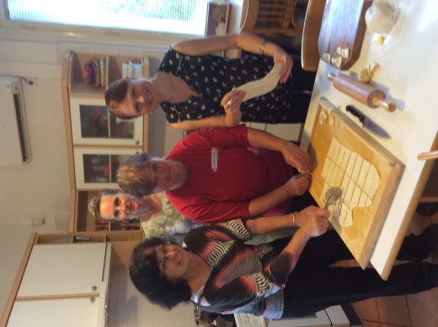

*Ms Z. Herclová, Ms M.Rubešová and*

*Ms M. Hlávková preparing koeksisters*

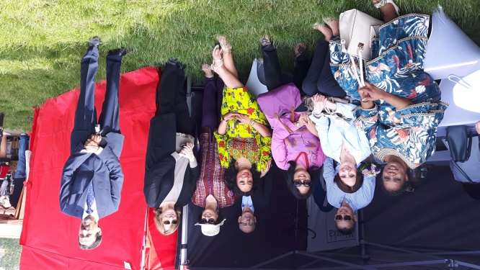

*Ambassadors Verwey and other Ambassadors at the Prague Food festival*

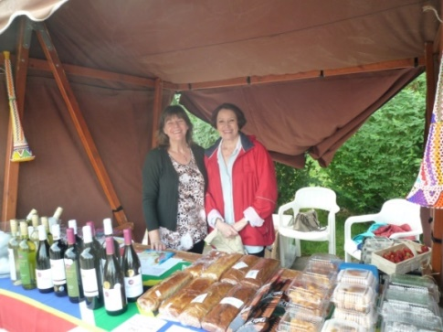

*Heather Crowther and Ambassador Verwey*

*at the South African stand*

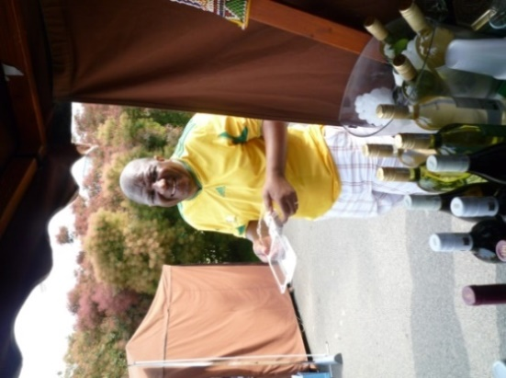 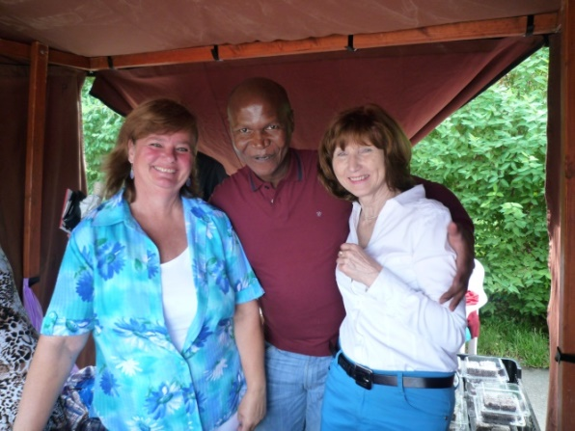

*Mr Z.M.Dasa, Ms M.Rubešová, Mr V.Ncongwane and Ms A. Růžičková at the festival*

***Prague Fringe Festival***

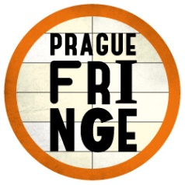Five performing groups from South Africa took part in this year’s Prague Fringe Festival from 26 May to 3 June 2016. Their performances, comprising theatre, dance and magic were very popular.

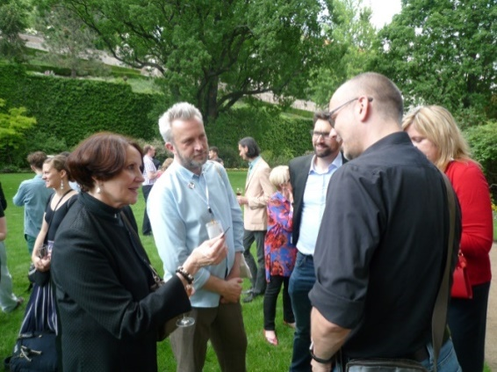

*Ambassador Verwey and Steve Gove, organizer of Prague Fringe Festival at the launch of the festival hosted by the British Ambassador.*

*Prague, 1 June 2016.*

***Export Festival***



The Embassy participated in the fourth annual Export Festival CZ which was held at the Prague Exhibition Area from 15-16 June 2016 to promote exports, international business cooperation and **enable direct contact between companies engaged in export activities.** More than 80 operators from 30 countries took part. The event was opened by President Zeman. Countries displayed typical products at their stands. The Embassy partnered with Red Espresso, Tombalina Wines & Zulu Biltong.

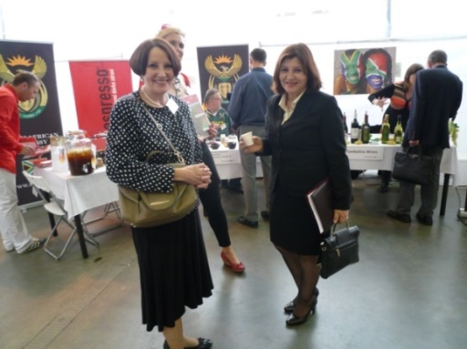

*Ambassador Verwey and Ambassador of*

*Peru in front of South African stand*

***Visit of MBA student group from Nelson Mandela Metropolitan University***

On 20 June 2016 the Ambassador received a group of MBA students from Nelson Mandela Metropolitan University, Port Elisabeth at the Official Residence. The students spent several days in Prague within their European tour.

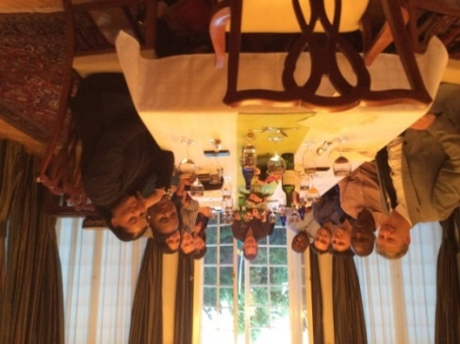

***Diplomatic functions***

In June, the Ambassador attended National Day celebrations of Italy, Philippines, Canada, USA, Belarus, Croatia and Venezuela; a Nordic-Baltic reception, a Swedish midsummer reception; annual receptions hosted by the President of Czech Academy of Sciences and the Order of Malta; and the Queen’s Birthday hosted by British Ambassador; working lunches hosted by Ambassadors of Norway, Denmark, China and Belgium; dinners hosted by Ambassadors of Serbia and Luxembourg; a festive concert on the occasion of the partnership between Kyoto and Prague; an event at Swiss Residence and a rugby match between a New Zealand Invitation XV and a Czech team.

Ambassador Verwey hosted a working lunch at the Official Residence for the Sub-Sahara Dept of the Foreign Ministry. It was also a farewell for Mr Michal Jeřábek, who is joining the Czech Embassy in South Africa.

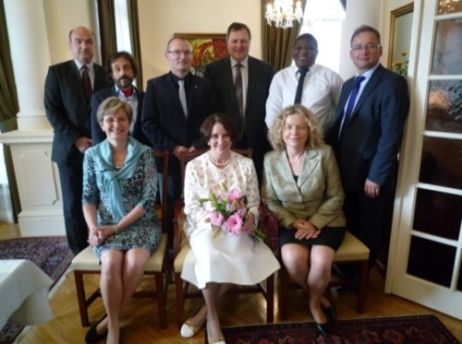

*Mr M. Machálek, Mr M. Jeřábek,*

*Mr I. Jukl, Mr J. Siro, Mr ZM Dasa, Mr I. Jančárek,*

*Ms B. Fajkusová, Ambassador Verwey and*

*Ms Z. Beranová*

Ambassador of Austria paid a courtesy call to Ambassador Verwey.

**STAFF NEWS/SA CITIZENS**

***Farewell to Mr Dasa***

Mr Mfundo “Kaiser” Dasa, Counsellor of the Embassy terminated his term of duty in Prague and left for the RSA on 30 June 2016.

We wish him much success in his further career.

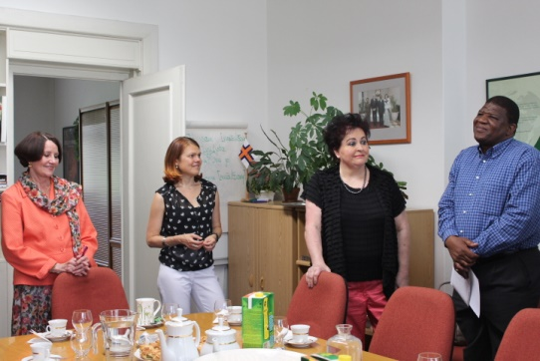

*Ambassador Verwey, Ms Hlávková,*

*Ms Andrštová and Mr Dasa*

**SOUTH AFRICAN NEWS**

***Middle East Peace Conference***

The Minister of International Relations and Co-operation, Ms Maite Nkoana-Mashabane attended the international conference on the Middle East Peace Process (MEPP) held on 3 June 2016 in Paris. The Ministerial Meeting was intended to pave the way for a larger conference to include Palestine and Israel in the second semester of 2016.

[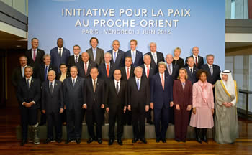](http://www.dirco.gov.za/images/gallery8/mashabane_mepp_france11.jpg)

*Family photograph of the Middle East Peace Process (MEPP) International Conference, Paris, France, 3 June 2016. Picture: Jacoline Schoonees*

***Visit to Lesotho***

President Jacob Zuma visited Lesotho on 9 June 2016 to consult on matters relating to the Southern African Customs Union (SACU). President Zuma is the current Chair of SACU, one of the oldest customs unions in the world. It consists of Botswana, Lesotho, Namibia, South Africa and Swaziland.

***Extra-Ordinary Summit in Botswana***

President Jacob Zuma and Deputy President Ramaphosa attended the SADC Double Troika Summit in Gaborone, Botswana on 28 June 2016. The summit considered the situation in the SADC region, paying a particular attention to the situation in the Kingdom of Lesotho.

***Youth Day***

South Africa celebrated the Youth Day on 16 June 2016 to commemorate the start of the Soweto riots of 1976, initially sparked by a government edict that all instruction in black schools would be held in Afrikaans.

[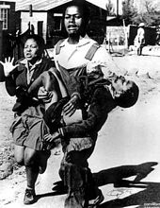](https://en.wikipedia.org/wiki/File:Hector_pieterson.jpg)

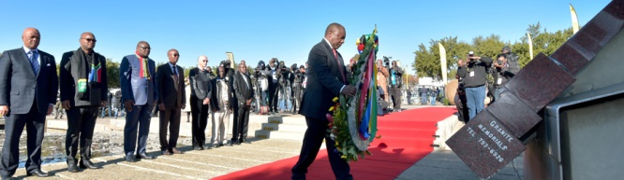

*Deputy President Cyril Ramaphosa laying a wreath at the Hector Pieterson Memorial in Soweto*

DIRCO hosted 100 boys and girls at the OR Tambo building to commemorate the 40-year anniversary of 1976 Youth Uprising under the theme *Youth Moving South Africa Forward.*

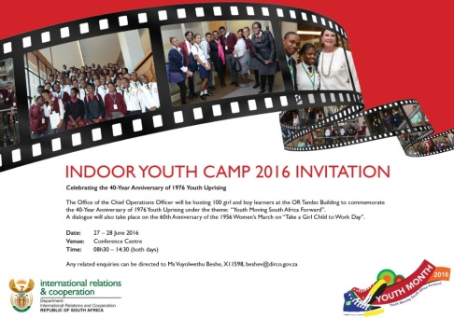

**CZECH NEWS**

***State Visit to Armenia and Macedonia***

President Miloš Zeman paid a State Visit to Armenia and Macedonia from 7-10 June 2016. In Armenia, Presidents Zeman and Serzh Sarkisian signed a *Joint Declaration on Friendly Relations, Partnership and Enhanced Cooperation.*

**[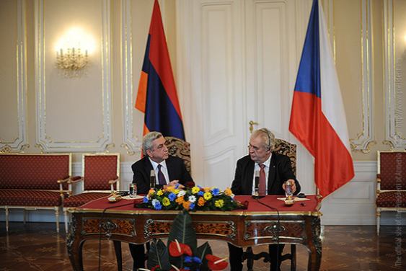](http://asbarez.com/wp-content/uploads/2016/06/sarkisianzeman.png)**

*Czech Republic President Miloš Zeman meets with Armenian President Serzh Sarkisian in Yerevan (Photo: President.am)*

In Macedonia, President Zeman was presented with the *September 8 Order,* Macedonia’s highest state recognition*.* Both presidents addressed the Macedonian-Czech Business Forum.

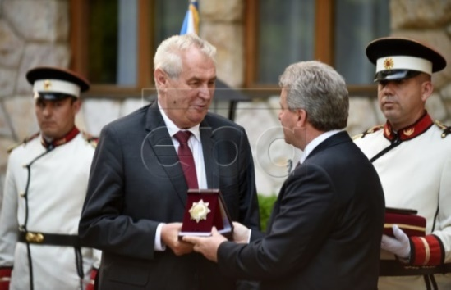

*President Miloš Zeman receives September 8 merit from President Gjorge Ivanov.*

*Picture: Nake Batev, Macedonia*

***Slovak PM visited Prague***

Slovak Prime Minister Robert Fico visited Prague on 8 June 2016 on his first foreign trip. He discussed energy and transport issues with Czech Prime Minister BohuslavSobotka, as well as plans for joint events in 2018 marking the anniversaries of the foundation of Czechoslovakia in 1918 and the Soviet-led invasion of 1968.

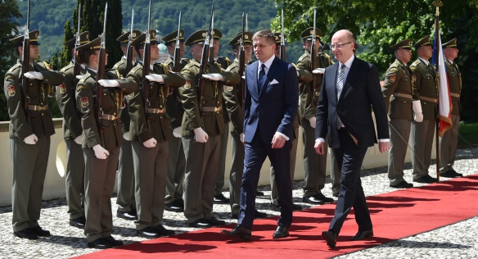

*On Wednesday 8th June, 2016, Prime Minister Bohuslav Sobotka met in Kramář´s Villa his Slovak counterpart Robert Fico. Picture: The goverment*

# *V4 summit in Prague*

# The final summit of the Prime Ministers of the Visegrad group countries during the Czech V4 Presidency was held in Prague on 8 June 2016. The Prime Ministers assessed the results of the Czech Presidency and also discussed the upcoming European Council session. From the beginning of July, the Presidency of the Visegrad group will be taken over by Poland.

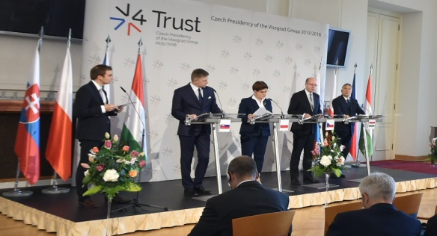

*V4 summit, Lobkowicz Palace, Prague, 8 June 2016. Picture: The government*

***Police reform***

Two elite police units, *the Squad for Uncovering Organised Crime* (UOOZ) and *the Office for Uncovering of Corruption and Financial Crime* (UOKFK) will merge into a single National Centre against Organised Crime (NCOZ). The plan prepared by Police President Tomáš Tuhý and promoted by Minister of Interior Milan Chovanec is opposed by Finance Minister Andrej Babiš and Justice Minister Robert Pelikán which led to a serious clash between the coalition parties. Several state attorneys presented their reservations; some top policemen, including Robert Šlachta, head of UOOZ resigned from their posts. On 28 June 2016 the Czech Chamber of Deputies established a commission to investigate the reshuffle of the elite national police bodies.

***Working group to deal with Brexit created***

The Czech government decided to create a special working group to deal with possible implications of the British referendum decision to leave the EU. The group will be headed by the Secretary of State for European Affairs, Mr Tomáš Prouza and will focus on determining the Czech priorities in the upcoming negotiations with Great Britain.

***Tomáš Halík awarded honorary doctorate***

[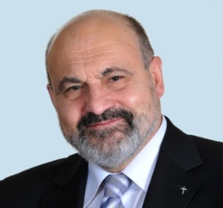](http://www.templetonprize.org/images/2014/halik-headshot.jpg)Czech theologian and philosopher Tomáš Halík was awarded an honorary doctorate at Encaenia, the Oxford University honorary degree ceremony on 22 June 2016. Before Halík, only three Czechs were awarded with the Oxford honorary doctorates, all of them former presidents: Tomáš Garrigue Masaryk (1927), Edvard Beneš (March 1940) and Václav Havel (October 1998).

***Jágr won 2016 Bill Masterton Trophy***

Forward Jaromír Jágr (44) won the 2016 Masterton Trophy for his perseverance, sportsmanship and dedication to hockey at the NHL Awards show in Las Vegas on 22 June 2016.

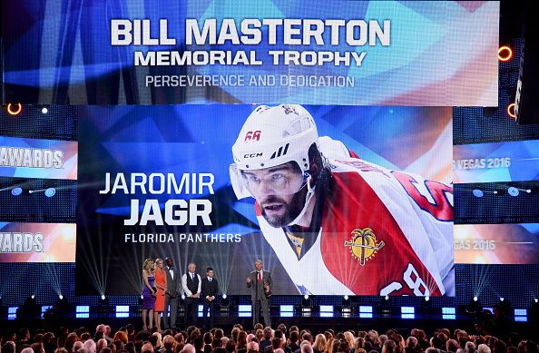

*Photo by Ethan Miller/Getty Images*

|  |
| --- |
| For more information about the activities of the South African Embassy in Prague please visit our website:  http://[www.saprague.cz](http://www.saprague.cz) |