|  |
| --- |
| [Click on the specific symbol to view its symbolism  [coatofarms.gif 22315 bytes)](http://www.gov.za/_vti_bin/shtml.dll/symbols/coatofarms.htm/map) |
|  |

**EMBASSY OF SOUTH AFRICA  
RUSKA 65, 100 00 PRAGUE 10**

**NEWSLETTER - July 2016 (No. 7 )**

[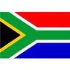](http://www.google.co.za/imgres?imgurl=http://sasportswear.co.za/images/sportswear/south_african_storm_flag.jpg&imgrefurl=http://sasportswear.co.za/sa-memorabilia-7/sports-flags-21/south-african-flag-storm-72.html&h=591&w=591&sz=35&tbnid=Uv7cCdEcYE0-pM:&tbnh=135&tbnw=135&prev=/images?q=South+African+flag&hl=en&usg=__g8gihHXhaZlPhuEToAfXga4s4Hw=&sa=X&ei=IslOTK-nNo-R4Qay7dWoCA&ved=0CAgQ9QEwAQ)



**WORD BY THE AMBASSADOR**

For us at the Embassy the highlight of July was our Mandela Day project. Every year, we identify a project to honour the legacy of Mr Mandela by doing community work on his birthday. In 2015, we went to a Home for the Elderly near Prague where we cleaned up the garden and painted some rooms. This year, we worked at a Shelter Home for Women and Children. The focus of project was particularly appropriate because of Madiba’s deep love of children.

It was also a pleasure for me to host the annual Bring&Braai at the Residence for the South African community in the Czech Republic. The event is clearly getting ever more popular because we had the biggest attendance yet this year. For the third consecutive year, we were very lucky with brilliant weather on the day.

Unfortunately, there was also one heartbreaking moment in the month. The day after the terrible incident in the city of Nice in France I attended the minute of silence in the square in front of the French Embassy to commemorate those who had been killed. It was such a stark contrast with the day before when the Embassy happily celebrated the French National Day.

**EMBASSY NEWS**

***Mandela Day in Czech Republic***

On 18 July 2016 the Embassy team commemorated Nelson Mandela International Day through community work at the Shelter Home of St. Gerard for Mothers and Children in Brandýs nad Labem.

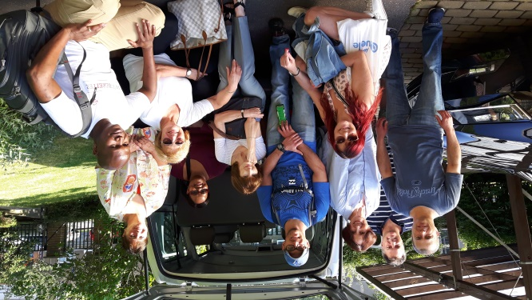

*Embassy team ready for day’s work: from left Mr Stifter, Mr Walters, Ambassador Verwey, Ms Jelinek, Mr Wood, Ms Růžičková, Ms Radebe-Mothibe, Ms Procházková, Ms Rubešová and Mr Ncongwane*

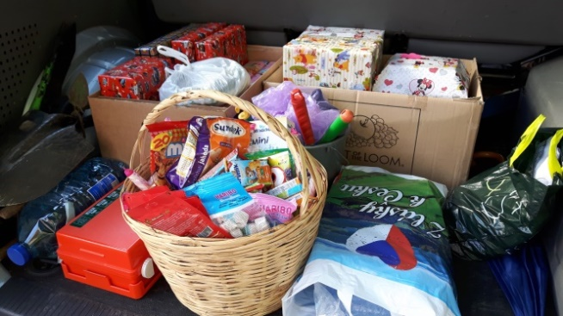

*Gifts and sweets for the children*

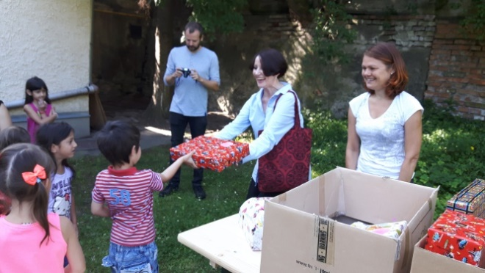

*Ambassador Verwey and Ms Hlávková distributing gifts to the children*

After presenting some gifts and basket of sweets to the children, the team set to work renovating and painting the fences around the property to keep the children safe.

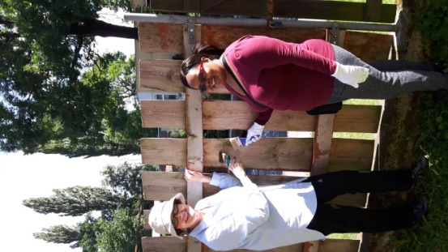 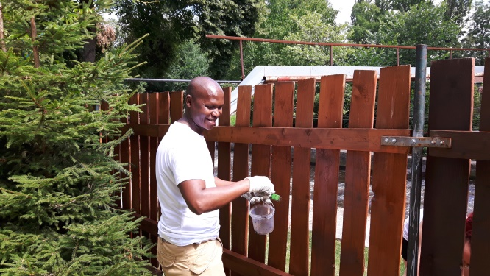

*Ambassador Verwey, Ms Radebe-Mothibe and Mr Ncongwane painting the fence*

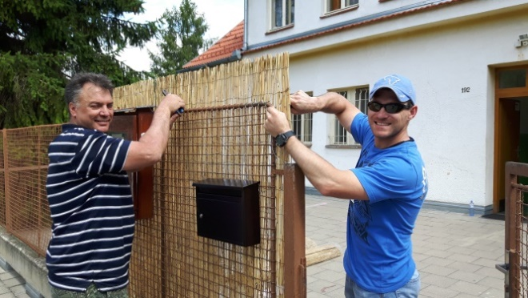

*Mr Walters and Mr Wood installing new matting*

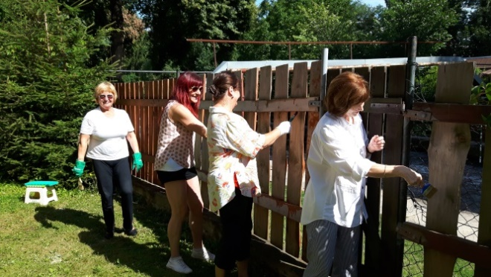

*Ms Procházková, Ms Jelinek, Ms Rubešová and Ms Růžičková paint the fence*

***Bring & Braai***

The annual Bring & Braai for the South African community was held on Friday, 22 July 2016. About 200 South Africans and friends of South Africa gathered at the Official Residence. The Embassy provided traditional boerewors, salads, desserts as well as drinks, including South African wines. Beer and cider were kindly provided by the Plzeňský Prazdroj company. The atmosphere was convivial, with lively conversation till late in the evening. RedEspresso partnered with the Embassy to introduce the products made of South African Rooibos.

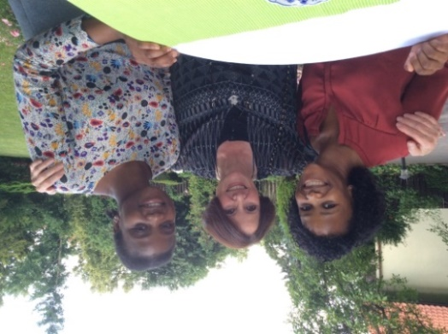

*Ambassador Verwey and South African students,*

*Ms Thankholi and Ms Baloyi*

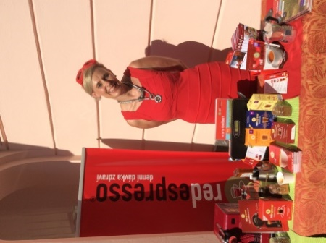

*Ms Jana Vaňková from RedEspresso*

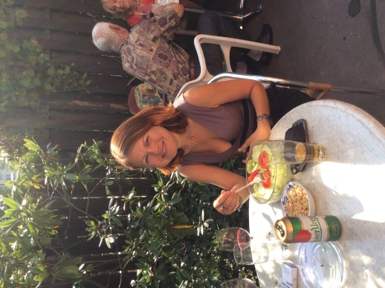 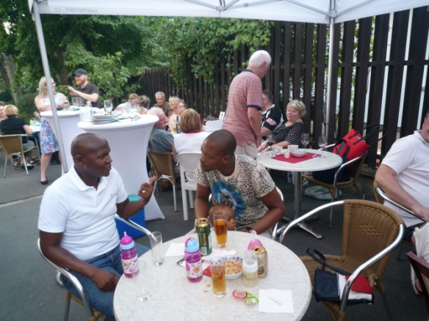

*Ms Hlávková, Mr Ncongwane talking to Mr Mothibe*

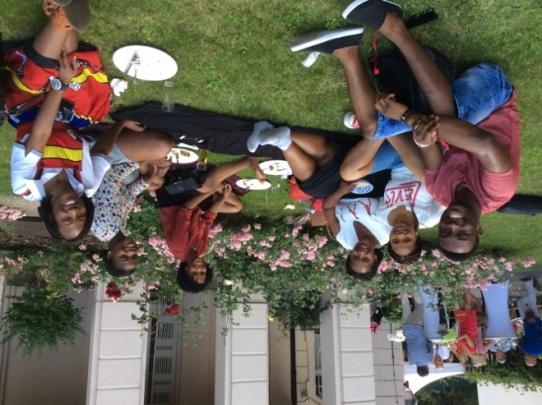

*Guests on the lawn of the Official Residence*

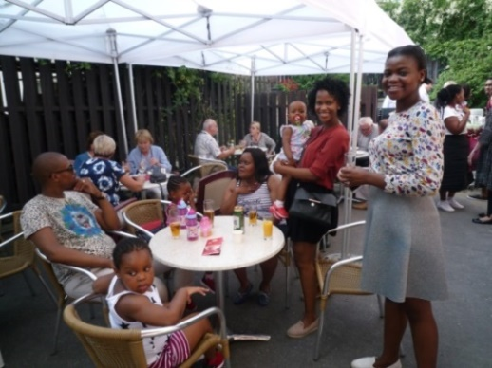

*Ms Radebe-Mothibe’s family and South African students*

*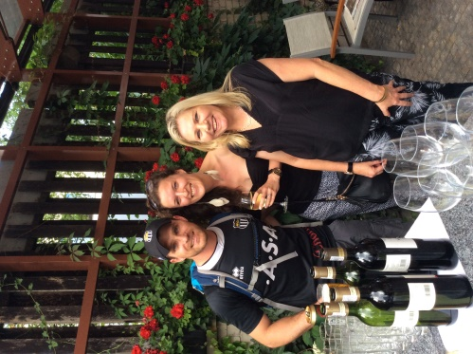****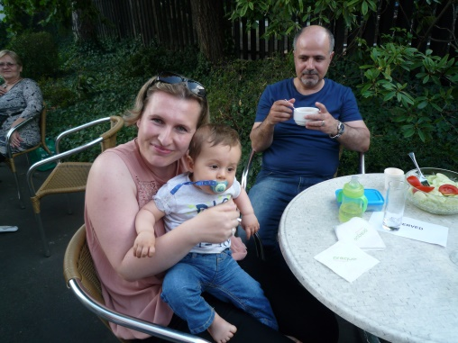***

*Mr Wood , his wife*

*& mother Ms Mahmoud & family*

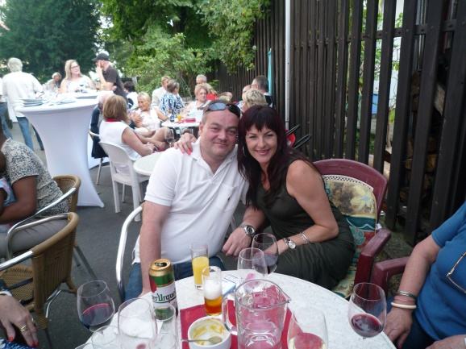

*Ms Zdenka Jelinek & her partner*

***TIKZN visit***

An advance team from *Trade and Investment KwaZulu Natal* (TIKZN) comprising Mr Neville Matje and Ms Donnee Kruger visited Prague on 19 July 2016. They were preparing for a trade mission from KZN later in the year. Ambassador Verwey accompanied them to their meetings.

[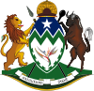](https://en.wikipedia.org/wiki/File:KwaZulu-Natal_arms.svg) [](http://www.southafrica.net/za/en)

***South African students visited Czech Republic***

[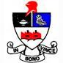](https://www.google.cz/url?url=https://twitter.com/randfonteinhigh&rct=j&frm=1&q=&esrc=s&sa=U&ved=0ahUKEwig_Ibm1aLOAhXJCMAKHfZqCnYQwW4IHjAE&usg=AFQjCNHTMyr52XCN57XTBjVgSyWfBPSf3A)On 21 July 2016 the Ambassador met a group of South African students from the Randfontein High School. They had participated in an international debating competition in Olomouc.

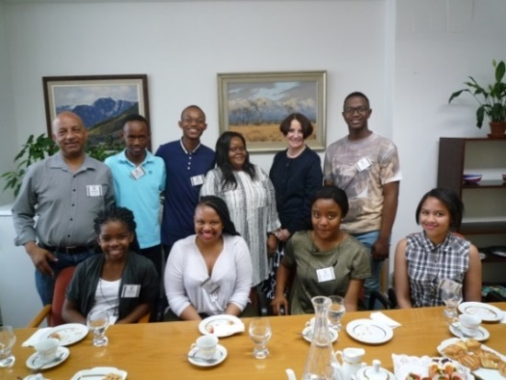

*Ambassador Verwey and Ms Radebe-Mothibe among the South African students & their teacher Mr Fisher*

***Birthday get-together***

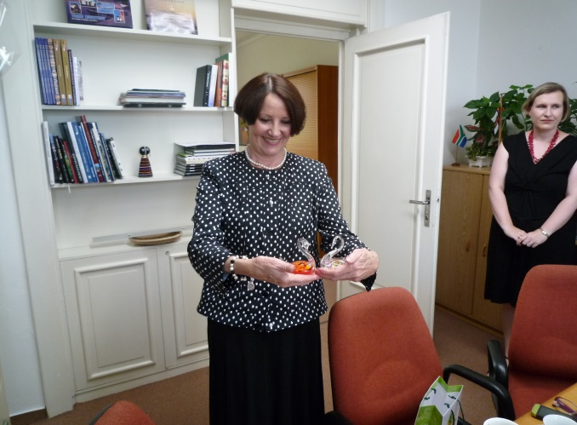

A social get-together was held at the Embassy on the occasion of Ambassador’s birthday.

Dear Ambassador,

Many Happy Returns of the Day!

***World Scholars Cup*** [Description: Image result for world scholars cup logo](http://www.google.cz/url?url=http://www.prweb.com/releases/scholarscup/2009/prweb2558974.htm&rct=j&frm=1&q=&esrc=s&sa=U&ved=0ahUKEwjr_Lri5qnOAhXHtBoKHcQhDqoQwW4IHDAC&usg=AFQjCNEuFsIYetY8s4Zzes0aMkPISVX4zA)

Mr Ncongwane represented the Embassy at the opening ceremony of the Global Round of the World Scholar’s Cup which took place in Prague from 22-26 July 2016. He briefly met with the South African team participating in the event.

***Diplomatic functions***

The Ambassador attended National Day celebrations of Argentina, Egypt, Peru and Morocco; farewell receptions hosted by the outgoing Ambassadors of Belgium and Greece; diplomatic dinners hosted by the Ambassadors of Thailand, India and Malaysia and a farewell lunch for Swedish Ambassador hosted by the Ambassador of Norway.

**STAFF NEWS/SA CITIZENS**

***Nick Wood got married***

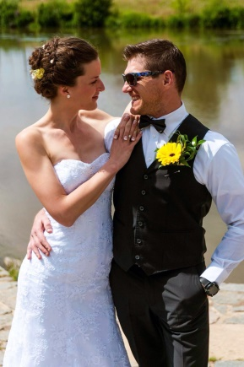

Our colleague Nicholas Wood married his fiancée Markéta in July 2016.

Congratulations to the newlyweds! We wish them a happy life!

**SOUTH AFRICAN NEWS**

***Official Visit by Prime Minister of* *India***

[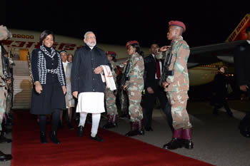](http://www.dirco.gov.za/images/gallery8/mashabane_india_modi4.jpg)

*Arrival of Indian Prime Minister Narendra Modi . He is received by Minister Maite Nkoana-Mashabane, Waterkloof Air Force Base, Pretoria, South Africa, 7 July 2016. Picture: Jacoline Schoonees*

Prime Minister of India, Mr Shri Narendra Modi paid an official visit to South Africa from 7 – 9 July 2016 to meet President Jacob Zuma, Deputy President Cyril Ramaphosa and other personalities. Three Memoranda of Understanding plus *Programme of Cultural Cooperation* were signed during his visit.

***State Visit to Paris***

President Jacob Zuma paid a three-day State Visit to Paris from 10 - 12 July 2016 under the theme *Working together as equal partners to explore opportunities and address the challenges of the 21st Century*. The visit concentrated on trade and economic deals. President Zuma also attended the centenary commemoration of the Battle of Delville Wood during WWI where many South African soldiers, especially from the South African Infantry Brigade, lost their lives.

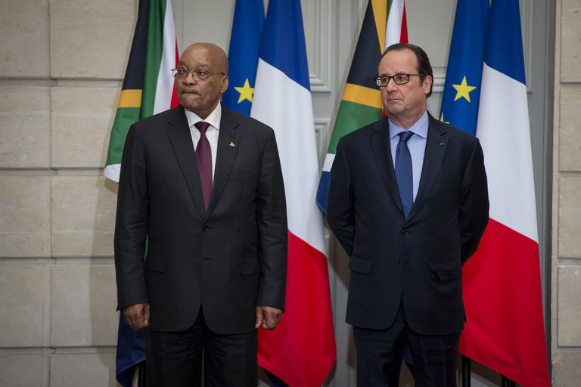

*President Jacob Zuma and his French counterpart President François Hollande, Paris, France*.

*Picture: The Presidency*

***AU Summit in Rwanda***

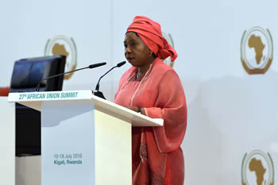

*The Chairperson of the African Union Commission, Dr Nkosazana Dlamini Zuma, opens the AU Summit, Kigali, Rwanda, 10-18 July 2016. Picture: Jacoline Schoonees*

[](http://www.au.int/en/summit/27)

South Africa attended the 27th Ordinary Session of the Assembly of the African Union Summit in Kigali, Rwanda from 17-18 July 2016.

***Minister Nkoana-Mashabane visited China***

The Minister of International Relations and Cooperation, Ms Maite Nkoana-Mashabane participated in and co-chaired the Co-ordinators Meeting of the Forum on China-Africa Cooperation (FOCAC) on 29 July 2016 in Beijing.

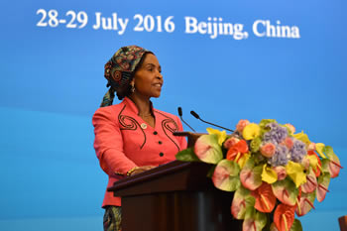

*Minister Ms Maite Nkoana-Mashabane at the Co-ordinators Meeting of the Forum on China-Africa Cooperation (FOCAC), Beijing, People’s Republic of China, 29 July 2016. Picture: Yolande Snyman*

Minister Nkoana-Mashabane also held a meeting with the President of the BRICS New Development Bank, Kundapur Vaman Kamath, in Shanghai. The African Regional Centre of the BRICS New Development Bank will be based in South Africa.

***AIDS conference in Durban***

[](http://www.aids2016.org/)The International AIDS Conference, the largest conference on any global health or development issue, was held in Durban, RSA from 18 to 22 July 2016. The Opening Session of the Conference was addressed by Deputy President Cyril Ramaphosa.

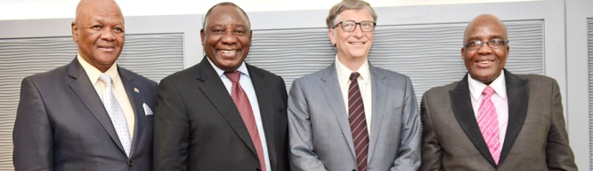

*Deputy President Cyril Ramaphosa hosts Microsoft founder, Bill Gates, on the sidelines of the 21st International AIDS Conference, Durban . Picture: The Presidency*

***Mandela Day in South Africa***

Many events were held in South Africa on Nelson Mandela’s birthday on 18 July 2016 and continued during the whole month to celebrate Madiba’s life and legacy.

President Zuma visited Marhulana Primary School as part of the government's 2016 Mandela Month Programme.

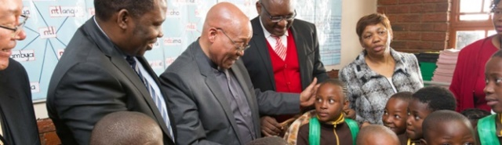

*Picture: The Presidency*

Minister Maite Nkoana-Mashabane took part in a Nelson Mandela Day charity event at the Emmanuel Disability and Old Age Centre in Jouberton, Matlosana on 21 July 2016.

[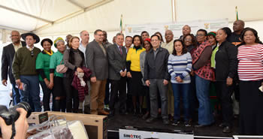](http://www.dirco.gov.za/images/gallery8/mashabane_ppp_mandela-day_matlosana2.jpg)

*Picture: Jacoline Schoonees*

***We can change the world and make it a better place. It is in your hands to make a difference. Nelson Mandela***

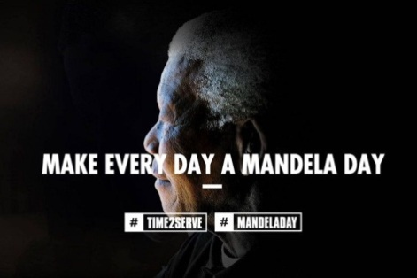

***Motor racing driver Gugu Zulu died***

[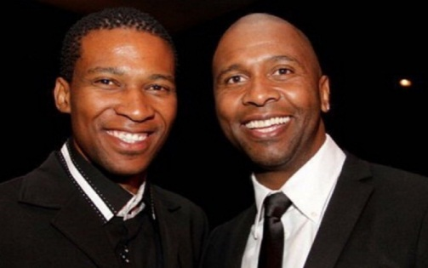](http://www.thenewage.co.za/wp-content/uploads/2016/07/gugu-zulu-27.jpg)A popular South African motor racing driver Gugu Zulu died on 18 July 2016 while trying to reach the summit of Mount Kilimanjaro for a charity linked to Nelson Mandela. The attempt was part of the Trek4Mandela expedition to raise money to buy sanitary pads for underprivileged girls.

***Kagiso Ramada awarded***

On 26 July 2016 President Jacob Zuma congratulated the South African National Cricket Team fast bowler, Mr Kagiso Rabada for scooping the record breaking six awards at the annual Cricket South Africa Awards. Mr Rabada won the SA Cricketer of the Year; Test Cricketer of the Year; ODI Cricketer of the Year; SA Players' Player of the Year; the ‘Delivery of the Year’; as well as the SA Fans' Cricketer of the Year.

The President has further praised the entire South African Cricket Team, the Proteas, for continuing to be among the best teams in the world of cricket.

[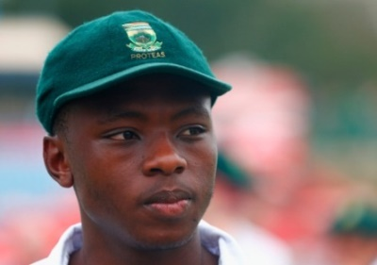](http://www.gettyimages.com/detail/news-photo/kagiso-rabada-of-south-africa-looks-on-after-receiving-man-news-photo/506929130) [](https://en.wikipedia.org/wiki/File:Southafrica_cricket_logo.svg)

*Kagiso Rabada Logo of Proteas*

**CZECH NEWS**

***President Zeman visited Mongolia***

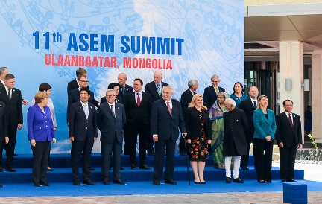

*Photo: Leaders pose for a family photo at ASEM11 Summit. Picture: The Castle*

President Miloš Zeman attended the 11th Asia-Europe Summit (ASEM) which was held in Ulaanbaatar, Mongolia from 14-16 July 2016. ASEM was established in 1996 and currently has 53 member states. The Czech Republic joined the organization in 2004.

***V4 Summit in Warsaw***

**The Prime Ministers of the Visegrad Group countries met in Warsaw on 21 July 2016 to coordinate the common position of the V4 before upcoming meetings at EU level. They agreed on the necessity of continued cooperation in EU-27 and on the future reform of the EU.**

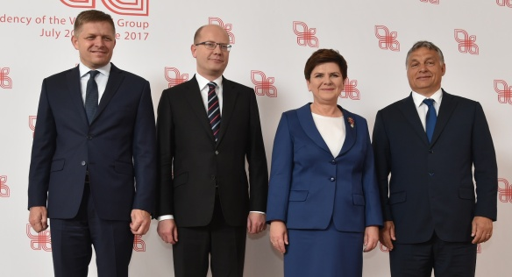

*Prime Ministers Robert Fic (Slovakia), Bohuslav Sobotka (Czech Republic), Beata Szydlo (Poland) and Viktor Orbán (Hungary) at the Summit of the Visegrad Group countries in Warsaw, 21. July 2016.*

*Picture: The Government*

***French President’s visit to Prague cancelled***

French President François Hollande cancelled his visit to the Czech Republic scheduled for 20 July 2016 due to the deadly attack in Nice; the second visit scheduled for 27 July 2016 was cancelled after the attack on a church in France. President Hollande spoke to Czech President by phone and stressed that the EU’s main mission should be to ensure the security of its citizens.

# *Minister Zaorálek visited the USA*

# Minister of Foreign Affairs Lubomír Zaorálek visited the USA from July 19-23, 2016. He participated at the Economic and Social Council of the UN (ECOSOC) Pledging Conference for Iraq and Global Coalition against ISIL Conference.

***Deputy Minister Tlapa visited Kenya and Rwanda***

Deputy Minister of Foreign Affairs Martin Tlapa visited Africa in July 2016. On 19 July 2016, he addressed the international conference of UNCTAD 14 in Nairobi, Kenya.

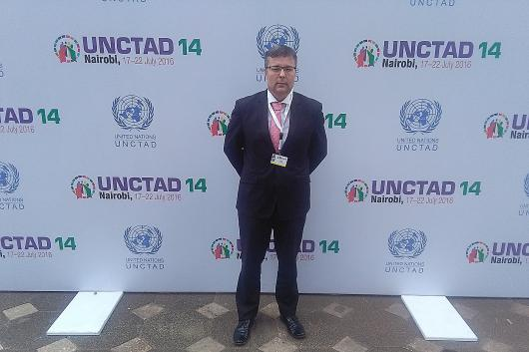

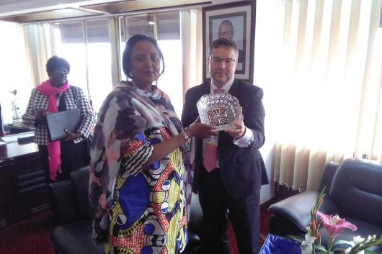

*Deputy Minister Martin Tlapa held a bilateral meeting with Kenyan Minister of Foreign Affairs Amina Mohamed. Pictures: MFA*

**In Rwanda, the Deputy Minister Tlapa held talks with Minister of Foreign Affairs and Cooperation Ms Louisa Mushikiwabo and with the Permanent Secretary of the Ministry of Industry and Trade Emmanuel Hategekou.**

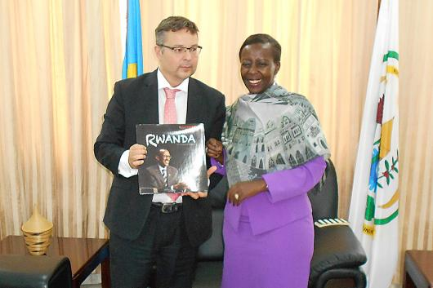

***Deputy Minister Martin Tlapa and Minister Louisa Mushikiwabo. Rwanda, 22 July 2016. Picture: MFA***

***Ethiopian delegation in Prague***

**Deputy Minister Martin Tlapa discussed Czech Development Cooperation within the *Aid for Trade* projects with the delegation of the Ethiopian** Chamber of Commerce led by its President Elias Geneti Simma in Prague on 28 July 2016.

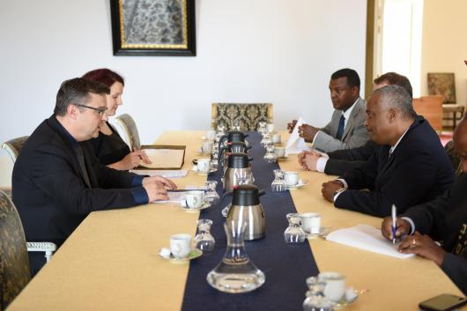

*Meeting at the MFA, Prague, 28 July 2016.*

*Picture: MFA*

***Michal Koudelka appointed head of BIS***

[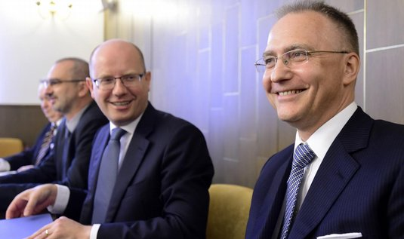](http://zpravy.e15.cz/domaci/udalosti/potvrzeno-novym-reditelem-bis-bude-michal-koudelka-1311199/galerie/?id=251181)The Czech government approved the appointment of Mr Michal Koudelka as the new head of the Civilian Counter-Intelligence Service (BIS) on 27 July 2016. He replaces outgoing BIS head Jiří Lang.

***Africa Live Festival***

An *Africa Live* festival was held in Dvůr Králové Zoo under the auspices of the South African Embassy from 23 to 31 July 2016. The visitors admired African arts and crafts, tasted African food and listened to African music.

 [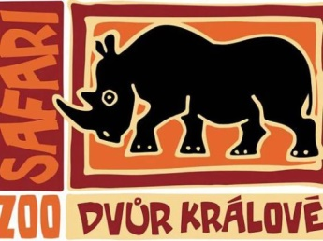](https://www.obrazky.cz/?q=Zoo%20Dvur%20Kralove%20logo&fulltext&mm=2#utm_source=search.seznam.cz&utm_medium=hint&utm_term=Zoo%20Dvur%20Kralove%20logo&utm_content=obrazky&id=689578a2d733255e)

|  |
| --- |
| For more information about the activities of the South African Embassy in Prague please visit our website:  http://[www.saprague.cz](http://www.saprague.cz) |

***Mandela Day 2016***

***Shelter Home of St Gerard for Mothers and Children***

***Brandýs nad Labem***

***18 July 2016***

[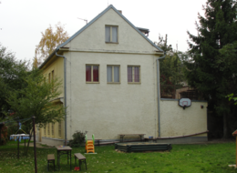](http://praha.charita.cz/res/archive/028/003341_05_042807.png?seek=1428945824)[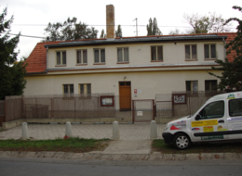](http://praha.charita.cz/res/archive/028/003342_05_042823.png?seek=1428945933)

[Description: Arcidiecézní charita Praha](http://praha.charita.cz/)

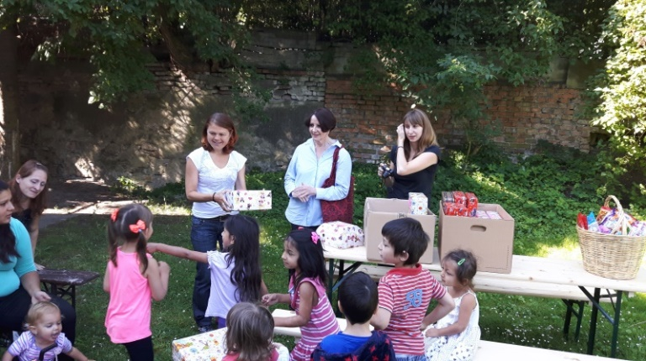

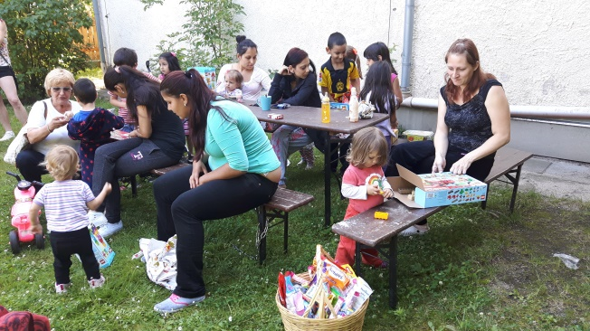 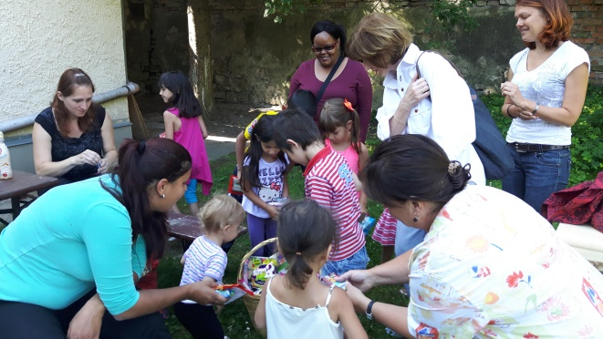

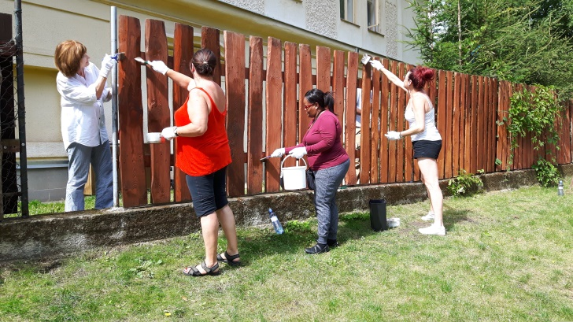

***Bring & Braai***

***Official Residence***

***22 July 2016***



