|  |
| --- |
| [Click on the specific symbol to view its symbolism  [coatofarms.gif 22315 bytes)](http://www.gov.za/_vti_bin/shtml.dll/symbols/coatofarms.htm/map) |
|  |

**EMBASSY OF SOUTH AFRICA  
RUSKA 65, 100 00 PRAGUE 10**

**NEWSLETTER - AUGUST 2016 (No. 8 )**

[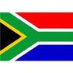](http://www.google.co.za/imgres?imgurl=http://sasportswear.co.za/images/sportswear/south_african_storm_flag.jpg&imgrefurl=http://sasportswear.co.za/sa-memorabilia-7/sports-flags-21/south-african-flag-storm-72.html&h=591&w=591&sz=35&tbnid=Uv7cCdEcYE0-pM:&tbnh=135&tbnw=135&prev=/images?q=South+African+flag&hl=en&usg=__g8gihHXhaZlPhuEToAfXga4s4Hw=&sa=X&ei=IslOTK-nNo-R4Qay7dWoCA&ved=0CAgQ9QEwAQ)



**WORD BY THE AMBASSADOR**

[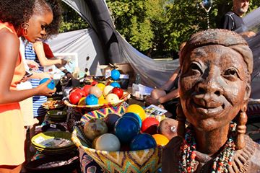](https://www.facebook.com/photo.php?fbid=1193988063957765&set=pcb.1194009963955575&type=3)

*South African stand at the 2016 Vibrant Nine Ethnic Festival, Podviní Park - Prague 9, 27 August 2016*

August: the last month of what has been quite a mild summer in Prague with enough rain to keep the gardens beautifully green. It is also the holiday month in Europe with most families on vacation. While many Praguers were out of town, it seemed as if the space they left behind was filled with tourists from all over the world. The city teemed with groups of visitors happily following their tour guide around the beautiful city.

Workwise, August is traditionally a quiet month for us at the Embassy, giving us an opportunity to catch up with matters that got left aside during previous busy months.

We were very happy to welcome a new colleague at the Embassy when Karen Hosking arrived to take up the post of Counsellor.

**EMBASSY NEWS**

***Visit to Pilsen***

On 23 August, the Ambassador visited Plzeň, West Bohemia. She paid a courtesy call on the Mayor, Mr Martin Zrzavecký and Deputy Mayor Martin Baxa.

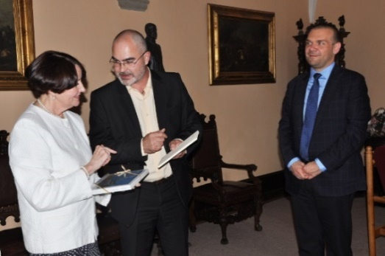

*Ambassador Verwey, Mayor Martin Zrzavecký and Deputy Mayor Martin Baxa.*

*Pictures: E. Kriegerová, Mayor’s Office*

In the evening, the Ambassador attended a wine pairing dinner presented by Hotel Continental Executive Chef Mr. Jan Leitl in cooperation with House of Wine. Ms Elsie Pells, Cape Wine Master, selected and introduced a wide selection of wines from South Africa, California and Italy.

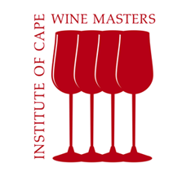 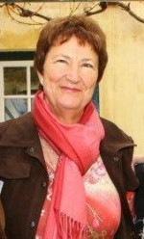

*Ms Elsie Pells*

***Vibrant Nine***

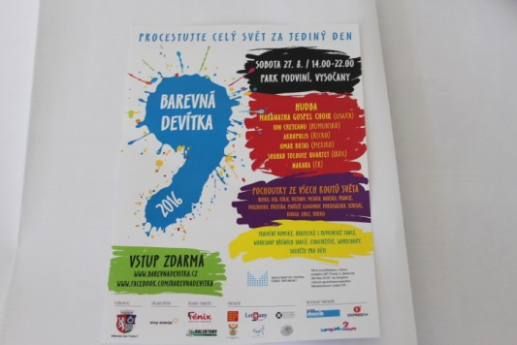

The Embassy hosted a stand at the 2016 *Vibrant Nine Ethnic Festival* held in Prague 9 Podviní Park on 27 August 2016.

The Embassy partnered with Ms Heather Crowther (Tombalina Wines) with her range of South African wines; Mr Jan Brett (Original Afrika) with African arts and crafts; and Ms Diana Růžičková (Kafíčko33) offering RedEspresso and other Rooibos products. They greatly contributed to the success of the event.

[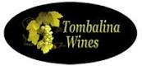](https://www.tombalinawines.cz/img/tombalina-wines-logo-1450614820.jpg) 

[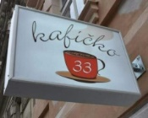](https://www.tripadvisor.com/LocationPhotoDirectLink-g274707-d7123438-i127523265-Kaficko33-Prague_Bohemia.html#127523265)

For more details about the companies please see: [www.tombalinawine.cz](http://www.tombalinawine.cz); [www.original-afrika.cz](http://www.original-afrika.cz); <http://kaficko33.cz/>

[](http://www.tombalinawines.cz/)

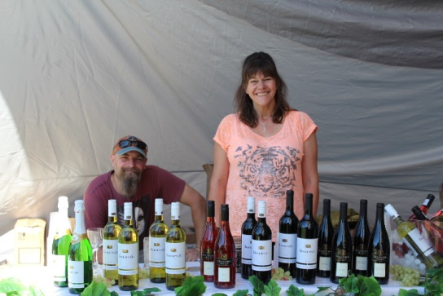

*Ms Heather Crowther & spouse (Tombalina wines)*

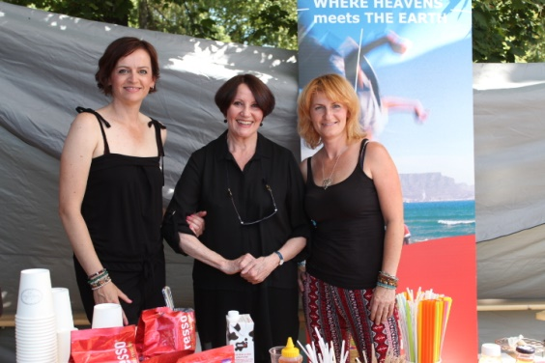

*Ms Diana Růžičková (Kafíčko33), Ambassador Verwey and Ms Helena Brtová (Kafíčko33)*

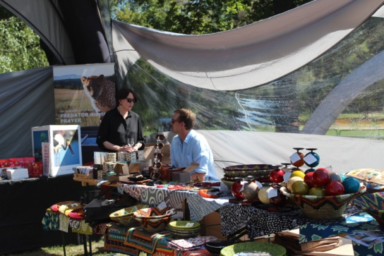

*Ambassador Verwey and Mr Jan Brett (Original Afrika)*

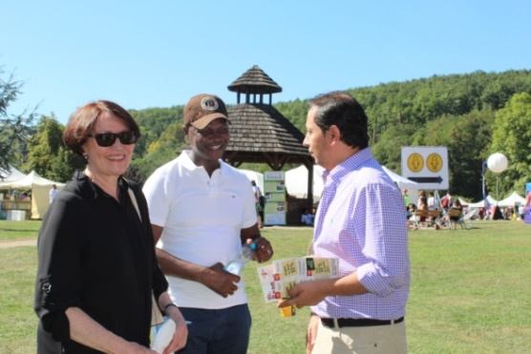

*Ambassador Verwey & Mr Vivian Ncongwane talking to the Counsellor of the Egyptian Embassy, Mr Rany Mohie Eldin Adbellatif KENAWY*

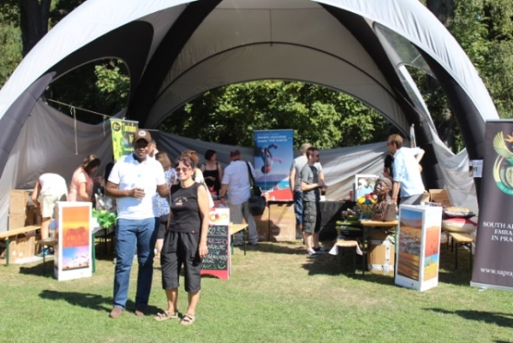

*Mr Ncongwane and Ms Herclová in front of the*

*South African stand*

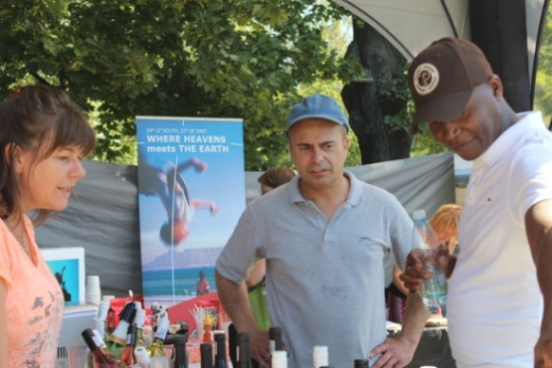

*Ms Crowther, Mr Stifter and Mr Ncongwane*

In spite of tropical weather, hundreds of people visited the festival.

***Meeting with Keith Mackintosh***

[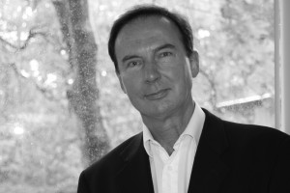](http://balletmasterclass.com/faculty-2013/keith-mackintosh/keith-mackintosh/)Mr Keith Mackintosh, Artistic Executive Director of the Cape Town City Ballet, met the Ambassador on 4 August 2016. Mr Mackintosh was invited by Czech Prima Ballerina Daria Klimentová to teach at the International Ballet Master Class in Prague during summer.

***Diplomatic functions***

The Ambassador attended a working lunch hosted by the Ambassador of Malaysia; farewell lunches for the Ambassador of Belgium hosted by the Ambassadors of Luxembourg and Kuwait; and a farewell dinner for the Canadian Ambassador hosted by the Ambassador of Netherlands.

The new Ambassador of Romania paid a courtesy call on Ambassador Verwey.

**STAFF NEWS/SA CITIZENS**

***Arrival of Ms Hosking***

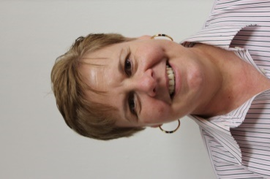Ms Karen Hosking arrived in Prague on 28 August 2016 to take up the post of Political Counsellor at the Embassy.

She is a diplomat with many years of experience.

***We wish our new colleague much success and happiness in her new job.***

***Wedding party for Mr & Mrs Wood***

On 5 August 2016, the Embassy staff gathered at the Official Residence to celebrate the wedding of our colleague, Nick Wood and his wife Markéta. His mother Gillian, on visit from South Africa, was also present.

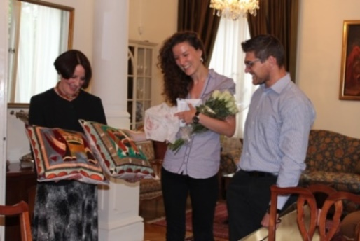

*Ambassador Verwey presenting a wedding gift*

*from the Embassy staff to Markéta and Nick*

**SOUTH AFRICAN NEWS**

***Municipal elections***

On 3 August 2016, elections were held in all nine South African provinces to elect representatives for district, metropolitan and local municipalities.

[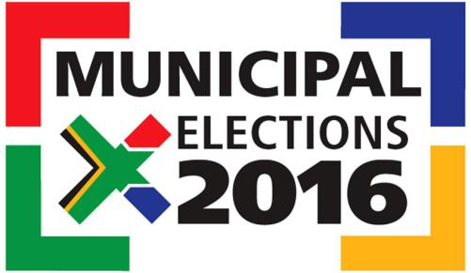](http://www.iol.co.za/news/politics/where-do-parties-stand-amongst-registered-voters-2050498)

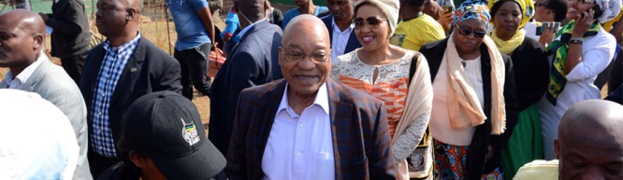

*President Jacob Zuma and his family queue up at Ntolwane Primary School in Nkandla to cast their vote in the 2016 Local Government Elections*

[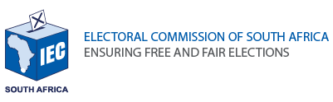](http://www.elections.org.za/content/default.aspx)

Four parties, African National Congress, Democratic Alliance, Economic Freedom Fighters and Inkatha Freedom Party together won about 93 % of the vote.

The ruling ANC won in most of the municipalities, but dropped about 8% of support compared to the previous election.

|  |  |  |
| --- | --- | --- |
| **Party** | [African National Congress](https://en.wikipedia.org/wiki/African_National_Congress)  [African National Congress logo.svg](https://en.wikipedia.org/wiki/File:African_National_Congress_logo.svg) | [Democratic Alliance](https://en.wikipedia.org/wiki/Democratic_Alliance_(South_Africa))  [Democratic Alliance (South Africa) logo 2008.png](https://en.wikipedia.org/wiki/File:Democratic_Alliance_(South_Africa)_logo_2008.png) |
|  | [Jacob Zuma 2014 (cropped).jpg](https://en.wikipedia.org/wiki/File:Jacob_Zuma_2014_(cropped).jpg) | [Mmusi Maimane (cropped).jpg](https://en.wikipedia.org/wiki/File:Mmusi_Maimane_(cropped).jpg) |
| **Leader** | [Jacob Zuma](https://en.wikipedia.org/wiki/Jacob_Zuma) | [Mmusi Maimane](https://en.wikipedia.org/wiki/Mmusi_Maimane) |
| **Last**  **election** | 61.95% | 23.94% |
| **Popular**  **vote** | 16,103,206 | 8,033,630 |
| **Percentage** | 53.91% | 26.90% |
| **Swing** | Decrease8.04% | Increase2.96% |

|  |  |  |
| --- | --- | --- |
| **Party** | [Economic Freedom Fighters](https://en.wikipedia.org/wiki/Economic_Freedom_Fighters)  [Logo of the EFF.png](https://en.wikipedia.org/wiki/File:Logo_of_the_EFF.png) | [Inkatha Freedom Party](https://en.wikipedia.org/wiki/Inkatha_Freedom_Party)  [Inkatha.jpg](https://en.wikipedia.org/wiki/File:Inkatha.jpg) |
|  | [Julius Malema 2011-09-14 cropped.jpg](https://en.wikipedia.org/wiki/File:Julius_Malema_2011-09-14_cropped.jpg) | [Mangosuthu Buthelezi (1983).jpg](https://en.wikipedia.org/wiki/File:Mangosuthu_Buthelezi_(1983).jpg) |
| **Leader** | [Julius Malema](https://en.wikipedia.org/wiki/Julius_Malema) | [Mangosuthu Buthelezi](https://en.wikipedia.org/wiki/Mangosuthu_Buthelezi) |
| **Party** | [Economic Freedom Fighters](https://en.wikipedia.org/wiki/Economic_Freedom_Fighters) | [Inkatha Freedom](https://en.wikipedia.org/wiki/Inkatha_Freedom_Party) |
| **Last**  **election** | --- | 3.57% |
| **Popular**  **vote** | 2,447,353 | 1,268,824 |
| **Percentage** | 8.19% | 4.25% |
| **Swing** | Increase8.19% (new) | Increase0.68% |

*Source: Wikipedia*

The Democratic Alliance won the mayoral posts in South African Metros Johannesburg (Mr Herman Mashaba), Tshwane (Mr Solly Msimanga), Cape Town (Ms Patricia de Lille) and Nelson Mandela Bay (Mr Athol Trollip).

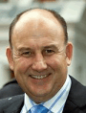 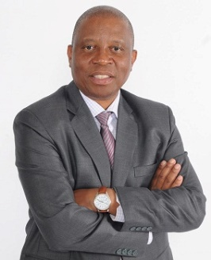 [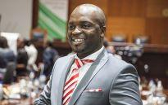](http://ewn.co.za/2016/08/29/Msimanga-gives-mayoral-committee-100-days-to-effect-real-change) [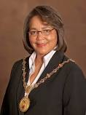](https://www.google.cz/url?url=https://www.capetown.gov.za/en/mayor&rct=j&frm=1&q=&esrc=s&sa=U&ved=0ahUKEwiB06DkiOnOAhWlJsAKHcEdCIEQ_B0IZTAK&usg=AFQjCNFScc9U4dR5DK-0CZK7xqu9n7o5IQ)

*Herman Mashaba Patricia de Lille*

*Solly Msimanga Athol Trollip*

***Visit to Kenya***

President Jacob Zuma participated in the 6th Summit of the Tokyo International Conference on African Development (TICAD VI). The Summit, which was held in Nairobi from 25-28 August 2016 was attended by Japan’s Prime Minister Shinzo Abe as well as 35 African Heads of State.

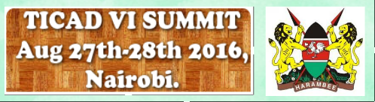

About 140 Japanese firms operate in South Africa and employ over 140 000 South Africans.

***SADC Session in Swaziland***

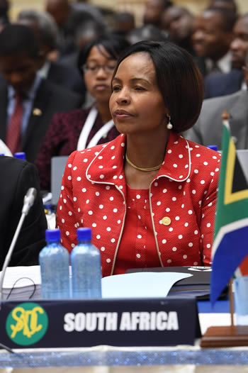President Jacob Zuma attended the 36th Ordinary Session of the Southern African Development Community (SADC) in Mbabane, Swaziland from 29-31 August 2016.

*Minister Maite Nkoana-Mashabane leads the South African delegation at the SADC Council of Ministers Meeting in Mbabane, Kingdom of Swaziland,*

*26 August 2016.*

*Picture: Jacoline Schoonees*

***Twelfth World Islamic Economic Forum***

On 2 August 2016 the Minister of International Relations and Cooperation, Ms Maite Nkoana-Mashabane, attended the Opening Session of the 12th World Islamic Economic Forum (WIEF) under the theme: *Decentralising Growth and Empowering Future Business* inJakarta, Indonesia. The Minister delivered a special address on behalf of President Jacob Zuma*.*

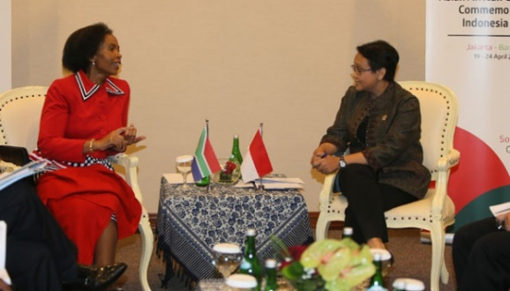

*Indonesian Foreign Minister Retno Marsudi talking to South Africa Foreign Minister Maite Nkoana Mashabane, Jakarta, 2 August 2016. Tempo/Aditia Noviansyah*

***Women’s Month in RSA***

South Africa commemorated Women’s Month in August as a tribute to the more than 20 000 women who marched to the Union Buildings on 9 August 1956 in protest against the extension of Pass Laws to women.

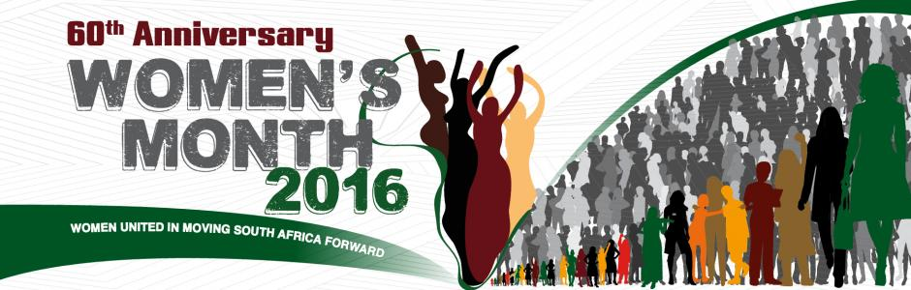

President Jacob Zuma addressed the 60th Anniversary of the National Women’s Day at the Union Buildings in Pretoria under the theme *Women United in Moving South Africa.*

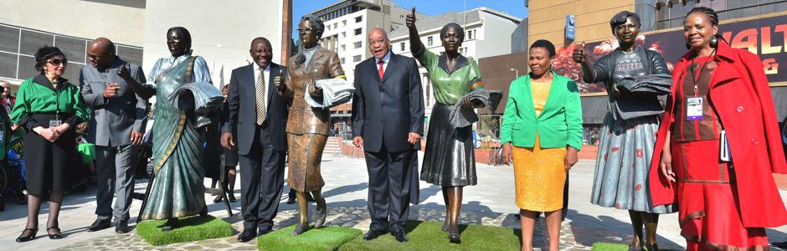

*President Zuma unveils the Women’s Living Heritage Monument. Pretoria, 9 August 2016.*

*Picture: The Presidency*

***Gertrude Shope Annual Dialogue Forum***

The Department of International Relations and Cooperation hosted the Gertrude Shope Dialogue Forum on Conflict Resolution and Peace-Making themed *Women in Conflict Resolution and Peace Building* from11-12 August 2016.

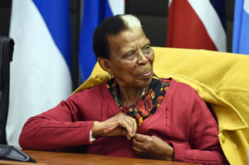*Ms Gertrude Shope at the Annual Dialogue Forum, Pretoria, South Africa, 11 August 2016. Picture: Jacoline Schoones*

On 12 August 2016 the International Relations and Cooperation Minister Ms Maite Nkoana-Mashabane delivered a statement entitled *60 years of leadership: The role of women in moving South Africa, Africa and the world forward*.

Minister Maite Nkoana-Mashabane delivered the Keynote Address at the Thirteenth Annual Top Women Awards Ceremony at the Emperors Palace, Kempton Park, South Africa on 18 August 2016.

[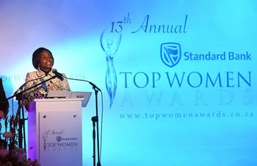](http://www.dirco.gov.za/images/gallery8/mashabane_top_woman_award_2016_4.jpg)

*Picture: Jacoline Schoonees*

**CZECH NEWS**

***German Chancellor*** ***visited Prague***

German Chancellor Angela Merkel visited the Czech Republic on 25 August 2016.

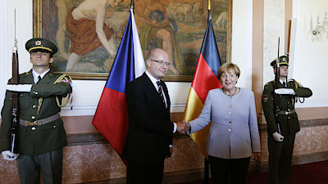

*Prime Minister Bohuslav Sobotka and German Chancellor Angela Merkel, Prague, 25 August 2016.*

*Picture: The Government*

Angela Merkel met the Czech Prime Minister Bohuslav Sobotka, President Miloš Zeman and other personalities. The main topics were the continuation of Czech-German strategic dialogue and cooperation in science, research and modern technologies, as well as modernization of transport infrastructure and cooperation on security issues.

***V4 meeting in Warsaw***

Prime Minister Bohuslav Sobotka attended the Summit of the Visegrad Group in Warsaw on 26 August 2016 to discuss the future of the European Union and other topics. Chancellor Angela Merkel was the guest of honour at the Summit.

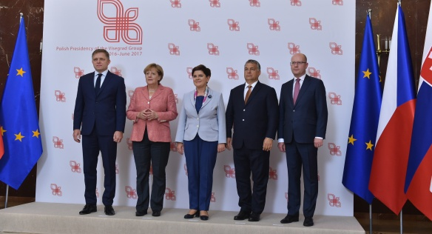

*Visegrad Group Prime Ministers and German Chancellor Angela Merkel, Warsaw, 26 August 2016*

*Picture: The government*

***General Šebesta takes over command of Czech Airforce***

On 9 August 2016, Brigadier [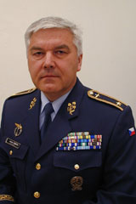](http://www.acr.army.cz/images/lide/sebesta/BG_SebestaV.jpg)General Jaromír Šebesta took over command of the Czech Air Force from General Libor Štefánik. The Czech Air Force has 5,400 pilots who fly Gripen planes, helicopters and CASA transport planes.

***Security beefed up at Prague Castle***

In response to the deterioration of the security situation all around Europe, from the beginning of August 2016 all visitors to Prague Castle have to undergo security checks before being admitted inside. Metal detectors are gradually installed at the entrance gates.

***Olympic champion*** ***Věra Čáslavská died***

[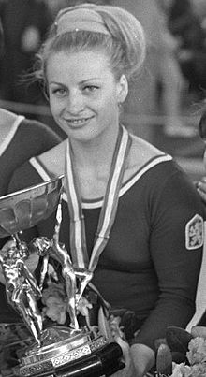](https://en.wikipedia.org/wiki/File:Vera_Caslavska.JPG)Czech Olympic champion gymnast Věra Čáslavská died after a long battle with pancreatic cancer on 30 August 2016 aged 74. Čáslavská is the most decorated Czech gymnast in history: she won seven gold medals at two consecutive Olympics (3 medals in Tokyo in 1964 and 4 medals in 1968 in Mexico City).

***Rio 2016 Summer Olympics***

|  |
| --- |
| Description: http://results.nbcolympics.com/imgml/customer/header/logo.png  Description: Image result for rio medal 2016  ***SOUTH AFRICA CZECH REPUBLIC***  South Africa FlagCzech Republic Flag  ***137 competitors 105 competitors***  ***in 15 sports in 20 sports***  ***Medals: 10 Medals: 10***  ***2 gold, 6 silver, 1 gold, 2 silver,***  ***2 bronze 6 bronze***    ***Rank: 30 Rank: 43***    *For more details see the attachment to the Newsletter.* |

|  |
| --- |
| For more information about the activities of the South African Embassy in Prague please visit our website:  http://[www.saprague.cz](http://www.saprague.cz) |

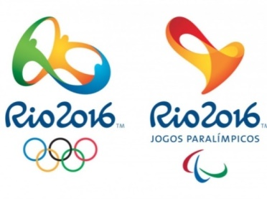 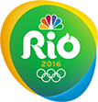 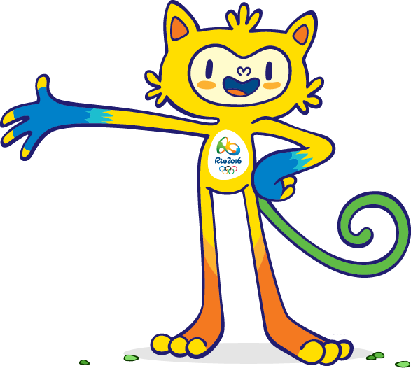

**REPUBLIC OF SOUTH AFRICA** [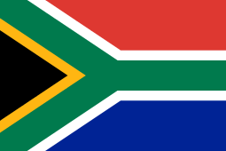](https://en.wikipedia.org/wiki/File:Flag_of_South_Africa.svg)

|  |  |  |  |  |
| --- | --- | --- | --- | --- |
| **Medal** | **Name** | | **Sport** | **Event /Date** |
| Gold  Description: Image result for rio medal 2016 | Wayde van Niekerk | Wayde van Niekerk of South Africa presents his gold medal as he poses on the podium after the men's 400 metres final during the 15th IAAF World Championships at the National Stadium in Beijing, China, August 27, 2015.   REUTERS/Damir Sagolj | Athletics | Men’s 400 metres  14/8/2016 |
| Gold  Description: Image result for rio medal 2016 | [Caster Semenya](https://en.wikipedia.org/wiki/Caster_Semenya) | [Gold medallist Caster Semenya poses on the podium for the Women's 800m Final during the Rio 2016 Olympic Games.  Picture: AFP](http://ewn.co.za/2016/08/22/its-a-wrap-for-Team-SA-after-successful-Rio-Games-campaign) | Athletics | [Women's 800 metres](https://en.wikipedia.org/wiki/Athletics_at_the_2016_Summer_Olympics_%E2%80%93_Women%27s_800_metres)  20/8/2016 |
| Silver  Description: Image result for rio medal 2016 | Cameron van der Burgh | Cameron van der Burgh poses on the podium after he won the bronze medal in the Men’s 100m Breaststroke Final during the swimming event at the Rio 2016 Olympic Games at the Olympic Aquatics Stadium in Rio de Janeiro on 7 August, 2016. Picture: AFP. | Swimming | Men ‘s 100m breaststroke  7/8/2016 |
| Silver  Description: Image result for rio medal 2016 | Chad le Clos | South Africa’s Chad Guy Bertrand Le Clos poses with his silver medal on the podium of the Men’s 200m Freestyle during the swimming event at the Rio 2016 Olympic Games at the Olympic Aquatics Stadium in Rio de Janeiro on 8 August, 2016. Picture: AFP. | Swimming | Men’s 200 m freestyle  8/8/2016 |
| Silver  Description: Image result for rio medal 2016 | Men’s 100 m butterfly  12/8/2016 |
| Silver  Description: Image result for rio medal 2016 | Lawrence Brittain  Shaun Keeling | https://images.enca.com/encadrupal/styles/600_383/s3/Keeling_Brittain.jpg | Rowing | Men’s coxless pair  11/8/2016 |
| Silver  Description: Image result for rio medal 2016 | Luvo Manyonga | https://ssl.gstatic.com/onebox/media/olympics/photos/o16/live/RIOEC8E03X01D_768x432.JPG | Athletics | Men’s long jump  13/8/2016 |
| Silver  Description: Image result for rio medal 2016 | Sunette Viljoen | https://ssl.gstatic.com/onebox/media/olympics/photos/o16/headshots/MTZSPDEC71N5KI67_128x128.JPG | Athletics | [Women's javelin throw](https://en.wikipedia.org/wiki/Athletics_at_the_2016_Summer_Olympics_%E2%80%93_Women%27s_javelin_throw)  18/8/2016 |
| Bronze  Description: Image result for rio medal 2016 | South Africa national rugby seven team | | Rugby seven | Men’s tournament  11/8/2016 |
| Rugby sevens men  https://ssl.gstatic.com/onebox/media/olympics/photos/o16/headshots/MTZSPDEC8BQ9MENN_128x128.JPG https://ssl.gstatic.com/onebox/media/olympics/photos/o16/headshots/MTZSPDEC7S1NBCLU_128x128.JPG https://ssl.gstatic.com/onebox/media/olympics/photos/o16/headshots/MTZSPDEC7LOSOPFJ_128x128.JPG https://ssl.gstatic.com/onebox/media/olympics/photos/o16/headshots/MTZSPDEC8BQ955KV_128x128.JPG https://ssl.gstatic.com/onebox/media/olympics/photos/o16/headshots/MTZSPDEC817RBUPH_128x128.JPG  *Dylan Sage Philippus Snyman Timothy Agaba Kwagga Smith Werner Kok*  https://ssl.gstatic.com/onebox/media/olympics/photos/o16/headshots/MTZSPDEC7PVO6EWH_128x128.JPG https://ssl.gstatic.com/onebox/media/olympics/photos/o16/headshots/MTZSPDEC7U3Y7RZ1_128x128.JPG https://ssl.gstatic.com/onebox/media/olympics/photos/o16/headshots/MTZSPDEC8CS5M03T_128x128.JPG https://ssl.gstatic.com/onebox/media/olympics/photos/o16/headshots/MTZSPDEC7U3ZJK27_128x128.JPG https://ssl.gstatic.com/onebox/media/olympics/photos/o16/headshots/MTZSPDEC7LOSOPFJ_128x128.JPG  *Kyle Brown Cheslin Kolbe Rosko Speckman Justin Geduld Cecil Afrika*  https://ssl.gstatic.com/onebox/media/olympics/photos/o16/headshots/MTZSPDEC7T200Z11_128x128.JPG https://ssl.gstatic.com/onebox/media/olympics/photos/o16/headshots/MTZSPDEC8CS51SVZ_128x128.JPG Francois Hougaard gave his bronze medal to teammate Seabelo Senatla.  *Seabelo Senatla Juan de Jongh Francois Hougaard* | | | |
| Bronze  Description: Image result for rio medal 2016 | Henri Schoeman | https://ssl.gstatic.com/onebox/media/olympics/photos/o16/live/RIOEC8I1AHEBZ_768x432.JPG | Triathlon | Men triathlon  18/8/2016 |
| TOTAL: 10 = 2 gold + 6 silver + 2 bronze  Description: Image result for rio medal 2016 Description: Image result for rio medal 2016 Description: Image result for rio medal 2016 Description: Image result for rio medal 2016 Description: Image result for rio medal 2016 Description: Image result for rio medal 2016 Description: Image result for rio medal 2016 Description: Image result for rio medal 2016 Description: Image result for rio medal 2016 Description: Image result for rio medal 2016  Athlete Wayde van Niekerk broke the 17-year-old 400m world record to win Olympic gold at Rio 2016. He finished the men’s 400 metres run in 43.03 seconds, 0.15 quicker than Michael Johnson in Seville in 1999. | | | | |

**CZECH REPUBLIC**  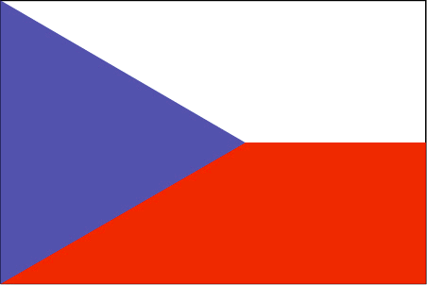

|  |  |  |  |  |
| --- | --- | --- | --- | --- |
| **Medal** | **Name** | | **Sport** | **Event** |
| Gold  Description: Image result for rio medal 2016 | Lukáš Krpálek | [http://img.radio.cz/new-banners/en/promo-bottom/krpalek2.jpg](http://www.radio.cz/en/section/curraffrs/krpalek-clinches-olympic-gold-in-judo-competition) | Judo | Men’s 100 kg  11/8/2016 |
| Silver  Description: Image result for rio medal 2016 | Josef Dostál | Description: https://ssl.gstatic.com/onebox/media/olympics/photos/o16/headshots/MTZSPDEC7KMKUNLA_128x128.JPG | Canoeing | Men’s K-1  1000metres  16/8/2016 |
| Silver  Description: Image result for rio medal 2016 | [Jaroslav Kulhavý](https://en.wikipedia.org/wiki/Jaroslav_Kulhav%C3%BD) | https://ssl.gstatic.com/onebox/media/olympics/photos/o16/live/RIOEC8L1DSRDR_768x432.JPG | Cycling | [Men's cross-country](https://en.wikipedia.org/wiki/Cycling_at_the_2016_Summer_Olympics_%E2%80%93_Men%27s_cross-country)  21/8/2016 |
| Bronze  Description: Image result for rio medal 2016 | Jiří Prskavec | https://ssl.gstatic.com/onebox/media/olympics/photos/o16/headshots/MTZSPDEC8DTVN14N_128x128.JPG | Canoeing | Men’s K-1  10/8/2016 |
| Bronze  Description: Image result for rio medal 2016 | Ondřej Synek | https://ssl.gstatic.com/onebox/media/olympics/photos/o16/headshots/MTZSPDEC71N63BB3_128x128.JPG | Rowing | Men’s single sculls  13/8/2016 |
| Bronze  Description: Image result for rio medal 2016 | Petra Kvitová | [https://upload.wikimedia.org/wikipedia/commons/thumb/d/d7/Petra_Kvitov%C3%A1_French_Open_2016.jpg/250px-Petra_Kvitov%C3%A1_French_Open_2016.jpg](https://commons.wikimedia.org/wiki/File:Petra_Kvitov%C3%A1_French_Open_2016.jpg) | Tennis | Women’s singles  13/8/2016 |
| Bronze  Description: Image result for rio medal 2016 | Lucie Šafářová  Barbora Strýcová | https://ssl.gstatic.com/onebox/media/olympics/photos/o16/headshots/MTZSPDEC7V5RJXIL_128x128.JPG https://ssl.gstatic.com/onebox/media/olympics/photos/o16/headshots/MTZSPDEC7S1LWDJP_128x128.JPG | Tennis | Women’s doubles  13/8/2016 |
| Bronze  Description: Image result for rio medal 2016 | Lucie Hradecká  Radek Štěpánek | Description: Tenisový pár Lucie Hradecká, Radek Štěpánek přehrál v souboji o bronz z mixu Indy Mirzaovou a Bopannu. (14. srpna 2016) | Tennis | Mixed doubles  14/8/2016 |
| Bronze  Description: Image result for rio medal 2016 | Barbora Špotáková | https://ssl.gstatic.com/onebox/media/olympics/photos/o16/headshots/MTZSPDEC7FDCFNT1_128x128.JPG | Athletics | Women’s javelin throw 19/8/2016 |
| Bronze  Description: Image result for rio medal 2016 | [Josef Dostál](https://en.wikipedia.org/wiki/Josef_Dost%C3%A1l_(canoeist)) [Daniel Havel](https://en.wikipedia.org/wiki/Daniel_Havel) [Jan Štěrba](https://en.wikipedia.org/wiki/Jan_%C5%A0t%C4%9Brba) [Lukáš Trefil](https://en.wikipedia.org/wiki/Luk%C3%A1%C5%A1_Trefil) | [Čtyřkajak ve složení Daniel Havel, Lukáš Trefil, Josef Dostál, Jan Šterba - Foto:  ASC Dukla](http://media.rozhlas.cz/_obrazek/3689190--ctyrkajak-ve-slozeni-daniel-havel-lukas-trefil-josef-dostal-jan-sterba--1-950x0p0.jpeg) | Canoeing | [Men's K-4 1000 m](https://en.wikipedia.org/wiki/Canoeing_at_the_2016_Summer_Olympics_%E2%80%93_Men%27s_K-4_1000_metres)  20/8/2016 |
|  | Description: https://ssl.gstatic.com/onebox/media/olympics/photos/o16/headshots/MTZSPDEC7KMKUNLA_128x128.JPG Description: https://ssl.gstatic.com/onebox/media/olympics/photos/o16/headshots/MTZSPDEC8BQ9MDNI_128x128.JPG Description: https://ssl.gstatic.com/onebox/media/olympics/photos/o16/headshots/MTZSPDEC76VGXAVA_128x128.JPG Description: https://ssl.gstatic.com/onebox/media/olympics/photos/o16/headshots/MTZSPDEC829FHUV0_128x128.JPG  [***Josef Dostál***](https://en.wikipedia.org/wiki/Josef_Dost%C3%A1l_(canoeist))[***Daniel Havel***](https://en.wikipedia.org/wiki/Daniel_Havel)[***Jan Štěrba***](https://en.wikipedia.org/wiki/Jan_%C5%A0t%C4%9Brba)[***Lukáš Trefil***](https://en.wikipedia.org/wiki/Luk%C3%A1%C5%A1_Trefil) | | | |
| TOTAL: 10 = 1 gold + 2 silver + 7 bronze  Description: Image result for rio medal 2016 Description: Image result for rio medal 2016 Description: Image result for rio medal 2016 Description: Image result for rio medal 2016 Description: Image result for rio medal 2016 Description: Image result for rio medal 2016 Description: Image result for rio medal 2016 Description: Image result for rio medal 2016 Description: Image result for rio medal 2016 Description: Image result for rio medal 2016 | | | | |