|  |
| --- |
| [Click on the specific symbol to view its symbolism  [coatofarms.gif 22315 bytes)](http://www.gov.za/_vti_bin/shtml.dll/symbols/coatofarms.htm/map) |
|  |

**EMBASSY OF SOUTH AFRICA**

**RUSKA 65, 100 00 PRAGUE 10**

**NEWSLETTER - SEPTEMBER 2016 (No.9 )**

[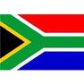](http://www.google.co.za/imgres?imgurl=http://sasportswear.co.za/images/sportswear/south_african_storm_flag.jpg&imgrefurl=http://sasportswear.co.za/sa-memorabilia-7/sports-flags-21/south-african-flag-storm-72.html&h=591&w=591&sz=35&tbnid=Uv7cCdEcYE0-pM:&tbnh=135&tbnw=135&prev=/images?q=South+African+flag&hl=en&usg=__g8gihHXhaZlPhuEToAfXga4s4Hw=&sa=X&ei=IslOTK-nNo-R4Qay7dWoCA&ved=0CAgQ9QEwAQ)



**WORD BY THE AMBASSADOR**

September in Europe always has a back-to-school feel as life and business returns to normal after the summer holiday period.

We started off our activities for the autumn period with an event at the Official Residence to promote tourism to South Africa. As we talked about places to visit in South Africa, I had a nostalgic vision of golden beaches and mountains.

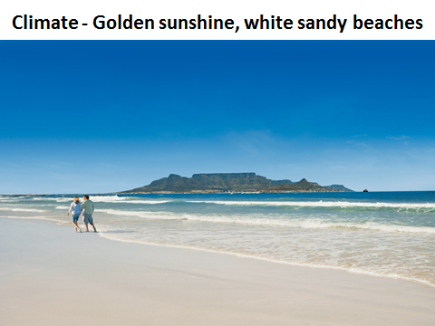

September is Heritage Month in South Africa when we commemorate our diversity. At Head Office in Pretoria, many officials wear their national dress for one day during the month, creating a kaleidoscope of colours and styles. It is always a reminder how the diversity of South Africa’s Rainbow Nation adds depth and richness.

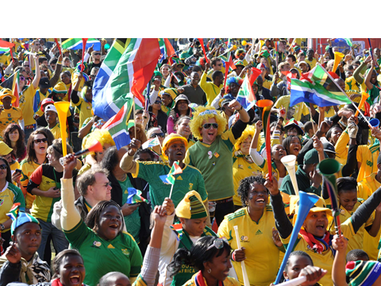

**EMBASSY NEWS**

***Joint event with SAA***

The Embassy teamed up with the representatives in Prague of South African Airways (SAA) and Travel Advance/SW Africa Destination Management to organize a tourism promotional event at the Official Residence on 8 September 2016. It was attended by managers from travel agencies and tour operators in Prague. Mr Petr Gol gave a presentation on the services offered by SAA; followed by a film on tourism attractions in South Africa.

**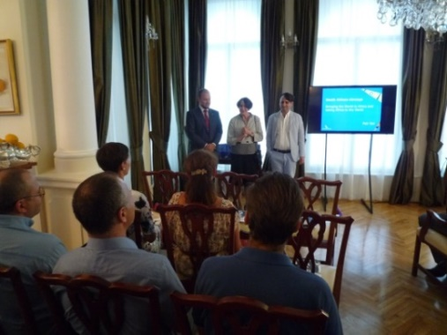**

*Mr Petr Gol (SAA), Ambassador Verwey*

*and Mr Paddington Tucker open the event*

**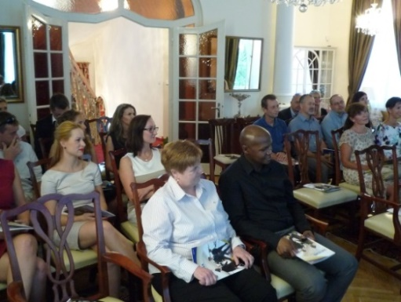**

*Ms Hosking, Mr Ncongwane and representatives*

*of travel organisations watching the presentation*

***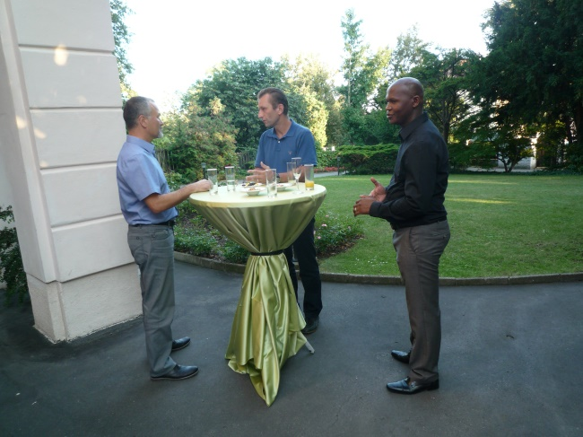 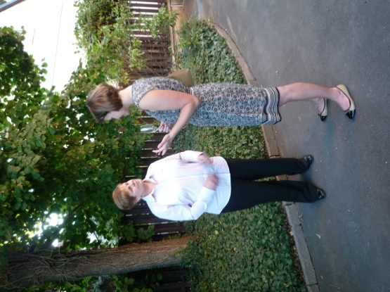***

*Mr Ncongwane and Ms Hosking talking to the guests*

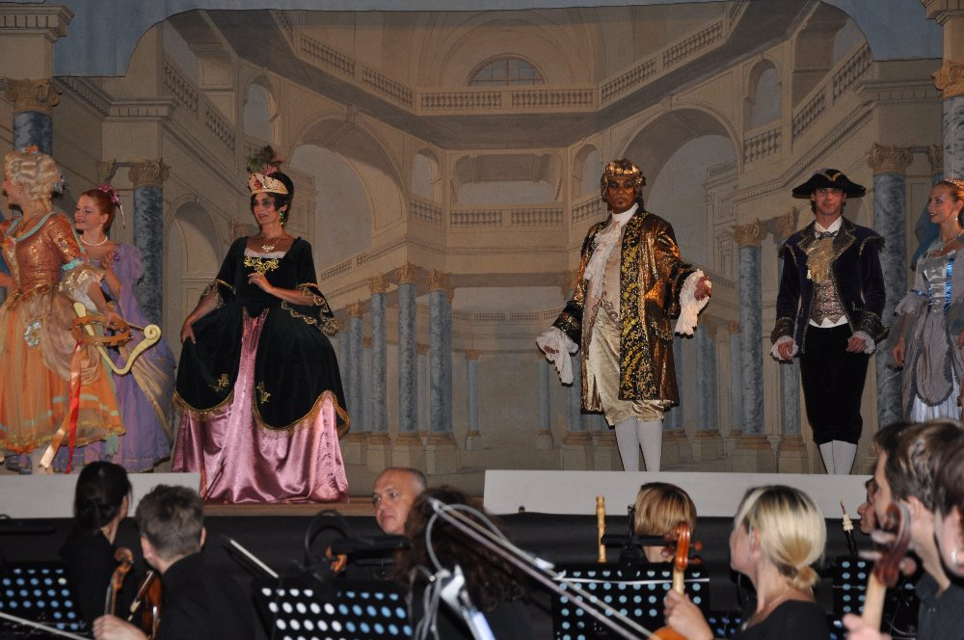***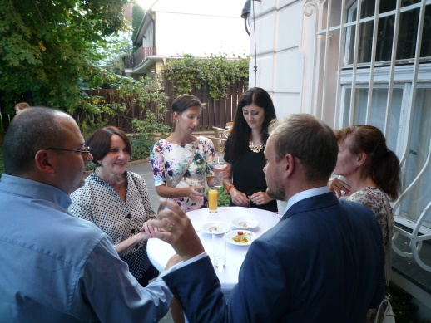***

*Ambassador Verwey among the guests*

It was a warm early autumn evening and the guests enjoyed a typical “braai” in the Residence garden with South African wines.

***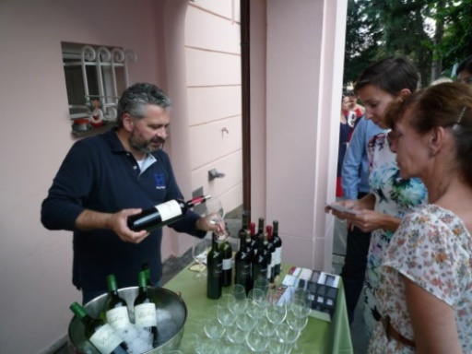***

*Mr Zdeněk Lang from Cape Point Wine*

*Bar presenting South African wines*

***Czech Foreign Policy Symposium***

**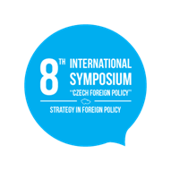**The Ambassador and Counsellor attended the 8th International Symposium *Czech Foreign Policy* organised by the Institute of International Relations in Prague in cooperation with the Ministry of Foreign Affairs on 22 September 2016 under the topic *Strategy in Foreign Policy*.

***Czech Aerospace Industry Day***

The Ministry of Defence in co-operation with the Ministry of Industry & Trade organized a Czech Aerospace Industry Day including the demonstration of aerospace technology and equipment for members of the Diplomatic Corps and Defence Attachés accredited to the Czech Republic at the premises of the LOM company in Kbely, Prague 8 on 1 September 2016.

***Countertenor Roger Isaac in Prague***

A well known South African countertenor, Mr Roger Isaacs, visited Prague to perform the role of Apollon in the opera *Terpsicore* by G. F. Hӓndel on 8 September 2016. Ms Herclová and Ms Hlávková from the Embassy attended the performance rehearsal in the unique baroque theatre Florea Theatrum and enjoyed a wonderful musical experience.

***Diplomatic functions***

The Ambassador attended a working breakfast hosted by the Ambassador of Morocco; National Days of Armenia, Chile, China, Macedonia, Mexico, Moldova, Saudi Arabia and Slovakia; an awards ceremony hosted by US Ambassador; a welcome lunch hosted by the Swiss Ambassador for the new Ambassadors of Belgium, Canada and Sweden; a farewell lunch for French Ambassador hosted by Ambassador of Germany; a farewell reception hosted by Ambassador of Brazil; a farewell dinner for the Brazilian Ambassador hosted by Ambassador of Luxembourg; a farewell BBQ hosted by outgoing Ambassador of Canada.

The Ambassador also attended Pakistani Mango Day and Malaysia Food Festival hosted by the relevant Embassies; and a performance by Peruvian mezzo-soprano Fátima Espinosa de Zavala hosted by the Ambassador of Peru.

Ambassador hosted a diplomatic working lunch at the Official Residence on 26 September 2016.

**South African architect Kate Otten to give lecture in Prague**

Ambassador Verwey met Ms Čermáková from the Civic Association Kruh (Circle) which organizes lectures on architecture by leading Czech and foreign architects.

This year, a South African architect Kate Otten will give a lecture in Kino Světozor in Prague on 1 December 2016.

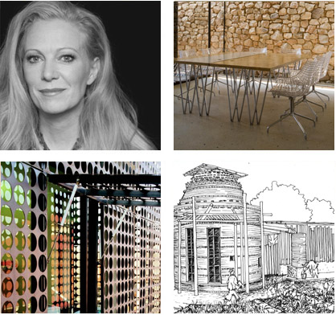

For more details about Kate Otten, please see

[**http://www.kateottenarchitects.com/**](http://www.kateottenarchitects.com/)

The Embassy will partner with Kruh on this occasion.

***Visit of Deputy Minister Kuchta to RSA***

Deputy Minister of Defence Mr Tomáš Kuchta and a delegation participated in the Africa Aerospace and Defence Exhibition held at the Air Force Base Waterkloof, [Midrand](http://10times.com/midrand-za/tradeshows),  [South Africa](http://10times.com/southafrica/tradeshows) from 14-18 September 2016.

. [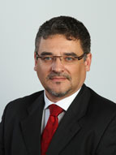](http://www.army.cz/images/lide/kuchta/kuchta-tomasV.jpg)

*Deputy Minister Tomáš Kuchta*

Prior to his departure for South Africa, Ambassador hosted Deputy Minister Kuchta and his delegation at a small event.

**STAFF NEWS/SA CITIZENS**

***Social meeting***

The Embassy staff gathered at the Official Residence on 16 September 2016 at a special Embassy team building event to welcome our new colleague, Ms Karen Hosking. The team had a lot of fun holding a darts competition.

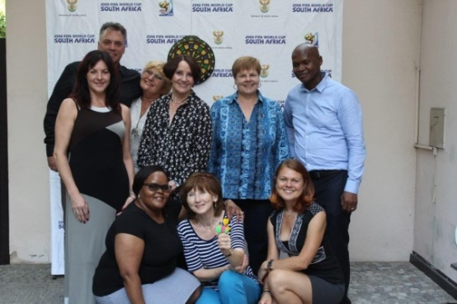

*Ms Jelinek, Mr Walters, Ms Procházková, Ambassador Verwey, Ms Hosking & Mr Ncongwane.*

*Sitting: Ms Radebe-Mothibe, Ms Růžičková and Ms Hlávková*

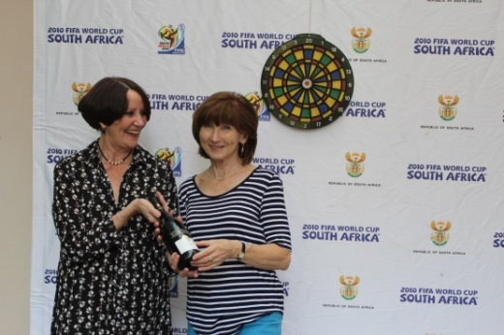

*Ambassador Verwey awarding a bottle of South African wine*

*to Alena Růžičková, winner of the darts competition*

***Birell Grand Prix Praha***

The *Birell Prague Grand Prix* 10 km evening race was held in the historic center of Prague on 10 September 2016. Mr Ncongwane and Ms Hlávková participated in the race and achieved very good times in spite of tropical weather.

***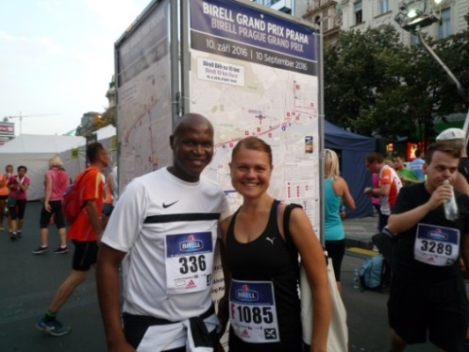***

Congratulations!

**SOUTH AFRICAN NEWS**

***CITES COP 17***

The 17th meeting of the Conference of the Parties to the Convention on the International Trade in Endangered Species of Wild Fauna and Flora (CITES COP 17) takes place at the Sandton Convention Centre in Johannesburg from 24 September - 5 October 2016.

[](http://cites.org/cop17)

South Africa, one of the first signatories to CITES in 1975, continues to play an active role in the implementation and enforcement of the convention.

***UNGA71 session in New York***

President Jacob Zuma attended the general debate of the 71st session of the United Nations General Assembly (UNGA71) held in New York, USA from 20-26 September 2016 under the theme *The Sustainable Development Goals: A Universal Push to Transform our World.*

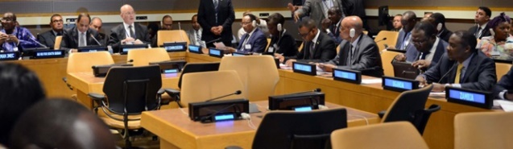

*President Jacob Zuma addressing the Opening Plenary of the High Level Summit of the United Nations General Assembly*

***G20 Leaders’ Summit in China***

President Jacob Zuma led the South African delegation to the G20 Leaders’ Summit held in Hangzhou, China from 3-5 September 2016 under the theme *Towards An Innovative, Invigorated, Interconnected and Inclusive World Economy.*

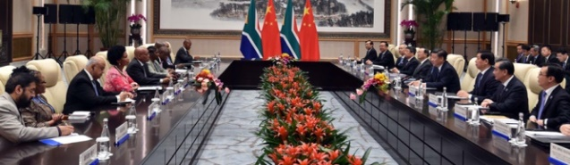

*Bilateral meeting between President Jacob Zuma and President Xi Jinping of China ahead of the G20 Leaders' Summit in China. Picture: The Presidency*

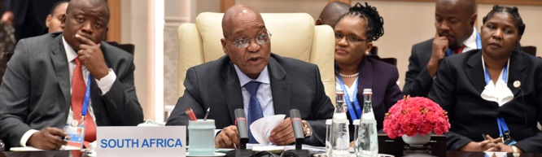

*President Zuma during* *BRICS Leaders’ Informal Meeting which annually meets on the margins of the G20 Summit, 4 September 2016,* *Hangzhou, China.*

*Picture: The Presidency*

***Investing in Africa Forum***

President Zuma attended the *2nd Investing in Africa Forum* in Guanghou, China on 7 September 2016 to promote experience-sharing between China and Africa and accelerate Chinese investments on the African continent.

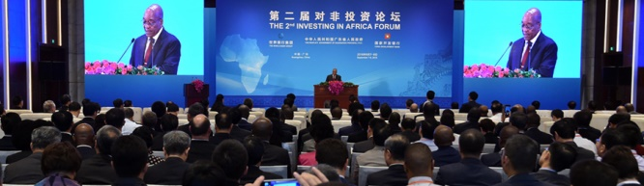

*President Zuma addressing the 2nd Investing in Africa Forum, 7 September 2016, Guangzhou, China. Picture: The Presidency.*

[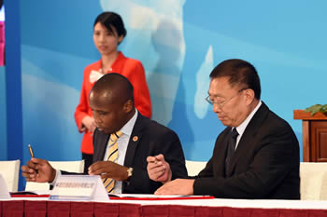](http://www.dirco.gov.za/images/gallery8/letsoalo_prasa_ccc_zhen_china3.jpg)

*The Acting Group CEO of Prasa, Mr Collins Letsoalo, and the Vice President of CCC, Mr Zhen Shaohua, sign the Memorandum of Understanding between Prasa and the China Communications Construction (CCC) on the Moloto Rail Corridor, Gungzhou, PRC, 7 September 2016.*

*Picture: Jacoline Schoonees*

***UN Seminar on Peace in the Middle East***

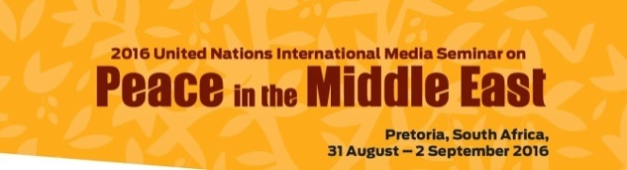

The South African Government co-hosted the United Nations International Media Seminar on Peace in the Middle East in Pretoria, South Africa, from 31 August - 2 September 2016.

The purpose of the seminar was to sensitise public opinion and media coverage on the peace processes and to enhance dialogue between the Israelis and Palestinians.

***Second Medupi Unit added to National Grid***

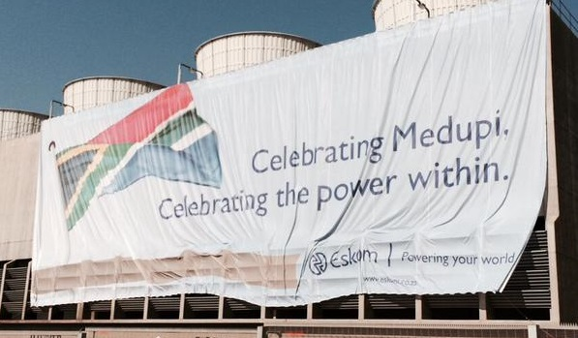

Unit 5 of Eskom’s Medupi power station was synchronized to the national grid on 8 September 2016, becoming the second of Medupi’s six units to come on stream. The Medupi power station was opened by President Jacob Zuma just over a year ago. Once completed, it will be largest dry-cooled power station in the world.

***Heritage Month and Day***

***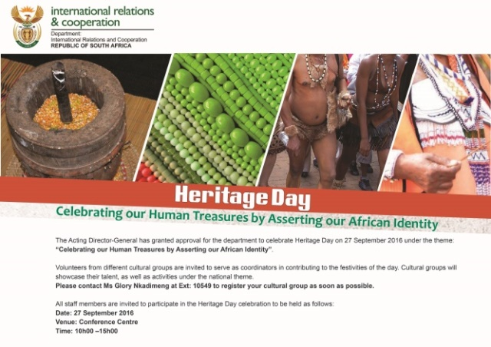***

South Africa celebrated Heritage Day on 24 September 2016 by remembering the diverse cultural heritage, beliefs and traditions of the *rainbow nation.*

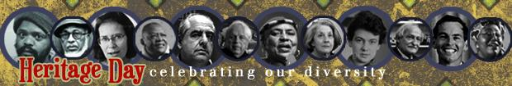

This year, Heritage Month was celebrated under the theme *Celebrating our* *Human Treasures by Asserting our African Identity*.

**CZECH NEWS**

***President Zeman met Norbert Hofer***

President Miloš Zeman met Austrian presidential candidate and leader of the Freedom Party Norbert Hofer on 12 September 2016 to discuss moves to boost the importance of Central Europe within the EU, as well as Temelín nuclear power plant and Beneš decrees.

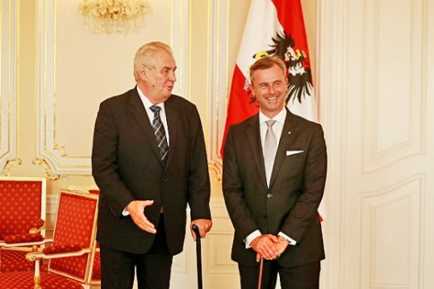

*Czech President Miloš Zeman welcomes Austrian presidential candidate Norbert Hofer at the Castle, Prague, 12 September 2016. Picture: The Castle*

***Visit of Bulgarian President***

Bulgarian President Rosen Plevneliev paid a two-day visit to the Czech Republic on September 5-6 to meet his Czech counterpart Miloš Zeman and other leading politicians. The two presidents primarily discussed migration, economic cooperation and Czech investments to Bulgaria.

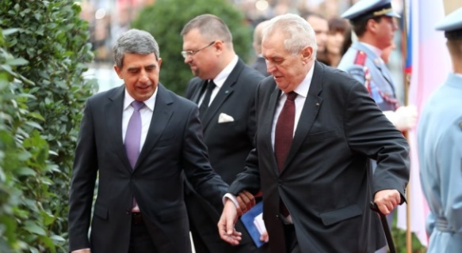

*Presidents Rosen Plevneliev and Miloš Zeman* *during the* *welcoming ceremony at Prague Castle, September 5, 2016. Picture: The Castle*

***Czech and Slovak governments met in Bratislava***

The Czech and Slovak governments held a joint working session on 26 September 2016. Security issues, cooperation in defence and transport, as well as EU unity in the Brexit talks were discussed.

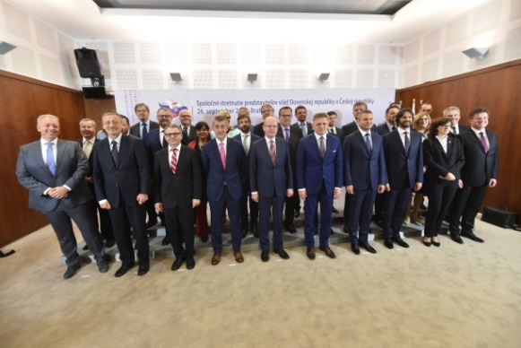

*Family photo of the members of the Czech and Slovak governments. Picture: The Government*

***EU Summit in Bratislava***

Prime Minister Bohuslav Sobotka attended the EU summit in Bratislava on September 16. The Summit was focused mainly on post-Brexit EU reforms.

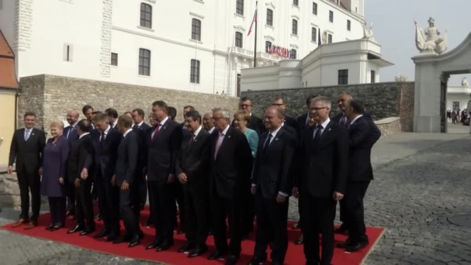

*Informal meeting of 27 Heads of State or Government, Bratislava, 16 September 2016.*

*Picture: The Government*

***V4 Summit in Poland***

Visegrad Group Prime Ministers met their Ukrainian counterpart Volodymyr Groysman at the 26th Economic Forum in Krynica, Poland on September 6, 2016. The Visegrad Group countries expressed their support for Ukraine’s eventual joining of the EU

[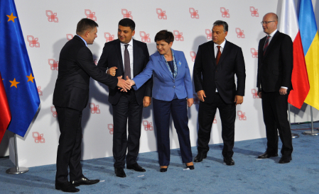](http://www.radio.cz/en/section/curraffrs/v4-bloc-seeks-united-front-ahead-of-eu-summit)

*Prime Ministers Robert Fico (Slovakia), Volodymyr Groysman (Ukraine), Beata Szydlo (Poland), Victor Orbán (Hungary) and Bohuslav Sobotka (Czech Republic),* *Krynica, 6 September 2016. Picture: CTK*

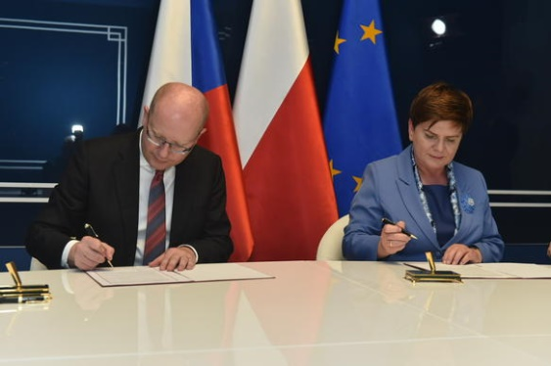

*On the sidelines of the V4 Summit, Prime Ministers Bohuslav Sobotka and Beata Szydlo signed* ***a memorandum of cooperation on the Stork II gas pipeline****.*

***Rio 2016 Summer Paralympics***

|  |
| --- |
| ***7 – 18 September 2016***  http://nanonews.org/wp-content/uploads/2016/09/Rio-Paralympics-organiser.jpg  Image 1  ***SOUTH AFRICA CZECH REPUBLIC***  South Africa FlagCzech Republic Flag  ***45 competitors 39 competitors***  ***in 10 sports in 8 sports***  ***Medals: 17 Medals: 7***  ***7 gold, 6 silver, 1 gold, 2 silver,***  ***4 bronze 4 bronze***    ***Rank: 22 Rank: 51***    *For more details see the attachment to the Newsletter.* |

|  |
| --- |
| For more information about the activities of the South African Embassy in Prague please visit our website:  http://[www.saprague.cz](http://www.saprague.cz) |

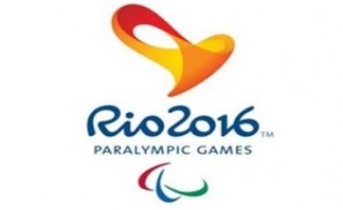[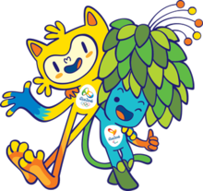](https://en.wikipedia.org/wiki/File:Vinicius_and_Tom.png)

**REPUBLIC OF SOUTH AFRICA** [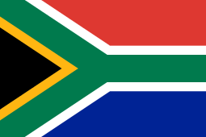](https://en.wikipedia.org/wiki/File:Flag_of_South_Africa.svg)

|  |  |  |  |  |  |  |
| --- | --- | --- | --- | --- | --- | --- |
| **Medal** | **Name** | | | **Sport** | **Event /Date** | |
| Gold Gold  Image 1 Image 1 | [Charl du Toit](https://en.wikipedia.org/w/index.php?title=Charl_du_Toit&action=edit&redlink=1) | C:\Users\herclovaz\AppData\Local\Microsoft\Windows\INetCache\Content.Word\IMG_3188.jpg | | Athletics | Men's 100m - T37  5  !New World Record!  Men's 400m - T37 | |
| Gold  Image 1 | [Dyan Buis](https://en.wikipedia.org/wiki/Dyan_Buis) |  | | Athletics | Men's 400m - T38 | |
| Gold  Image 1 | [Reinhardt Hamman](https://en.wikipedia.org/wiki/Reinhardt_Hamman) |  | | Athletics | Men's Javelin Throw - F38 | |
| Gold  Image 1 | [Ernst van Dyk](https://en.wikipedia.org/wiki/Ernst_van_Dyk) |  | | Cycling | Men's Road Race - H5 | |
| Gold  Image 1 | [Kevin Paul](https://en.wikipedia.org/wiki/Kevin_Paul) |  | | Swimming | Men's 100m Breaststroke - SB9 | |
| Gold Silver  Image 1 Image 1 | [Hilton Langenhoven](https://en.wikipedia.org/wiki/Hilton_Langenhoven) |  | | Athletics | Men's Long Jump - T12  Men’s 200 m – T12 | |
| Silver  Image 1 Image 1 | [Ilse Hayes](https://en.wikipedia.org/wiki/Ilse_Hayes) | |  | Athletics | | Women's 100m - T13  Women's 400m - T13 | |
| Silver  Image 1 | [Ntando Mahlangu](https://en.wikipedia.org/w/index.php?title=Ntando_Mahlangu&action=edit&redlink=1) | |  | Athletics | | Men's 200m - T42 | |
| Silver  Image 1 | [Anrune Liebenberg](https://en.wikipedia.org/wiki/Anrune_Liebenberg) | |  | Athetics | | Women's 400m - T47 | |
| Silver  Image 1 | [Jonathan Ntutu](https://en.wikipedia.org/wiki/Jonathan_Ntutu) | | http://images.supersport.com/2016/9/NNdodomzi-Jonathan-Ntutu-Bronze-160915AI300.jpg | Athletics | | Men's 100m - T12 | |
| Bronze  Image 1 | [Fanie van der Merwe](https://en.wikipedia.org/wiki/Fanie_van_der_Merwe) | | http://www.sapeople.com/wp-content/uploads/2016/09/Paralympics.jpg | Athletics | | Men's 100m - T37 | |
| Bronze  Image 1 | [Tyrone Pillay](https://en.wikipedia.org/w/index.php?title=Tyrone_Pillay&action=edit&redlink=1) | | [http://scontent.cdninstagram.com/t51.2885-15/s480x480/e35/c181.0.718.718/14269023_645441422306796_30539631_n.jpg?ig_cache_key=MTM0MDQzMTg1NDk2ODQyMjkzNg%3D%3D.2.c](http://www.pictaram.com/media/1340431854968422936_426776344) | Athletics | | Men's Shot Put - F42 | |
| Bronze  Image 1 | [Zanele Situ](https://en.wikipedia.org/wiki/Zanele_Situ) | |  | Athletics | | Women's Javelin Throw – F53/54 | |
| Bronze  Image 1 | Dyan Buis | | http://www.sascoc.co.za/wp-content/uploads/2016/09/rsz_dyan-1-615x400.jpg | Athletics | | Men's 400m - T38 | |

**CZECH REPUBLIC**  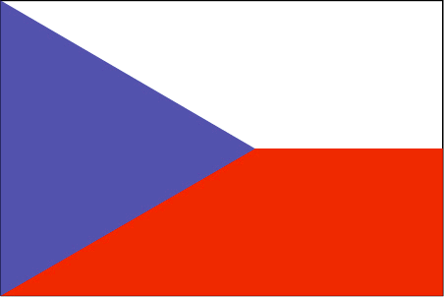

|  |  |  |  |  |
| --- | --- | --- | --- | --- |
| **Medal** | **Name** | | **Sport** | **Event /Date** |
| Gold  Image 1 | Arnošt Petráček | Plavec Arnošt Petráček. | Swimming | Men's 50m Backstroke – S4 |
| Silver  Image 1 | David Drahonínský | Lukostřelec David Drahonínský získal třetí paralympijskou medaili. | Archery | Men's Individual - W1 |
| Silver Bronze  Image 1 Image 1 | Běla Třebínová | [2016 Rio Paralympics - Day 5](http://www.zimbio.com/pictures/a3dYusWuU4e/2016+Rio+Paralympics+Day+5/CSwwr0x-AHg/Bela+Trebinova) | Swimming | Women’s 50m backstroke – S5  Women’s 50m freestyle – S5 |
| Bronze  Image 1 | Jiří Suchánek | [137_suchanek](http://vozickar.com/wp-content/uploads/2016/09/137_Suchánek.jpg) | Table tennis | Table tennis men’s singles – class 2 |
| Bronze  Image 1 | Eva Berná | Koulařka Eva Berná s bronzovou medailí z paralympijských her v Riu de Janeiro. | Athletics | Shot put –F37 |
| Bronze  Image 1 | Šárka Musilová  David Drahonínský | Sarka Musilovahttps://extranet.worldarchery.org/ProfilePictures/?Id=10174 | Archery | Mixed team – W1 |

[](https://en.wikipedia.org/wiki/File:Flag_of_South_Africa.svg)

|  |  |  |  |  |  |  |
| --- | --- | --- | --- | --- | --- | --- |
| [**Medals**](https://en.wikipedia.org/wiki/2016_Summer_Paralympics_medal_table) [Rank](https://en.wikipedia.org/wiki/Olympic_medal_table): 22 | **Total** 17 | **Gold** 7 | **Silver** 6 | | **Bronze** 4 | |
| [**Medals**](https://en.wikipedia.org/wiki/2016_Summer_Paralympics_medal_table) [Rank](https://en.wikipedia.org/wiki/Olympic_medal_table): 51 | **Total** 7 | **Gold** 1 | | **Silver** 2 | | **Bronze** 4 | |

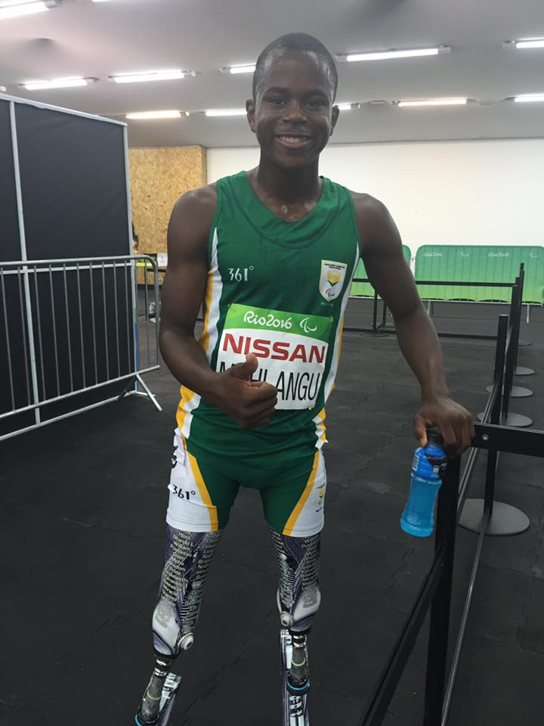  Ntando Mahlangu (200m in 23.77s) at the tender age of 14 ![pic.twitter.com/Xtp8LtlzW4](https://t.co/Xtp8LtlzW4)

