|  |
| --- |
| [Click on the specific symbol to view its symbolism  [coatofarms.gif 22315 bytes)](http://www.gov.za/_vti_bin/shtml.dll/symbols/coatofarms.htm/map) |
|  |

**EMBASSY OF SOUTH AFRICA  
RUSKA 65, 100 00 PRAGUE 10**

**NEWSLETTER - NOVEMBER 2016 (No.11)**

[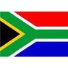](http://www.google.co.za/imgres?imgurl=http://sasportswear.co.za/images/sportswear/south_african_storm_flag.jpg&imgrefurl=http://sasportswear.co.za/sa-memorabilia-7/sports-flags-21/south-african-flag-storm-72.html&h=591&w=591&sz=35&tbnid=Uv7cCdEcYE0-pM:&tbnh=135&tbnw=135&prev=/images?q=South+African+flag&hl=en&usg=__g8gihHXhaZlPhuEToAfXga4s4Hw=&sa=X&ei=IslOTK-nNo-R4Qay7dWoCA&ved=0CAgQ9QEwAQ)



**WORD BY THE AMBASSADOR**

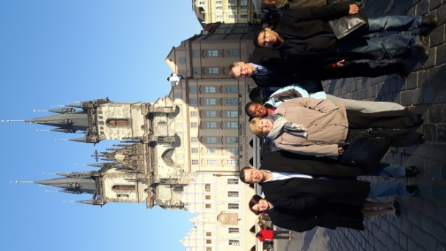*Ambassador Verwey, Deputy Minister Luwellyn Landers,*

*Ms Karen Hosking,*

*Ms T. Malepane,*

*Mr Johan Oberholzer and Mr Amien*

*at the Old Town Square, Prague, 14 November 2016*

November was a highlight of the year for the Embassy with the visit of Deputy Minister Landers to co-chair Bilateral Consultations with his Czech counterpart. It was all the more special since this year also marks 25 years of diplomatic relations between South Africa and the Czech Republic. The talks presented an excellent platform to review and strengthen bilateral relations at all levels; to identify further areas of cooperation between the two countries and to deepen understanding on regional, multilateral and global issues of mutual concern. We were particularly happy that the Deputy Minister made time for a brief visit to the Embassy to meet the staff.

It was, as always, a deeply touching moment to attend the Commonwealth Remembrance Sunday at the military cemetery to lay a wreath and remember those who had died in battle. I always take time to visit the graves of each of the 19 South Africans buried there, so young and so far from home.

**EMBASSY NEWS**

***Visit of DM Luwellyn Landers***

Deputy Minister of International Relations and Cooperation of South Africa, Mr. Luwellyn Landers paid a Working Visit to the Czech Republic from 14-15 November 2016. On 15 November 2016, the Deputy Minister Landers co-chaired Bilateral Consultations with his counterpart, Czech Deputy Minister of Foreign Affairs Mr Martin Tlapa.

Both partners discussed further enhancement of political and economic cooperation as well as strengthening partnership in the area of science and technology. They also marked the 25th anniversary of diplomatic relations between the two countries, concluded on 29th October 1991. On this occasion, the Ministry published a booklet of archival documents tracing the history of Czech-South African relations.

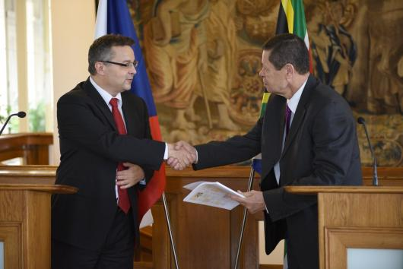

*DM Tlapa handing over a booklet on Czech-South African diplomatic relations to DM Landers, Ministry of Foreign Affairs (MFA), Prague, 15 November 2016. Picture: MFA*

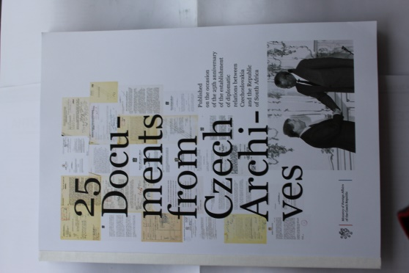

*A booklet documenting*

*the history of the*

*Czech- South African relations*

[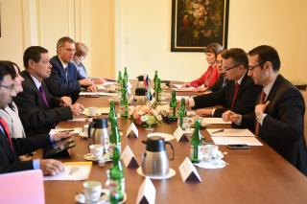](http://www.mzv.cz/public/56/89/85/2179801_1622223_x2016_11_15_Konzultace_NM_CR_JAR_20.jpg)

*Czech-South African Consultations - Mr Amien, Ambassador Verwey, DM Landers, Mr Oberholzer, Ms Hosking, Ms Adamcová, Mr Válek, DM Tlapa, Mr Jančárek, MFA, Prague, 15 November 2016, Picture: MFA*

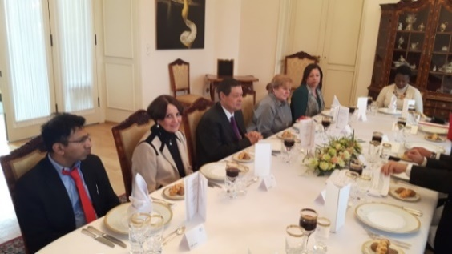

*South African delegation at a working lunch at the Ministry of Foreign Affairs : Mr Amien, Ambassador Verwey, DM Landers, Ms Hosking, Ms Istain & Ms Molepane. MFA, Prague, 15 November 2016*

On 14 November 2016, the Deputy Minister and other members of the delegation visited the Embassy.

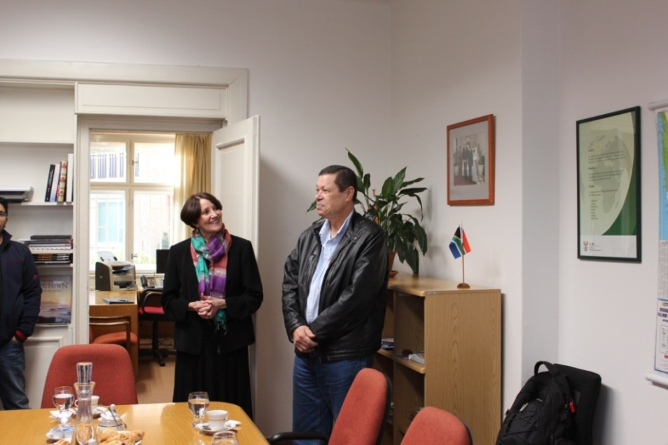

*Ambassador welcomes DM Landers at the*

*Embassy in Prague, 14 November 2016*

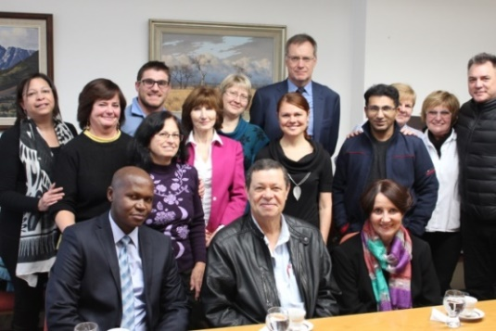

*SA delegation with the staff of the Embassy. Standing: Ms Istain, Ms Rubešová, Mr Wood, Ms Herclová, Ms Růžičková, Ms Haklová, Ms Hlávková, Mr Oberholzer, Mr Amien, Ms Hosking, Ms Procháková, Mr Walters Sitting: Mr Ncongwane, DM Landers and Ambassador Verwey.*

A group of Czech business people, including the chairman of the Czech-South African Chamber of Commerce Mr Vilé $m Růžička$ had an opportunity to meet the South African delegation at a dinner hosted by the Ambassador on 14 November 2016.

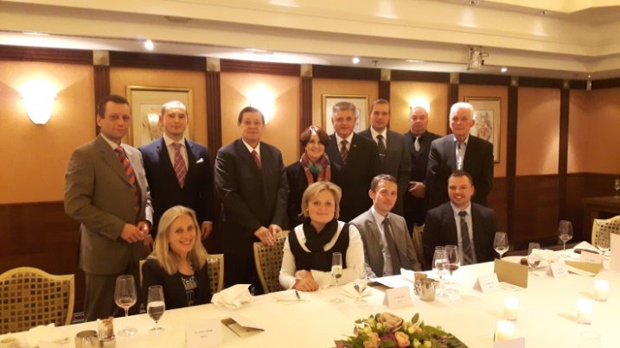

*DM Luwellyn Landers and Ambassador Verwey among the participants of the dinner, Cafe Imperial, Prague, 14 November 2016*

***Tugela Falls expedition***

Under the auspices of the South African Embassy, an expedition led by Czech traveller, photographer and musician Martin Šíl left for South Africa in November 2016.

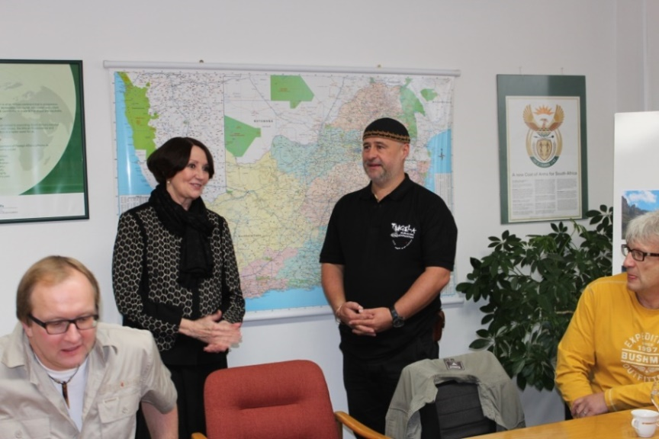

*Ambassador Verwey and Martin Šíl*

The expedition that includes Czech as well as South African geologists intends measuring the Tugela Falls to determine whether their theory is correct that the Falls are higher than the Angel Falls (Salto Ángel) in Venezuela, which is currently regarded as the tallest waterfall in the world.

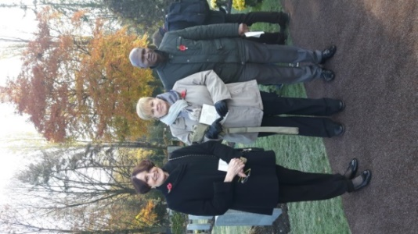A press conference with the members of expedition was held at the Embassy on 8 November 2016, one day before their departure.

[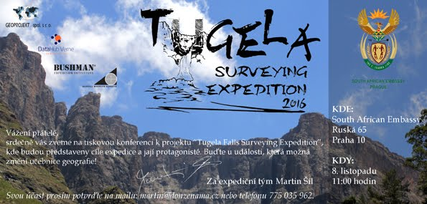](http://www.doneznama.cz/home/tiskovkaoexpedicitugelafalls/tugela%20surveying%20expedition%20pozvanka.jpg?attredirects=0)

*Invitation to the press conference*

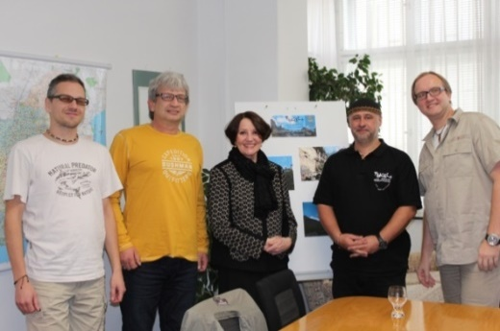

*Ambassador Verwey with the members of the expedition, SA Embassy in Prague, 8 November 2016*

***Remembrance Day***

The Ambassador, Ms Hosking and Mr Ncongwane attended the traditional Remembrance Day ceremony which was held in the Olšany Commonwealth War Cemetery Prague on Sunday, 13 November 2016 to remember all those who have given their lives for the peace and freedom in the two World Wars of the 20 Century. The Ambassador laid wreath at the Central Cross and paid tribute to South Africans who are buried in Czech soil.

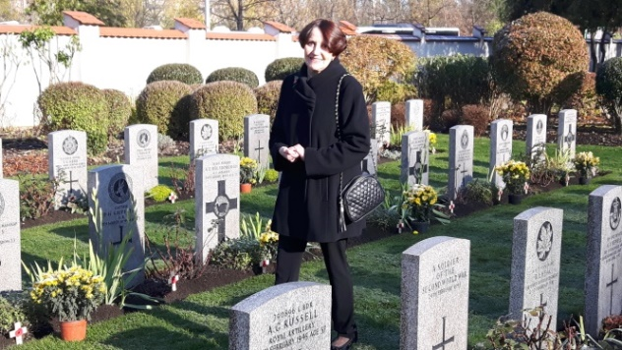

*Ambassador Verwey paying tribute to nineteen South Africans buried at the cemetary*

[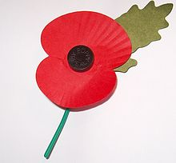](https://en.wikipedia.org/wiki/File:Royal_British_Legion's_Paper_Poppy_-_white_background.jpg)

*Poppy–emblem of Remembrance Day*

*Ambassador Verwey, Ms Hosking*

*and Mr Ncongwane*

***Christmas festival***

Forty-five diplomatic missions, including the South African Embassy, took part at the annual Diplomatic Christmas festival organized by the Diplomatic Spouses Association at the Prague Hilton Hotel on 27 November 2016. The festival was opened by the First Lady Ms Ivana Zemanová.

The South African stand offered South African arts & crafts and wines. As in previous years, Ms Heather Crowther from *Tombalina Wines* and Mr Jan Brett and his wife Jana from *Original Afrika* partnered with the Embassy and contributed to the success of the event.

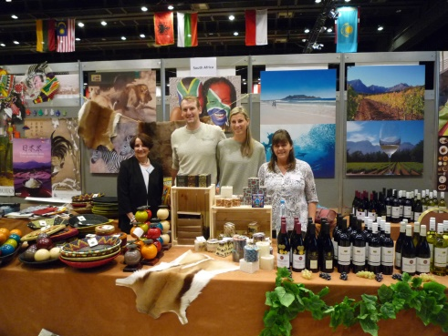

*Ambassador Verwey, jan Brett, Jana Brettová*

*and Heather Crowther at South African stand*

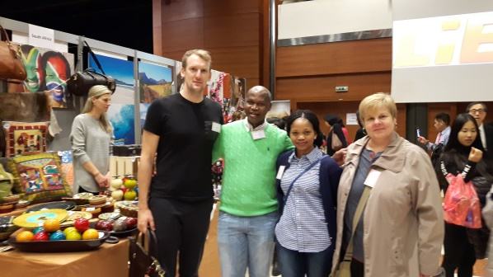

*Mr Brett, Mr Ncongwane and his wife and Ms Hosking in front of South African stand*

***Diplomatic events***

The Ambassador attended National Day celebrations of Afghanistan and Albania; farewell dinners hosted by Ambassadors of Saudi Arabia, Japan and Algeria; a farewell reception hosted by Ambassador of Chile; a welcome lunch for new French Ambassador; a lunch hosted by Ambassador of Denmark; as well as days of Korean cuisine.

Ms Hosking attended a lecture *50 years of occupation and how to end it* organized by the Embassy of Palestine.

The new Ambassador of Belgium paid a courtesy call on Ambassador Verwey.

**STAFF NEWS/SA CITIZENS**

Two Corporate Services trainees from DIRCO, Ms Kearata Motsemme and Mr Sipho Griffiths Msiza arrived in Prague on 19 November 2016 for three weeks of training in Mission administration.

Mr Humphrey Mahlamvu, a technician from the Embassy in Vienna spent a week in Prague from 20-26 November 2016 to conduct work on the computer network system.

The Ambassador hosted a welcome lunch for them at the Official Residence on 24 November 2016.

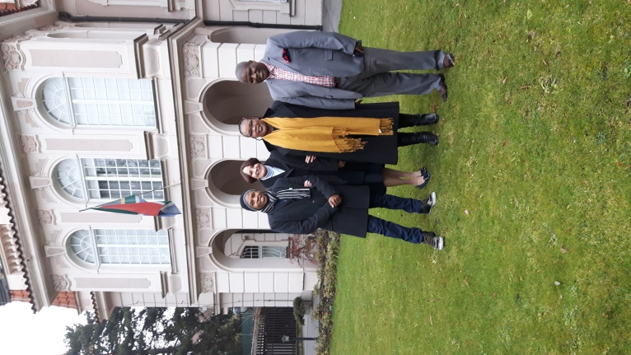

*Mr Mahlamvu, Ambassador Verwey,*

*Ms Motsemme and Mr Msiza*

*in front of the Residence*

**SOUTH AFRICAN NEWS**

***SA-China Bi-National Commission***

Deputy President Cyril Ramaphosa hosted the Vice President of the Peoples Republic of China, Mr LI Yuanchao, for the 6th Session of the South Africa-China Bi-National Commission in Cape Town on 22 November 2016.

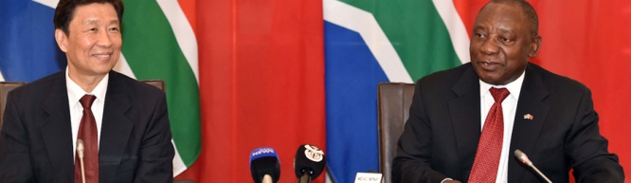

*The 6th South Africa-China Bi-National Commission co-chaired by Deputy President Cyril Ramaphosa and Vice President Dr Li Yuanchao in Cape Town*

***Deputy Minister Landers undertook a three-nation working visit to Europe***

The Deputy Minister of International Relations and Cooperation, Mr Luwellyn Landers, undertook a three-nation working visit to the Czech Republic, the Republic of

Hungary and the Republic of Poland, respectively, from 14-17 November 2016 for bilateral political consultations.

Bilateral trade between South Africa and all three Central European countries has grown considerably since the establishment of diplomatic relations between South Africa and the three countries 25 years ago.

***South Africa – Russian Federation Intergovernmental Committee on ITEC***

International Relations and Cooperation Minister Maite Nkoana-Mashabane and the Minister of Natural Resources and Environment of the Russian Federation, Mr Sergey Donskoy, co-chaired the 14th Session of the Joint Intergovernmental Committee on Trade and Economic Cooperation (ITEC) between South Africa and Russia on 18 November 2016 in Pretoria.

[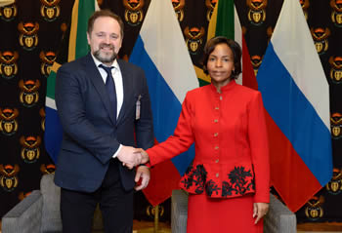](http://www.dirco.gov.za/images/gallery8/mashabane_itec_donskoy4.jpg)

*Ministers Sergey Donskoy and Maite Nkoana-Mashabane, Pretoria, South Africa, 18 November 2016. Picture: Jacoline Schoonees*

***Working Visit to Germany***

International Relations and Cooperation Minister Maite Nkoana-Mashabane undertook a Working Visit to Munich, Bavaria, on 14-15 November 2016, before proceeding to Berlin to co-chair the 9th SA-Germany Bi-National Commission.

[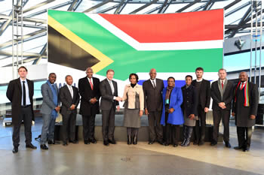](http://www.dirco.gov.za/images/gallery8/mashabane_germany_bmw5.jpg)

*Working Visit by Minister Maite Nkoana-Mashabane to Munich, Bavaria, Germany, 14-15 November 2016. Picture: Yolande Snyman*

***South Africa Botswana Bi-National Commission (BNC)***

President Jacob Zuma hosted his Botswana counterpart, President Lt General Seretse Khama Ian Khama on the occasion of the  **Third Session of the South Africa-Botswana Bi-National Commission in Pretoria on 11 November 2016.**

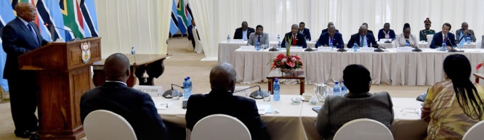

*President Jacob Zuma addressing the 3rd session of the South Africa-Botswana Bi-National Commission (BNC) in Pretoria.  Picture: The Presidency*

**Inaugural Session of the SA-Zimbabwe Bi-National Commission**

On 3 November 2016, President Jacob Zuma co-chaired the Inaugural Session of the Zimbabwe-South Africa Bi-National Commission (BNC) together with President Robert Mugabe of Zimbabwe.

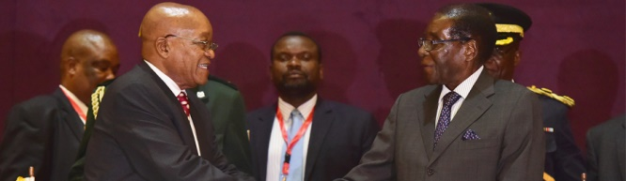

*President Jacob Zuma and President Robert Mugabe of Zimbabwe during SA-Zimbabwe Bi-National Commission in Harare. Picture: The Presidency*

***16 Days of Activism 2016***

The 16 Days of Activism for no Violence against Women and Children take place from 25 November to 10 December 2016 under the slogan *Count me in: together moving a non-violent South Africa forward.*

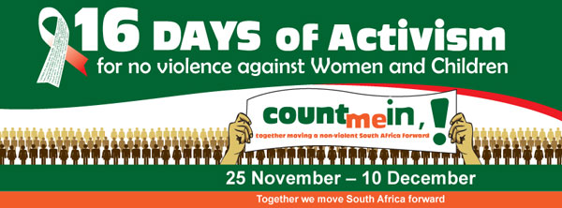

South Africa adopted the campaign in 1998 with the aim to create awareness and contribute to a society free of violence.

***IMBIZO Week***

National Imbizo Focus week, direct face-to-face communication between government and members of the community was held from 7 -13 November 2016 under the theme *Together we move South Africa forward: Our Future – make it work.*

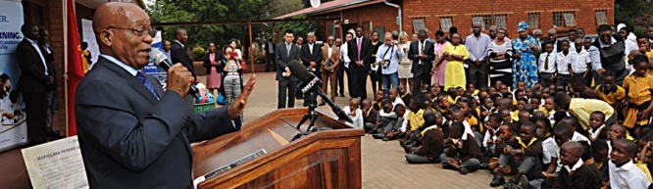

*President Jacob Zuma commences Government-wide National Imbizo Focus Week at Marhulana Primary School in Tembisa, Ekurhuleni. Picture: The Presidency*

***Floods in RSA***

Parts of Gauteng were hit by a 200-year flood in November after widespread spring rains. The floods caused extensive damage to infrastructure‚ homes‚ vehicles and claimed the lives of at least six people in Johannesburg and Ekurhuleni. Some areas in the province were declared disaster zones.

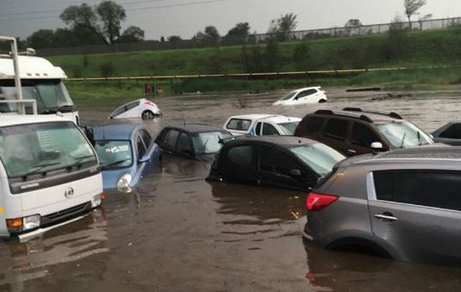

*Image by: Njabulo Cele ‏@njabuloc via Twitter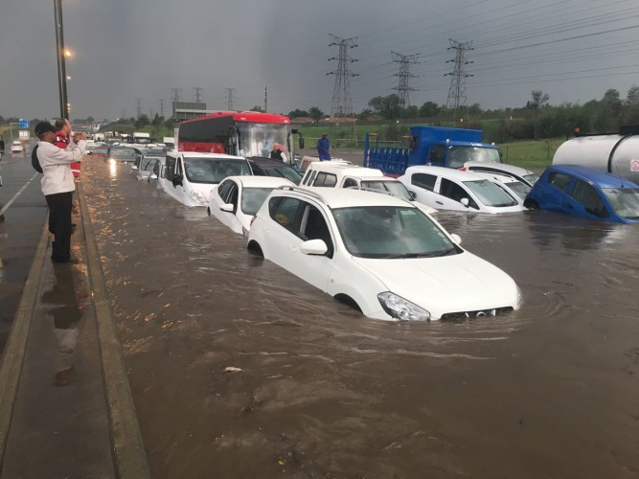*

**CZECH NEWS**

***Visit of French President***

French President Francois Hollande paid a visit to Prague on 30 November 2016 to meet the Czech Head of State, Miloš Zeman and Prime Minister Bohuslav Sobotka. The future of the European Union, terrorism and bilateral matters were on the agenda during Mr. Hollande’s visit.

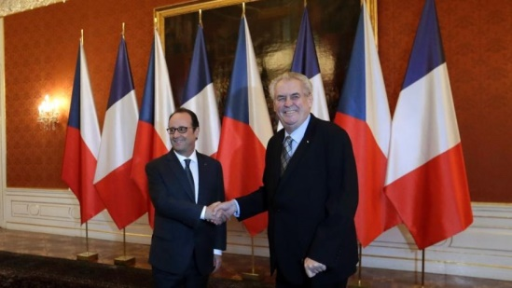

*President Miloš Zeman, right, welcomes his French counterpart Francois Hollande, left, at the Prague Castle, Czech Republic, 30 November 2016.*

*(AP Photo/Petr David Josek)*

***Two Ministers leave the cabinet***

Following the ČSSD's weak showing in the October regional and Senate elections, Prime Minister Bohuslav Sobotka re-shuffled the cabinet.

Human Rights Minister Jiří Dienstbier will be replaced by ČSSD Deputy Jan Chvojka as from 1 December 2016. Health Minister Svatopluk Němeček will be replaced by Miloslav Ludvík, a Prague hospital director.

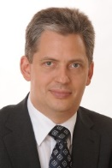 [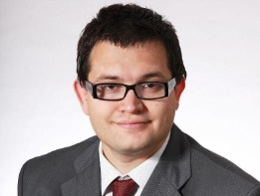](http://chrudimsky.denik.cz/galerie/foto.html?mm=jan_chvojka_poslanec) 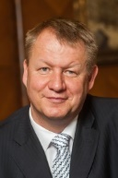 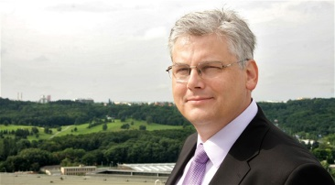

*Jiří Dienstbier Svatopluk Němeček*

*Jan Chvojka Miloslav Ludvík*

***UK Secretary of State visited Prague***

Boris Johnson, Secretary of State for Foreign and Commonwealth Affairs of the United Kingdom of Great Britain and Northern Ireland paid a working visit to Prague on 11 November 2016. Relations between the Czech Republic and the UK after the Brexit referendum in June 2016, as well security policy, the fight against terrorism, regional conflicts and migration were discussed.

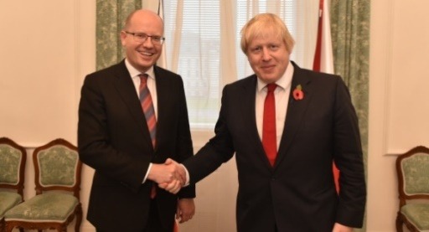

*PM Bohuslav Sobotka and UK Secretary of State Boris Johnson, Prague, 11 October 2016.*

*Picture:The Government*

***Milan Štech re-elected Senate chairman***

Milan Štěch was re-elected chairman of the Senate on 16 November 2016 at the upper chamber’s first session since the partial Senate elections in October.

***November revolution anniversary***

On 17 November 2016 commemorative events took place around the Czech Republic to mark the anniversary of the Velvet Revolution that led to the fall of communism in 1989. Politicians, cultural figures and members of the public laid flowers and lit candles at key sites linked to the events of 1989. Marches, demonstrations and events took place around the capital. A street party called *Thank You That We Can* was held in the centre of Prague. The celebrations culminated with a Concert for Freedom on Wenceslas Square.

[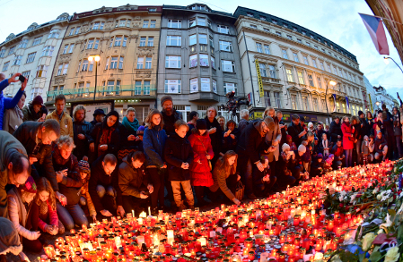](http://www.radio.cz/en/section/breaking/biggest-turnout-in-years-for-democracy-celebrations-on-november-17)*Candles lit at Národní třída,* *where police brutally dispersed a quiet student demonstration in 1989*

***Veteran Day***

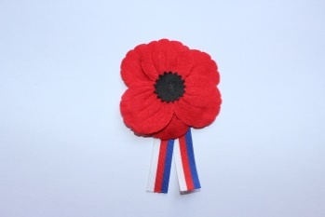Several commemorative events were held across the Czech Republic on 11 November 2016 to mark International Veterans

Day.

|  |
| --- |
| For more information about the activities of the South African Embassy in Prague please visit our website:  http://[www.saprague.cz](http://www.saprague.cz) |